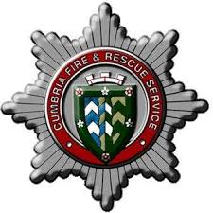
Cumbria Fire & Rescue Service
Leadership Framework Form – WM Process

Name:

Candidates are required to provide evidence against the “Leading Others” level of the NFCC Leadership Framework Quadrants:
- Personal Impact;
- Outstanding Leadership;
- Service Delivery;
- Organisational Effectiveness.
Candidates are asked to follow the link to the Leadership Framework document to get specific information for the required criteria:
Link to NFCC Leadership Framework

- Personal Impact (Max 500 words)

- Outstanding Leadership (Max 500 words)

- Service Delivery (Max 500 words)

- Organisational Effectiveness (Max 500 words)

