Suicide Alertness Additional Information
Context:
Talking about suicide does not increase the risk
We know there is a huge about of stigma surrounding suicide – if we can as a society reduce the stigma – that is going to help
Asking directly about thoughts of suicide will not put the idea in someone’s head
Thoughts of suicide are relatively common
It is thought that each year one in seventeen of us will have thoughts of suicide, over a lifetime this is 1 in 5. APMS 2016 (see reference section at end)
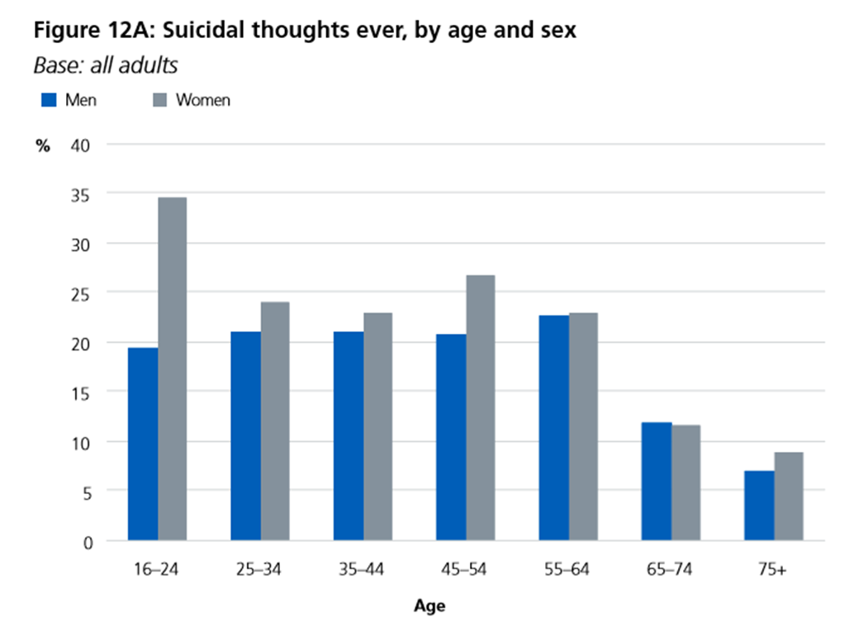

Anyone can be at risk of suicide
It is important to be aware that anyone can be at risk of suicide.
There are higher risk groups including:
• young and middle-aged men
• people in the care of mental health services, including inpatients
• people in contact with the criminal justice system
• specific occupational groups, such as doctors, nurses, veterinary workers, farmers and agricultural workers
• people with a history of self-harm.
Also highlighted:
- Children and young people
- Users of drug and alcohol services
- Perinatal mental health
- People in receipt of employment benefits

There are also certain life events that may well lead to someone being at increased risk- job loss, relationship breakdown, debt, illness etc

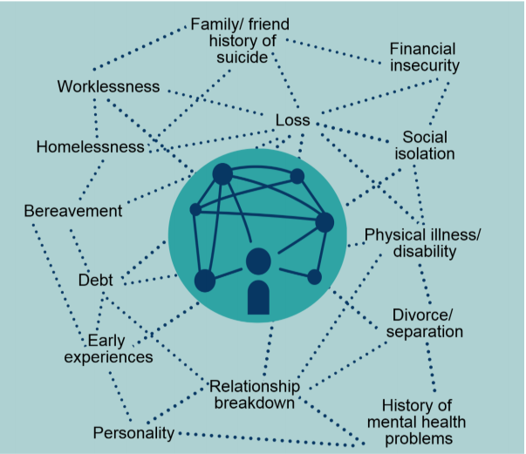
but it is important to remember anyone can be at risk

75% of all completed suicides are men.
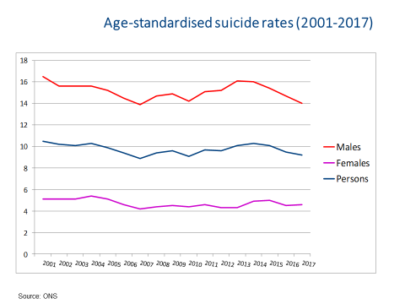
The highest risk aged range is middle aged men.
Recommend Samaritans report: https://www.samaritans.org/about-us/our-research/research-report-men-suicide-and-society and the work of CALM
Please be aware though that more women are attempting than men.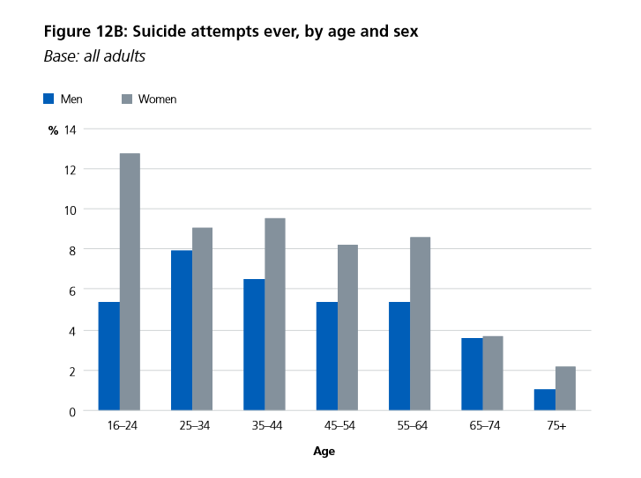

Suicide is the biggest killer of young people in the UK
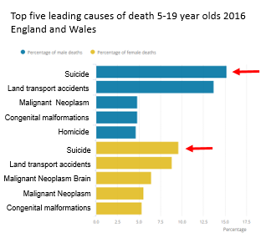
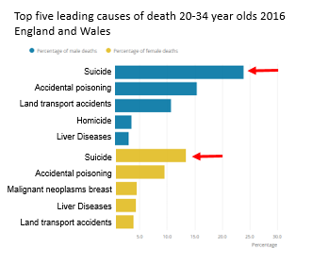
Recommended reading:
Suicide by children and young people. National Confidential Inquiry into Suicide and Homicide by People with Mental Illness (NCISH). Manchester: University of Manchester, 2017. http://documents.manchester.ac.uk/display.aspx?DocID=37566
Young Minds report on Adverse Childhood Experiences:
https://youngminds.org.uk/resources/policy/addressing-adversity-book/
Cumbria Public Health Annual Report 2018 focussing on ACEs: www.cumbria.gov.uk/elibrary/Content/Internet/536/671/4674/5223/43508134148.pdf

Cumbria’s suicide rates are considerably higher than the national average
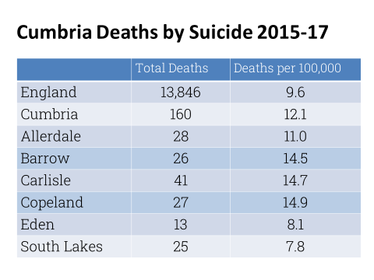
Link to most recent ONS data: https://www.ons.gov.uk/peoplepopulationandcommunity/birthsdeathsandmarriages/deaths/datasets/suicidesbylocalauthority

Key Issues:
Suicide Prevention is everyone’s business – we all have a role to play.
The key concept is safety for now – not expected to sort out all of someone’s problems and get them to the point where they are never going to have a suicidal thought again but could be pivotal in recognising that there is an issue and being willing to have that conversation and then signpost to help them get the support they need
Suicide is not inevitable- it can be prevented
Be Helpfully Nosey
It is hard for someone to come out and say “I am suicidal help me” – they tend to ask for help in more subtle ways. It is about being aware and alert – picking up on the signs, clues, invitations that someone may be having thoughts of suicide – and being willing to ask another question. And remember the importance of gut instinct.
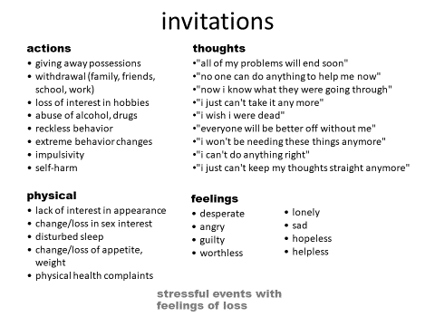
The importance of asking directly about thoughts of suicide: You will not put the idea in someone’s head
Homework!! How would you ask?
Listen: The importance of not needing to fix but allowing someone if they can to talk; and to talk about their reasons for dying – and from there often comes a reason for living
ASK LISTEN GET HELP
The importance to be real life and realistic within this – we often know that waiting lists are long and referral can take time it is vital to make appropriate referrals but also be mindful of how long these can take – so what other support can be there for someone

Its about being ALERT
A ask how it feels like to have shared feelings
L listen without being judgemental or criticising
E empathise by showing you really do care and are trying to understand
R reassure that the desperate feelings are common and can be overcome
T try to give practical support without taking over
(from Papyrus)

Negotiation Staircase:
Sometimes if someone is in crisis or particularly vulnerable we may have to be more directive than we normally would be
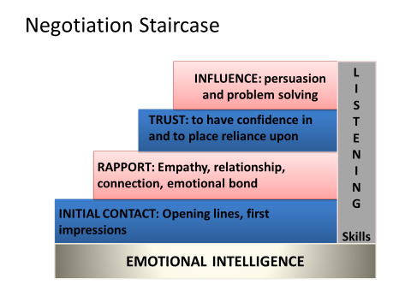

Resources: Remember the full resource sheet given in the training session
Key resources:
- GP
- Crisis Team /CAMHS
- First Step (access to Silver Cloud)
- Possibly friends and or relatives
- Cumbria Mindline 0300 561 0000
- Suicide Bereavement Support (formerly SOBS)
- Specialist support agencies (CADAS, SAFA)
- www.kooth.com
- Papyrus – Prevention of Young Suicides
- CALM – Campaign Against Living Miserably
- Young Minds Crisis Messenger
- SHOUT
- Samaritans -116123
- Childline
- Silverline
- A&E
- Police
Also the role of online resource and apps (Grassroots Stay Alive, CalmHarm etc)
Every Life Matters website will have links to resources: www.every-life-matters.org.uk

Safety Planning
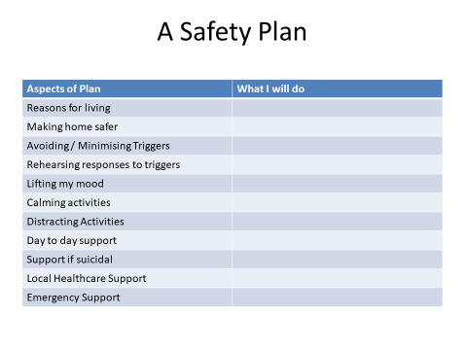
Also check out Dr Alys Cole King’s website www.stayingsafe.net for on line safety plans etc
Remember the importance of protective factors not just risk factors
Other key reports/ guidance:
Support after Suicide: www.suicideaftersuicide.org.uk really useful website with postvention information and support including on line versions of Help is at Hand and Find the Words
Theories of Suicidality / Suicidal Behaviour:
Within the session we often do not get to look at theories of suicidality. Recommended further reading would be Rory O’Connor’s work on the Integrated Motivational Volitional Model http://www.suicideresearch.info/the-imv
Adult Psychiatric Morbidity Survey:
https://digital.nhs.uk/data-and-information/publications/statistical/adult-psychiatric-morbidity-survey/adult-psychiatric-morbidity-survey-survey-of-mental-health-and-wellbeing-england-2014

Cumbria Audit: https://www.cumbria.gov.uk/eLibrary/Content/Internet/536/671/4674/6164/4214615337.pdf
Samaritans Dying from Inequality – the link between suicide and socio-economic disadvantage
https://www.samaritans.org/dying-from-inequality
Guidance for professionals working with children and young people who self harm
https://www.cumbria.gov.uk/eLibrary/Content/Internet/537/6683/6688/6754/4232014152.pdf
BMJ produce a useful infograph for initial assessment in primary care
https://www.bmj.com/content/bmj/suppl/2017/03/30/bmj.j1128.DC1/suicide_v23_web.full.pdf

Public Health England Cluster Guidance: https://assets.publishing.service.gov.uk/government/uploads/system/uploads/attachment_data/file/459303/Identifying_and_responding_to_suicide_clusters_and_contagion.pdf
And finally:
Be helpfully nosey and also remember to look after yourselves – self care is a necessity not a luxury.
Juliet
Every Life Matters
Juliet.Gray@every-life-matters.org.uk
Facebook: @everylifecumbria
Twitter: @Every_Life_Cumb
Instagram: @everylifecumbria

