WOW Referral Form
WOW 413

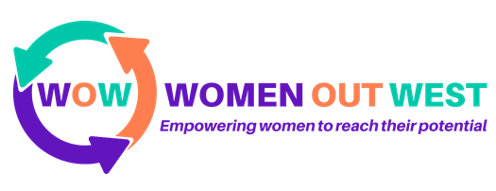

If you work with a lady who you think would benefit from the services that we offer at Women Out West then you can refer them to us using this form.

Thank you very much for working with us, if you have any queries please call 01946 550103 or email contactus@womenoutwest.co.uk

YOUR DETAILS:
Surname: |  | First Name:
Organisation: |  | Position:
Connection to person referred:
Main Contact Number: |  | Email:
REFERRAL DETAILS:
Surname: |  | First Name:
Email: |  | Safe to email? | Yes/No
Main Contact Number: |  | Safe to call? | Yes/No
Address: |  | Safe to write? Yes/No
Preferred method of contact (please delete) Phone call/ Text Message/ Email/ Letter
Are there any days/times that we shouldn’t make contact?

Can you briefly detail what your involvement has been with the person you are referring and why you are referring them?
Which aspect(s) of our services are you referring this person to? See Appendix A for more information.
- Beautiful Me Course
- The Key Course
- Activities and Drop-In
- One-to-One Sessions.
What benefit do you think this person will gain from our services?
Are there any safety concerns that we need to be aware of?

Are there any mental health conditions that we should be aware of?

Are there any physical health conditions that we should be aware of?
Is there any other information that you think we need to know?
Signature:
Print Name: | Signature:
Date:

Appendix A-Information about WOW Services
- Beautiful Me Course
  - A personal development course of self-reflection and personal growth through activities, discussion and group work.
  - Aimed at ladies who need to rebuild their self-worth and confidence, especially those who have suffered domestic abuse.
  - A 12-week course run weekly, split into 2 parts which are 6 weeks each.
- The Key Course
  - Confidence and work readiness course.
  - More details to follow!
- Activities and Drop-In
  - From November 4th 2019 our Centre will be open 10-3 Monday-Thursday and 10-1 on a Friday for drop-in. There will be a Peer Support Worker and Project Worker available to receive women, listen to them and sign-post them to services.
  - In addition, there will be different daily activities including art and craft, English and Maths, special topic sessions, a job shop and financial support.
- One-to-One Sessions.
  - Ladies who require counselling or one-to-one support. Their case will be assessed by either by our Peer Support Worker or Project Worker and they will refer them to the appropriate service either internally or externally.

If you would like more information on any of our services please contact us. 01946 550103 or email contactus@womenoutwest.co.uk

