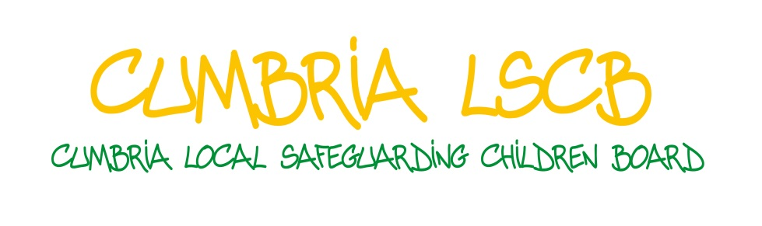

Lay Member:
Job Description,
Person Specification and
Confidentiality Agreement

Lay Member: Cumbria Local Safeguarding Children Board

- Purpose of the Role

In line with statutory requirements and as part of the Local Safeguarding Children Board’s (LSCB) commitment to engaging communities in safeguarding and promoting the welfare of children and young people, we will be appointing two volunteer Lay Members to the LSCB.
The role of Lay Members is to bring a more ‘grass roots’ perspective to the work of the Board on safeguarding children; to think as a member of the public; and to play a part in the oversight and scrutiny of decisions and policies made by the Board.

- Job Description

The main duties will be to:
- attend and contribute to 6 half day LSCB meetings and participate in a small number of relevant Sub Groups of the LSCB as appropriate;
- attend one development day per year;
- actively support stronger public engagement in local child safety issues and contributing to an improved understanding of the LSCB’s child protection work in the wider community;
- challenge the LSCB on the accessibility by the public and children and young people of its plans and procedures; and
- help to make links between the LSCB and community groups.

- Person Specification

Essential:
- Lay Members must have an interest in children’s issues and the safety of children;
- Lay Members must have an ability to communicate effectively within meetings and the confidence to ask questions and challenge people in a constructive way;
- Lay Members must have a commitment to improving outcomes for children and keeping children and young people safe;
- Lay Members must have a commitment to the values and vision established by the LSCB;
- Lay Members must have a commitment to equality and diversity within their own life experience and in promoting good outcomes for children and young people in the county;
- Applicants will be required to demonstrate an understanding of the handling of sensitive and confidential data.
- Lay Members must be a resident of Cumbria or be able to evidence working experience of and ability to travel in Cumbria.
- A Lay Member must declare any prior connection with agencies or elected members working with children within the County. This includes both Lay Members and their family members;
- Understanding of the complexity of safeguarding, at both an organisational and individual level.
- Ability to understand and interpret complex written and numerical information.
- Ability to challenge senior managers and professionals constructively.
- Recruitment and selection

Lay Members will be appointed following an interview process and subject to statutory checks and references including an enhanced DBS (Disclosure and Barring Scheme – previously known as Criminal Records Bureau) disclosure.

One personal and one professional reference will also be taken up.

Applicants will be required to disclose any previous personal involvement in the child protection process although it should be noted that this would not necessarily constitute a barrier to appointment.

Successful applicants will be asked to sign a confidentiality agreement before taking up the role (see below).

- Induction, training and support

All new LSCB members will be entitled to a process of induction which will involve:

- basic briefing on the function of the Board and the duties of Board members. This will include receiving a copy of the LSCB Annual Report and Business Plan;
- a meeting with the LSCB Chair and Senior Manager;
- observing a Board meeting prior to becoming a member;
- identification of further training and learning needs.

Lay Members will be expected to complete multi-agency Safeguarding Training in within the first three months of appointment.

A ‘buddying’ arrangement will be in place for each Lay Member, which will involve meeting with a member of the Board before and/or after each meeting to prepare and de-brief if necessary.

Lay Members will be subject to annual appraisals undertaken by the LSCB Chair and will be provided with safeguarding development activity on an ongoing basis.

- Expenses

The role is a voluntary one, although expenses such as travel costs and subsistence will be reimbursed if required.

- Appointment and notice period

The appointment is for a three year period with an annual review. The appointment can be terminated at any time with an expectation of one month’s notice period on either side.
LSCB Lay Members’ Confidentiality Agreement

- Scope of the Agreement

In your role as Lay Member to the Local Safeguarding Children Board (hereinafter referred to as ‘The Board’), you will have access to sensitive personal and business information which may be held in electronic format or on paper or similar hard copy, or may be spoken in face to face or telephone conversations and is of a confidential nature.

The personal and business information held by The Board and its constituent agencies is subject to the common law duty of confidentiality (i.e. where you are trusted with potentially sensitive information in confidence and are obliged not to disclose the information without permission from The Board). You are also bound by the Data Protection Act 1998 which provides for the protection of personal information.

For the purposes of this agreement, all personal and business information is considered to be ‘confidential information’, unless specifically stated otherwise.

- Conditions of the Agreement

In consideration of The Board providing you with confidential information you are required to accept and comply with the following terms and conditions:
2.1 You will maintain the confidential information in the strictest confidence and will not divulge any of the confidential information to any third party without the prior written permission of The Board.
2.2 You will not under any circumstances speak to the media. All such communications will be made directly through the LSCB.
2.3 You will not make use of the confidential information in connection
with any similar activity undertaken by you or on your behalf.

2.4 You acknowledge The Board’s proprietary rights in the confidential information and that disclosure of confidential information shall not be deemed to confer upon you any rights whatsoever in respect of any part thereof.

2.5 You will not take copies of any document or other material (in whatsoever medium) embodying any of the confidential information without the prior written agreement of The Board or the Chair of The Board.

2.6 You will store any reports or other papers, in electronic format or otherwise, securely at all times including keeping all documents in a locked filing cabinet in your home.

2.6 You will confirm to The Board in writing at any time on request that you have complied with the provisions hereof and if so requested shall provide a statutory declaration to the effect that no confidential information (in whatever medium) has been used or disclosed to any third party by you or on your behalf in breach of the terms of this agreement.
N.B Failure to comply with its provisions will result in the immediate termination of your engagement as Lay Member and could result in civil or criminal action being taken against you.

You acknowledge that you are aware and have been advised that:

2.7 The Board, as individuals or organisations, does not accept responsibility or liability for or make any representation, statement or expression of opinion or warranty, express or implied, with respect to the accuracy or completeness of the confidential information.

2.8 The provisions of this agreement shall continue beyond the term of your involvement as Lay Member to The Board.

2.9 The confidential information is highly confidential and sensitive, whereby disclosure may cause irreparable damage to The Board or individuals.

2.10 Nothing in this agreement shall be construed to grant you any license or rights in respect of the confidential information or in connection with The Board.

2.11 The restrictions on use or disclosure of the ‘confidential information’ will NOT apply to any information, which is already in the public domain (provided that this has not happened because of a breach of this agreement or any other duty of confidentiality).

- Duty of Care

If during the course of your appointment as a Lay Member to the Board you become aware of information about a child, young person or family, or service which causes you concern, you must discuss your concerns with the person nominated to support you in this role or in their absence the Senior Manager - LSCB or LSCB Chair.
- Review

The forgoing constitutes the entire agreement between you and The Board with respect to confidential information. The terms of this agreement can only be changed by a written document, agreed by The Board and signed by you. If at any time any provision of this agreement is found to be illegal, unenforceable or invalid in whole or in part, then the remaining portions of the agreement will continue to be binding and in full force and effect.

The provisions hereof shall be governed and construed by English law, and by your acceptance hereof you agree to submit to the exclusive jurisdiction of the English Courts.

- Consent

Please indicate your acceptance of the above by signing below:

I refer to the provisions of the agreement and hereby confirm my agreement to the terms thereof

Signed by…………………………………………….

Full Name …………………………………………….

Date………..………………………………………….
In the presence of (signature) ………………………………..

Name ……………………………………………….

Address ……………………………………………………
…………………………………………..

Occupation ……………………………………..

