Information
Governance

Data Protection Act 1998
Freedom of Information Act 2000
Environmental Information Regulations 2004

Request Form

Information Governance Team
January 2017

Using the Form

This form can be used if you are making a request for information under any of the following:

- Data Protection Act 1998 (including CCTV)
- Environmental Information Regulations 2004
- Freedom of Information Act 2000

Sections marked (*) are mandatory and must be completed.

Applicant Details*

Note: To assist the council with processing your request you must supply your name and your preferred method of contact - either an email address OR postal address. If you are submitting a request for personal data about a person other than yourself under the Data Protection Act 1998 please include full details in Information Required.

Title

Name*

Address

Telephone

Fax

E-mail

Information Required*

Please provide a description of the information you require i.e. date of birth, dates, department. If you need any help with your request see Hints and Tips for Making Requests

Description of the information you require:

How would you like to receive the information?*

Note: a fee may be payable for some services. (Details can be found in the Council's Charging Policy)

By email
By inspecting/viewing the information in person (appointment required)
In permanent electronic/paper format e.g. photocopies, CD
In an alternative format e.g. large print, braille, other languages

Do I need to provide anything else?

When requesting information from the council you should provide your name, address and telephone number. Also provide a full description of the information you require. If you can tell us dates and who the information is held by, for example the department, team or employee, it will help us to locate it more quickly. We will contact you if we need any further details or clarification.

The council is legally obligated to verify your identity before any personal data is disclosed. This is to prevent the unauthorised disclosure of information about data subjects. If further evidence of your identity, address, legal status or relationship to the data subject is required the Information Governance Team will contact you directly.

Further Information

Address: Information Governance Team, Cumbria House, 117 Botchergate, Carlisle Cumbria CA1 1RD
Email: information.governance@cumbria.gov.uk
Website: Access to Information

Privacy Notice

Any personal information you provide on this form will be held and processed by Cumbria County Council for the purpose of administering and responding to your request. This information will be held securely and will not be disclosed to other parties, without your permission. The information which you provide will be destroyed in a secure manner when the retention period has expired.

Agreement

Only send this form if you agree to Cumbria County Council processing the data for the purpose stated above.

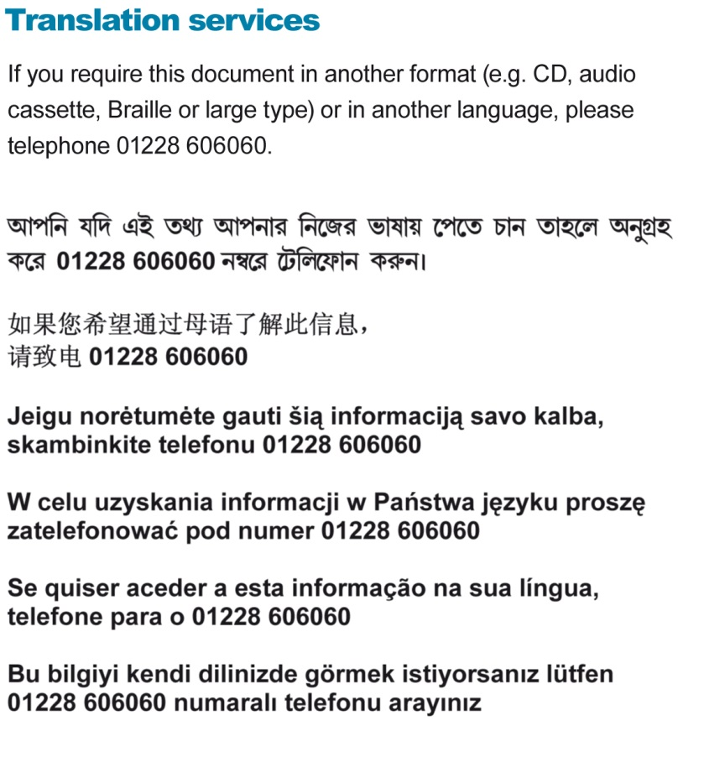

cumbria.gov.uk

