

**Walney North**

**Electoral Division Profile**

**2014**

# Overview of Electoral Division

Walney North is in the electoral division of Barrow Borough and has a population of 5,344.

# Map



# Statistical Profile

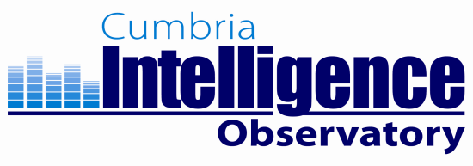**Statistical Profile: Walney North Electoral Division**

The 2011 Census estimated that the population of **Walney North Electoral Division (ED)** was **5344** persons.

The table below presents estimated numbers of residents in **Walney North** **ED** by age group:

|  |  |  |  |  |  |  |  |  |
| --- | --- | --- | --- | --- | --- | --- | --- | --- |
|  | **No. Persons by Age Group (Years)** | | | | | | | |
| **All Ages** | **0 - 14** | **15 - 29** | **30 - 44** | **45 - 59** | **60 - 74** | **75 - 84** | **85+** |
| *Walney North ED* | *5344* | *819* | *817* | *967* | *1048* | *1155* | *408* | *130* |

Source: Office for National Statistics, 2011 Census

The chart below compares the proportion of **Walney North ED’s** population within each age group with the proportion of the population within each age group across Barrow-in-Furness district, Cumbria and England & Wales:

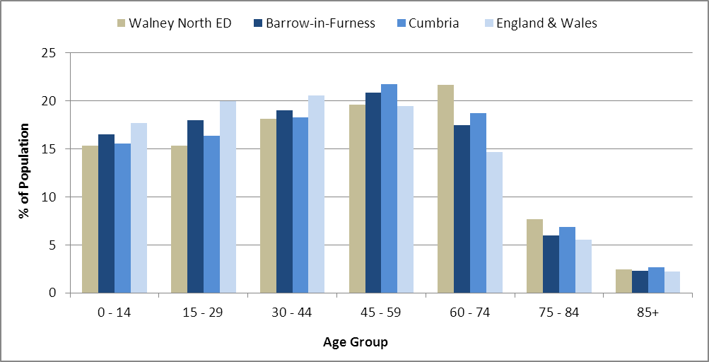

Source: Office for National Statistics, 2011 Census

County Council Electoral Divisions cover large spatial areas and so division averages can mask variation between communities within the division. Furthermore, beyond Census data, there is little statistical information available for Electoral Divisions. However, most statistical agencies produce data for Electoral Wards. Therefore, there is a very wide rangeof statistical information available for Electoral Wards. Furthermore, as Electoral Wards are generally smaller than Electoral Divisions, statistics at this level provide more insight into variations between communities.

The table below identifies which Electoral Wards are fully or partially within the boundaries of **Walney North** **ED**, and what proportion of **Walney North** **ED**’s population live within each ward:

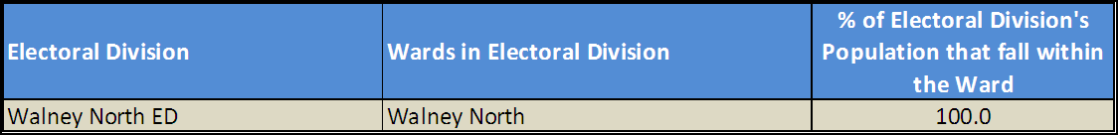

Source: Cumbria Intelligence Observatory, 2013

The map below overlays Electoral Ward boundaries on to **Walney North** **ED’s** boundary: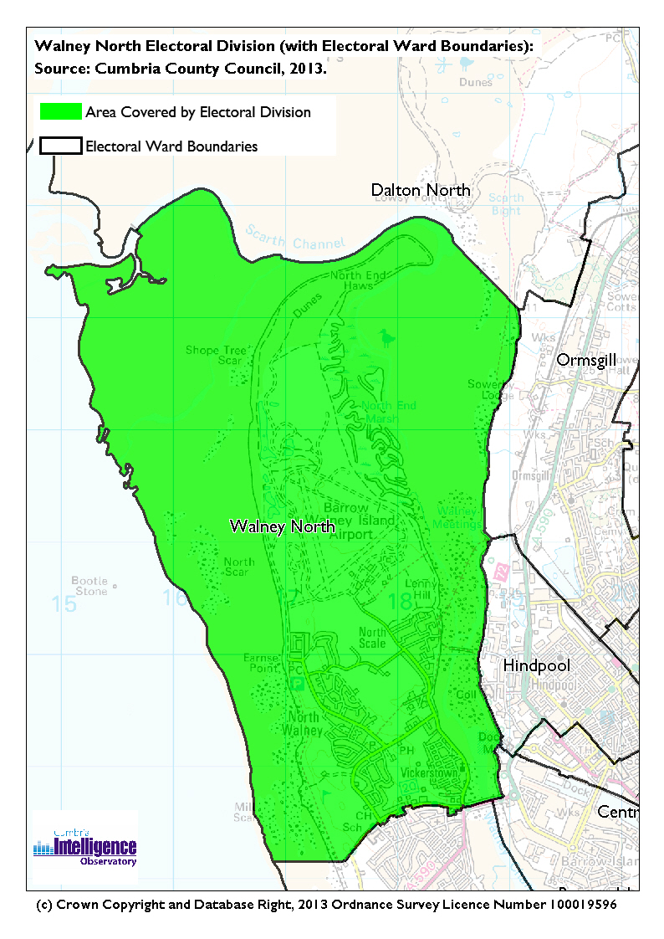

The Cumbria Intelligence Observatory presents many Electoral Ward statistics via the interactive’ **Cumbria ‘Atlas’** tool. The statistics provided within the **Cumbria Atlas** cover topics such as, but not limited to, population, housing, health, economy, poverty, ethnicity, language and transport. The datasets with the **Cumbria Atlas** are regularly updated and expanded.

For simple step by step instructions to use the **Cumbria Atlas** to explore statistics for the wards within your Electoral Division, please visit the following web page:

[*http://www.cumbria.gov.uk/eLibrary/view.asp?ID=56017*](http://www.cumbria.gov.uk/eLibrary/view.asp?ID=56017)

The Information and Intelligence Team within Cumbria County Council are happy to talk you through using the Cumbria Atlas over the phone, or face to face. Training sessions can also be arranged for small groups.

To contact the team please call **01228 226309**, or e-mail [**info@cumbriaobservatory.org.uk**](mailto:info@cumbriaobservatory.org.uk)

# Parks, Open Spaces and Leisure Facilities

Park Vale

Vickerstown Park

North Scale Community Centre Play Area

Mill Lane/West Shore Road Skateboard Park

North Walney Nature Reserve

North and South of Cows Tarn Lane

Earnsie Bay Playing Fields

Foreshore & Channel

Vickerstown Cricket

Vickerstown Soccer

Walney Central Rugby

Walney Windcheetahs

Walney Golf Club

North Scale Bowling Club

Vickerstown Park Bowling Club

Kite Surfing – Earnsie Bay

Walney Boating Club

# Active Community Organisations

North Scale Residents

Walney North Residents

Walney North Pensioners

Walney Scout Group/Cubs/Beavers

Walney First Responders

Barrow & District Credit Union

Barrow Foodbank

# Key Communication Networks

North West Evening Mail – Borough wide daily

Advertiser – Borough wide weekly

Barrow Borough Council Housing Matters - quarterly

# Community Assets

North Scale Community

Central Drive Community

Knox Street Hall

Mill Lane Children’s Centre

Vickerstown Primary School

North Walney Primary School

George Hastwell

Combe House Residential Home

Tarn House Hostel

Burnett Edgar Medical Centre

Walney Fire Station

Vickerstown Community Development Centre (CDC)

Vickerstown Adult Education Centre (CDC)

Walney Library

# Local Cumbria County Council Service Hubs

Walney Library

Vickerstown Community Development Centre

Vickerstown Adult Education Centre (CDC)

# Community Engagement

Monthly Cumbria County Council Neighbourhood Grants Panel considers grant applications from constituted non-profit making groups whose project benefits the Barrow Borough communities.

Issue-based meetings are held in liaison with the local County Councillor to discuss community concerns.

|  |  |
| --- | --- |
| Key Community Contacts | |
|  | |
| County Councillor Melvyn Worth |  |
|  |  |
| Area Support Team Barrow |  |
|  |  |
| Barrow Borough Council |  |
|  |  |
| Cumbria Council for Voluntary Service (CVS) |  |