

**Harrington**

**Electoral Division Profile**

**2014**

# Overview of Electoral Division

Harrington Electoral Division lies within the District of Allerdale, bordering Copeland on the western coast North from Whitehaven and south from Workington. The division is a mix of housing and industrial land on the outskirts of Workington Town covering Harrington, Salterbeck, Lillyhall and Winscales.

Salterbeck was formed as a large council housing estate, built by local authority in the 1930’s on farmland. These properties were built to accommodate the number of steelworkers and their families relocating to the area. 700 of these properties transferred to Impact Housing, the remainder are now in private ownership. Impact Housing operates from The Oval Centre within Salterbeck. There is also a small trading estate at Salterbeck.

Harrington is a more traditional area with terraced housing built for the growing number of miners in the area at the time which were built around the harbour and railway where coal and limestone were exported from. The harbour was a significant feature in the late 1800’s it was greatly enlarged in 1891 and covered two and a half acres with a quay 1250 feet long. It could take ships up to 1200 tons and had cranes capable of lifting 10 tons. In 1899 755 steam ships with a total tonnage of 270,000 tons used the harbour. The harbour is now developed as a marina for leisure purposes and is managed by Harrington Harbour and Dock Board, ran by Allerdale Borough Council. The area has a small nature reserve situated between Harrington, Salterbeck and Lillyhall.

Lillyhall is a strategic employment site; it resembles a large industrial estate with large warehouses, industrial units, office blocks and a large waste landfill site. The area is home to a number of car dealers, engineering and construction firms and manufacturers, as well as a number of small businesses. Organisations operating on the site include Stobbarts, Waste Recycling Group, Cumbria Waste Management, Stagecoach North West, Derwent Pencils, Cumbria County Council Highways, HM Revenues & Customs. Some of the land remains in public ownership, owned by the Homes and Communities Agency, it is also a centre for a number of education establishments including:

* Lakes College West Cumbria which provides further and higher education
* Energus - a training and conference centre with The Energy Coast, the University of Cumbria and the Centre for Leadership Performance
* The Energy Coast, University Technical College (UTC). A newly built facility providing 14 - 19 year olds high level practical and academic education
* GEN II Engineering & Technology Training Ltd

Winscales is a parish area, with a number of small hamlets and a couple of hotels. Within Winscales is a wind farm with a community benefit fund managed by Cumbria Community Foundation and is available for projects in the parishes of Winscales, Great Clifton and Little Clifton which are within the boundaries for the electoral division of St. Johns and Great Clifton.

# Map

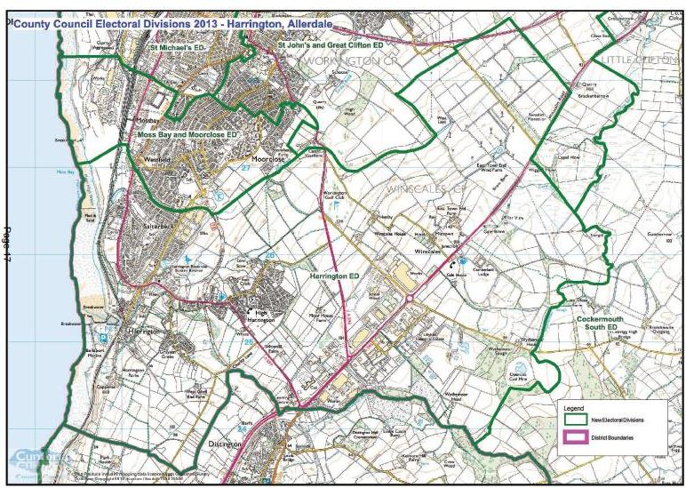

*http://www.cumbria.gov.uk/Election2013/maps.asp*

# Communities

Harrington Electoral Division spreads between the civil parishes of Workington and Windscales and incorporates the communities of Harrington, High Harrington, Salterbeck, Windscales and Lillyhall.

# Statistical Profile

The 2011 Census estimated that the population of Harrington Electoral Division (ED) was 5866 persons. The table below presents estimated numbers of residents in Harrington ED by age group:

|  |  |  |  |  |  |  |  |  |
| --- | --- | --- | --- | --- | --- | --- | --- | --- |
|  | **No. Persons by Age Group (Years)** | | | | | | | |
| **All Ages** | **0 - 14** | **15 - 29** | **30 - 44** | **45 - 59** | **60 - 74** | **75 - 84** | **85+** |
| *Harrington ED* | *5866* | *981* | *994* | *1060* | *1223* | *1061* | *401* | *146* |

*Source: Office for National Statistics, 2011 Census*

The chart below compares the proportion of Harrington ED’s population within each age group with the proportion of the population within each age group across Allerdale district, Cumbria and England & Wales:

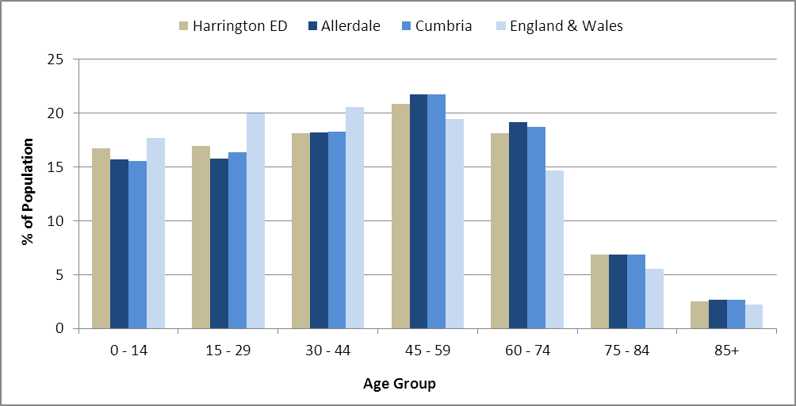

*Source: Office for National Statistics, 2011 Census*

County Council Electoral Divisions cover large spatial areas and so division averages can mask variation between communities within the division. Furthermore, beyond Census data, there is little statistical information available for Electoral Divisions. However, most statistical agencies produce data for Electoral Wards. Therefore, there is a very wide range of statistical information available for Electoral Wards. Furthermore, as Electoral Wards are generally smaller than Electoral Divisions, statistics at this level provide more insight into variations between communities.

The table below identifies which Electoral Wards are fully or partially within the boundaries of Harrington ED, and what proportion of Harrington ED’s population live within each ward:

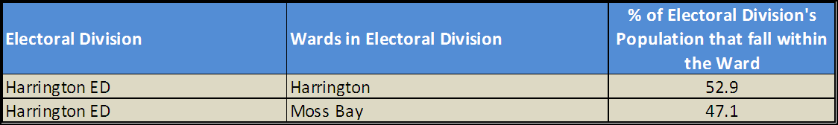

*Source: Cumbria Intelligence Observatory, 2013*

The map below overlays Electoral Ward boundaries on to Harrington ED’s boundary: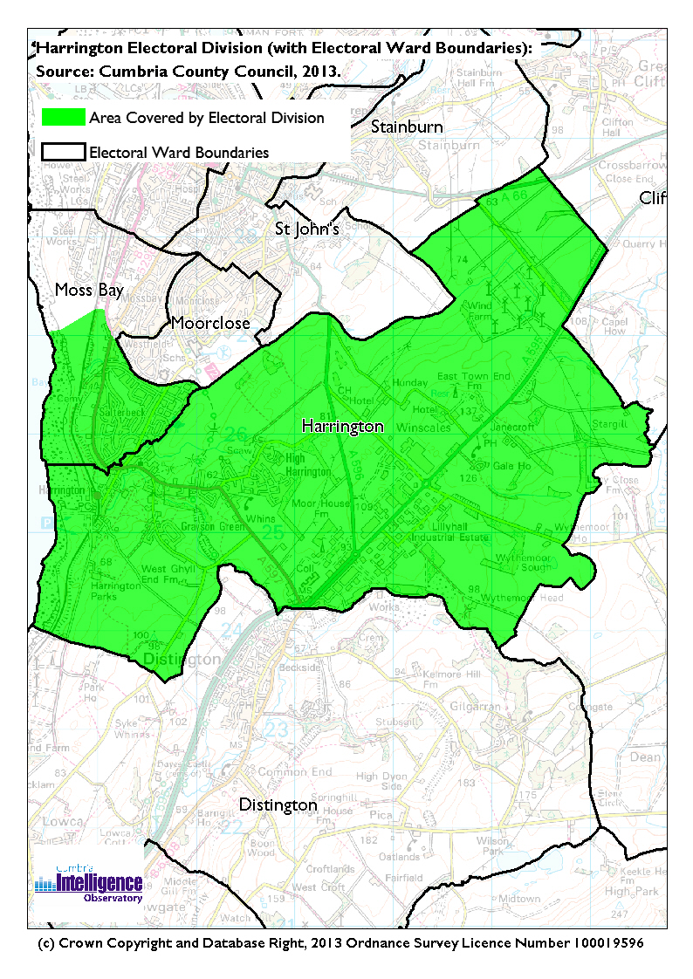The Cumbria Intelligence Observatory presents many Electoral Ward level statistics via the interactive ‘Cumbria Atlas’ tool. The Statistics provided within the Cumbria Atlas cover topics such as, but not limited to, population, housing, health, economy, poverty, ethnicity, language, and transport. The datasets within the Cumbria Atlas are regularly updated and expanded.

For simple step by step instructions to use the Cumbria Atlas to explore statistics for the wards within your Electoral Division, please visit the following web page:

<http://www.cumbria.gov.uk/eLibrary/view.asp?ID=56017>

The Information and Intelligence Team within Cumbria County Council are happy to talk you through using the Cumbria Atlas over the phone, or face to face. Training sessions can also be arranged for small groups.

To contact the team please call 01228 226309, or email [info@cumbriaobservatory.org.uk](mailto:info@cumbriaobservatory.org.uk)

# Parks, Open Spaces and Leisure Facilities

There are a number of parks and open spaces within Harrington Electoral Division including:

* Harrington Harbour & Beach
* The West Cumbria Cycle Network which passes through Harrington on its way from Whitehaven to Workington using the disused railway. The West Cumbria Cycle network forms part of the national cycle network, within the local area there is the sea to sea, Hadrians and Reivers routes.
* Harrington ponds and Nature Reserve between Harrington and Salterbeck which includes a small reservoir, beck, play area, woodland and green fields.
* Marina play area, Harrington; Brewery House play area, Harrington; the Oval play area, Salterbeck

Leisure facilities include:

* Workington Golf Club
* The Oval, Salterbeck which has a gym and outdoor games area, football and rugby pitches.
* Community Gym at Lakes College
* Walker Road Pitches, Salterbeck
* Harrington Lawn Tennis Club

# Active Community Organisations

* High Harrington Community Centre Management and Community Centre which includes a ladies club and dancing club
* Harrington Youth Group

<http://www.hyc-cumbria.co.uk/>

* Harrington marina festival
* North Shore Street Residents, Harrington
* Harrington Lawn Tennis Club
* St Mary’s RC Church Hall, Harrington
* 11th Workington. (Harrington) Scout Group <http://www.harringtonscouts.co.uk/>
* Harrington Social & Working Mens Club
* Harrington fishing club
* The Friends of Harrington Nature Reserve

<http://www.harrington-nature-reserve.org.uk>

* Harrington Marina Regeneration Action Group
* Harrington Harbour and Dock Board. <http://www.allerdale.gov.uk/default.aspx?page=932>
* Harrington Residents Association
* Harrington in Bloom
* Harrington Sailing and Fishing Cub
* Harrington History Society

<http://www.harringtonhistory.co.uk/>

* Harrington Boat Owners Association.
* Salterbeck ACE, Oval Centre, including Community Centre, Community Café and local online hub. <http://www.ovalcentre.org/>
* Salterbeck Residents Association
* Salterbeck Youth Group
* Salterbeck Storm ARLFC
* Salterbeck FC
* British Legion, Salterbeck
* Harrington Mothers Union

# Key Communication Networks

# News & Star

# A daily newspaper, produced by CN group; they produce different editions for North and West Cumbria.

# Times and Star

# Weekly newspaper produced by CN group for the Allerdale district of Cumbria they produce different editions for Maryport, Cockermouth and Workington

# BBC Radio Cumbria

# Local radio station produced by the BBC for Cumbria

# CFM Radio

# Local radio station produced by the Bauer Media Group, covering Cumbria and Southwest Scotland

ITV News, Border region

Programme news, weather and information provided by ITV Broadcasting Limited for the England/Scotland border region, covering the majority of Cumbria, Dumfries and Galloway, the Scottish Borders and parts of Northumberland.

<http://www.itv.com/news/border/story/2013-10-11/get-in-touch/>

BBC News – Look North (North East & Cumbria)

BBC's nightly regional news programme for the North East of England and Cumbria

<http://www.bbc.co.uk/programmes/b0070g1d/faq>

The Oval, Salterbeck provides for a range of communication opportunities including tenants’ newsletter.

Parochial newsletters

# Community Assets

Schools:

* Lakes College West Cumbria
* Energy Coast University Technical College
* West Cumbria Learning Centre - Pupil Referral Unit
* St Mary’s Catholic Primary, Harrington
* Beckstone Primary School, Harrington

Churches:

* St Marys, Harrington RC
* St Mary, Harrington CofE
* Harrington Methodist
* Harrington United Reformed Church

Other:

Ambulance Station Lillyhall

The Oval Salterbeck

Harrington Community Centre

Harrington Nature Reserve

Harrington train station

Harrington Harbour (Marina)

Harrington harbour amenity block

Harrington House (boating club)

Harrington, St Mary’s Church Hall

Harrington, Scouts Hall

Harrington, Youth Group Buildingh

Salterbeck Cemetery

# Local Cumbria County Council Service Hubs

**Service Type Service Point**

Adult Education Centres Lakes College West Cumbria Adult Ed

Fleet Workshops Lillyhall Depot

Highways Depots Lillyhall Depot

Primary Schools St. Mary's Catholic Primary School

Primary Schools Beckstone Primary School

# Community Engagement

Harrington Electoral Division is part of the Workington Neighbourhood Forum which meets twice yearly. For more information, please contact Allerdale Area Support Team (see key contacts)

|  |
| --- |
| Key Community Contacts |
| Cumbria County Councillor, Marjorie Rae, Harrington Electoral Division   * Address: 3 Springfield Avenue, High Harrington, Workington, CA14 4LW * Phone: 01946 831004 * Mobile: 07719 325644 * Email: Marjorie.Rae@cumbria.gov.uk |
| Allerdale Area Support Team   * Address: Workington Library, Vulcans Lane, Workington, CA14 2ND * Phone: 01900 706015 * Email: ted.thwaites@cumbria.gov.uk * Web: www.cumbria.gov.uk |
| Allerdale Borough Council   * Address: Allerdale House, Workington, Cumbria, CA14 3YJ * Phone: 01900 702702 * Email: enquiries@allerdale.gov.uk * Web: http://www.allerdale.gov.uk/ |
| Winscales Parish Council   * Clerk: Mrs H Blacklock * Address: 2 Hall Garth, Great Clifton, Workington, CA14 1UN * Phone: 0796101 2391 * Email: baxterjack@virginmedia.com |