

**Hindpool**

**Electoral Division Profile**

**2014**

# Overview of Electoral Division

Hindpool is in the electoral division of Barrow Borough and has a population of 6,815.

# Map



# Communities

Thwaite Street & Surrounding Communities Residents group (TASC)

Hindpool Community Hub

# Statistical Profile

**Statistical Profile: Hindpool Electoral Division**

The 2011 Census estimated that the population of **Hindpool Electoral Division (ED)** was **6815** persons.

The table below presents estimated numbers of residents in **Hindpool** **ED** by age group:

|  |  |  |  |  |  |  |  |  |
| --- | --- | --- | --- | --- | --- | --- | --- | --- |
|  | **No. Persons by Age Group (Years)** | | | | | | | |
| **All Ages** | **0 - 14** | **15 - 29** | **30 - 44** | **45 - 59** | **60 - 74** | **75 - 84** | **85+** |
| Hindpool ED | 6815 | 1174 | 1597 | 1335 | 1267 | 968 | 333 | 141 |

Source: Office for National Statistics, 2011 Census

The chart below compares the proportion of **Hindpool ED’s** population within each age group with the proportion of the population within each age group across Barrow-in-Furness district, Cumbria and England & Wales:

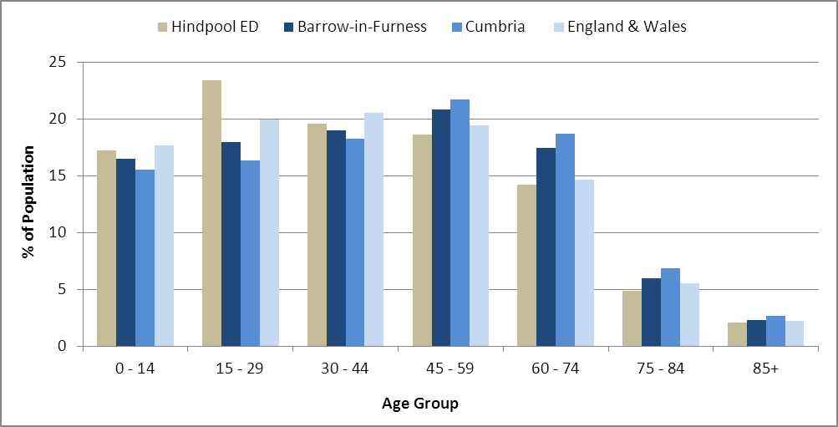

Source: Office for National Statistics, 2011 Census

County Council Electoral Divisions cover large spatial areas and so division averages can mask variation between communities within the division. Furthermore, beyond Census data, there is little statistical information available for Electoral Divisions. However, most statistical agencies produce data for Electoral Wards. Therefore, there is a very wide range of statistical information available for Electoral Wards. Furthermore, as Electoral Wards are generally smaller than Electoral Divisions, statistics at this level provide more insight into variations between communities.

The table below identifies which Electoral Wards are fully or partially within the boundaries of **Hindpool** **ED**, and what proportion of **Hindpool** **ED**’s population live within each ward:

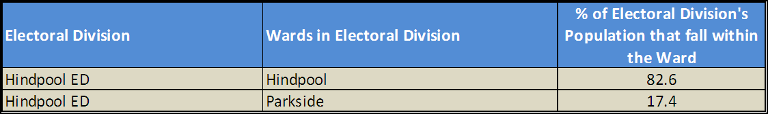

Source: Cumbria Intelligence Observatory, 2013

The map below overlays Electoral Ward boundaries on to **Hindpool** **ED’s** boundary: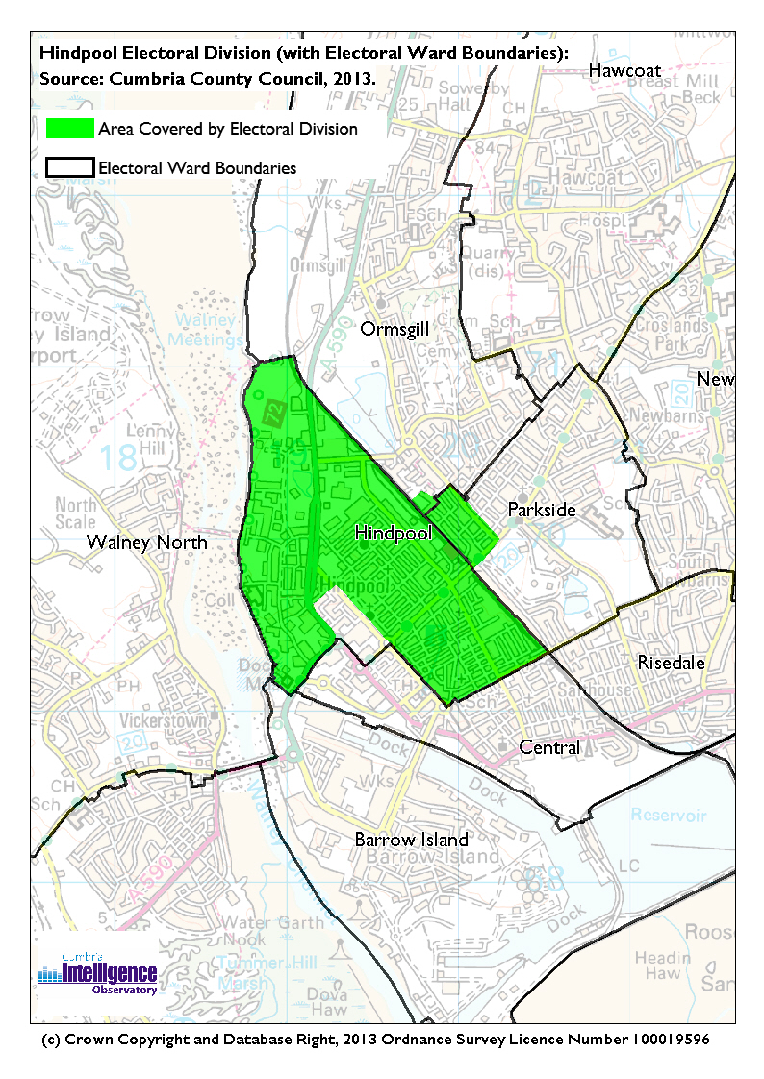The Cumbria Intelligence Observatory presents many Electoral Ward level statistics via the interactive ‘Cumbria Atlas’ tool. The Statistics provided within the Cumbria Atlas cover topics such as, but not limited to, population, housing, health, economy, poverty, ethnicity, language, and transport. The datasets within the Cumbria Atlas are regularly updated and expanded.

For simple step by step instructions to use the Cumbria Atlas to explore statistics for the wards within your Electoral Division, please visit the following web page:

http://www.cumbria.gov.uk/eLibrary/view.asp?ID=56017

The Information and Intelligence Team within Cumbria County Council are happy to talk you through using the Cumbria Atlas over the phone, or face to face. Training sessions can also be arranged for small groups.

To contact the team please call 01228 226309, or email info@cumbriaobservatory.org.uk

# Parks, Open Spaces and Leisure Facilities

Brisbane Park

Hindpool Urban Park

Manchester Street

TASC community garden

Channelside

Cocken Lake

Hindpool Tigers

Furness Gym Club

Pat’s Gym

Barrow AFC

Furness Rovers – Barrow AFC additional pitch

Holker Street Football ground

# Active Community Organisations

Thwaite Street & Surrounding Communities Residents group (TASC)

Hindpool Community Hub

Barrow & District Credit Union

Barrow Foodbank

Barrow & District Disability Association

# Key Communication Networks

North West Evening Mail – Borough wide daily

The Advertiser – Borough wide weekly

Barrow Borough Council Housing Matters - quarterly

# Community Assets

St. James Junior School

Brisbane Park Infants

Ramsden Infants

Hindpool Nursery

Old Vicarage Nursery

Furness College

Bath Street Annex

Hindpool Community Centre

Central & Hindpool Neighbourhood Management Office

Hindpool Children’s Centre

St. Mark’s Church

St. James Church

Bluebirds Study Centre/Crossbar

The Forum

Dock Museum

British Legion

Grange & Cartmel

Barrow Library

Station View Extra Care Housing

Hartington Street Medical Practice

Dr R Karamchandani & Partners

Norwood Medical Centre

# Local Cumbria County Council Service Hubs

Barrow Library

Barrow Archives and Local Studies Centre

Barrow & District Disability Association – Adult Education Centre

Hindpool Children’s Centre

Barrow-in-Furness Recycling Centre

Barrow Fire Station

# Community Engagement

Monthly Cumbria County Council Neighbourhood Grants Panel considers grant applications from constituted non-profit making groups whose project benefits the Barrow Borough communities.

Central & Hindpool Neighbourhood Management Board (partners come together to discuss and resolve issues for the benefit of the community).

Issue-based meetings are held in liaison with the local County Councillor to discuss community concerns.

|  |  |
| --- | --- |
| Key Community Contacts | |
|  | |
| County Councillor Anne Burns |  |
|  |  |
| Area Support Team Barrow |  |
|  |  |
| Barrow Borough Council |  |
|  |  |
| Cumbria Council for Voluntary Service (CVS) |  |
|  |  |