

**Hawcoat**

**Electoral Division Profile**

**2014**

# Overview of Electoral Division

Hawcoat is in the electoral division of Barrow Borough and has a population of 5,575.

# Map



# Statistical Profile

**Statistical Profile: Hawcoat Electoral Division**

The 2011 Census estimated that the population of **Hawcoat Electoral Division (ED)** was **5575** persons.

The table below presents estimated numbers of residents in **Hawcoat** **ED** by age group:

|  |  |  |  |  |  |  |  |  |
| --- | --- | --- | --- | --- | --- | --- | --- | --- |
|  | **No. Persons by Age Group (Years)** | | | | | | | |
| **All Ages** | **0 - 14** | **15 - 29** | **30 - 44** | **45 - 59** | **60 - 74** | **75 - 84** | **85+** |
| *Hawcoat ED* | *5575* | *608* | *630* | *798* | *1215* | *1369* | *704* | *251* |

Source: Office for National Statistics, 2011 Census

The chart below compares the proportion of **Hawcoat ED’s** population within each age group with the proportion of the population within each age group across Barrow-in-Furness district, Cumbria and England & Wales:

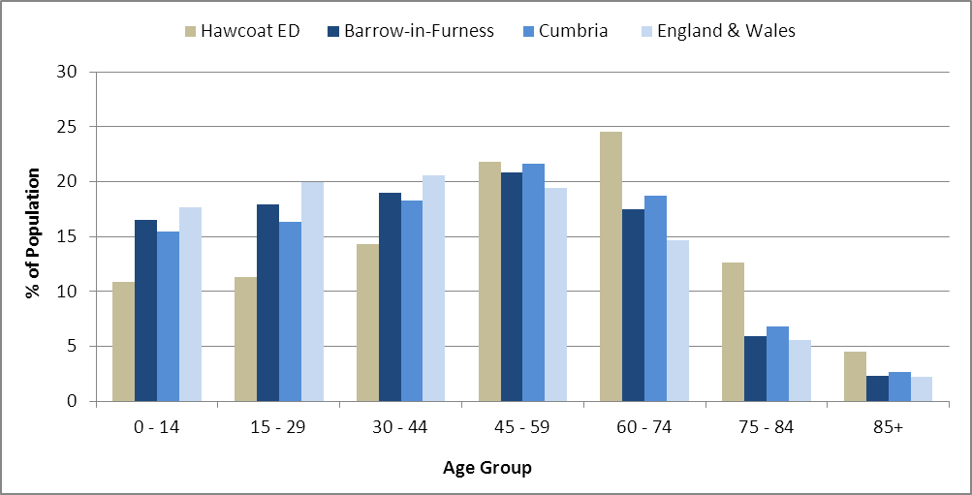

Source: Office for National Statistics, 2011 Census

County Council Electoral Divisions cover large spatial areas and so division averages can mask variation between communities within the division. Furthermore, beyond Census data, there is little statistical information available for Electoral Divisions. However, most statistical agencies produce data for Electoral Wards. Therefore, there is a very wide rangeof statistical information available for ElectoralWards. Furthermore, as Electoral Wards are generally smaller than Electoral Divisions, statistics at this level provide more insight into variations between communities.

The table below identifies which Electoral Wards are fully or partially within the boundaries of **Hawcoat** **ED**, and what proportion of **Hawcoat** **ED**’s population live within each ward:

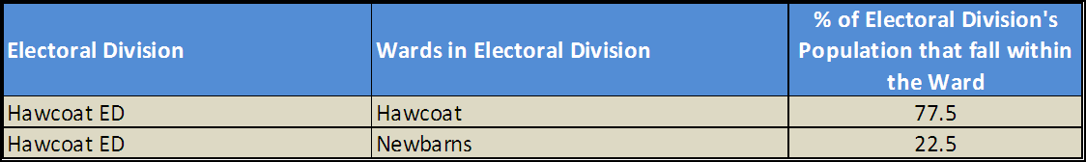

Source: Cumbria Intelligence Observatory, 2013

The map below overlays Electoral Ward boundaries on to **Hawcoat** **ED’s** boundary: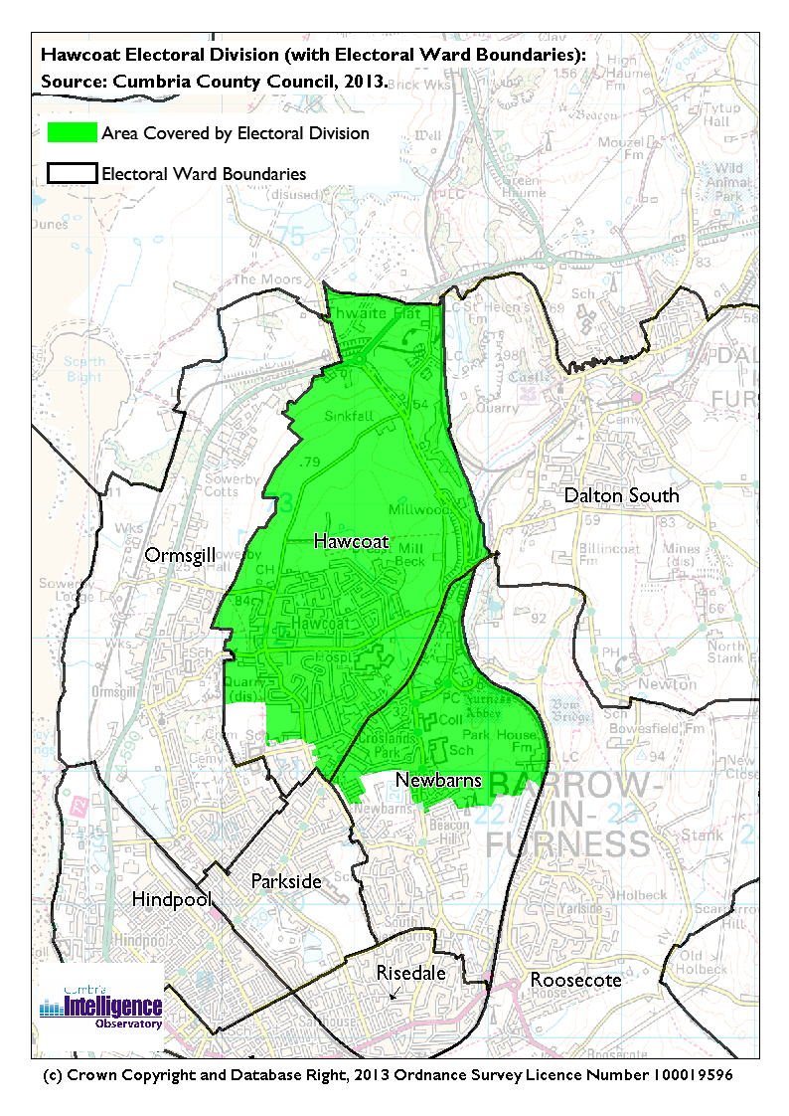The Cumbria Intelligence Observatory presents many Electoral Ward level statistics via the interactive ‘Cumbria Atlas’ tool. The Statistics provided within the Cumbria Atlas cover topics such as, but not limited to, population, housing, health, economy, poverty, ethnicity, language, and transport. The datasets within the Cumbria Atlas are regularly updated and expanded.

For simple step by step instructions to use the Cumbria Atlas to explore statistics for the wards within your Electoral Division, please visit the following web page:

http://www.cumbria.gov.uk/eLibrary/view.asp?ID=56017

The Information and Intelligence Team within Cumbria County Council are happy to talk you through using the Cumbria Atlas over the phone, or face to face. Training sessions can also be arranged for small groups.

To contact the team please call 01228 226309, or email info@cumbriaobservatory.org.uk

# Parks, Open Spaces and Leisure Facilities

Playground next to Hawcoat Community Centre

Hawcoat Park Sports & Social Club

Walney Terriers American Football

Co-op Bowling Club

Barrow Cricket Club

Holker Old Boys Football Club

Barrow Golf Club

Furness Rugby Union/Furness Rovers Clubhouse (not pitches)

Hawcoat Memorial Hall

Hawcoat Community Centre

St. Paul’s Scout Hut

Hawcoat Park Sports & Social Club

Barrow Cricket Club

Furness Rugby Union/Furness Rovers Clubhouse

Holker Old Boys

# Active Community Organisations

Hawcoat Over 60’s

Hawcoat Mother & Toddler

St. Paul’s Scouts Groups

Barrow Foodbank

Barrow & District Credit Union

# Key Communication Networks

North West Evening Mail – Borough wide daily

Advertiser – Borough wide weekly

# Community Assets

St. Paul’s C of E Primary School

Dane Ghyll Primary School

St. Bernards RC Secondary School

Barrow Sixth Form College

Chetwynde School

Hawcoat Memorial Hall

Hawcoat Community Centre

St. Paul’s Scout Hut

Hawcoat Park Sports & Social Club

Barrow Cricket Club

Furness Rugby Union/Furness Rovers Clubhouse

Holker Old Boys

Furness General Hospital

Rock Lea Care Home

Ostley House

Kingsfield Care Home

Abbotsfield

Croft Village

Croft Nursing Home

# Local Cumbria County Council Service Hubs

# Community Engagement

Monthly Cumbria County Council Neighbourhood Grants Panel considers grant applications from constituted non-profit making groups whose project benefits the Barrow Borough communities.

Issue-based meetings are held in liaison with the local County Councillor to discuss community concerns.

|  |  |
| --- | --- |
| Key Community Contacts | |
|  | |
| County Councillor Dave Roberts |  |
|  |  |
| Area Support Team Barrow |  |
|  |  |
| Barrow Borough Council |  |
|  |  |
| Cumbria Council for Voluntary Service (CVS) |  |