

**Moss Bay & Moorclose**

**Electoral Division Profile**

**2014**

# Overview of Electoral Division

The Moss Bay and Moorclose Electoral Division is situated in the town of Workington within the District of Allerdale and has a population of 7,254. Workington has its own Town Council the grassroots local council for the civil parish of Workington.

Moss Bay was once the centre for Coal and Steel industry in Workington. Jane Pit & Annie Pit were 19th Century coal mines built by Henry Curwen on Moss Bay. By the mid-19th century coal-mining was in decline but Workington experienced a major expansion as a centre of iron and steel making and Moss Bay housed the world's first large-scale steelworks. The site of Jane Pitt remains as a scheduled ancient monument.

Moss Bay now houses part of Derwent Howe and Clay Flatts Industrial Estates. The rest of the division is largely housing and has a number of community facilities including a sports centre, community centre, youth club, library, adult education centre, Moorclose shops and pharmacy and three schools. A newly built fire station is also housed in Moorclose.

# Map

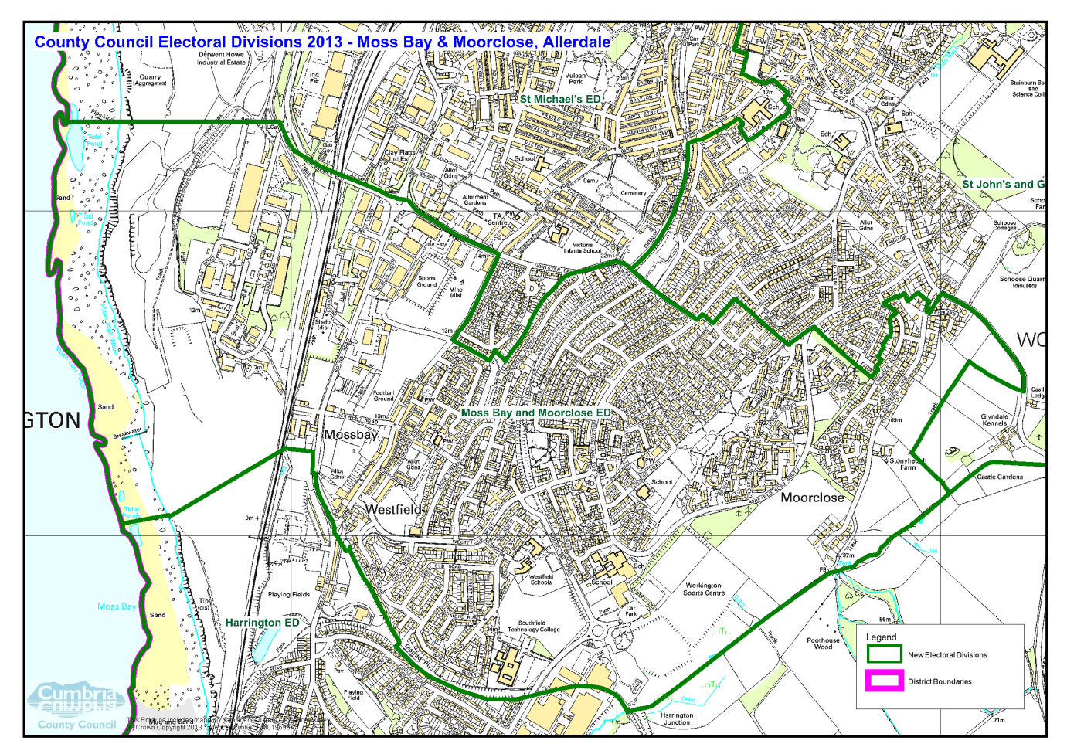

PDF copy of map: http://www.cumbria.gov.uk/Election2013/maps.asp

# Communities

The Electoral Division covers the Electoral Wards of Mossbay, Moorclose and St Johns, incorporating the housing estates of:

* Moss Bay
* Moorclose
* Westfield
* Frostoms (Annie Pitt)
* St Johns (Ellerbeck Lane/Chaucer Rd)

The housing estates were named after isolated farms.

# Statistical Profile

The 2011 Census estimated that the population of Moss Bay and Moorclose Electoral Division (ED) was 7254 persons.

The table below presents estimated numbers of residents in Moss Bay and Moorclose ED by age group:

|  |  |  |  |  |  |  |  |  |
| --- | --- | --- | --- | --- | --- | --- | --- | --- |
|  | **No. Persons by Age Group (Years)** | | | | | | | |
| **All Ages** | **0 - 14** | **15 - 29** | **30 - 44** | **45 - 59** | **60 - 74** | **75 - 84** | **85+** |
| *Moss Bay and Moorclose ED* | *7254* | *1296* | *1446* | *1260* | *1428* | *1199* | *480* | *145* |

*Source: Office for National Statistics, 2011 Census*

The chart below compares the proportion of Moss Bay and Moorclose ED’s population within each age group with the proportion of the population within each age group across Allerdale district, Cumbria and England & Wales:

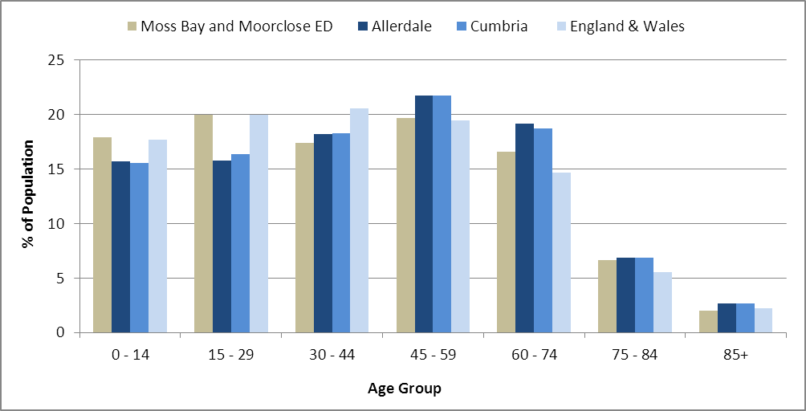

*Source: Office for National Statistics, 2011 Census*

County Council Electoral Divisions cover large spatial areas and so division averages can mask variation between communities within the division. Furthermore, beyond Census data, there is little statistical information available for Electoral Divisions. However, most statistical agencies produce data for Electoral Wards. Therefore, there is a very wide range of statistical information available for Electoral Wards. Furthermore, as Electoral Wards are generally smaller than Electoral Divisions, statistics at this level provide more insight into variations between communities.

The table below identifies which Electoral Wards are fully or partially within the boundaries of Moss Bay and Moorclose ED, and what proportion of Moss Bay and Moorclose ED’s population live within each ward:

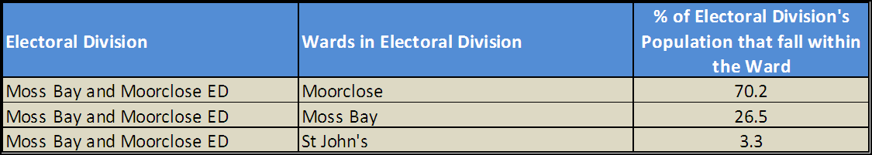*Source: Cumbria Intelligence Observatory, 2013*

The map below overlays Electoral Ward boundaries on to Moss Bay and Moorclose ED’s boundary: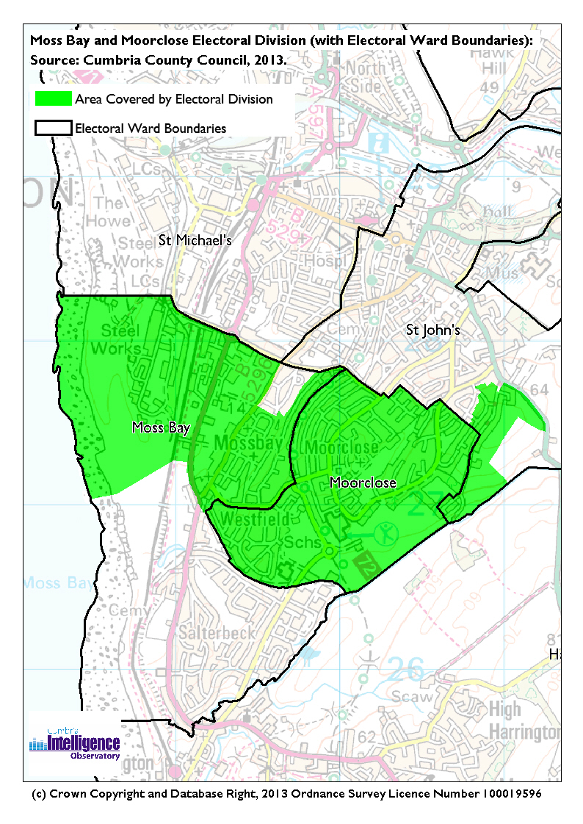The Cumbria Intelligence Observatory presents many Electoral Ward level statistics via the interactive ‘Cumbria Atlas’ tool. The Statistics provided within the Cumbria Atlas cover topics such as, but not limited to, population, housing, health, economy, poverty, ethnicity, language, and transport. The datasets within the Cumbria Atlas are regularly updated and expanded.

For simple step by step instructions to use the Cumbria Atlas to explore statistics for the wards within your Electoral Division, please visit the following web page:

<http://www.cumbria.gov.uk/eLibrary/view.asp?ID=56017>

The Information and Intelligence Team within Cumbria County Council are happy to talk you through using the Cumbria Atlas over the phone, or face to face. Training sessions can also be arranged for small groups.

# To contact the team please call 01228 226309, or email [info@cumbriaobservatory.org.uk](mailto:info@cumbriaobservatory.org.uk)

# Parks, Open Spaces and Leisure Facilities

* Moorclose Community Centre Sports Hall
* Play areas on each of the housing estates (inc. large play area at Grasmere Avenue)
* Cycle path
* Workington RFC, Ellis Sports Ground, Moss Bay Road

# West Sports Football Ground

# Workington Sports Centre, Moorclose

# Sports Centre and Gym

# Pool

# Running Track

# Football Pitches (x2)

# Allotments – Mossbay (Cranbourne St) and Westfield Community Allotments

* Youth Club

# Active Community Organisations

Moorclose Community Centre, Needham Drive, Workington, Cumbria, CA14 35E

This building houses the Adult Education Centre and has its own sports hall. It is the hub for many community groups and activities in the area including a well-attended playgroup.

Minto Centre, Nilsson Drive, Workington, Cumbria, CA14 5BD

This building houses a number of organisations including the local Surestart Childrens Centre, Footsteps Nursery and Westfield Housing. It is also a local drop in centre for nurses and health visitors.

South Workington Youth Partnership (Youth Club)

Contact: David McGarry Phone: 01900 873174 or Angela Good

Moorclose Residents Group

# Key Communication Networks

# News & Star

# A daily newspaper, produced by CN group; they produce different editions for North and West Cumbria.

# Times and Star

# Weekly newspaper produced by CN group for the Allerdale district of Cumbria they produce different editions for Maryport, Cockermouth and Workington

# Cumberland News

# The most widely read newspaper in Cumbria. This bridges the north and west communities.

# BBC Radio Cumbria

# Local radio station produced by the BBC for Cumbria

# CFM Radio

# Local radio station produced by the Bauer Media Group, covering Cumbria and Southwest Scotland

ITV News, Border region

Programme news, weather and information provided by ITV Broadcasting Limited for the England/Scotland border region, covering the majority of Cumbria, Dumfries and Galloway, the Scottish Borders and parts of Northumberland.

<http://www.itv.com/news/border/story/2013-10-11/get-in-touch/>

BBC News – Look North (North East & Cumbria)

Look North is the BBC's nightly regional news programme for the North East of England and Cumbria

<http://www.bbc.co.uk/programmes/b0070g1d/faq>

# St Mary’s Parish Newsletter outlining local events

# Derwent & Solway and Westfield housing also produce information for their residents.

St Gregorys church and school provide separate newsletters for residents.

# Community Assets

* Moorclose community centre
* Sixth form centre and library
* Youth Club
* Parish Church St Mary Westfield
* St Gregorys Catholic Church
* Adult Education Centre
* Westfield Primary School
* St Gregorys Catholic Primary School
* Minto Centre
* Southfield Technical College
* Workington Leisure Centre and Pool
* Fire Station (housing Fire Service, Trading Standards & Youth Offending Team)
* Pharmacy
* Salisbury Court (Sheltered accommodation with warden)
* Laybourn House (Sheltered accommodation without warden)

# Local Cumbria County Council Service Hubs

|  |  |
| --- | --- |
| Adult Education Centres: Childrens Centres: Fire Stations: Household Waste Recycling Centres:  Libraries:  Primary Schools:  Primary Schools:  Secondary Schools: | Workington Adult EdWorkington Children's Centre, Minto CentreWorkingtonWorkington HWRCMoorclose LibraryWestfield Primary School St. Gregory's Catholic Primary School Southfield Technology College |

# 

# Community Engagement

The division forms part of the Workington Neighbourhood Forum area which meets three times a year. A topic specific to Moorclose and Mossbay, may be considered at a separate meeting or surgeries set up involving the local Councillor.

|  |
| --- |
| Key Community Contacts |
| Councillor Gerald Humes, Mossbay and Moorclose, Cumbria County Council   * Address: 34 Bowness Court, Moorclose, Workington, CA14 3SG * Phone: 01900 63976 Mobile: 07768 925922 * Email: Gerald.Humes@cumbria.gov.uk |
| Allerdale Area Support Team, Cumbria County Council   * Address: 2nd Floor Workington Library, Vulcan’s Lane, Workington, CA14 2ND. * Phone: 01900 706011 * Email: allerdaleteam@cumbria.gov.uk * Web: www.cumbria.gov.uk |
| Workington Town Council   * Address: Old Town Hall, Oxford Street, Workington, Cumbria. CA14 2RS * Phone: 01900 702986 * Email: WorkingtonTownCouncil@allerdale.gov.uk * Web: http://www.workingtontowncouncil.com |
| Allerdale Borough Council   * Address: Allerdale House, Workington, Cumbria, CA14 3YJ * Phone: 01900 702702 * Email: enquiries@allerdale.gov.uk * Web: http://www.allerdale.gov.uk/ |