

**Ormsgill**

**Electoral Division Profile**

**2014**

# Overview of Electoral Division

Ormsgill is in the electoral division of Barrow Borough and has a population of 7,038.

# Map



# Statistical Profile

**Statistical Profile: Ormsgill Electoral Division**

The 2011 Census estimated that the population of **Ormsgill Electoral Division (ED)** was **7038** persons.

The table below presents estimated numbers of residents in **Ormsgill** **ED** by age group:

|  |  |  |  |  |  |  |  |  |
| --- | --- | --- | --- | --- | --- | --- | --- | --- |
|  | **No. Persons by Age Group (Years)** | | | | | | | |
| **All Ages** | **0 - 14** | **15 - 29** | **30 - 44** | **45 - 59** | **60 - 74** | **75 - 84** | **85+** |
| Ormsgill ED | 7038 | 1244 | 1364 | 1439 | 1471 | 1079 | 300 | 141 |

Source: Office for National Statistics, 2011 Census

The chart below compares the proportion of **Ormsgill ED’s** population within each age group with the proportion of the population within each age group across Barrow-in-Furness district, Cumbria and England & Wales:

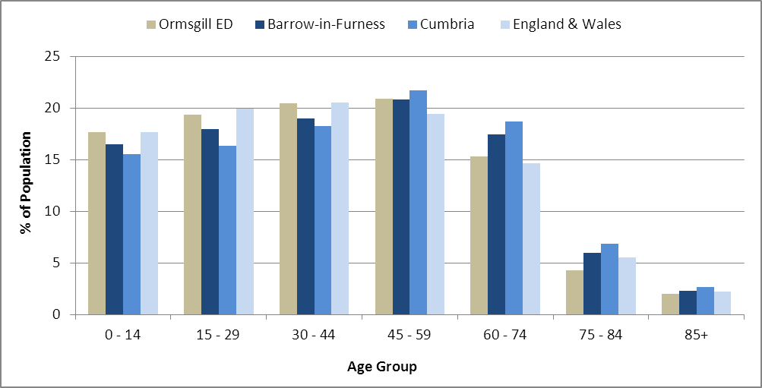

Source: Office for National Statistics, 2011 Census

County Council Electoral Divisions cover large spatial areas and so division averages can mask variation between communities within the division. Furthermore, beyond Census data, there is little statistical information available for Electoral Divisions. However, most statistical agencies produce data for Electoral Wards. Therefore, there is a very wide rangeofstatistical information available for Electoral Wards. Furthermore, as Electoral Wards are generally smaller than Electoral Divisions, statistics at this level provide more insight into variations between communities.

The table below identifies which Electoral Wards are fully or partially within the boundaries of **Ormsgill** **ED**, and what proportion of **Ormsgill** **ED**’s population live within each ward:

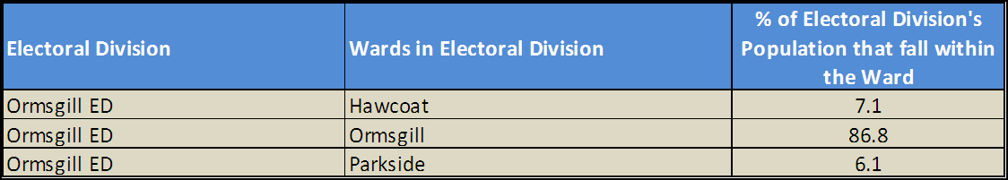

Source: Cumbria Intelligence Observatory, 2013

The map below overlays Electoral Ward boundaries on to **Ormsgill** **ED’s** boundary: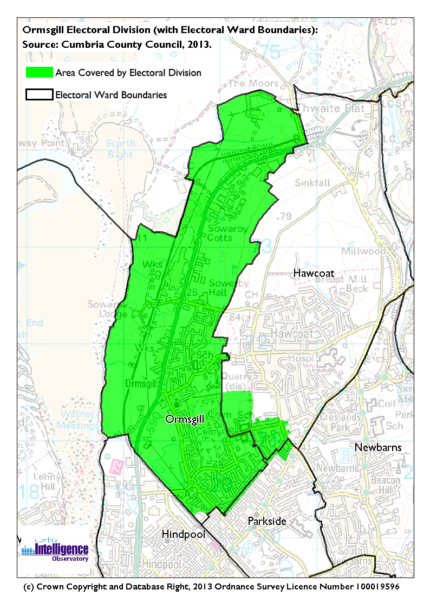The Cumbria Intelligence Observatory presents many Electoral Ward level statistics via the interactive ‘Cumbria Atlas’ tool. The Statistics provided within the Cumbria Atlas cover topics such as, but not limited to, population, housing, health, economy, poverty, ethnicity, language, and transport. The datasets within the Cumbria Atlas are regularly updated and expanded.

For simple step by step instructions to use the Cumbria Atlas to explore statistics for the wards within your Electoral Division, please visit the following web page:

http://www.cumbria.gov.uk/eLibrary/view.asp?ID=56017

The Information and Intelligence Team within Cumbria County Council are happy to talk you through using the Cumbria Atlas over the phone, or face to face. Training sessions can also be arranged for small groups.

To contact the team please call 01228 226309, or email info@cumbriaobservatory.org.uk

# Parks, Open Spaces and Leisure Facilities

Lodge Green

Ormsgill Playing Fields

Thorncliffe Playing Fields/Youth Fields

Newby Terrace

Lichfield Close play area

Ormsgill Multi-Use Games Area & Skateboard

Ormsgill Quarry

How Tun Woods

Ormsgill Reservoir

Sowerby Woods

Furness Cricket Club

Barrow Celtic

Barrow Golf Club

Hoops Basketball Centre

# Active Community Organisations

Ormsgill Youth Group

Ormsgill Residents & Tenants Association

Barrow & District Credit Union

Barrow Foodbank

# Key Communication Networks

North West Evening Mail – Borough wide daily

Advertiser – Borough wide weekly

Barrow Borough Council Housing Matters - quarterly

# Community Assets

Ormsgill Nursery & Primary School

St. Pius School

Victoria Infants & Nursery School

Victoria Junior School

Quarry Brow Nursery

Ormsgill Library

Ormsgill Children’s Centre

Ormsgill Adult Education Development Centre (CDC)

Ormsgill Community Development Centre (CDC)

Griffin Community Centre

St. Matthews Hall

MS Hall

Ormsgill Family Centre

Community Gym

Ormsgill Youth Centre

# Local Cumbria County Council Service Hubs

Ormsgill Adult Education Development Centre (CDC)

Ormsgill Community Development Centre (CDC)

Ormsgill Library

Ormsgill Family Centre

Highways Depot – Sowerby Woods

Fleet Workshop – Sowerby Woods

Waste Treatment Plant – Sowerby Woods

# Community Engagement

Monthly Cumbria County Council Neighbourhood Grants Panel considers grant applications from constituted non-profit making groups whose project benefits the Barrow Borough communities.

Issue-based meetings are held in liaison with the local County Councillor to discuss community concerns.

|  |  |
| --- | --- |
| Key Community Contacts | |
|  | |
| County Councillor William McEwan |  |
|  |  |
| Area Support Team Barrow |  |
|  |  |
| Barrow Borough Council |  |
|  |  |
| Cumbria Council for Voluntary Service (CVS) |  |
|  |  |
| Ormsgill Children’s Centre |  |
|  |  |
| Ormsgill Family Centre |  |
|  |  |