

**Keswick**

**Electoral Division Profile**

**2014**

# Overview of Electoral Division

Keswick Electoral Division lies within the boundaries of the Lake District National Park, within the District of Allerdale. The electoral division covers the market town of Keswick and beyond into Derwentwater, Borrowdale valley, St. Johns Vale, Thirlmere Valley and the Wythburn Fells (including Helvellyn).

The Lake District National Park is a world-wide tourist destination and Keswick is one of the many hotspots for tourists. Tourism is a large economic factor within the division, 27.9% of employment within the division is in the accommodation and food industry and 16.2% in wholesale or retail. The majority of Keswick's businesses are tourism related, providing accommodation and facilities for the tens of thousands of people visiting the area each year.

There are a number of local attractions including:

* Cumberland Pencil Museum
* Castlerigg stone circle
* Bowder Stone
* Keswick Climbing Wall
* Keswick Museum & Art Gallery
* Theatre by the Lake
* Lake Cruises – Keswick Launch
* Alhambra Cinema
* Keswick Leisure Centre - Pool
* Watendlath
* Lodore Falls
* Derwent Island House

There are two primary schools within the division, one in Keswick, the other in Borrowdale. Secondary education is provided at Keswick School which is also recognised as the top comprehensive in Cumbria in national league tables and received a status of ‘Outstanding’ at recent Ofsted inspections. Keswick school provides post 16 education and is one of 37 state boarding schools in England & Wales attracting boarders from Britain and overseas.

The electoral division incorporates two lakes, Derwent Water in the Valley of Borrowdale and Thirlmere. Thirlmere is a reservoir managed by United Utilities and supplies 11 per cent of the North West’s water supply – about one glass of water in every nine comes from here. Derwent Water is largely recreational with a number of marinas; a regular passenger launch operates on the lake, taking passengers between various landing stages.

# Map

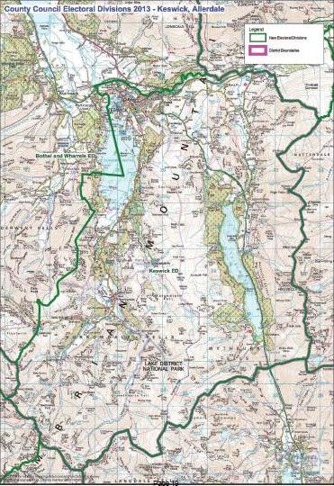

http://www.cumbria.gov.uk/Election2013/maps.asp

# Communities

Keswick Electoral Division spans across the civil parishes of Keswick, Borrowdale and St. Johns Castlerigg incorporating the town of Keswick and the neighbouring villages & hamlets of Wadendlath, Grange, Rosthwaite, Stonethwaite, Seatoller, Birkett Mire, Dale Bottom, Legburthwaite, Thirlmere, and Wythburn.

# Statistical Profile

The 2011 Census estimated that the population of Keswick Electoral Division (ED) was 5660 persons.

The table below presents estimated numbers of residents in Keswick ED by age group:

|  |  |  |  |  |  |  |  |  |
| --- | --- | --- | --- | --- | --- | --- | --- | --- |
|  | **No. Persons by Age Group (Years)** | | | | | | | |
| **All Ages** | **0 - 14** | **15 - 29** | **30 - 44** | **45 - 59** | **60 - 74** | **75 - 84** | **85+** |
| *Keswick ED* | *5660* | *721* | *827* | *993* | *1249* | *1110* | *509* | *251* |

*Source: Office for National Statistics, 2011 Census*

The chart below compares the proportion of Keswick ED’s population within each age group with the proportion of the population within each age group across Allerdale district, Cumbria and England & Wales:

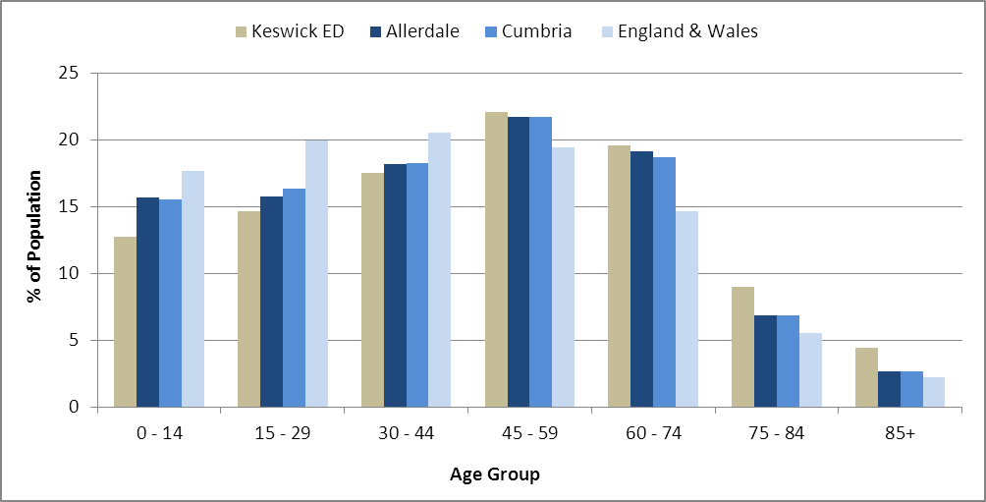

*Source: Office for National Statistics, 2011 Census*

County Council Electoral Divisions cover large spatial areas and so division averages can mask variation between communities within the division. Furthermore, beyond Census data, there is little statistical information available for Electoral Divisions. However, most statistical agencies produce data for Electoral Wards. Therefore, there is a very wide range of statistical information available for Electoral Wards. Furthermore, as Electoral Wards are generally smaller than Electoral Divisions, statistics at this level provide more insight into variations between communities.

The table below identifies which Electoral Wards are fully or partially within the boundaries of Keswick ED, and what proportion of Keswick ED’s population live within each ward:

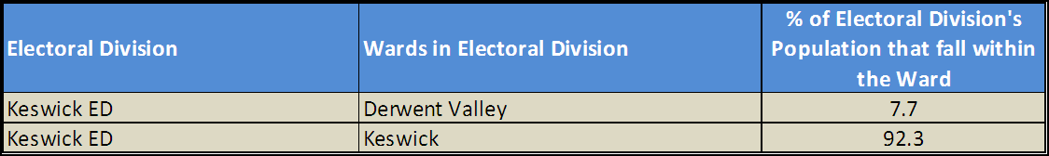

*Source: Cumbria Intelligence Observatory, 2013*

The map below overlays Electoral Ward boundaries on to Keswick ED’s boundary:

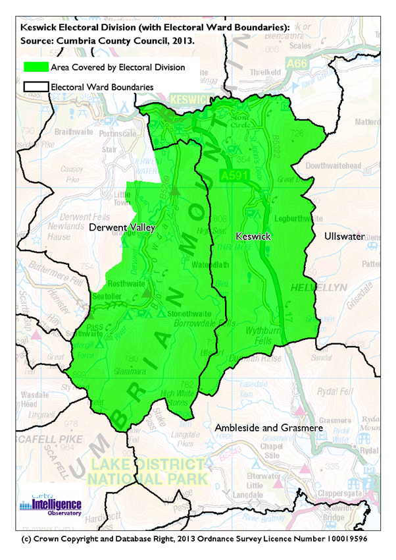

The Cumbria Intelligence Observatory presents many Electoral Ward level statistics via the interactive ‘Cumbria Atlas’ tool. The Statistics provided within the Cumbria Atlas cover topics such as, but not limited to, population, housing, health, economy, poverty, ethnicity, language, and transport. The datasets within the Cumbria Atlas are regularly updated and expanded.

For simple step by step instructions to use the Cumbria Atlas to explore statistics for the wards within your Electoral Division, please visit the following web page:

http://www.cumbria.gov.uk/eLibrary/view.asp?ID=56017

The Information and Intelligence Team within Cumbria County Council are happy to talk you through using the Cumbria Atlas over the phone, or face to face. Training sessions can also be arranged for small groups.

To contact the team please call 01228 226309, or email info@cumbriaobservatory.org.uk

# Parks, Open Spaces and Leisure Facilities

Keswick and the wider electoral division is a playground for outdoor recreation. In the heart of the Lake District National Park, it provides an array of activities including walking, cycling, swimming, fell walking, fishing, sailing, kayaking, ghyll scrambling, climbing, paragliding,

Fitz Park is a large open space in Keswick, home to the local football, cricket, athletics, tennis and bowling clubs and has public tennis, bowling, putting and croquet as well as a large play area, BMX track and museum/art gallery.

Hope Park and Gardens is on the edge of Derwentwater and incorporates community gardens, a bird viewing area, putting pitch and putt, boules and obstacle golf.

Registered open spaces include the Townsfield, a village green on the river Greta and there are community allotments at Hawthorns, Penrith Road, Keswick. Play areas are at a number of locations including Fitz Park and Windebrowe Avenue

Within the division, there are a number of sports clubs & facilities:

Keswick Anglers

<http://www.keswickanglers.co.uk/>

Keswick Archers

[www.keswickarchers.co.uk/](http://www.keswickarchers.co.uk/)

Keswick Athletics Club

<http://www.keswickac.org.uk/>

Greta (Keswick) Junior Badminton Club

[www.keswick.cumbria.sch.uk/content/greta-keswick-junior-badminton-club](http://www.keswick.cumbria.sch.uk/content/greta-keswick-junior-badminton-club)

Keswick Fitz Park Bowls Club

[www.keswickbowlsclub.co.uk](http://www.keswickbowlsclub.co.uk)

Keswick Climbing Wall

<http://www.keswickclimbingwall.co.uk/>

Keswick Cricket Club

[www.keswickcc.co.uk](http://www.keswickcc.co.uk)

Keswick Croquet Club

[www.croquetnw.co.uk/croquet-clubs-in-the-north-west/keswick-croquet-club/](http://www.croquetnw.co.uk/croquet-clubs-in-the-north-west/keswick-croquet-club/)

Keswick Football Club

[www.keswickfootballclub.co.uk](http://www.keswickfootballclub.co.uk)

Keswick Rugby Football Club

[www.keswickrugbyclub.co.uk](http://www.keswickrugbyclub.co.uk)

Keswick Tennis Club

[www.keswick-tennis-club.com](http://www.keswick-tennis-club.com)

# Active Community Organisations

* Amateur Operatic Society <http://www.keswickoperaticsociety.co.uk/index.htm>
* Beavers/Cubs/Explorers/Scouts <http://keswickscouts.org/>
* Bridge Clubs <http://www.keswickbridgeclub.co.uk/>
* Brownies/ Girl Guides <http://www.girlguidingcumbriasouth.org.uk/join_brownies.html>
* Canoe Club <http://www.westcumbriacanoeclub.org.uk/>
* Choral Society <http://www.keswickchoral.org.uk/>
* Cumbria Army Cadet Force <https://armycadets.com/contact-us/?unit=Keswick>
* Fair Trade <http://www.fairtradekeswick.org.uk/>
* Film Club <http://www.keswickfilmclub.org/kfc/index.php>
* Flower Club <http://www.flowersnorthwest.net/club/Keswick-Flower-Club>
* Friends of Keswick Museum <http://keswickmuseum.webs.com/thefriends.htm>
* Friends of Keswick Parks
* Friends At Theatre by the Lake <http://www.theatrebythelake.com/about-the-friends-benefits-and-how-it-helps-tbtl>
* Keswick Community Housing Trust <http://www.keswickcommunityhousingtrust.co.uk/>
* Keswick Flood Action Group <http://keswickfloodactiongroup.org/>
* Keswick Mountain Rescue <http://www.keswickmrt.org.uk/>
* Keswick Tourism Association <http://www.keswick.org/>
* Keswick in Bloom <http://www.keswickinbloom.org.uk/>
* Keswick Bee Keepers <http://www.cumbriabeekeepers.co.uk/Branches/Keswick/keswick_home.htm>
* Keswick & District Old Folks Circle
* Keswick Senior Citizens Club
* Keswick Convention Trust <http://www.keswickministries.org/home>
* Lecture Society <http://www.keswicklecturesociety.co.uk/>
* Lions <http://keswicklions.weebly.com/>
* Music Society <http://www.keswick-music-society.org.uk/>
* Natural History Society <http://www.keswicknathist.co.uk/>
* Photographic Society <http://www.keswickphotosoc.co.uk/>
* Rambling Club <http://keswickramblingclub.com/>
* Rotary <http://www.keswickrotary.org.uk/>
* Society of Art <http://www.keswicksocietyofart.co.uk/>
* SusKes <http://www.suskes.org.uk/>
* Theatre Club <http://keswicktheatreclub.com/>
* Womens Institute East Keswick & Thirlmere

# Key Communication Networks

News & Star

A daily newspaper, produced by CN group; they produce different editions for North and West Cumbria.

Times and Star

Weekly newspaper produced by CN group for the Allerdale district of Cumbria they produce different editions for Maryport, Cockermouth and Workington

Keswick Reminder

The Keswick Reminder is a local paper, produced every Friday for Keswick and the surrounding villages and valleys.

Cumberland & Westmorland Herald

An independent weekly broadsheet newspaper covering a large area of East Cumbria, including the towns of Penrith, Appleby, Kirkby Stephen, Keswick and Alston.

Cumbria Crack

An online facility for News in Cumbria <http://www.cumbriacrack.com/>

BBC Radio Cumbria

Local radio station produced by the BBC for Cumbria

CFM Radio

Local radio station produced by the Bauer Media Group, covering Cumbria and Southwest Scotland

Lakeland Radio

A community commercial radio station covering the Lakeland Area (Kendal, Windermere & Keswick)

ITV News, Border region

Programme news, weather and information provided by ITV Broadcasting Limited for the England/Scotland border region, covering the majority of Cumbria, Dumfries and Galloway, the Scottish Borders and parts of Northumberland.

<http://www.itv.com/news/border/story/2013-10-11/get-in-touch/>

BBC News – Look North (North East & Cumbria)

Look North is the BBC's nightly regional news programme for the North East of England and Cumbria

<http://www.bbc.co.uk/programmes/b0070g1d/faq>

Parish Newsletters, notice boards & websites

(see Key Community Contacts)

Parochial Parish newsletters

# Community Assets

Schools:

* Borrowdale CE Primary School
* St. Herbert's CE (VA) Primary & Nursery
* Keswick School

Churches:

* St John’s-in-the-Vale Church
* St. Andrew's Church, Borrowdale
* Holy Trinity Church, Grange in Borrowdale
* Grange in Borrowdale Methodist Chapel
* Keswick - Friends Meeting House
* Keswick - Keswick Methodist Church
* Keswick - Lake Road Chapel
* Keswick - Orthodox Community of St Bega, St Mungo and St Herbet
* Keswick - Our Lady of the Lakes and St Charles Borromeo
* Keswick - St John
* Keswick - St Kentigern
* Stonethwaite near Borrowdale School - St Andrew's
* Wythburn Church

Other:

* Cricket Pavillion, Fitz Park
* Fitz Park & Hope Park
* Keswick Fire Station
* Keswick Library
* Keswick Town Hall
* Keswick Museum & Arts Gallery
* Keswick Theatre by The Lake
* Keswick Pool
* Keswick Rugby Club
* Mary Hewitson cottage Hospital
* National Trust Shop and Information Centre, Derwent Foreshore
* Keswick National Park Information Centre, Town Hall
* Rawnsley Centre
* Rosthwaite Institute
* St Herberts Centre, Keswick
* Thirlmere Rec Hall.
* Thirlmere Reservoir
* Toilets at:
  + Lakeside, Keswick
  + Lakeside Car Park, Keswick
  + Banks Court, Keswick (closed permanently)
  + Central Car Park, Keswick
  + Station Platform, Keswick
  + Belle Close, Keswick
  + Lodore, Keswick
  + Grange Bridge, Keswick
  + Rosthwaite, Keswick (Lake District National Park)
  + Seatoller, Keswick (Lake District National Park)
  + Seathwaite, Keswick (Lake District National Park)

# Local Cumbria County Council Service Hubs

|  |  |
| --- | --- |
| **Service Type** | **Service Point** |
| Childrens Centres | Derwent Valley Children's Centre |
| Doctors Surgeries | Castlehead Medical Centre |
| Doctors Surgeries | Bank Street Surgery |
| Fire Stations | Keswick |
| Hospitals | Mary Hewetson Cottage Hospital |
| Libraries | Keswick Library |
| Primary Schools | Borrowdale CE Primary School |
| Primary Schools | St. Herbert's CE (VA) Primary & Nursery |
| Secondary Schools | Keswick School |

# Community Engagement

Keswick has Neighbourhood Forums twice yearly. For more information about neighbourhood forums, please contact Allerdale Area Support Team (see key community contacts)

|  |
| --- |
| Key Community Contacts |
| Cumbria County Councillor, Andrew Lysser, Keswick Electoral Division   * Address: Apt. 2, Gatesgarth, Braithwaite, Keswick, CA12 5RY * Phone: 017687 78833 * Email: Andrew.Lysser@cumbria.gov.uk |
| Allerdale Area Support Team   * Address: Workington Library, Vulcans Lane, Workington, CA14 2ND * Phone: 01900 706015 * Email: ted.thwaites@cumbria.gov.uk * Web: www.cumbria.gov.uk |
| Allerdale Borough Council   * Address: Allerdale House, Workington, Cumbria, CA14 3YJ * Phone: 01900 702702 * Email: enquiries@allerdale.gov.uk * Web: http://www.allerdale.gov.uk/ |
| Keswick Town Council   * Address: 50 Main Street, Keswick, CA12 5JS * Phone: 01768 773607 * Email: townclerk@keswicktowncouncil.co.uk * Web: http://keswicktowncouncil.gov.uk |
| Borrowdale Parish Council   * Clerk: Becx Carter * Address: 40 Windebrow Avenue, Keswick, CA12 4JA * Email: clerk@borrowdale.org.uk * Web: http://www.borrowdale.org.uk/index.html |
| St. Johns Castlerigg Parish Council   * Clerk: Mrs SM Bickerdyke * Address: Manesty, Springs Garth, Keswick, CA12 4BG * Phone: 017687 73537 * Email: sally.bickerdyke@btinternet.com |