

**Old Barrow**

**Electoral Division Profile**

**2014**

# Overview of Electoral Division

Old Barrow is in the electoral division of Barrow Borough and has a population of 7,588.

# Map



# Statistical Profile

**Statistical Profile: *Old Barrow Electoral Division***

The 2011 Census estimated that the population of**Old Barrow Electoral Division(ED)**was **7588** persons.

The table below presents estimated numbers of residents in **Old Barrow** **ED** by age group:

|  |  |  |  |  |  |  |  |  |
| --- | --- | --- | --- | --- | --- | --- | --- | --- |
|  | **No. Persons by Age Group (Years)** | | | | | | | |
| **All Ages** | **0 - 14** | **15 - 29** | **30 - 44** | **45 - 59** | **60 - 74** | **75 - 84** | **85+** |
| *Old Barrow ED* | *7588* | *1323* | *1691* | *1525* | *1447* | *1117* | *340* | *145* |

Source: Office for National Statistics, 2011 Census

The chart below compares the proportion of **Old Barrow ED’s** population within each age group with the proportion of the population within each age group across Barrow-in-Furness district, Cumbria and England & Wales:

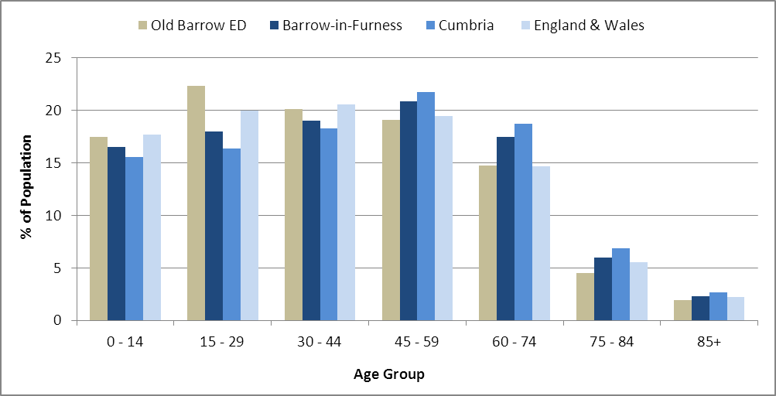

*of statistical information available* Source: Office for National Statistics, 2011 Census

County Council Electoral Divisions cover large spatial areas and so division averages can mask variation between communities within the division. Furthermore, beyond Census data, there is little statistical information available for Electoral Divisions. However, most statistical agencies produce data for Electoral Wards. Therefore, there is a very wide rangefor Electoral Wards. Furthermore, as ElectoralWards are generally smaller than Electoral Divisions, statistics at this level provide more insight into variations between communities.

The table below identifies which Electoral Wards are fully or partially within the boundaries of **Old Barrow** **ED**, and what proportion of **Old Barrow** **ED**’s population live within each ward:

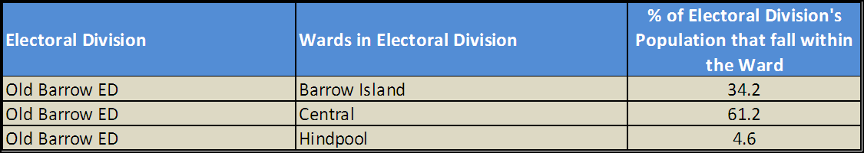

Source: Cumbria Intelligence Observatory, 2013

The map below overlays Electoral Ward boundaries on to **Old Barrow** **ED’s** boundary: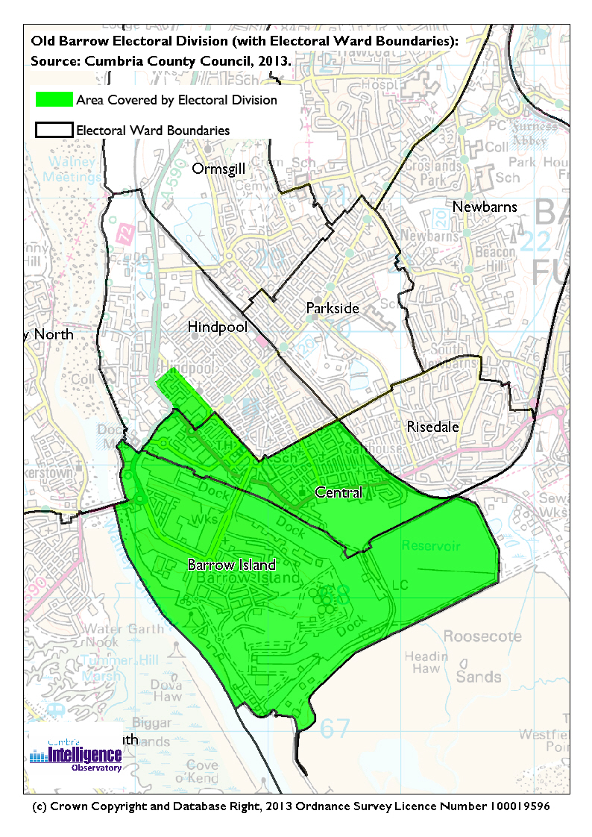The Cumbria Intelligence Observatory presents many Electoral Ward level statistics via the interactive ‘Cumbria Atlas’ tool. The Statistics provided within the Cumbria Atlas cover topics such as, but not limited to, population, housing, health, economy, poverty, ethnicity, language, and transport. The datasets within the Cumbria Atlas are regularly updated and expanded.

For simple step by step instructions to use the Cumbria Atlas to explore statistics for the wards within your Electoral Division, please visit the following web page:

http://www.cumbria.gov.uk/eLibrary/view.asp?ID=56017

The Information and Intelligence Team within Cumbria County Council are happy to talk you through using the Cumbria Atlas over the phone, or face to face. Training sessions can also be arranged for small groups.

To contact the team please call 01228 226309, or email info@cumbriaobservatory.org.uk

# Parks, Open Spaces and Leisure Facilities

Farm Street Rec

Stanley Road

Dock Museum

School Street

Vulcan Road

Lawson Street

Green Heart Den (half)

Cavendish Park

Waterfront

Cavendish Park Bowling Club

Salthouse Bowling Club

Barrow Raiders

Duddon Canoe Club

Barrow Island Boat Club

Barrow & District Sea Cadets

# Active Community Organisations

Barrow Island Trust Group - £1m

Vulcan Road Tenants & Residents

St. Vincent

Barrow & District Credit Union

Barrow Foodbank

# Key Communication Networks

North West Evening Mail – Borough wide daily

Advertiser – Borough wide weekly

Barrow Borough Council Housing Matters - quarterly

# Community Assets

Barrow Island Primary School

Bram Longstaffe School

St. Georges Primary School

Sacred Heart Primary School

Greengate Juniors School

Dundalk Street Community Hall

Community Development Centre (CDC)

Barrow Island Adult Education Centre (CDC)

Barrow Island Library

Barrow Island Community Trust Drop-in Shop

Bram Longstaffe Children’s Centre

St. John’s Church

Barrow & District Sea Cadets

Greengate Children’s Centre

St. Georges Church Hall

Dock Museum

Town Hall

Drop Zone

Burlington House

Canteen

Alfred Barrow

Atkinson Health Centre

Duke Street Surgery

Risedale at St. Georges Nursing Home

Risedale at Lonsdale

# Local Cumbria County Council Service Hubs

Barrow Island Library

Barrow Island Community Development Centre

Barrow Island Adult Education Centre (CDC)

Bram Longstaffe Children’s Centre

Greengate Children’s Centre

Cumbria Registrars

Nan Tait Centre

# Community Engagement

Monthly Cumbria County Council Neighbourhood Grants Panel considers grant applications from constituted non-profit making groups whose project benefits the Barrow Borough communities.

Issue-based meetings are held in liaison with the local County Councillor to discuss community concerns.

Barrow Island Trust Community Meetings.

|  |  |
| --- | --- |
| Key Community Contacts | |
|  | |
| County Councillor John Murphy |  |
|  |  |
| Area Support Team Barrow |  |
|  |  |
| Barrow Borough Council |  |
|  |  |
| Cumbria Council for Voluntary Service (CVS) |  |