

**Solway Coast**

**Electoral Division Profile**

**2014**

# Overview of Electoral Division

The Electoral Division of Solway Coast lies in the far North West of Cumbria overlooking Scotland and the Solway Firth. It sits within the District of Allerdale, with the district council base at Workington.

Silloth is the largest town within the division and is the most north westerly town in England. A popular Victorian seaside destination, the town has a discovery centre with tourist Information centre. The division lies to the west of the city of Carlisle and to the north of the market town of Wigton.

Bowness on Solway is the farthest point of North West England, and is the start of Hadrian’s Wall path, the National trail which follows the World Heritage Site of Hadrian's Wall, past Roman settlements and forts.

The wider Solway Coast is an Area of Natural Beauty (AONB) and houses four of the best remaining peat bogs in Europe which make up the South Solway Mosses Special Area of Conservation (SAC). There is also Campfield Marsh Nature Reserve and wetland education centre at Bowness-on-Solway managed by the RSPB and Drumburgh Moss Nature Reserve managed by Cumbria Wildlife Trust.

There are a number of primary schools within the electoral division, and Solway Community Technical College at Silloth provides secondary education. 6th form education is provided at Carlisle, Wigton, Maryport, Workington or Cockermouth.

Silloth is a tourist destination and offers a range of employment between the caravan parks, guest houses and hotels, however only 8.2% of employment within the division is in the food and accommodation sector. The largest sector is manufacturing with 16.4%. There are a number of large and national employers within the town including:

* Port of Silloth (Import/Export)
* Carrs Flour Mills (Food Production)
* Thomas Armstrong (Construction)
* D.A Harrison (Aggregates)
* Enkev (Natural Fibres Production)
* Caltech Crystalyx (Animal Supplements)
* Solway Shrimping Industry

The former RAF airfield at Silloth is base for a number of businesses. On Sunday it hosts a giant market and car boot sale.

Anthorn is home to the Anthorn Radio Station, which is one of three NATO Facilities in Europe. It occupies the former World War II military airfield which was operated by the Royal Navy Air Service as HMS Nuthatch. The facility houses a number of transmitters, antennas and atomic clocks.

# Map

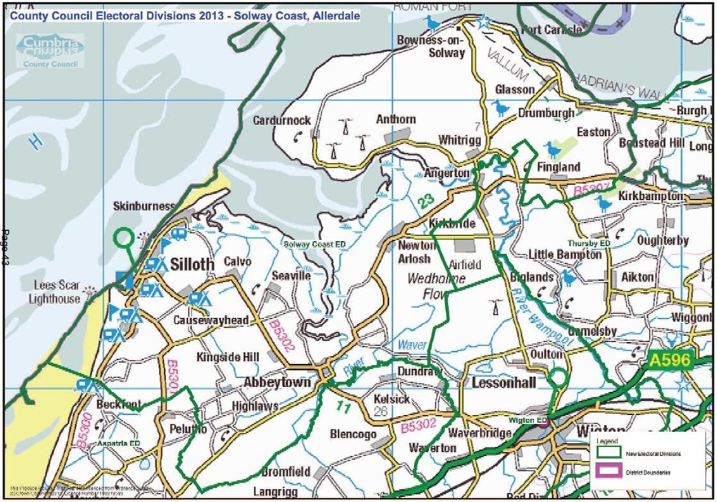

*http://www.cumbria.gov.uk/Election2013/maps.asp*

# Communities

The Electoral Division of Solway Coast incorporates the seaside town of Silloth and the neighbouring villages of:

|  |  |
| --- | --- |
| * Abbeytown * Angerton * Anthorn * Bowness on Solway * Causewayhead * Calvo * Cardurnock * Drumburgh * Easton | * Fingland * Glasson * Highlaws * Kingside Hill * Newton Arlosh * Port Carlisle * Seaville * Skinburness * Whitrigg |

Many of these local areas got their name from the time when Cistercian monks resided at Holme Cultram Abbey.

The area is also governed by the civil parishes of:

* Bowness on Solway
* Holme Abbey
* Holme East Waver
* Holme Low
* Silloth on Solway

# Statistical Profile

The 2011 Census estimated that the population of Solway Coast Electoral Division (ED) was 5531 persons.

The table below presents estimated numbers of residents in Solway Coast ED by age group:

|  |  |  |  |  |  |  |  |  |
| --- | --- | --- | --- | --- | --- | --- | --- | --- |
|  | No. Persons by Age Group (Years) | | | | | | | |
| All Ages | 0 - 14 | 15 - 29 | 30 - 44 | 45 - 59 | 60 - 74 | 75 - 84 | 85+ |
| *Solway Coast ED* | *5531* | *779* | *774* | *828* | *1222* | *1250* | *486* | *192* |

*Source: Office for National Statistics, 2011 Census*

The chart below compares the proportion of Solway Coast ED’s population within each age group with the proportion of the population within each age group across Allerdale district, Cumbria and England & Wales:

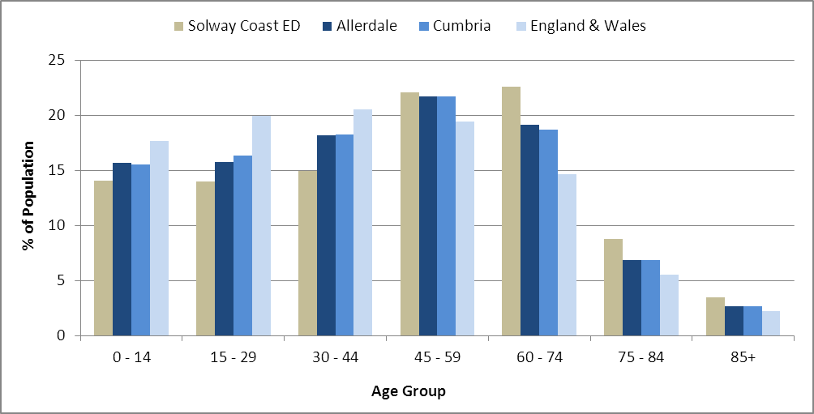

*Source: Office for National Statistics, 2011 Census*

County Council Electoral Divisions cover large spatial areas and so division averages can mask variation between communities within the division. Furthermore, beyond Census data, there is little statistical information available for Electoral Divisions. However, most statistical agencies produce data for Electoral Wards. Therefore, there is a very wide range of statistical information available for Electoral Wards. Furthermore, as Electoral Wards are generally smaller than Electoral Divisions, statistics at this level provide more insight into variations between communities.

The table below identifies which Electoral Wards are fully or partially within the boundaries of Solway Coast ED, and what proportion of Solway Coast ED’s population live within each ward:

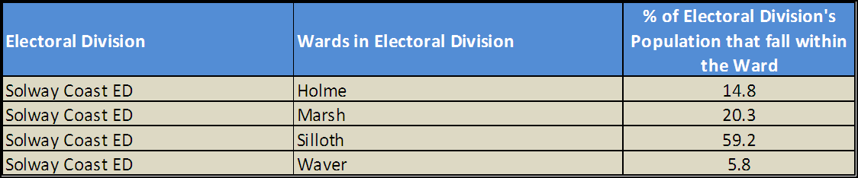

*Source: Cumbria Intelligence Observatory, 2013*

The map below overlays Electoral Ward boundaries on to Solway Coast ED’s boundary: 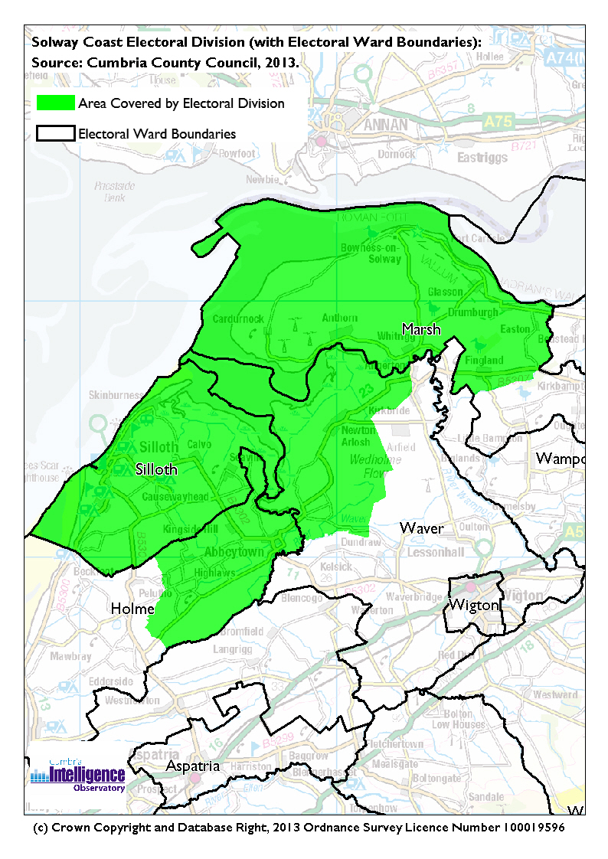The Cumbria Intelligence Observatory presents many Electoral Ward level statistics via the interactive ‘Cumbria Atlas’ tool. The Statistics provided within the Cumbria Atlas cover topics such as, but not limited to, population, housing, health, economy, poverty, ethnicity, language, and transport. The datasets within the Cumbria Atlas are regularly updated and expanded.

For simple step by step instructions to use the Cumbria Atlasto explore statistics for the wards within your Electoral Division, please visit the following web page:

[*http://www.cumbria.gov.uk/eLibrary/view.asp?ID=56017*](http://www.cumbria.gov.uk/eLibrary/view.asp?ID=56017)

The Information and Intelligence Team within Cumbria County Council are happy to talk you through using the Cumbria Atlas over the phone, or face to face. Training sessions can also be arranged for small groups.

To contact the team please call 01228 226309, or email [*info@cumbriaobservatory.org.uk*](mailto:info@cumbriaobservatory.org.uk)

# Parks, Open Spaces and Leisure Facilities

The coastal area of the electoral division provides a number of open spaces for walking, cycling, horse-riding and other leisurely activities.

The Green at Silloth is one of the UK’s longest and largest village greens; the area has also been awarded green flag status. ‘The Green’ incorporates a splash area with rubber flooring and water jets, a woodland adventure play area, a BMX track, a small putting green, community garden and rose garden alongside a vast green area and paved entertainment area. Silloth is located on both the Cumbria Coastal Way and Cumbria Cycle Way.

Silloth Golf Club is also a national feature for Solway Coast: in 2013 ‘Today’s Golfer’ magazine voted it the ‘Best Course in Britain and Ireland under £60’. It also appears in the Planetgolf.com top 100 golf courses in the world.

Sea fishing and ‘haaf netting’ is also a popular pastime with North West of England competitions held in the area. Haaf netting is a traditional and long-established method of fishing for salmon and sea trout on the rivers, haaf nets are permitted only on the Solway and nowhere else.

Local play areas can be found at The Green, Silloth; Eden Street, Silloth; Glasson; Anthorn and Port Carlisle. There are plans in place to provide one at Abbeytown with a community group set up to achieve this.

There are a number of community and private leisure facilities; this is not an exhaustive list, Leisure Facilities:

Solway Community Sports Hall (part of Solway Community Technology College)

Liddell Street, Silloth, Cumbria, CA7 4DD

Tel: 016973 31234

Solway Holiday Village

Provides a leisure centre, swimming pool, crazy golf and play area

Skinburness Drive, Wigton CA7 4QQ

Tel: 016973 31236

Stanwix Park Holiday Village

Provides a leisure centre with indoor & outdoor pools; Indoor bowling; snooker /pool

Greenrow, Silloth, Cumbria CA7 4HH

Tel: 016973 32666

Abbeytown FC Football club

Provides women’s, men’s and children’s football, plus indoor bowls

Recreational field, Abbeytown

Tel: 01697349391

Website: http://abbeytownfc.co.uk/

Blackdyke Farm

Provides horse riding and swimming

Tel: 01228 674633

Silloth Football Club

Contact: Mr Eric Telford

Tel: 016973 23297

Email: eric.telford@gmail.com

Silloth Rugby Club

Tel: 01697332299

Email: sillothrugbyclub@yahoo.co.uk

Silloth Fitness Centre

Contact: Mr Colin Baty

Tel: 016973 31297

Email: colinbaty@hotmail.co.uk

Silloth Tennis Club

Contact: Mr David Wise

Tel: 016973 32988

Email: tenniswise@sky.com

Silloth Bowling Club

32 Eden Street, Silloth, Cumbria, CA7 4AD

Tel: 016973 31547

Silloth-on-Solway Golf Club

The Club House, Station Road, Silloth, Cumbria, CA7 4BL

Tel: 016973 31304

Email: office@sillothgolfclub.co.uk

Website: www.sillothgolfclub.co.uk

Port Carlisle Bowling Club

Port Carlisle, Carlisle CA7 5BU.

Email: mowbray.noreen@googlemail.com

# Active Community Organisations

* Abbeytown Community Youth Group
* Abbeytown Road Run Committee
* Abbeytown Carnival Committee
* Abbeytown Play Park
* Abbeytown Assembly Rooms
* Abbeytown FC
* Abbeytown Sports Developnment
* Anthorn Sports Club
* Anthorn Heating Oil Club
* Anthorn AFC
* Anthorn Social Club
* Bowness on Solway WI
* Bowness-on-Solway Community Group
* Bowness on Solway - Lindow Hall Management Committee
* Drumburgh & Glasson WI
* Drumburgh Moss Nature Reserve
* Friends of Silloth Green
* Holme Cultram Mothers Union
* Hadrians Wall Heritage Ltd
* Newton Arlosh WI
* Rotary Club of Silloth on Solway
* RSPB Campfield Marsh Nature Reserve
* Silloth First Responders
* Silloth (CausewayHead) WI
* Silloth Carnival Committee
* Silloth Open Door Group
* Silloth Rainbows & Brownies
* Silloth Tots and Toddlers
* Silloth Pensioners Committee (Whist Group)
* Silloth RLNI Life Boat
* Silloth on Solway Community Shop
* Silloth Music & Beer Festival
* Silloth Tourism Action Group
* Silloth Vintage Rally
* Silloth Youth Group
* Solway Arts Society
* Solway Buzz
* Solway Coast AONB & Wetland Centre
* Silloth Golf Club (private members club)

# Key Communication Networks

News & Star

A daily newspaper, produced by CN group; they produce different editions for North and West Cumbria.

Times and Star

Weekly newspaper produced by CN group for the Allerdale district of Cumbria they produce different editions for Maryport, Cockermouth and Workington

Cumberland News

The most widely read newspaper in Cumbria. This bridges the north and west communities.

BBC Radio Cumbria

Local radio station produced by the BBC for Cumbria

CFM Radio

Local radio station produced by the Bauer Media Group, covering Cumbria and Southwest Scotland

ITV News, Border region

Programme news, weather and information provided by ITV Broadcasting Limited for the England/Scotland border region, covering the majority of Cumbria, Dumfries and Galloway, the Scottish Borders and parts of Northumberland.

http://www.itv.com/news/border/story/2013-10-11/get-in-touch/

BBC News – Look North (North East & Cumbria)

Look North is the BBC's nightly regional news programme for the North East of England and Cumbria

http://www.bbc.co.uk/programmes/b0070g1d/faq

The Solway Buzz is a community paper with articles and photos submitted by volunteers and up to 5,500 copies are distributed throughout an area within about six miles of Silloth-on-Solway

http://www.solwaybuzz.co.uk

Solway Plain Team Magazine solwayplainteammag@yahoo.co.uk

Parish Newsletters, notice boards & websites

(see Key Community Contacts)

# Community Assets

Schools:

* Solway Community Technical College
* Silloth School
* Bowness on Solway Primary School
* Holm Cultram Abbey CE School

Churches:

* Abbeytown - Methodist Church
* Abbeytown - St Mary Holme Cultram
* Holme Cultram Abbey
* Bowness on Solway - St Michael
* Newton Arlosh - St John the Evangelist
* Silloth - Christ Church
* Silloth - Our Lady of the Assumption
* Silloth - St Andrew
* Silloth - Trinity Methodist Church

Other:

* Silloth Library & Local Links
* Silloth Fire Station
* Tourist Information Centre and Discovery Centre Silloth
* Silloth Town Council’s Allotments
* Silloth Lifeboat Station
* Abbeytown Assembly Room
* Abbeytown Village Hall
* Lindow Hall, Bowness on Solway
* Newton Arlosh Parish Hall
* Trinity Methodist Church School Room
* Nature Reserves: Campfield Marsh & Drumburgh Moss
* Wetland Centre, Bowness-on-Solway
* Port Carlisle Bowling Club

# Local Cumbria County Council Service Hubs

|  |  |
| --- | --- |
| **Service Type** | **Service Point** |
| Doctors Surgeries | Silloth Group Medical Practice |
| Fire Stations | Silloth |
| Libraries | Silloth Library & Local Links |
| Primary Schools | Silloth Primary School |
| Primary Schools | Holm Cultram Abbey CE School |
| Primary Schools | Bowness School |
| Secondary Schools | Solway Community College |

# Community Engagement

Solway Coast ED is part of the North West Allerdale Neighbourhood Forum. Neighbourhood Forums are held three times yearly. For further information, please contact Allerdale Area Support Team (see key community contacts)

|  |
| --- |
| Key Community Contacts |
| Cumbria County Councillor, Tony Markley, Solway Coast ED   * Address: Verona, Blitterlees, Silloth, Cumbria, CA7 4JJ * Phone: 016973 31998 or 016973 31276 * Mobile: 07720 560596 * Email: Anthony.Markley@cumbria.gov.uk |
| Allerdale Area Support Team   * Address: Workington Library, Vulcans Lane, Workington, CA14 2ND * Phone: 01900 706015 * Email: ted.thwaites@cumbria.gov.uk * Web: www.cumbria.gov.uk |
| Allerdale Borough Council   * Address: Allerdale House, Workington, Cumbria, CA14 3YJ * Phone: 01900 702702 * Email: enquiries@allerdale.gov.uk * Web: http://www.allerdale.gov.uk/ |
| Silloth Town Council   * Clerk: Mrs W Jameson * Address: 5 Burnswark Terrace, Solway Street, Silloth, Cumbria, CA7 4EF * Phone: 016973 31128 * Email: townclerk@silloth-on-solway.co.uk * Web: http://www.silloth-on-solway-tc.gov.uk |
| Holme Low Parish Council   * Clerk: Mrs W Jameson * Address: 5 Burnswark Terrace, Solway Street, Silloth, CA7 4EF * Phone: 016973 31128 * Email: parishclerk@holmelow-pc.org.uk |
| Holme Abbey Parish Council   * Clerk: Mrs L Hanley * Address: 4 Abbey Terrace, Abbeytown, CA7 4TF * Phone: 016973 61841 * Email: lindsayhanley@talktalk.net |

|  |
| --- |
| Holme East Waver Parish Council   * Clerk: Mr Michael Abbs * Address: 7 Moricambe Crescent, Anthorn, CA7 5AS * Phone: 016973 51722 * Email: clerk@gomphus.demon.co.uk |
| Bowness-on-Solway Parish Council   * Clerk: Mr Michael Abbs * Address: 7 Moricambe Crescent, Anthorn, CA7 5AS * Phone: 016973 51722 * Email: clerk@gomphus.demon.co.uk |