

**Risedale**

**Electoral Division Profile**

**2014**

# Overview of Electoral Division

Risedale is in the electoral division of Barrow Borough and has a population of 5,932.

# Map



# Statistical Profile

**Statistical Profile: Risedale Electoral Division**

The 2011 Census estimated that the population of **Risedale Electoral Division (ED)** was **5932** persons.

The table below presents estimated numbers of residents in **Risedale** **ED** by age group:

|  |  |  |  |  |  |  |  |  |
| --- | --- | --- | --- | --- | --- | --- | --- | --- |
|  | **No. Persons by Age Group (Years)** | | | | | | | |
| **All Ages** | **0 - 14** | **15 - 29** | **30 - 44** | **45 - 59** | **60 - 74** | **75 - 84** | **85+** |
| *Risedale ED* | *5932* | *1142* | *1256* | *1156* | *1190* | *808* | *272* | *108* |

Source: Office for National Statistics, 2011 Census

The chart below compares the proportion of **Risedale ED’s** population within each age group with the proportion of the population within each age group across Barrow-in-Furness district, Cumbria and England & Wales:

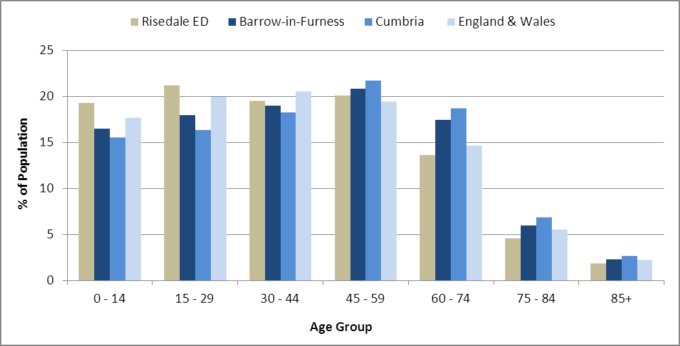

Source: Office for National Statistics, 2011 Census

County Council Electoral Divisions cover large spatial areas and so division averages can mask variation between communities within the division. Furthermore, beyond Census data, there is little statistical information available for Electoral Divisions. However, most statistical agencies produce data for Electoral Wards. Therefore, there is a very wide range of statistical information available for Electoral Wards. Furthermore, as Electoral Wards are generally smaller than Electoral Divisions, statistics at this level provide more insight into variations between communities.

The table below identifies which Electoral Wards are fully or partially within the boundaries of **Risedale** **ED**, and what proportion of **Risedale** **ED**’s population live within each ward:

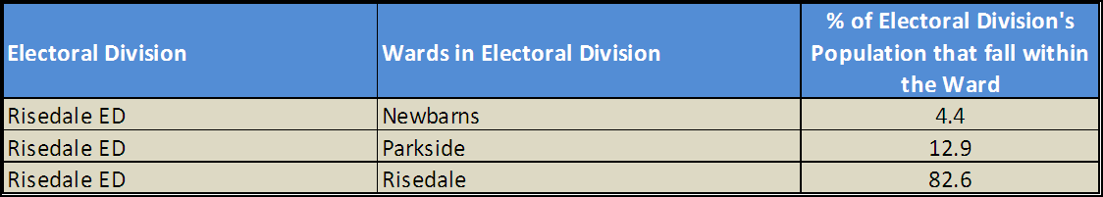

Source: Cumbria Intelligence Observatory, 2013

The map below overlays Electoral Ward boundaries on to **Risedale** **ED’s** boundary: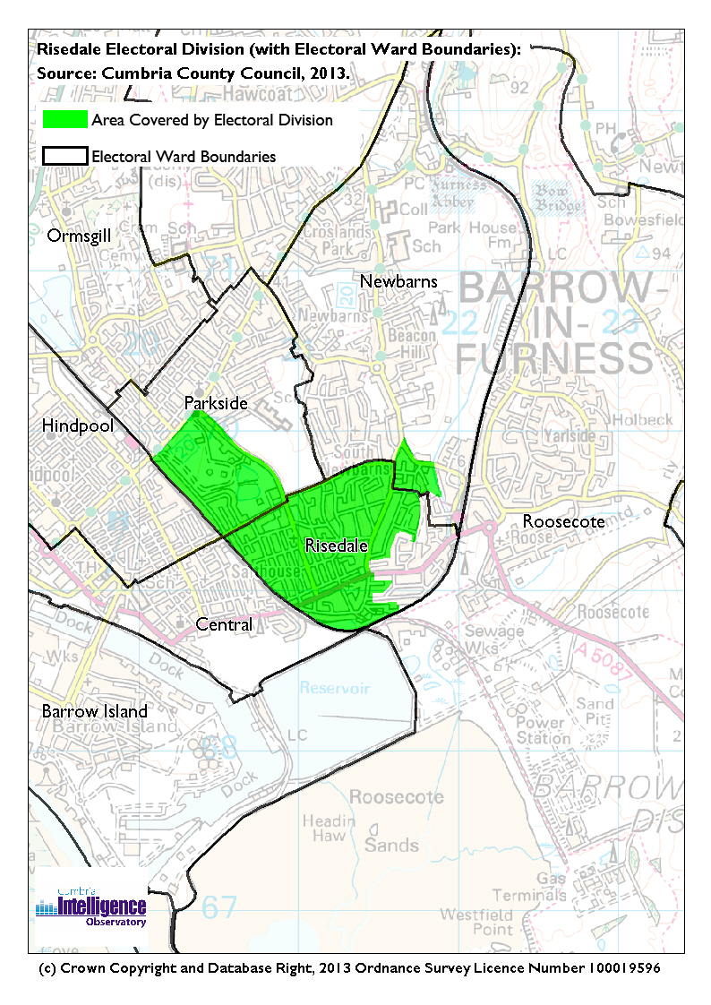

The Cumbria Intelligence Observatory presents many Electoral Ward level statistics via the interactive ‘Cumbria Atlas’ tool. The Statistics provided within the Cumbria Atlas cover topics such as, but not limited to, population, housing, health, economy, poverty, ethnicity, language, and transport. The datasets within the Cumbria Atlas are regularly updated and expanded.

For simple step by step instructions to use the Cumbria Atlas to explore statistics for the wards within your Electoral Division, please visit the following web page:

http://www.cumbria.gov.uk/eLibrary/view.asp?ID=56017

The Information and Intelligence Team within Cumbria County Council are happy to talk you through using the Cumbria Atlas over the phone, or face to face. Training sessions can also be arranged for small groups.

To contact the team please call 01228 226309, or email info@cumbriaobservatory.org.uk

**Parks, Open Spaces and Leisure Facilities**

Abbotsvale Park

Barrow Public Park

Brook Street Boxing Club

Newdale Bowling Club

# Active Community Organisations

Abbotsvale Community Association

Four Groves Community Association

Fife Street Neighbourhood Watch

Barrow & District Credit Union

Barrow Foodbank

# Key Communication Networks

North West Evening Mail – Borough wide daily

Advertiser – Borough wide weekly

Barrow Borough Council Housing Matters - quarterly

# Community Assets

Four Groves Resource Centre

Abbotsvale Community Centre

Abbotsmead Community Development Centre (CDC)

Abbotsmead Adult Education Centre (CDC)

Roose Library

Park Leisure Centre

Greengate Infants School

Cambridge Street School

Liverpool House Surgery

Bridgegate Medical Centre

Dr Jolliffe GC & Partners

# Local Cumbria County Council Service Hubs

Cambridge Street Community Development Centre

Roose Library

Abbotsmead Community Education Centre

# Community Engagement

Monthly Cumbria County Council Neighbourhood Grants Panel considers grant applications from constituted non-profit making groups whose project benefits the Barrow Borough communities.

Issue-based meetings are held in liaison with the local County Councillor to discuss community concerns.

|  |  |
| --- | --- |
| Key Community Contacts | |
|  | |
| County Councillor Kevin Hamilton |  |
|  |  |
| Area Support Team Barrow |  |
|  |  |
| Barrow Borough Council |  |
|  |  |
| Cumbria Council for Voluntary Service (CVS) |  |