

**Dalton South**

**Electoral Division Profile**

**2014**

# Overview of Electoral Division

Dalton South is in the electoral division of Barrow Borough and has a population of 6,207.

# Map



# Communities

Newton-in-Furness

Stank

Anty Cross

# Statistical Profile

**Statistical Profile: Dalton South Electoral Division**

The 2011 Census estimated that the population of **Dalton South Electoral Division (ED)** was **6207** persons.

The table below presents estimated numbers of residents in **Dalton South** **ED** by age group:

|  |  |  |  |  |  |  |  |  |
| --- | --- | --- | --- | --- | --- | --- | --- | --- |
|  | **No. Persons by Age Group (Years)** | | | | | | | |
| **All Ages** | **0 - 14** | **15 - 29** | **30 - 44** | **45 - 59** | **60 - 74** | **75 - 84** | **85+** |
| *Dalton South ED* | *6207* | *1024* | *1015* | *1175* | *1373* | *1139* | *343* | *138* |

Source: Office for National Statistics, 2011 Census

The chart below compares the proportion of **Dalton South ED’s** population within each age group with the proportion of the population within each age group across Barrow-in-Furness district, Cumbria and England & Wales:

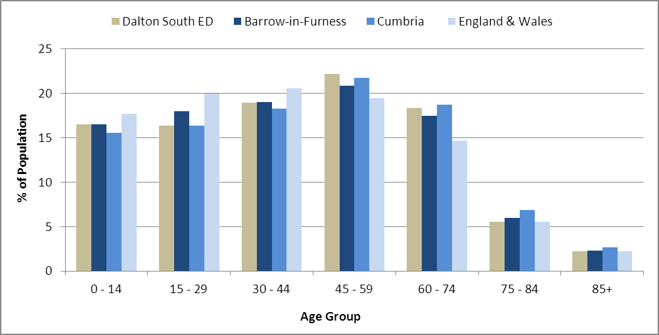

Source: Office for National Statistics, 2011 Census

County Council Electoral Divisions cover large spatial areas and so division averages can mask variation between communities within the division. Furthermore, beyond Census data, there is little statistical information available for Electoral Divisions. However, most statistical agencies produce data for Electoral Wards. Therefore, there is a very wide range of statistical information available for Electoral Wards. Furthermore, as Electoral Wards are generally smaller than Electoral Divisions, statistics at this level provide more insight into variations between communities.

The table below identifies which Electoral Wards are fully or partially within the boundaries of **Dalton South** **ED**, and what proportion of **Dalton South** **ED**’s population live within each ward:

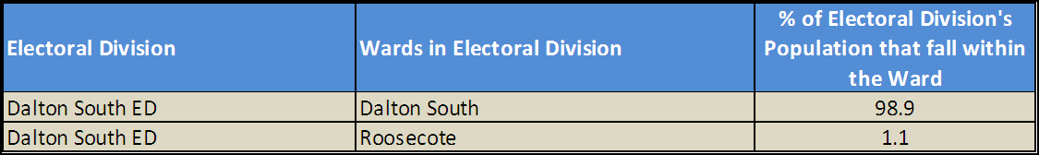

Source: Cumbria Intelligence Observatory, 2013

The map below overlays Electoral Ward boundaries on to **Dalton South** **ED’s** boundary: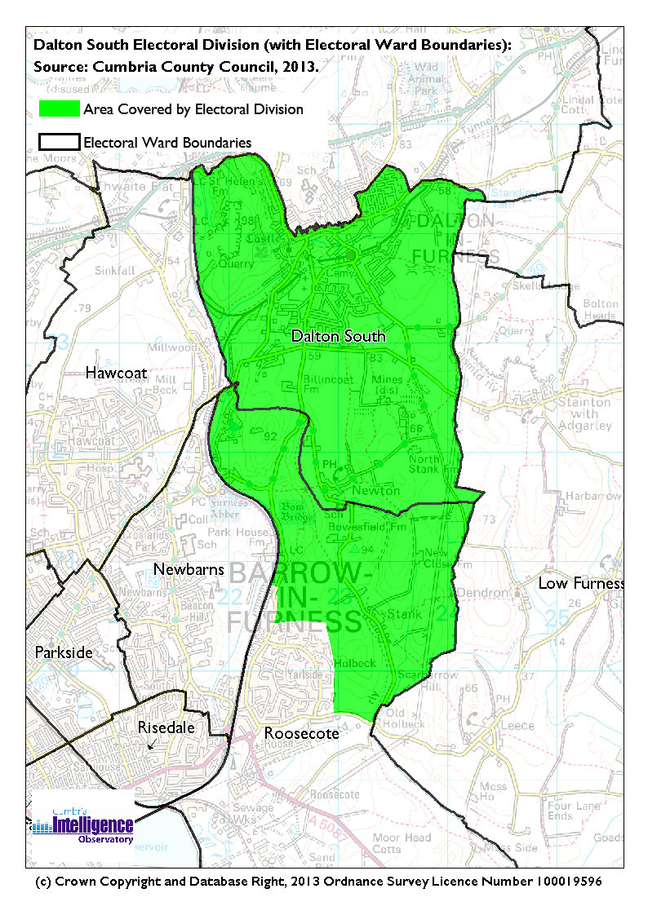The Cumbria Intelligence Observatory presents many Electoral Ward level statistics via the interactive ‘Cumbria Atlas’ tool. The Statistics provided within the Cumbria Atlas cover topics such as, but not limited to, population, housing, health, economy, poverty, ethnicity, language, and transport. The datasets within the Cumbria Atlas are regularly updated and expanded.

For simple step by step instructions to use the Cumbria Atlas to explore statistics for the wards within your Electoral Division, please visit the following web page:

http://www.cumbria.gov.uk/eLibrary/view.asp?ID=56017

The Information and Intelligence Team within Cumbria County Council are happy to talk you through using the Cumbria Atlas over the phone, or face to face. Training sessions can also be arranged for small groups.

To contact the team please call 01228 226309, or email info@cumbriaobservatory.org.uk

<Information to be provided by Rebecca Raw Information & Intelligence Team.>

# Parks, Open Spaces and Leisure Facilities

Off Buttermere Drive

Playground off Newton Village Hall

Storey Square Playground

Barrow Borough Council land at Goose Green

Abbotswood Nature Reserve

Dalton Cricket Club

Dalton United Football Club

Bowling Green

Abbotswood Nature Reserve

# Active Community Organisations

Goose Green Community Network Group

Dalton-in-Furness Flower Club (Methodist Church)

Dalton Town Band

Credit Union Outreach (Drill Hall)

# Key Communication Networks

North West Evening Mail – Borough wide daily

Advertiser – Borough wide weekly

Pinfold – Quarterly community newsletter

# Community Assets

Dalton Cricket Club

Dalton United Football Club

Bowling Green

Dalton St. Mary’s C of E Primary School

Newton Primary School

St. Mary’s Church and Church Community Centre

St. Margaret’s Church

United Reform Church

Cricket Club

Newton Village Hall

Dalton Railway Station

Dalton Castle (National Trust)

Cemetary

Market Street Medical Practice

Staveley House

# Local Cumbria County Council Service Hubs

Dalton Library

# Community Engagement

Monthly Cumbria County Council Neighbourhood Grants Panel considers grant applications from constituted non-profit making groups whose project benefits the Barrow Borough communities.

Issue-based meetings are held in liaison with the local County Councillor to discuss community concerns.

Dalton Flood Action Group

|  |  |
| --- | --- |
| Key Community Contacts | |
|  | |
| County Councillor Ernie Wilson |  |
|  |  |
| Area Support Team Barrow |  |
|  |  |
| Dalton with Newton Town Council |  |