

**Dalton North**

**Electoral Division Profile**

**2014**

# Overview of Electoral Division

Dalton North is in the electoral division of Barrow Borough and has a population of 6,135.

# Map



# Communities

Askam

Ireleth

Paradise

Greenscoe

Dunnerholme

# Statistical Profile

**Statistical Profile: Dalton North Electoral Division**

The 2011 Census estimated that the population of **Dalton North Electoral Division (ED)** was **6135** persons.

The table below presents estimated numbers of residents in **Dalton North** **ED** by age group:

|  |  |  |  |  |  |  |  |  |
| --- | --- | --- | --- | --- | --- | --- | --- | --- |
|  | **No. Persons by Age Group (Years)** | | | | | | | |
| **All Ages** | **0 - 14** | **15 - 29** | **30 - 44** | **45 - 59** | **60 - 74** | **75 - 84** | **85+** |
| *Dalton North ED* | *6135* | *1052* | *1031* | *1177* | *1376* | *1049* | *340* | *110* |

Source: Office for National Statistics, 2011 Census

The chart below compares the proportion of **Dalton North ED’s** population within each age group with the proportion of the population within each age group across Barrow-in-Furness district, Cumbria and England & Wales:

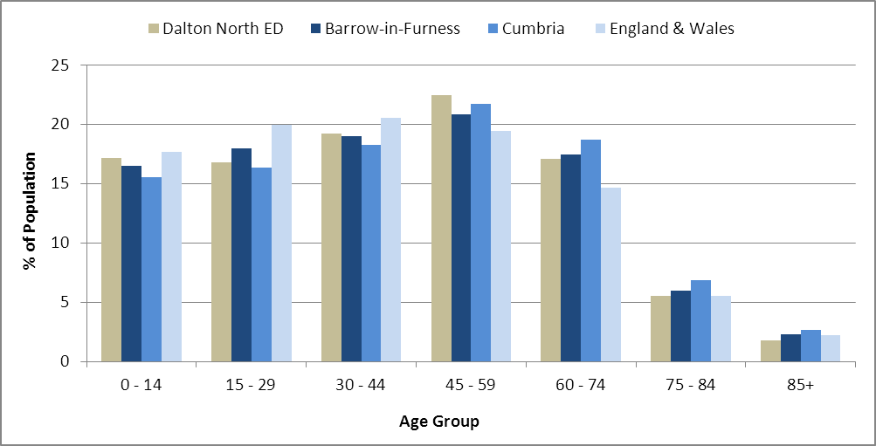

Source: Office for National Statistics, 2011 Census

County Council Electoral Divisions cover large spatial areas and so division averages can mask variation between communities within the division. Furthermore, beyond Census data, there is little statistical information available for Electoral Divisions. However, most statistical agencies produce data for Electoral Wards. Therefore, there is a very wide range of statistical information available for Electoral Wards. Furthermore, as Electoral Wards are generally smaller than Electoral Divisions, statistics at this level provide more insight into variations between communities.

The table below identifies which Electoral Wards are fully or partially within the boundaries of **Dalton North** **ED**, and what proportion of **Dalton North** **ED**’s population live within each ward:

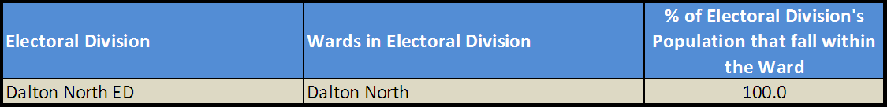

Source: Cumbria Intelligence Observatory, 2013

The map below overlays Electoral Ward boundaries on to **Dalton North** **ED’s** boundary: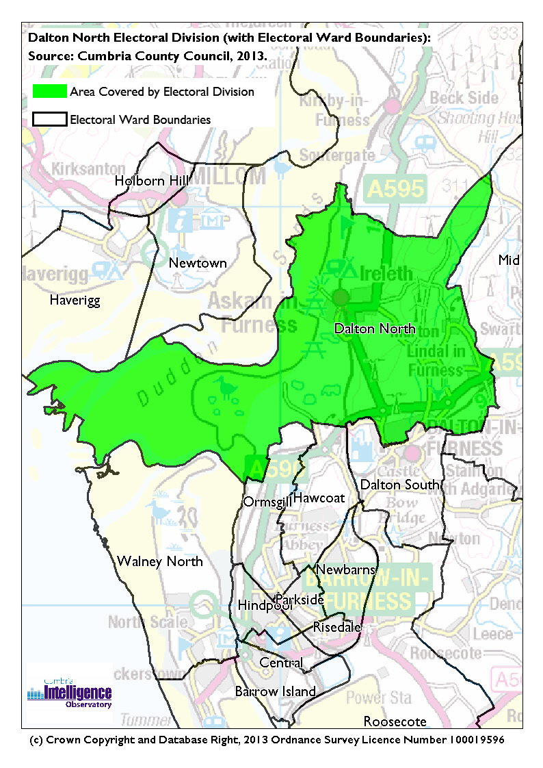The Cumbria Intelligence Observatory presents many Electoral Ward level statistics via the interactive ‘Cumbria Atlas’ tool. The Statistics provided within the Cumbria Atlas cover topics such as, but not limited to, population, housing, health, economy, poverty, ethnicity, language, and transport. The datasets within the Cumbria Atlas are regularly updated and expanded.

For simple step by step instructions to use the Cumbria Atlas to explore statistics for the wards within your Electoral Division, please visit the following web page:

http://www.cumbria.gov.uk/eLibrary/view.asp?ID=56017

The Information and Intelligence Team within Cumbria County Council are happy to talk you through using the Cumbria Atlas over the phone, or face to face. Training sessions can also be arranged for small groups.

To contact the team please call 01228 226309, or email info@cumbriaobservatory.org.uk

<Information to be provided by Rebecca Raw Information & Intelligence Team.>

# Parks, Open Spaces and Leisure Facilities

Kirkby Moors

Roanhead Fishing Ponds, Wildlife areas SSIs, Roanhead, Sandscales, Beaches, Askam Beach,

Dunnerholme Golf Course

Footpath network throughout rural area, The Lots Askam, Allotments

Picnic areas viewpoints

Dalton - Football, Rugby League (all ages), Cricket, Table Tennis

Askam - Football, Rugby League (all ages), Cricket, Bowls, Social Club

Dalton Leisure Centre with various activity groups

Body building Gym (Bernies)

Ladies keep fit gym

Dunnerholme Golf Club

South Lakes Wild Animal Park

# Active Community Organisations

Askam Community Association

Dalton Community Association

Guides, Scouts

Numerous small social groups scattered throughout the area such as quilting, flower clubs.

Dalton Book Club (Reputed to be the oldest in the world)

Dalton Town Band

Credit Union Outreach Askam Library

Askam Tea and Chat (monthly)

Askam Town Band

Askam WI

# Key Communication Networks

North West Evening Mail – Borough wide daily

Advertiser – Borough wide weekly

Pinfold – Quarterly information booklet

# Community Assets

Rankin Hall

Temperance Hall, Ireleth

Buccleuch Hall Lindal

Askam Village School

George Romney Junior School

Lindal & Marton School

Ireleth St. Peters School

Chapel St Infant & Nursery

Our Lady of the Rosary Catholic Primary School

Dowdales Secondary School

Playgroups – Jack & Jill in Dalton, Lindal and Marton Pre-School and Askam

Children’s Centre, Dalton

Dalton Drill Hall

Dalton Library

Dalton Adult Education Centre

Duddon Road Methodist Church Hall, Askam

Old People’s Day Centre (Adult Services) Dalton

Dalton Active Sports Hall

Dalton Leisure Centre

Lindal (Buccleuch Hall)

Band Hall, Askam

K Shoe Social Club, Askam

Askam Library

Dalton Methodist Church Hall

Askam Methodist Church, Duddon Road, Askam

Askam Catholic Church

Askam Community Centre

Dalton Fire Station

Nelson Street Surgery

The Surgery Askam

The Old Vicarage Askam

# Local Cumbria County Council Service Hubs

Dalton Library

Askam Library

Dalton Adult Education Centre

# Community Engagement

Monthly Cumbria County Council Neighbourhood Grants Panel considers grant applications from constituted non-profit making groups whose project benefits the Barrow Borough communities.

Issue-based meetings are held in liaison with the local County Councillor to discuss community concerns.

Dalton Flood Action Group

Goose Green Community Network Group

|  |  |
| --- | --- |
| Key Community Contacts | |
|  | |
| County Councillor Barry Doughty |  |
|  |  |
| Area Support Team Barrow |  |
|  |  |
| Dalton with Newton Town Council |  |
|  |  |
| Askam & Ireleth Parish Council |  |
|  |  |
| Lindal Parish Council |  |