CUMBRIA FIRE & RESCUE SERVICE

NEEDS ON CALL FIREFIGHTERS

at:

ALSTON, ARNSIDE, ASPATRIA, BOOTLE, CONISTON, FRIZINGTON, KIRKBY LONSDALE, KIRKBY STEPHEN, LAZONBY, LONGTOWN, MARYPORT, MILNTHORPE, SHAP, SILLOTH, STAVELEY, WALNEY
As An On Call firefighter you will

- Serve your local community
- Have the potential to earn between £4000 - £7000 per annum
- Learn new skills that will stay with you for life

On Call firefighters promote safety, save lives and are a vital part of your local community. Each station has a need for Firefighters at certain times of day/days of the week, please read the station information pack for details. You must be able to attend the fire station within 5 minutes when responding to call-outs, have practical ability and be physically fit. If successful, you will receive comprehensive training that will equip you with the skills required for the job.

For further details and an application pack telephone: 01768 812558
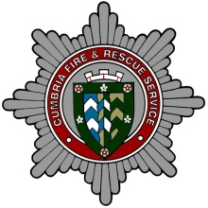
or email: hr.fire@cumbria.gov.uk, or write to: On Call Recruitment, Human Resources, Cumbria Fire & Rescue Service, Penrith Community Fire Station, Carleton Avenue, Penrith
CA10 2FA. Closing date is 9 January 2015
For further information visit our website: www.cumbriafire.gov.uk

We are particularly keen to encourage interest from women and people from ethnic minority groups, both of whom are currently under-represented in our Service.

