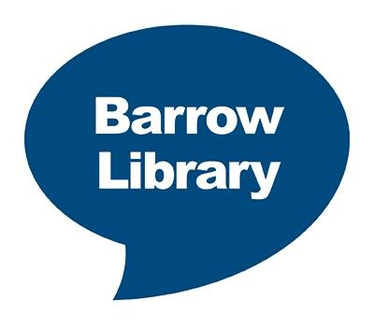
Who’s up for Summer Reading Challenge?

Over the long summer holiday, children’s reading levels can dip.
The Summer Reading Challenge is a fun and exciting way to encourage children to keep reading while they’re not at school.

Animal Agents is the theme of this year’s Challenge. This national activity takes place every year during the summer holidays. Children can sign up at any library in Cumbria to take part, and then read six library books of their choice to complete the Challenge. This summer there's something peculiar happening at the local library - and that's where the Animal Agents come in!

Daisy the rabbit asks children taking part in the Challenge to help the Animal Agents crack the case, by collecting clues in the form of stickers. As well as revealing the clues, each sticker sheet contains a code; the codes can be entered online at animal-agents.org.uk to unlock extra surprises. Children taking part in the Challenge in Cumbria will also get extra incentives as they read the books, including a certificate once the challenge is completed.

Children from 4 year old upwards can sign up for the challenge.

Children can sign up for the challenge at any library from Saturday 15th July and receive a FREE Summer Reading pack. The challenge runs until Saturday 9th September.

We also have lots of exciting activities taking place in the libraries, ranging from mini-beasts to interactive video games sessions.

It’s all FREE to take part, so get involved!

