Thursby
Electoral Division Profile
2014

Overview of Electoral Division

Thursby is a rural electoral division within the district of Allerdale, bordering the boundaries of Carlisle City, Eden district and the small market town of Wigton. Thursby, as an electoral division covers a large area of North Allerdale which includes the village of the same name.
The division incorporates the Northern Fells of the Lake District National Park, which include the Caldbeck Fells that overlook the Solway plain and coastline. The area is remote and one of the lesser known areas within the Lake District, the Cumbria Way passes through the village of Caldbeck and the parish of Sebergham and Welton, which is a long distance walk through Cumbria, from Carlisle to Ulverston.
There are seven primary schools within the division, and a number of options for secondary schools, although these are outside of the division, including Carlisle, Wigton, Penrith, Cockermouth and Keswick. Further education is provided in Carlisle, Penrith and Workington.
Employment within the division is diverse, many working within the city of Carlisle and Wigton. The area is very rural and farming is very much a feature of many of the communities.
Within the division there are two former airfields, one at Kirkbride, which is still used by small planes, micro lights and occasional by the military on exercises. The second is at Wiggonby, the former Great Orton Airfield. The old airfield is now the resting place of some half a million animals affected during the 2001 Foot and Mouth outbreak. It is now called the Watchtree Nature Reserve and is a haven for wildlife, managed by a successful group of trustees whom came together to develop the area. There are many walks in the site and is a haven for cyclists of all ages. The Knoxwood wildlife sanctuary is close by. Further there are three chapels and 10 churches, some of which are very old and historic. One of which is at Aikton. This had a rectory with a moat, and one of only two Death Knell Bells in the Solway on the Solway plain. The Solway Area of National Beauty (AONB) is close by, which includes the RSPB site and various Mosses including Bowness, Drumbugh and Glasson.

Map
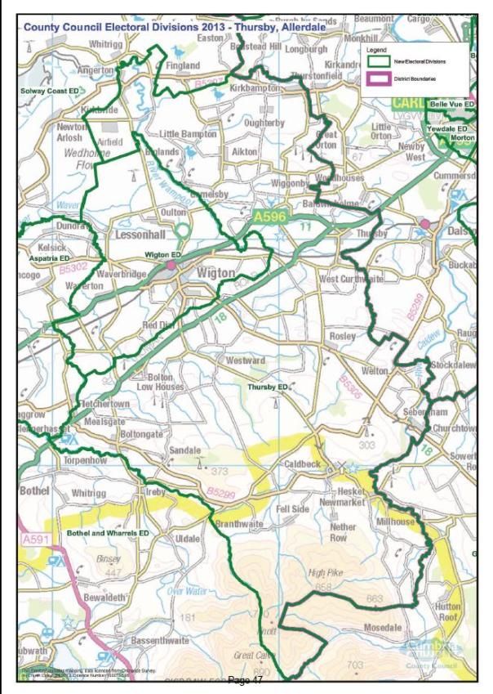
PDF Copy of map: http://www.cumbria.gov.uk/Election2013/maps.asp

Communities

There a number a villages and hamlets within the electoral division, these include:
- Aikton  - Biglands  - Bolton Low Houses  - Boltongate  - Brackenthwaite  - Branthwaite  - Caldbeck  - Churchtown  - East Curthwaite  - Flatt  - Gamelsby  - Hesket Newmarket  - High Whinnow  - Kirkbampton  - Kirkbride  - Little Bampton | - Low Whinnow  - Micklethwaite  - Mealsgate  - Nether Welton  - Oughterby  - Ploughlands  - Rosley  - Sandale  - Sebergham  - Studholme  - Thursby  - Warnell  - Welton  - West Curthwaite  - Westward  - Wiggonby

The division covers eight civil parishes:

Aikton | Boltons
Caldbeck | Kirkbride
Kirkbampton | Sebergham
Thursby | Westward

Statistical Profile

The 2011 Census estimated that the population of Thursby Electoral Division (ED) was 5223 persons.

The table below presents estimated numbers of residents in Thursby ED by age group:

 | No. Persons by Age Group (Years)
 | All Ages | 0 - 14 | 15 - 29 | 30 - 44 | 45 - 59 | 60 - 74 | 75 - 84 | 85+
Thursby ED | 5223 | 781 | 679 | 904 | 1265 | 1085 | 383 | 126
Source: Office for National Statistics, 2011 Census

The chart below compares the proportion of Thursby ED’s population within each age group with the proportion of the population within each age group across Allerdale district, Cumbria and England & Wales:
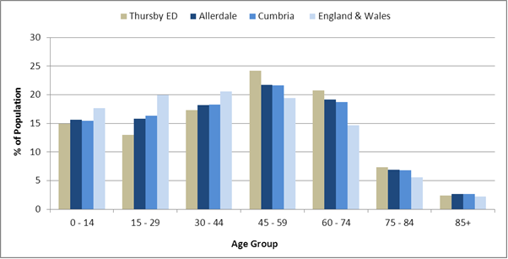Source: Office for National Statistics, 2011 Census
County Council Electoral Divisions cover large spatial areas and so division averages can mask variation between communities within the division. Furthermore, beyond Census data, there is little statistical information available for Electoral Divisions. However, most statistical agencies produce data for Electoral Wards. Therefore, there is a very wide range of statistical information available for Electoral Wards. Furthermore, as Electoral Wards are generally smaller than Electoral Divisions, statistics at this level provide more insight into variations between communities.
The table below identifies which Electoral Wards are fully or partially within the boundaries of Thursby ED, and what proportion of Thursby ED’s population live within each ward:
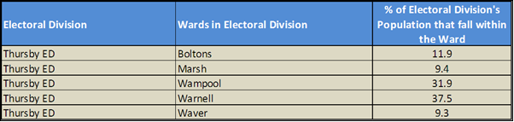Source: Cumbria Intelligence Observatory, 2013

The map below overlays Electoral Ward boundaries on to Thursby ED’s boundary: 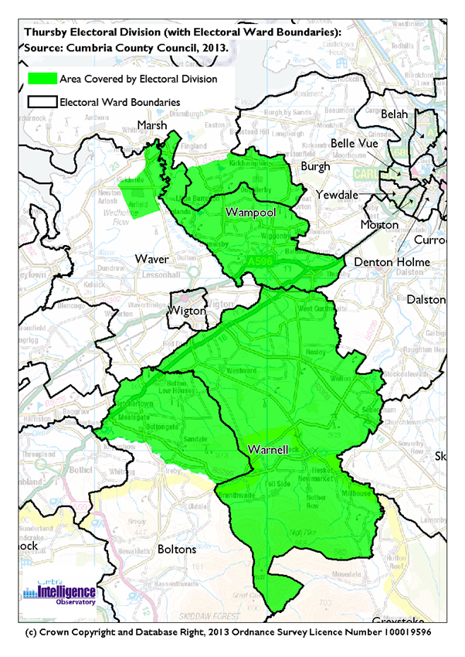
The Cumbria Intelligence Observatory presents many Electoral Ward level statistics via the interactive ‘Cumbria Atlas’ tool. The Statistics provided within the Cumbria Atlas cover topics such as, but not limited to, population, housing, health, economy, poverty, ethnicity, language, and transport. The datasets within the Cumbria Atlas are regularly updated and expanded.
For simple step by step instructions to use the Cumbria Atlas to explore statistics for the wards within your Electoral Division, please visit the following web page:
http://www.cumbria.gov.uk/eLibrary/view.asp?ID=56017
The Information and Intelligence Team within Cumbria County Council are happy to talk you through using the Cumbria Atlas over the phone, or face to face. Training sessions can also be arranged for small groups.
To contact the team please call 01228 226309, or email info@cumbriaobservatory.org.uk

Parks, Open Spaces and Leisure Facilities

There are three play areas within the division, these are at:
- Hesket Newmarket
- Paddocks Play area, Thursby
- Kirkbride

Further facilities include:

- The Green, Hesket Newmarket
- Jubilee Field, Thursby
- Whitrigglees Common
- Little Brampton pasture
- Parish Council fields at Biglands, Aikton
- Caldbeck Common
- Caldbeck Bowling and Social Club
- Caldbeck Tennis Courts
- Caldbeck Cricket Club
- Kirkbride Airfield
- Hesket New Market Allotments
- Thursby Allotments
- Biglands Allotments
- Watchtree Nature Reserve (previously known as Wiggonby airfield or Great Orton airfield)
- Parsons Park, Forest
- Finlandrigg Wood, Nature Reserve and Forest
- Park Wood, Westward
- Studholmerigg Wood, Westward
- Faulds Spring, Sandale
- Caldbeck fells

Active Community Organisations

- Aikton Mothers Union
- Northern Fells Group
- Caldbeck and District WI
- Sebergham WI
- Thursby WI
- Crofton WI
- Caldbeck Young Farmers
- Caldbeck Scouts
- Watchtree Nature Reserve
- Knoxwood Wildlife Trust
- Solway AONB
- Thursby and Westward Community First Responders
- Caldbeck First Responders
- Lake District National Park Authority

Key Communication Networks

News & Star
A daily newspaper, produced by CN group; they produce different editions for North and West Cumbria.

Times and Star
Weekly newspaper produced by CN group for the Allerdale district of Cumbria they produce different editions for Maryport, Cockermouth and Workington

Cumberland News
The most widely read newspaper in Cumbria. This bridges the north and west communities.

Cumberland & Westmorland Herald
An independent weekly broadsheet newspaper covering a large area of East Cumbria, including the towns of Penrith, Appleby, Kirkby Stephen, Keswick and Alston.

BBC Radio Cumbria
Local radio station produced by the BBC for Cumbria

CFM Radio
Local radio station produced by the Bauer Media Group, covering Cumbria and Southwest Scotland

ITV News, Border region
Programme news, weather and information provided by ITV Broadcasting Limited for the England/Scotland border region, covering the majority of Cumbria, Dumfries and Galloway, the Scottish Borders and parts of Northumberland.
http://www.itv.com/news/border/story/2013-10-11/get-in-touch/

BBC News – Look North (North East & Cumbria)
Look North is the BBC's nightly regional news programme for the North East of England and Cumbria
http://www.bbc.co.uk/programmes/b0070g1d/faq

Cumbria Crack
An online facility for News in Cumbria http://www.cumbriacrack.com/

Parish Newsletters, notice boards & websites
(see Key Community Contacts)

Parochial Parish newsletters:
Barony of Burgh (Aikton & Kirkbampton)
The Thursby (Thursby and Wigton)
Northern Fells (Westward, Caldbeck and Sebergham & Welton)
The Boltons (Boltons)
Solway (Kirkbride)

Community Assets

Schools:
- Fellview County Primary School, Caldbeck
- Kirkbampton CE Primary School
- Kirkbride Learning Centre
- Kirkbride Primary School
- Thursby Primary School & Nursery
- Rosley CE School & Busy Bees Nursery
- Bolton CE Primary School
- Bolton Low Houses Preschool, Toddlers and After School Club
- Wiggonby CE School & pre-school
Village Halls:
- Aikton Parish Room
- Bolton Low Houses Village Hall
- Caldbeck Parish Hall
- Westward Village Hall
- Rosley Village Hall
- Kirkbampton Village Hall
- Kirkbride Parish rooms
- Welton Village Hall
- Sebergham Village Hall
- Thursby Parish Hall
Churches:
- Aikton St Andrews
- Boltongate - All Saints Church
- Bolton Low Houses Methodist church
- Caldbeck Methodist Church
- Caldbeck - St Kentigerns
- Hesket Newmarket Free Church
- Kirkbampton - St Peters
- Kirkbride - St Bride Church
- Kirkbride - Angerton Church
- Mealsgate – All Saints
- Rosley – Holy Trinity
- Sebergham - St. Marys Church
- Thursby Methodist
- Thursby - St Andrews
- Thurstonfield Chapel
- Welton - St. James Church
- Westward –St Hilda
Other:
- Caldbeck Surgery
- Kirkbride Surgery (The Croft)
- Hesket New Market Allotments
- Thursby Allotments
- Biglands Allotments
- Sebergham Camping Barn
- Wigton Surgery
- Hudscales Camping Barn, Hesket New Market

Local Cumbria County Council Service Hubs

Service Type Service Point
Adult Education Centres Kirkbride Learning Centre
Book Drops Boltongate Book Drop
Book Drops Kirkbride Book Drop
Book Drops Thursby Book Drop
Community Development Centres Kirkbride CDC
Doctors Surgeries The Croft Surgery
Doctors Surgeries Caldbeck Surgery
Primary Schools Kirkbride School
Primary Schools Thursby School
Primary Schools Fellview Primary School
Primary Schools Boltons CE Primary School
Primary Schools Kirkbampton School
Primary Schools Rosley CE School
Primary Schools Wiggonby CE School

Community Engagement

The electoral division falls within the North East Allerdale Neighbourhood Forum which meets twice yearly.
The councillor for the division, Duncan Fairbairn holds surgeries at:
- Kirkbampton
- Hesket Newmarket
- Thursby
- Kirkbride
- Wigton

He can also be seen at most Parish Council meetings.
For further information please contact the Allerdale Area Support Team on 01900 706015

Key Community Contacts
Councillor Duncan Fairbairn for Thursby, Cumbria County Council
- Address: Thornby Moor House, Aikton, Wigton, Cumbria, CA7 0JZ
- Phone: 016973 43160 Mobile: 07813 702341 E
- Email: Duncan.Fairbairn@cumbria.gov.uk
Allerdale Area Support Team
- Address: Workington Library, Vulcans Lane, Workington, CA14 2ND
- Phone: 01900 706015
- Email: ted.thwaites@cumbria.gov.uk
- Web: www.cumbria.gov.uk
Allerdale Borough Council
- Address: Allerdale House, Workington, Cumbria, CA14 3YJ
- Phone: 01900 702702
- Email: enquiries@allerdale.gov.uk
- Web: http://www.allerdale.gov.uk/
Councillor Duncan Fairbairn, Allerdale Borough Council
- Ward: Warnell
- Address: Thornby Moor House, Aikton, Wigton, Cumbria, CA7 0JZ
- Phone: 016973 43160 Mobile: 07813 702341 E
- Email: Duncan.Fairbairn@allerdale.gov.uk
Councillor Pat McDonald, Allerdale Borough Council
- Ward: Wampool
- Address: 1 The Green, Dalston, Carlisle, Cumbria, CA5 7QB
- Phone: 01228 317095
- Email: patricia.macdonald@allerdale.gov.uk

Councillor Vaughan Hodgson, Allerdale Borough Council
- Ward: Marsh
- Address: Shaw Hill, Kirkbride, Wigton, CA7 5HW
- Phone: 016973 51473
- Email: vaughan.hodgson@allerdale.gov.uk

Councillor Joe Cowell, Allerdale Borough Council
- Ward: Waver
- Address: Fionaville, Lowmoor Road, Wigton, CA7 9QP
- Phone: 016973 43479
- Email: joe.cowell@allerdale.gov.uk

Caldbeck Parish Council
- Clerk: Mrs A Ward
- Mardale, Upton, Caldbeck, Wigton, CA7 8ER
- Phone: 016974 78220
- Email: aw.caldbeck@googlemail.com
- Web: http://www.caldbeck.org.uk
Boltons Parish Council
- Clerk: Mrs E Clark
- Address: 15 Howgill Close, Bolton Low Houses, Wigton, CA7 8PG
- Phone: 016973 45665
- Email: boltonspc@aol.com
Sebergham & Welton Parish Council
- Clerk: Ms PL Gauntlett
- Address: 54 Inglewood Crescent, Carlisle, Cumbria, CA2 6JL
- Phone: 01228 534565
- Email: plg511@live.co.uk
- Web: http://www.seberghamwelton.org.uk
Aikton Parish Council
- Clerk: Mrs E Clark
- Address: 15 Howgill Close, Bolton-Low-Houses, Wigton, CA7 8PG
- Phone: 016973 45665
- Email: AiktonClerk@aol.com
Kirkbampton Parish Council
- Clerk: Mrs A McCallum
- Address: C/o 21 Cawflands, Durdar, Carlisle, Cumbria, CA2 4UH
- Phone: 01228 595117
- Email: kirkbamptonpc@gmail.com
- Web: http://www.kirkbamptonweb.co.uk
Kirkbride Parish Council
- Clerk: Mr M Abbs
- Address: 7 Moricambe Crescent, Anthorn, Wigton, Cumbria, CA7 5AS
- Phone: 016973 51722
- Email: clerk@gomphus.demon.co.uk
Thursby Parish Council
- Clerk: Mrs Joanne Charlton
- Address: Blackbrow Farm, Aikton, Wigton, Cumbria, CA7 2JT
- Phone: 01228 711476
- Email: thursbypc@gmail.com
- Web: http://thursbyonline.co.uk/
Westward Parish Council
- Clerk: Mrs E Clark
- 15 Howgill Close, Bolton Low Houses, WIGTON, Cumbria, CA7 8PG
- Phone: 016973 45665
- Email: westwardclerk@aol.com
- Web: http://www.westward.org.uk

