Cumbria Learning Disability and Autism Partnership Board

Notes of the Meeting held on the 9th December 2020

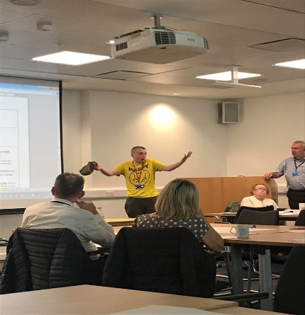 | The Partnership Board Meeting on the 9th of December 2020 took place using Microsoft Teams.  Please see the link below to the recording of the Board. This is the first time we have recorded the meeting and have left it unedited.  https://youtu.be/uFURcve16a8
Next Meeting | 8th of April 2021

Email: partnershipboard@cumbria.gov.uk
- https://www.facebook.com/CumbriaPB/ Twitter: @CumbriaPB

