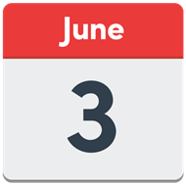
Cumbria Learning Disability and Autism Partnership Board
Visiting a Dr and Visiting a Dentist
Thursday 3rd June 2021
1pm to 3pm
MICROSOFT TEAMS

Cllr. Patricia Bell – Chair
Lou Townson – Co-Chair
Dr. Gay Eastoe – Co-Chair

Shortcut to Teams Meeting Invite -
Click here to join the meeting

1 | Welcome  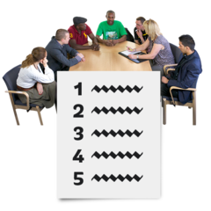 | 1pm 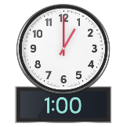 | Welcome from the Chair  Who is in on the call today?  Reminder about our Rules | Cllr. Patricia Bell  Lou Townson  Dr. Gay Eastoe
2 | Setting the scene – what we are here to talk about?  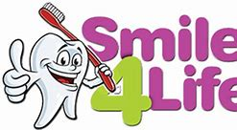  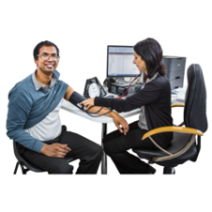 | 1.10pm  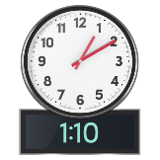 | At the Board on the 8th of April 2021 experts by experience shared their experiences of using GP or Doctors and Dentists.  We also heard from Cumbria Health on call (CHOC) and how they support people.  How GP practices can support people  And about the work of Cumbria Oral Health Improvement Team. | Patricia
3. | What do we think is really good about Dr and Dentists?  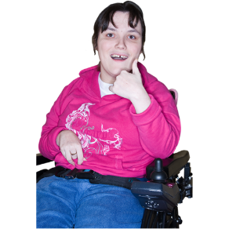 | 1.15pm  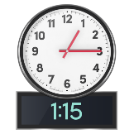 | People will share their experiences and ideas about using a Dr and or a Dentist.  It would be great if you could think about this before you come to the meeting. | Patricia, Lou and Gay
4. | What would we change about visiting the Dentist or Dr if we could?  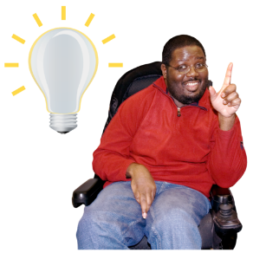 | 1.35 pm  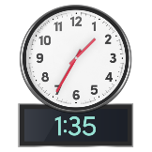 | People will share their ideas about how they would change things to make visits better. | Patricia, Lou and Gay
5 | Let’s have a Break | 2pm  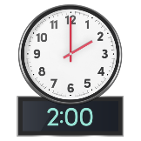 | Let’s stretch and take a short break | Lou
5 | What makes a great service?  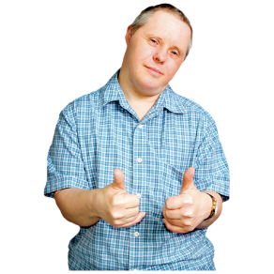 | 2.10 pm  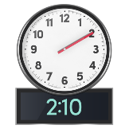 | People will share their ideas about what a perfect visit to the Dr or Dentist would look like. | Patricia, Lou and Gay
6 | Any Comments or anything else? | 2:30 pm  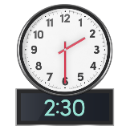 | Any final comments | Gay Eastoe
Next Meeting |  |  | Date to be agreed

Email: partnershipboard@cumbria.gov.uk
- https://www.facebook.com/CumbriaPB/ Twitter: @CumbriaPB

