Cumbria Learning Disability and Autism Partnership Board

Notes of the Meeting held on the 8th April 2021

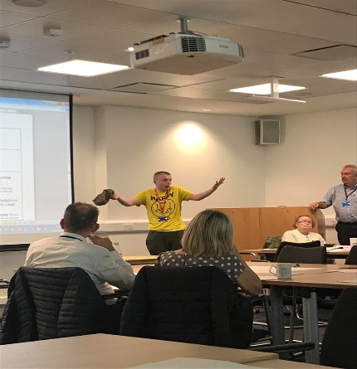 | The Partnership Board meeting on the 8th of April 2021 took place using Microsoft Teams.  At the Board we talked about going to  the Doctor or GP and  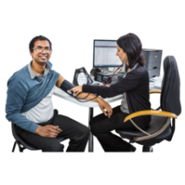  going to the Dentist  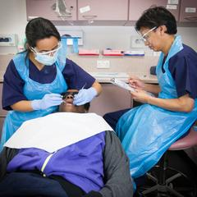  Please see the link below to the recording of the Board.  https://www.youtube.com/embed/nX_psDKwLJI
Next Meeting | 3rd of June 2021

Email: partnershipboard@cumbria.gov.uk
- https://www.facebook.com/CumbriaPB/ Twitter: @CumbriaPB

