Cumbria Learning Disability and Autism Partnership Board

“How People Spend Their Days and Evenings”
Wednesday 7th July 2021
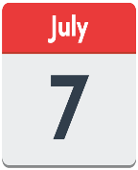
11am to 1pm

MICROSOFT TEAMS

Cllr. Patricia Bell – Chair
Lou Townson – Co-Chair
Dr. Gay Eastoe – Co-Chair

Shortcut to Teams Meeting Invite -
Click here to join the meeting

1 | Welcome  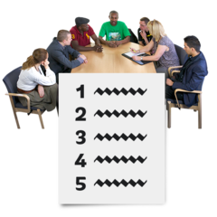 | 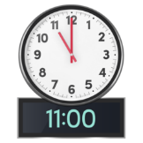 | Welcome from the Chair -  Who is in on the call today?  Reminder about our Rules | Cllr. Patricia Bell  Lou Townson  Dr. Gay Eastoe
2. | What we plan to talk about  How People spend their days and evenings  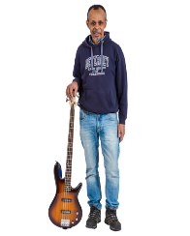 | 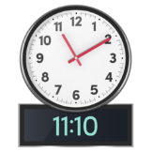 | The Chairs will set out why we are meeting. | Patricia/Lou/Gay
3. | Let’s hear what people think about this. | 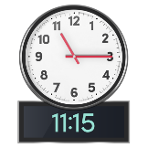 | People First and Triple A will share their thoughts on this. Other self- advocates who attend day opportunities will also share their thoughts and ideas. | Patricia  People First and Triple A
4. | 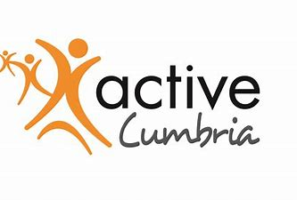 | 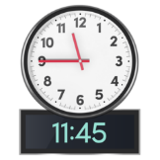 | Active Cumbria will tell us about what opportunities there are to keep active and well. | Patricia  Richard Johnston
5. | Some ideas about what might already exist in your area.  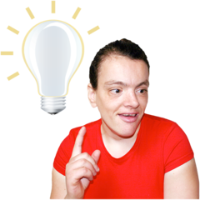 | 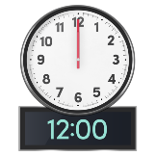 | Council Area Managers will tell us about what opportunities there are in local communities to connect into things that are happening. | Gay  Karen Johnson and Tracey Ingham
5 | Let’s have a Break  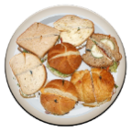 | 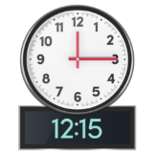 | Let’s stretch and take a short break | Lou
5 | What does a good day look like?  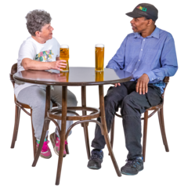 | 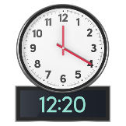 | People will share their ideas about  - What makes a great day/evening for them?  - What do they do now?  - What changes /support is needed to make things better | Patricia/Lou/Gay  Everyone
6 | Any Comments or anything else? | 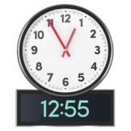 | Any final comments | Gay
Next Meeting |  |  | July 20th, 2021 11am -1pm

Email: partnershipboard@cumbria.gov.uk
- https://www.facebook.com/CumbriaPB/ Twitter: @CumbriaPB

