Cumbria Learning Disability and Autism Partnership Board

“How People Spend Their Days and Evenings” Part 2
Tuesday 20th July 2021
11am to 1pm

MICROSOFT TEAMS

Cllr. Patricia Bell – Chair
Lou Townson – Co-Chair
Dr. Gay Eastoe – Co-Chair

Shortcut to Teams Meeting Invite -
Click here to join the meeting

1. | Welcome  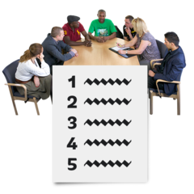 | 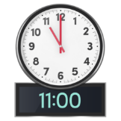 | Welcome from the Chairs -  Reminder about our Rules  How to use TEAMS | Cllr. Patricia Bell  Lou Townson and Dr Gay Eastoe  Gay
2. | What we said last time.  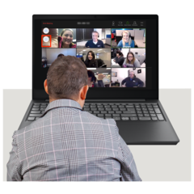 | 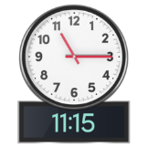 | What we said last time – an update  The chairs will recap on the meeting on the 7th of July 2021  Remind you what people said at the Board on 20th March 2020 when we talked about Dream Jobs.  At the end of the meeting we have two questions that we want you to all answer.  - Name one activity you would like to do that you have never done before.  - One thing you would like to learn to do. | Patricia/Lou/Gay
3. | Doing new things | 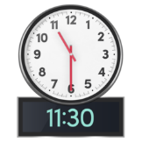 | At the last meeting people said that they wanted to:  - Learn new things  - Want to get better at things  - Wanted to be creative  - Wanted to explore their local area  We will share some slides and ask people to share any ideas they have about each topic. We are keen to know how and where you did these things. | Patricia
4. | 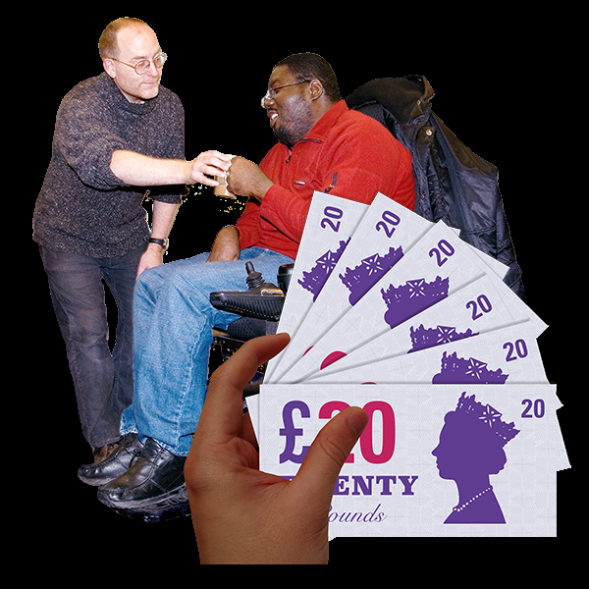 | 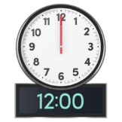 | If you had money to spend on activities how would you spend it?  This is a chance to think about what you have heard and to share your ideas and get as creative as you can! | Patricia
5. | Let’s have a Break  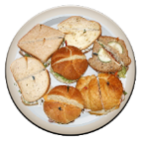 | 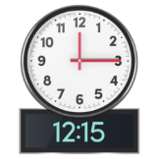 | Let’s stretch and take a short break | Lou
6. | Your Ideas about new things you would like to try | 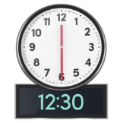 | Patricia and her Magic Wand  - Name one activity you would like to do that you have never done before.  - One thing you would you like to learn to do? | Patricia/Lou/Gay  ALL
7. | The Next Meeting  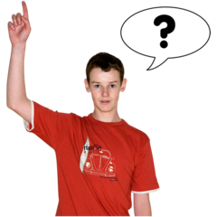 | 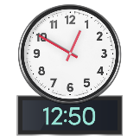 | At the next meeting we want to talk some more about how people want to spend their days and evenings.  Some people use personal budgets to pay for their social care support how about someone coming to talk to the Board about Personal Budgets? | Patricia
8. | Any Comments or anything else?  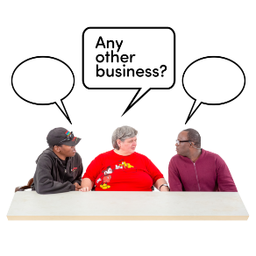 | 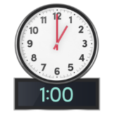 | Any final comments | Gay
Next Meeting |  |  | We will let you know

Email: partnershipboard@cumbria.gov.uk
- https://www.facebook.com/CumbriaPB/ Twitter: @CumbriaPB

