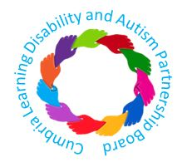
At the Cumbria Learning Disability and Autism Partnership Board on the 20th of July 2021 we talked about things to do during the day and in the evening, this followed on from the last meeting on the 7th of July 2021. These are some of the things we said
1. learning new things – people told us about new things they tried and how.  - Playing the ukulele at fun to do and the community centre in harraby  - Jewellery making in a social group  - Arts and drawing classes  - Knitting  - Costume making using you tube videos to learn how to do this  - Working and volunteering:  - In an office, answering the telephone, photocopying, and interviewing  - In a charity shop  - In a bakery  - In an animal refuge  - Some people need support to do this and some people don’t  - Some people get paid and other people don’t | 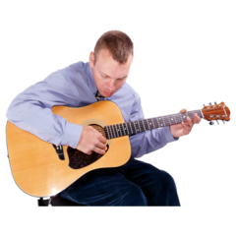  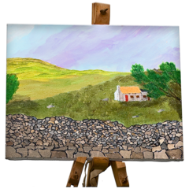  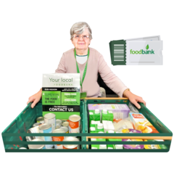
2. These are the things people wanted to get better at.  - Crocheting  - Using technology and the internet to get in touch with people  - Some people had learned to use the internet:  - With support from staff and over the phone  - It took a while to learn how to use this  - Some people found this easier than others  - It was easier to learn when people repeated the skills, they had used  - Some people learn better by doing a task rather than being shown how to do a task  - Some people used YouTube tutorials to learn new skills. These were good because you could repeat things and learn at your own pace  - Mark asked if it would help people to learn to use the internet and whether they should learn with other people in the community  - Some people felt safer and supported in a service rather than in the community  - Some people might want support in a service to go into the community at first  - Patricia talked about some services that are already in libraries that could help with this  - We talked about how people learn in different ways and that we need to provide different options for this  - Mark talked about how we wanted the community to be accessible so that all people had the choice to do the same things  - We talked about whether there could be links with schools for around IT training as this would also be opportunities for pupils to volunteer to help people learn how to use IT easily  - We talked about how some people with Asperger’s would prefer to work things out on their own | 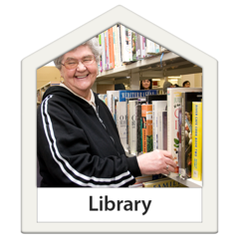  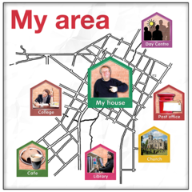
3. These are the ways people can be creative.  - Creative wellbeing with communal drawing at Carlisle Station (we don’t think this is still running)  - Triple A arts what’s app group to share pictures and drawings with competitions  - Singing  We also talked about:  - Some people feeling nervous when they are in bigger groups and don’t enjoy this  - How people have done more creative things during lockdown than they would do normally | 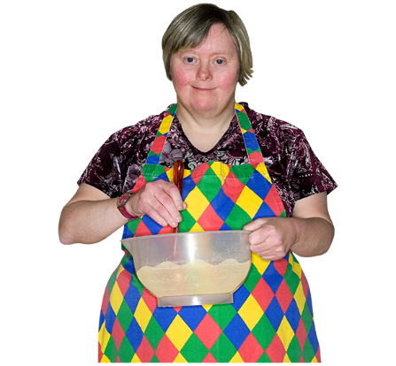
4. These are some places you can explore  - Lots of free activities  - Castles, parks, and lakes  - Brougham Castle  - Walking  - Catbells  - Aeroforce  - Hadrian’s Wall Walk  - Talkin Tarn  - Beaches  - Silloth  - Open top bus at Keswick  - Launches at Keswick  - Harboursides  - Maryport  - Workington  - Whitehaven  - Hiking, swimming, and kayaking  - Cycling clubs  - Museums  - Tullie House  - Imperial War Museum  Transport museums  There are loads of places to visit and many are free –  For some transport and support are the issues. | 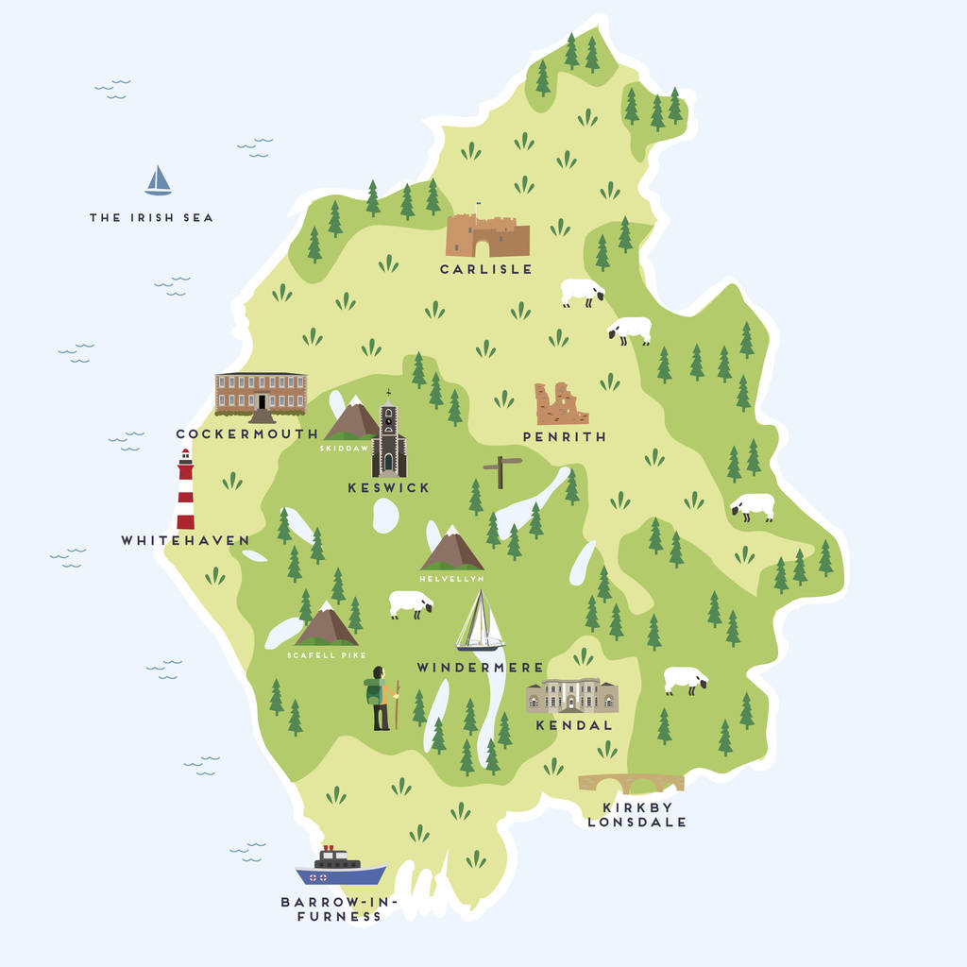  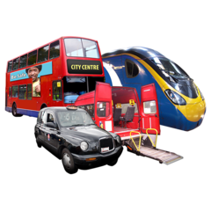
5. We talked about what activities we would spend our money on:  - Internet and technology  - Water skiing  - Cycling  - Dream holiday  - Camping – Caldbeck, Gosforth  Sometimes people would need help transport to visit places and activities. We talked about:  - Passes for public transport  - How support to learn how to use transport would help people to feel safer and more confident  - How bus drivers can help people when they use transport  - How people from the partnership board could support with training and could make a video to help with this  Mark will revisit work with Arriva around driver training and support on the bus, train and in places like the library | 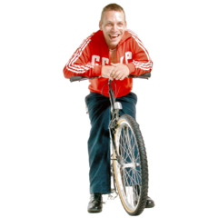  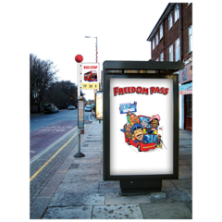
6. Patricia and her Magic Wand  We asked people to name one activity they would like to do which they had never done before.  People talked about:  - Cold water swimming  - Quad biking  - Freedom wizard – adapted chairs for walking  - Gliding  - Canoeing  - Diving  - Travel to another country  We also asked people to name one thing you would you like to learn to do.  People talked about:  - Plastering  - Driving  - water-skiing  - Woodworking  - Gardening  - New languages  - Drumming | 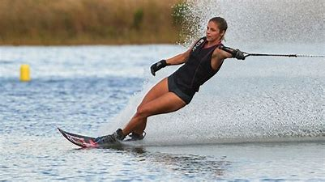
7. Other Things  We talked about how important changing places are in supporting everyone to have a great life.  You can find out more about changing places here  https://www.changing-places.org/about  We also talked about the idea of No Bedtimes and the work of staying up late – they say adults should choose when they go to bed.  You can find some information here.  https://stayuplate.org/ | 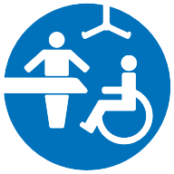
You can find a link to the Board on the 20th of July 2021 here. | https://youtu.be/CXyNz5ANSWY

CUMBRIA LEARNING DISABILITY AND AUTISM PARTNERSHIP BOARD – 20th July 2021

