

**Aspatria**

**Electoral Division Profile**

**2014**

# Overview of Electoral Division

Aspatria Electoral Division lies within the District of Allerdale. The division incorporates the town and civil parish of Aspatria and the surrounding villages including the coast at Allonby. The area is served by Aspatria railway station. Aspatria is located on the fringe of the Lake District National Park.

Allonby lies within a designated Area of Outstanding Beauty on the Solway Coast, the Bay has a superb long sandy beach, with spectacular views across the Solway Firth to the mountains of Southern Scotland and to the Lake District Fells in the East. On a clear day the Isle of Man can be seen in the distance.

Most of the land in the Electoral Division is agricultural.

# Map

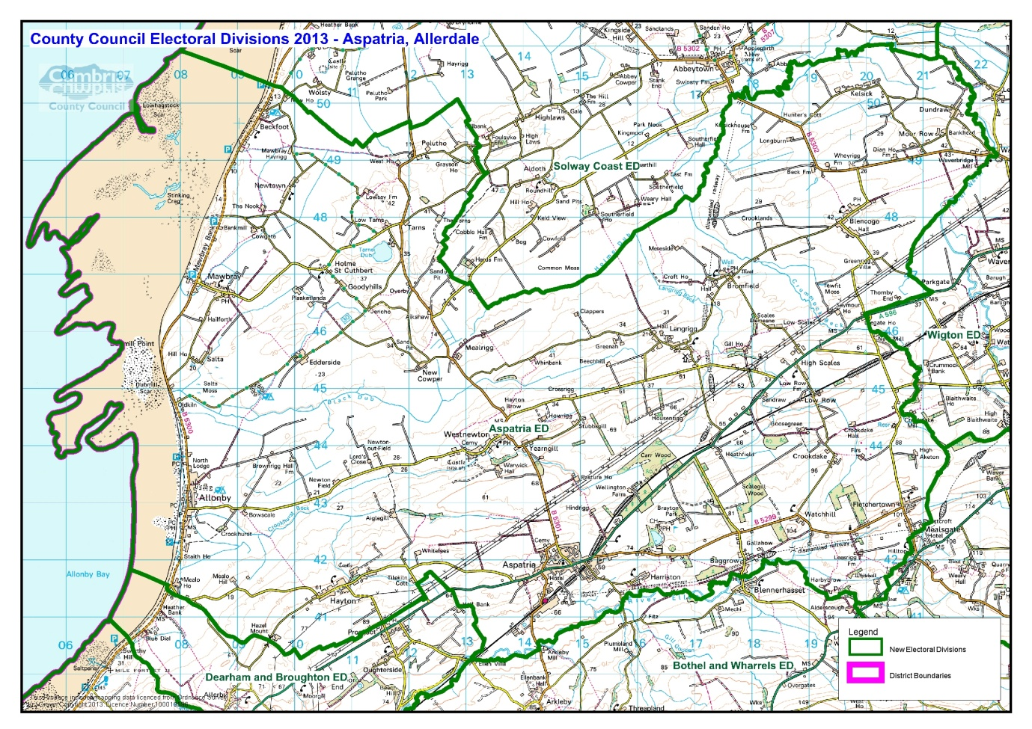

# Communities

There are a number a villages and hamlets with the electoral division, these include:

|  |  |
| --- | --- |
| * Aspatria * Allonby * Allhallows * Dundraw * Hayton & Mealo * Westnewton | * Harriston * Bromfield * Baggrow * Blencogo * Holme St. Cuthbert * Mawbray |

# The division covers eight civil parishes:

|  |  |
| --- | --- |
| Aspatria | Hayton & Mealo |
| Allonby | Holme St. Cuthbert |
| Allhallows | Westnewton |
| Dundraw | Bromfield |

# Statistical Profile

The 2011 Census estimated that the population of Aspatria Electoral Division (ED) was 5475 persons.

The table below presents estimated numbers of residents in Aspatria Electoral Division by age group*:*

|  |  |  |  |  |  |  |  |  |
| --- | --- | --- | --- | --- | --- | --- | --- | --- |
|  | **No. Persons by Age Group (Years)** | | | | | | | |
| **All Ages** | **0 - 14** | **15 - 29** | **30 - 44** | **45 - 59** | **60 - 74** | **75 - 84** | **85+** |
| *Aspatria ED (%)* | *5475* | *872*  *(16%)* | *859*  *(15.5%)* | *995*  *(18%)* | *1196*  *(22%)* | *1085*  *(20%)* | *357*  *(6.5%)* | *111*  *(2%)* |

Source: Office for National Statistics, 2011 Census

The chart below compares the proportion of Aspatria ED’s population within each age group with the proportion of the population within each age group across Allerdale district, Cumbria and England & Wales:

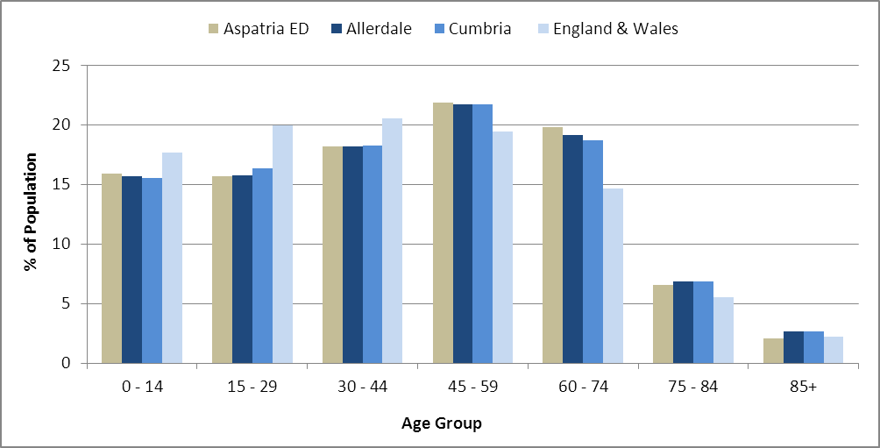

Source: Office for National Statistics, 2011 Census

County Council Electoral Divisions cover large spatial areas and so division averages can mask variation between communities within the division. Furthermore, beyond Census data, there is little statistical information available for Electoral Divisions. However, most statistical agencies produce data for Electoral Wards. Therefore, there is a very wide range of statistical information available for Electoral Wards. Furthermore, as Electoral Wards are generally smaller than Electoral Divisions, statistics at this level provide more insight into variations between communities.

The table below identifies which Electoral Wards are fully or partially within the boundaries of Aspatria Electoral Division, and what proportion of Aspatria Electoral Division’s population live within each ward:

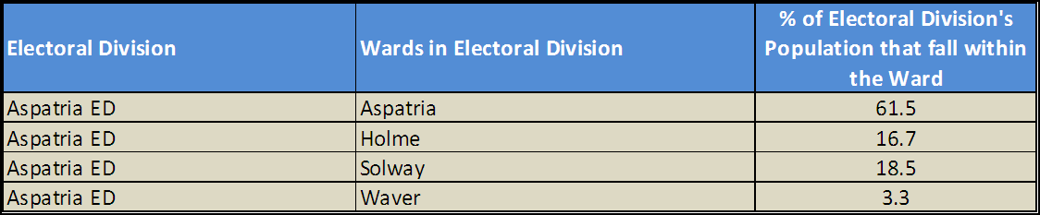*Source: Cumbria Intelligence Observatory, 2013*

The map below overlays Electoral Ward boundaries on to Aspatria Electoral Division’s boundary: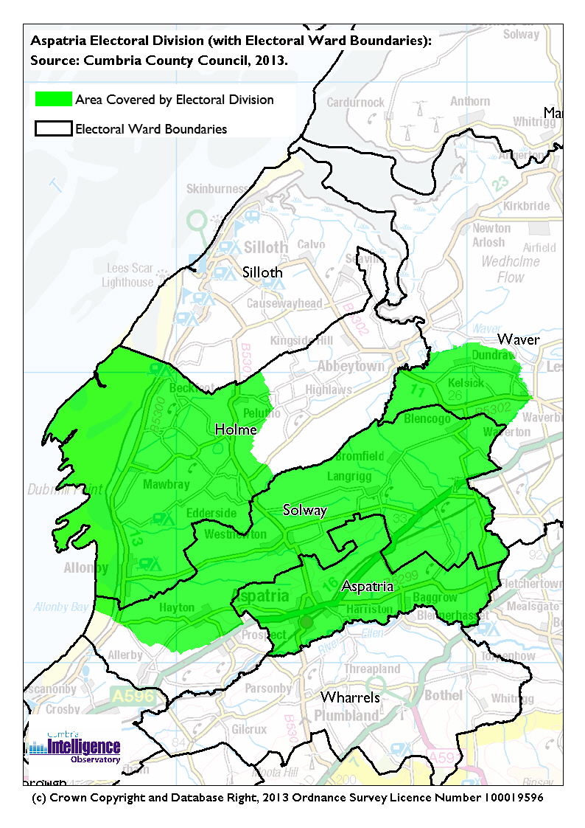The Cumbria Intelligence Observatory presents many Electoral Ward level statistics via the interactive ‘Cumbria Atlas’ tool. The Statistics provided within the Cumbria Atlas cover topics such as, but not limited to, population, housing, health, economy, poverty, ethnicity, language, and transport. The datasets within the Cumbria Atlas are regularly updated and expanded.

For simple step by step instructions to use the Cumbria Atlas to explore statistics for the wards within your Electoral Division, please visit the following web page:

<http://www.cumbria.gov.uk/eLibrary/view.asp?ID=56017>

The Information and Intelligence Team within Cumbria County Council are happy to talk you through using the Cumbria Atlas over the phone, or face to face. Training sessions can also be arranged for small groups.

To contact the team please call 01228 226309, or email [info@cumbriaobservatory.org.uk](mailto:info@cumbriaobservatory.org.uk)

# Parks, Open Spaces and Leisure Facilities

There are play areas in some of the villages including:

* Mawbray Play Park
* Blencogo Play Area
* Allonby Play Area

Further facilities include:

* Childs soft play
* Kite flying
* Wind surfing
* Kite Boarding
* Tennis
* Golf club
* Hadrian’s Cycle Way Route IV (Allonby to Maryport)
* Sea fishing
* Holiday and leisure centre offering –
  + Pool
  + Games room
  + Spa
  + Camping and caravanning
  + Solway Coastal way

# Active Community Organisations

Aspatria Community Child care

First Responders Group

Golf Club

Barnardo’s

Rugby Club

Football Club

Aspatria Dream Scheme

Aspatria angling club

Abbeytown JFC

Aspatria Hornets RLFC

Spring Lea Leisure Centre

# Key Communication Networks

Aspatria Voice – Aspatria Town Council Newsletter

Allonby Beach Comber (ABC) –provided by the Parish Council containing lots of current information.

News & Star

A daily newspaper, produced by CN group; they produce different editions for North and West Cumbria.

Times and Star

Weekly newspaper produced by CN group for the Allerdale district of Cumbria they produce different editions for Maryport, Cockermouth and Workington

Cumberland News

The most widely read newspaper in Cumbria. This bridges the north and west communities.

BBC Radio Cumbria

Local radio station produced by the BBC for Cumbria

CFM Radio

Local radio station produced by the Bauer Media Group, covering Cumbria and Southwest Scotland

Parish Newsletters, notice boards & websites

# Community Assets

Schools:

* Allonby Primary School
* Richmond Hill School
* St Matthew’s C of E School
* St Michael’s C of E primary School
* Holme St Cuthbert School
* Blennerhasset School
* Beacon hill community School

Village Halls:

* Westnewton village hall
* Aspatria Community Centre
* Allonby village hall
* Allhallows community centre
* Blencogo Village hall
* Holme St. Cuthbert Village Hall

Churches:

* St Kentigern’s Church - Aspatria
* Christ church – Allonby
* St Mungo’s – Bromfield
* St Cuthbert’s Catholic Church - Dundraw

Other:

* Village greens
* Library (Aspatria)
* Coastal walks
* Sandy beaches
* Garden centre
* Camping and caravanning
* Horse riding
* Various water sports

# Local Cumbria County Council Service Hubs

* Aspatria Children’s Centre. SRI Building, King St, Aspatria. CA7 3ET  
  016973 22777
* Aspatria Library and Local Links. Market Square, Aspatria, Wigton. CA7 3EZ. Tel: 01697320515.

# Community Engagement

The electoral division falls within the North West Allerdale Neighbourhood Forum area which meets three times a year. There are several Cumbria County Councillors responsible the North West Allerdale Forum and these include:

* Cllr Jim Lister (Aspatria)
* Cllr Tony Markley (Solway Coast)
* Cllr Alan Bowness (Bothel & Wharrels)
* Cllr Alan Clark (Dearham and Broughton)

For further information please contact the Allerdale Area Support Team on 01900 706010

|  |
| --- |
| Key Community Contacts |
| Councillor Jim Lister, Cumbria County Council   * Address: Moorgill Farm West Moor End, Aspatria. Cumbria, CA7 2NG * Phone: 016973 23253 Mobile: 07761818500 * Email: Jim.Lister@cumbria.gov.uk |
| Allerdale Area Support Team   * Address: Workington Library, Vulcans Lane, Workington, CA14 2ND * Phone: 01900 706010 * Email: allerdaleteam@cumbria.gov.uk * Web: www.cumbria.gov.uk |
| Allerdale Borough Council   * Address: Allerdale House, Workington, Cumbria, CA14 3YJ * Phone: 01900 702702 * Email: enquiries@allerdale.gov.uk * Web: http://www.allerdale.gov.uk/ |
| Allonby Parish Council   * Clerk: Mrs A Bradley * Address: Marina House, Allonby, Maryport, CA15 6RB * Phone: 01900 881265 * Email: [allonby.pc@btinternet.com](mailto:allonby.pc@btinternet.com) |
| Aspatria Parish Council   * Clerk: Mrs H Ostle * Address: Yhanwelen, Allerby, Wigton, CA7 2NH * **Phone:** 07971798477 * **Email:** [clerk.aspatriatc@yahoo.co.uk](mailto:clerk.aspatriatc@yahoo.co.uk) |
| Westnewton Parish Council   * Clerk: Mrs J Love * Address: Hillcrest, Westnewton, Wigton, CA7 3PD * **Phone:** 016973 22623 * **Email:** [janetlove311@btinternet.com](mailto:janetlove311@btinternet.com) |
|  |
| Holme St Cuthbert Parish Council   * Clerk: Mrs LJ Housby * Address: Gillfoot Aikshaw, Silloth, Wigton, CA7 4NF * **Phone:** 016973 20839 * **Email:** [ljhousby@btinternet.com](mailto:ljhousby@btinternet.com) |
| Hayton & Mealo Parish Council   * Clerk: Mr B Warren * Address: Gilston House, West Street, Wigton, CA7 9NX * **Phone:** 016973 49265 * **Email:** [gilstonhouse27@btinternet.com](mailto:gilstonhouse27@btinternet.com) |
| Aspatria Rural Partnership   * Contact: Shirley Muir * Tel: 016973 20803 * Email: <shirleymuir7@btinternet.com> |

|  |
| --- |
| Allhallows Parish Councils   * Clerk: Mr T Gear * Address: Brandraw Mount, West Street, Aspatria, Wigton, CA7 3HG * **Phone**:**** 016973 21935 * **Email:** allhallows.parishcouncil@yahoo.co.uk * Web: <http://www.allhallowspccumbria.co.uk> |
| ****Bromfield Parish Council****   * Clerk: Mrs E Clark * Address: 15 Howgill Close, Bolton Low Houses, Wigton, CA7 8PG * **Phone:** 016973 45665 * **Email:** [Bromfieldpc@aol.com](mailto:Bromfieldpc@aol.com) |