St. Johns
& Great
Clifton
Electoral Division Profile
2014

Overview of Electoral Division

Stainburn is the home of Stainburn School of Science; it is currently a state school for boys and girls aged between 11 and 18 years. The school has plans to merge with Southfield Technology College and become an academy. The School will be named Workington Academy from September 2015 There is a Hotel called The Briary.

Great Clifton is a village and civil parish in the Borough of Allerdale in the English county of Cumbria. In the 2001 census, it had a population of 1,101 The Village contains three pubs (Market Cross, The Queens Head (formerly the Lions Club) and The Old Ginn House, the latter also being a hotel and a restaurant. The village also has a butchers which is owned by Cumberland sausage maker Rodney Flett, and a Post Office.
The village school, Derwent Vale Primary School, was built in 1995. The previous school was opposite the old pit and still stands now, only as a house.
There are several wind farms nearby, one being the Winscales Moor Wind Farm who’s Community Fund has contributed money to the local village hall.
The local Rugby League team, the Great Clifton Lions, currently compete in the Cumberland Group C.
The parish of Clifton is a village with a church, primary school, a pub and a hotel
St John’s ward is named after St John's Church, Workington, on Washington Street, Workington, Cumbria, England. It is an active Anglican parish church in the deanery of Solway, the archdeaconry of West Cumberland, and the diocese of Carlisle. The church is designated by English Heritage as a Grade II* listed building

Map
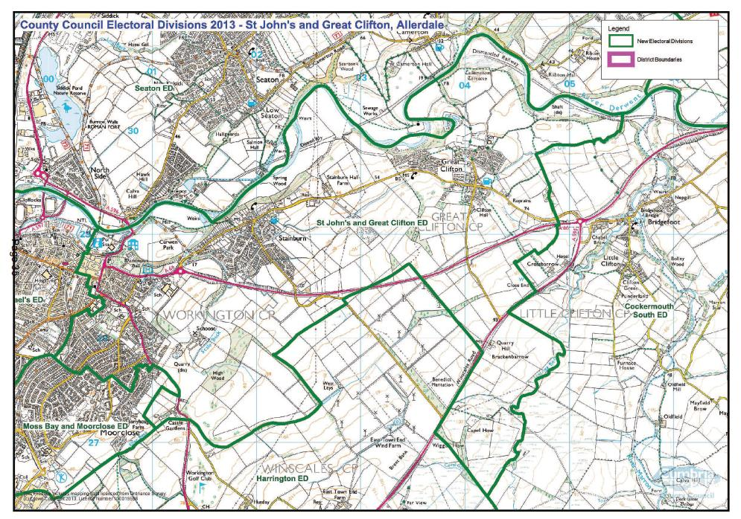
PDF copy of map: http://www.cumbria.gov.uk/Election2013/maps.asp

Communities

The Electoral Division of St Johns and Great Clifton covers: St Johns, a town centre electoral ward in Workington, Stainburn, a suburb of Workington and the village of Great Clifton which is also a civil parish. It also falls into some grassland area of Windscales Parish bordering the Windscales wind farm.

Statistical Profile

The 2011 Census estimated that the population of St Johns and Great Clifton Electoral Division (ED) was 6078 persons.
The table below presents estimated numbers of residents in St Johns and Great Clifton ED by age group:

 | No. Persons by Age Group (Years)
 | All Ages | 0 - 14 | 15 - 29 | 30 - 44 | 45 - 59 | 60 - 74 | 75 - 84 | 85+
St Johns and Great Clifton ED  (%) | 6078 | 774  (13%) | 922  (15%) | 1082  (18%) | 1386  (23%) | 1260  (21%) | 427  (7%) | 227  (3%)

Source: Office for National Statistics, 2011 Census
The chart below compares the proportion of St Johns and Great Clifton ED’s population within each age group with the proportion of the population within each age group across Allerdale district, Cumbria and England & Wales:
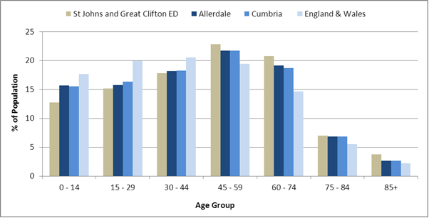
Source: Office for National Statistics, 2011 Census
County Council Electoral Divisions cover large spatial areas and so division averages can mask variation between communities within the division. Furthermore, beyond Census data, there is little statistical information available for Electoral Divisions. However, most statistical agencies produce data for Electoral Wards. Therefore, there is a very wide range of statistical information available for Electoral Wards. Furthermore, as Electoral Wards are generally smaller than Electoral Divisions, statistics at this level provide more insight into variations between communities.
The table below identifies which Electoral Wards are fully or partially within the boundaries of St Johns and Great Clifton ED, and what proportion of St Johns and Great Clifton ED’s population live within each ward:
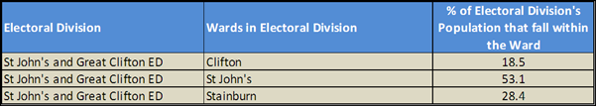
Source: Cumbria Intelligence Observatory, 2013

The map below overlays Electoral Ward boundaries on to St Johns and Great Clifton ED’s boundary: 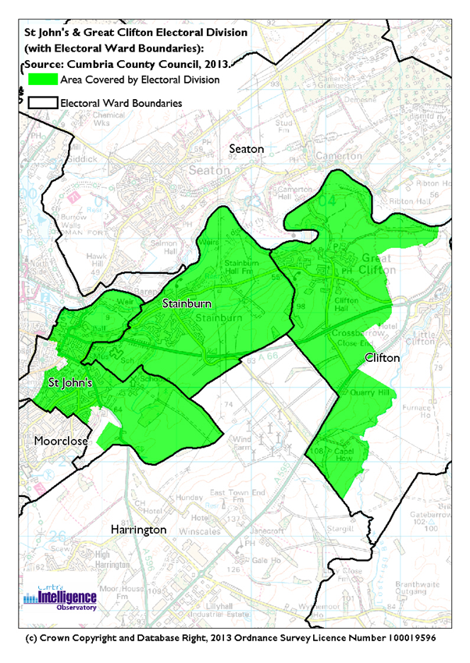
The Cumbria Intelligence Observatory presents many Electoral Ward level statistics via the interactive ‘Cumbria Atlas’ tool. The Statistics provided within the Cumbria Atlas cover topics such as, but not limited to, population, housing, health, economy, poverty, ethnicity, language, and transport. The datasets within the Cumbria Atlas are regularly updated and expanded.
For simple step by step instructions to use the Cumbria Atlas to explore statistics for the wards within your Electoral Division, please visit the following web page:
http://www.cumbria.gov.uk/eLibrary/view.asp?ID=56017
The Information and Intelligence Team within Cumbria County Council are happy to talk you through using the Cumbria Atlas over the phone, or face to face. Training sessions can also be arranged for small groups.
To contact the team please call 01228 226309, or email info@cumbriaobservatory.org.uk

Parks, Open Spaces and Leisure Facilities

Workington Hall Parklands is a large multi-use area, popular with dog walkers incorporating a number of facilities:
- Curwen Park
- Mill Field
- Horse Close Skate Park
- Curwen Park Sports Pitches

Cricket field, Earnest Valentine Ground
The Cloffocks
Newlands play area
Newlands Allotments
Cloffocks Allotments
High Wood, Scale Beck
Great Clifton Lions field

Active Community Organisations

Helena Thompson Museum

The Friends of Workington Hall Parklands

The West Cumbria Guild of Model Engineers (WCGME)

The Workington Youth Alternative Sports Group (WYASG)

British legion

St Johns community hall

- West Cumbria Guild of Model Engineers

- The Workington Nature Partnership

Mind in West Cumbria

Key Communication Networks

Internet Notices – outlining both church and community activities in the local area.
Times and Star
A weekly newspaper released on a Friday; with three main editions for Workington, Cockermouth and Maryport. Produced by CN Group

Cumberland News
A weekly newspaper released on a Friday bridging the east and west communities of north Cumbria. Produced by CN Group

News & Star
A daily newspaper for North Cumbria, produced by CN Group

Radio Cumbria
Local BBC Radio for the whole of Cumbria

CFM Radio

Community Assets

Schools:
Ashfield Infant School
Ashfield Junior School
Derwent Vale Primary School, Great Clifton
Stainburn School
Churches:
St Johns church

Other:
Former Fire Station
Curwen Park
Workington Hall
Magistrates Court and Registrars
Helena Thompson museum
Police station
Town centre
Great Clifton Village Hall
The Curwen Centre
Cricket Pavilion & Grounds

Local Cumbria County Council Service Hubs

Cumbria County Council Adult Social Care
New Oxford Street, Workington, Cumbria. CA14 2LW. Tel: 01900 706 326
Email: workingtonssd@cumbria.gov.uk

Community Engagement

The division forms part of the Workington Engagement area, which meet three times a year. Topics specific to any area may be considered at a separate meeting or surgeries set up involving the local Councillor.

Key Community Contacts
Cumbria County Council |  | Area Support Team,  Cumbria County Council,  2nd Floor Workington Library, Vulcan’s Lane,  Workington. Cumbria CA14 2ND.  T: 01900 706010  E: allerdaleteam@cumbria.gov.uk
Councillor Joe Holliday, St John’s  & Great Clifton | 12 Northumberland Street  Workington  Cumbria  CA14 3HA  Phone: 01900 66319  M: 07870 275974 E: Joe.Holliday@cumbria.gov.uk
Great Clifton Parish Council
Clerk: Mrs Angela Meek
4 Hyde Street
WORKINGTON
Cumbria
CA14 2SB
T: 01900 65762
E:Clerk@Greatcliftonparishcouncil.co.uk
Workington Town Council
Clerk: Mr C Bagshaw
Town Hall
Oxford Street
WORKINGTON
Cumbria
CA14 2RS
T: 01900 702986
E:workingtontowncouncil@allerdale.gov.uk
Allerdale Borough Council
Allerdale House, New Bridge Road, Workington. CA14 3YJ.
T: 01900 702702
E: enquiries@allerdale.gov.uk

