Bothel & Wharrels
Electoral Division Profile
2014

Overview of Electoral Division

The electoral division of Bothel & The Wharrels is a rural division within the district of Allerdale. It covers four of the lakes in the Lake District National park, these being Bassenthwaite, Loweswater, Crummock Water and Buttermere, it also incorporates Mockerkin tarn and part of Derwentwater (Hawesend & Nichol End) including the village of Portinscale. Keswick and the remainder of Derwentwater fall into the electoral division of Keswick.
The division is large and stretches from the small hamlet of Uldale in the Northern Fells (Caldbeck fells) to the edge of Ennerdale Valley. The division has a population of 5,222.
There are eight primary schools within the division, secondary education is provided out with the division at a number of towns: Penrith, Cockermouth, Keswick and Wigton

Map
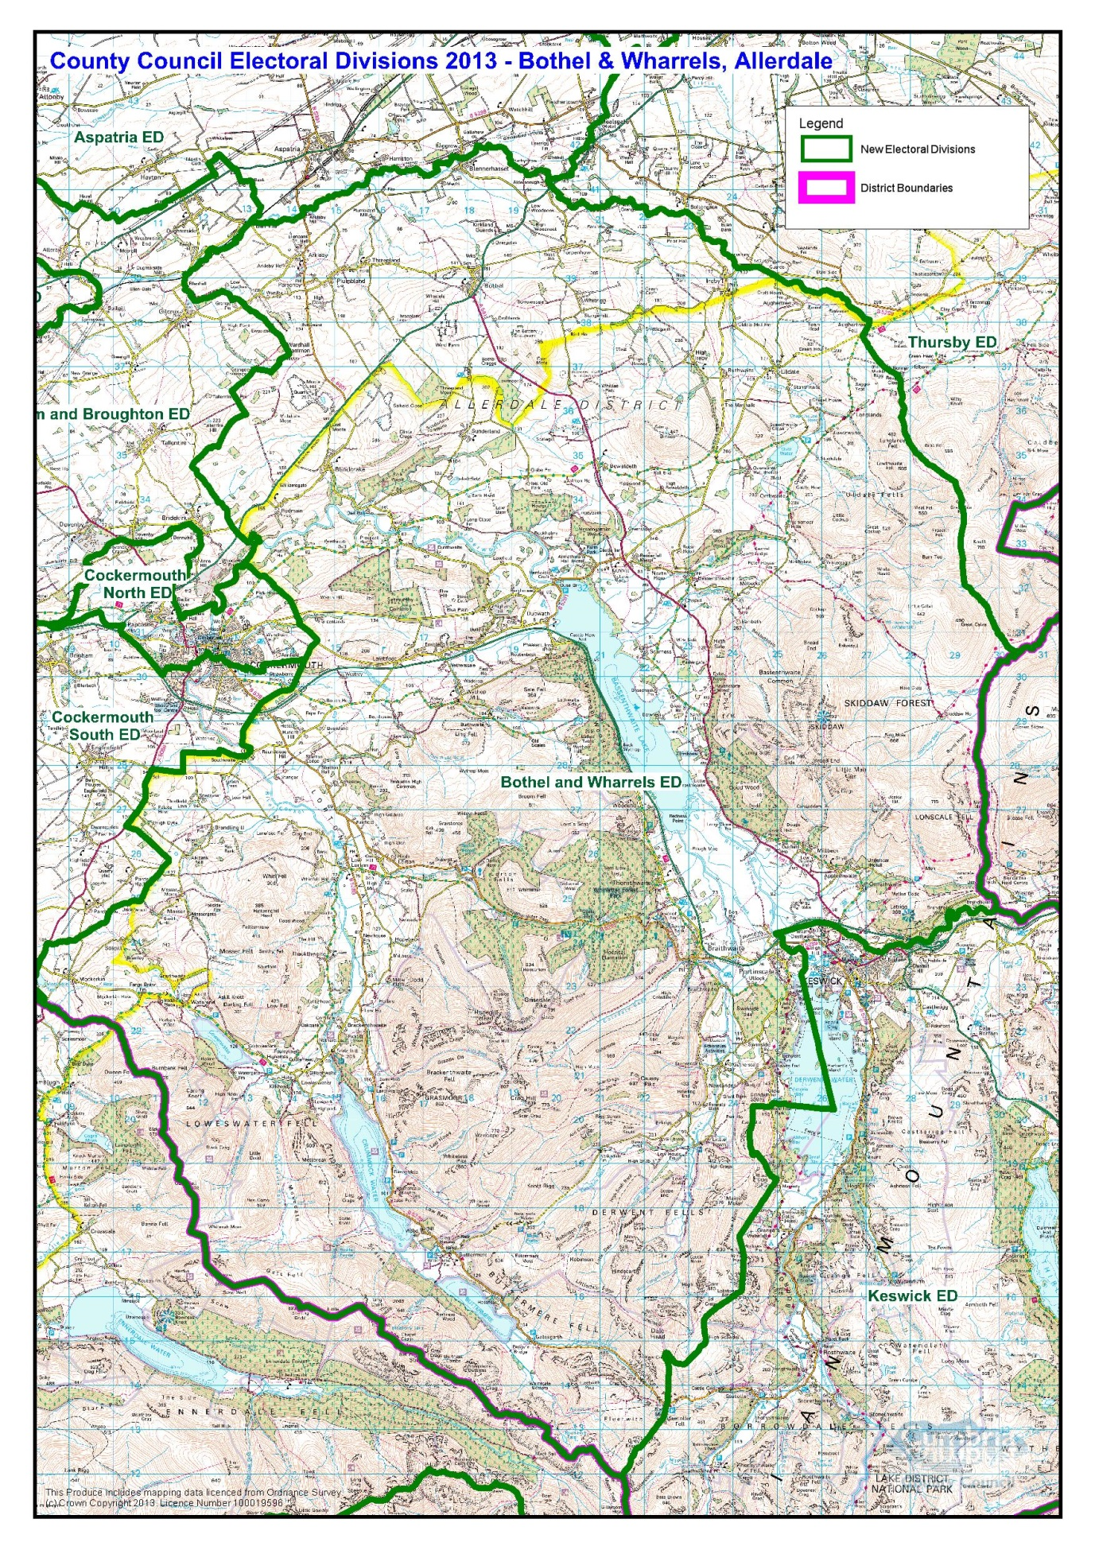
Copy of PDF Map: http://www.cumbria.gov.uk/Election2013/maps.asp

Communities

The electoral division covers many villages and hamlets including:
- Mockerkin  - Loweswater  - Blindbothel  - Embleton  - Dubwath  - Buttermere  - Low Lorton  - High Lorton  - Redmain  - Blindcrake  - Sunderland  - Bothel  - Blennerhasset | - Parsonby  - Plumbland  - Threapland  - Uldale  - Ireby  - Bassethwaite  - Bewaldeth  - Thornthwaite  - Braithwaite  - Portinscale
These are within the twelve parishes of:
- Loweswater  - Buttermere  - Blindbothel  - Lorton  - Embleton and District  - Above Derwent | - Bassenthwaite  - Underskiddaw  - Ireby  - Blindcrake  - Bothel and Threaplands  - Blennerhasset and Torpenhow  - Bewaldeth & Snittlegarth

Blindbothel, Buttermere, Lorton and Loweswater are known as the Melbreak communities, these parish councils have joined together to create a community led plan for their local area.

Statistical Profile

The 2011 Census estimated that the population of Bothel and Wharrels Electoral Division (ED) was 5220 persons. The table below presents estimated numbers of residents in Bothel and Wharrels ED by age group:

 | No. Persons by Age Group (Years)
 | All Ages | 0 - 14 | 15 - 29 | 30 - 44 | 45 - 59 | 60 - 74 | 75 - 84 | 85+
Bothel and Wharrels ED | 5220 | 696 | 641 | 838 | 1208 | 1253 | 447 | 137

Source: Office for National Statistics, 2011 Census

The chart below compares the proportion of Bothel and Wharrels ED’s population within each age group with the proportion of the population within each age group across Allerdale district, Cumbria and England & Wales:

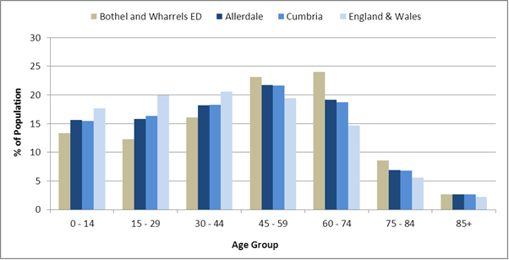
Source: Office for National Statistics, 2011 Census

County Council Electoral Divisions cover large spatial areas and so division averages can mask variation between communities within the division. Furthermore, beyond Census data, there is little statistical information available for Electoral Divisions. However, most statistical agencies produce data for Electoral Wards. Therefore, there is a very wide range of statistical information available for Electoral Wards. Furthermore, as Electoral Wards are generally smaller than Electoral Divisions, statistics at this level provide more insight into variations between communities.

The table below identifies which Electoral Wards are fully or partially within the boundaries of Bothel and Wharrels ED, and what proportion of Bothel and Wharrels ED’s population live within each ward:

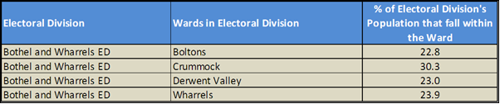
Source: Cumbria Intelligence Observatory, 2013

The map below overlays Electoral Ward boundaries on to Bothel and Wharrels ED’s boundary:

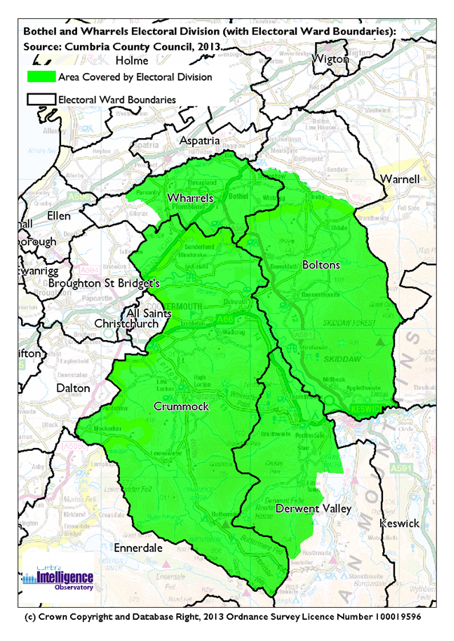

The Cumbria Intelligence Observatory presents many Electoral Ward level statistics via the interactive ‘Cumbria Atlas’ tool. The Statistics provided within the Cumbria Atlas cover topics such as, but not limited to, population, housing, health, economy, poverty, ethnicity, language, and transport. The datasets within the Cumbria Atlas are regularly updated and expanded.

For simple step by step instructions to use the Cumbria Atlas to explore statistics for the wards within your Electoral Division, please visit the following web page:

http://www.cumbria.gov.uk/eLibrary/view.asp?ID=56017

The Information and Intelligence Team within Cumbria County Council are happy to talk you through using the Cumbria Atlas over the phone, or face to face. Training sessions can also be arranged for small groups.

To contact the team please call 01228 226309, or email info@cumbriaobservatory.org.uk

Parks, Open Spaces and Leisure Facilities

The Electoral Division is largely situated within the Lake District National Park, which provides an array of outdoor leisure facilities and open spaces.

The area contains many woods and forests. Whinlatter forest, located on Whinlatter pass is part of the larger Thornthwaite forest and is a well-known tourist destination with a visitor centre, cafe, Go Ape adventure centre, large play area, cycle hire and many forest trails for walking, cycling or off road vehicles.

The Electoral Division houses five lakes: Bassenthwaite, Derwentwater, Loweswater, Crummock Water and Buttermere. Each lake, neighbouring woods and surrounding fells are accessible for walking. A range of watersports including windsurfing, sailing and outdoor activities are available at Nichol End Marina, Derwentwater Marina and Bassenthwaite Sailing club. Bassenthwaite is also a region for paragliding.

Bassenthwaite Lake also has a nature reserve and a wildlife park. The nature reserve at Dodd Wood is home to Osprey viewing facilities which have been returning to the area each year since 2001 to rise their chicks.

There is a children’s play area at Embleton and a small play are in Bassenthwaite village.

There are a range of sports clubs in the division, including tennis, bowling, cricket, golf and sailing. Parish & Village Halls also provide a range of recreational/leisure facilities including dance and exercise classes.

Active Community Organisations

- Northern Fells Group (covering Ireby & Uldale parishes)
- Ireby Festival committee
- Ireby Globe Hall
- Ireby WI
- Lorton WI
- Thornthwaite & Braithwaite WI
- Portinscale WI
- Bassenthwaite WI
- Lorton Oil Group
- Lorton and Derwent Fells Local History Society
- Lorton After school club
- Lorton Tennis Club
- Lorton Gardening Club
- Mockerkin Mob
- Loweswater ‘77’ club
- Loweswater Farming Discussion Group
- Loweswater Ladies
- Bassenthwaite Sailing Club
- Cockermouth Golf Club
- Skiddaw U3A
- Braithwaite and Thornthwaite Neighbourhood Watch
- Ireby Neighbourhood Watch
- Isel/Bridekirk First Responders
- Blindcrake Mothers Union
- Friends of Blennerhasset
- Cumbria Soaring Club

Key Communication Networks

News & Star
A daily newspaper, produced by CN group; they produce different editions for North and West Cumbria.

Times and Star
Weekly newspaper produced by CN group for the Allerdale district of Cumbria they produce different editions for Maryport, Cockermouth and Workington

Cumberland News
The most widely read newspaper in Cumbria. This bridges the north and west communities.

Keswick Reminder
The Keswick Reminder is a local paper, produced every Friday for Keswick and the surrounding villages and valleys.

Cumberland & Westmorland Herald
An independent weekly broadsheet newspaper covering a large area of East Cumbria, including the towns of Penrith, Appleby, Kirkby Stephen, Keswick and Alston.

Cumbria Crack
An online facility for News in Cumbria http://www.cumbriacrack.com/

BBC Radio Cumbria
Local radio station produced by the BBC for Cumbria

CFM Radio
Local radio station produced by the Bauer Media Group, covering Cumbria and Southwest Scotland

ITV News, Border region
Programme news, weather and information provided by ITV Broadcasting Limited for the England/Scotland border region, covering the majority of Cumbria, Dumfries and Galloway, the Scottish Borders and parts of Northumberland.
http://www.itv.com/news/border/story/2013-10-11/get-in-touch/

BBC News – Look North (North East & Cumbria)
Look North is the BBC's nightly regional news programme for the North East of England and Cumbria
http://www.bbc.co.uk/programmes/b0070g1d/faq

Parish Newsletters, notice boards & websites
(see Key Community Contacts)

Portinscale News
http://www.portinscale.org.uk/Newsround.php

The Link is the invaluable monthly newsletter about what’s going on in the area please contact Anne Style on 01900 85318.

Parochial Parish newsletters

Community Assets

Schools:

- Bassenthwaite School
- Lorton School
- Blennerhasset School
- Ireby CofE School
- St Michael's CofE Primary School - Bothel
- Eaglesfield Paddle C.E. V.A. Primary School
- Braithwaite CofE VA school
- Plumbland CofE school

Churches:

- Bassenthwaite - Methodist Church
- Bassenthwaite - St John
- Braithwaite - Braithwaite Methodist Church
- Braithwaite - St Herbert
- Ireby - Old Chancel
- Ireby - St James
- Plumbland - Evangelical Chapel
- Plumbland - St Cuthbert
- Portinscale – Mission
- Thornthwaite - St Mary
- Uldale - St James
- Wythop, St Margarets
- Embleton, St Cuthberts
- Embleton, The Old Wesleyan Chapel
- Setmurthy, St Barnabas’ Church
- Newlands Church
- United Benefice of Lorton and Loweswater with Buttermere:
- St Cuthbert, Lorton
- St Bartholomew, Loweswater
- St James, Buttermere
- St Michael and All Angels, Torpenhow

Other:
Hawesend outdoor centre
Whinlatter Forest Visitor Centre
Trotters World of Animals - Wildlife Park
The Lakes Distillery, Bassenthwaite
Thornthwaite-cum- Braithwaite Victory Memorial Hall,
Village Hall, Portinscale,
Newlands Old Schoolroom, Newlands
Bassenthwaite Church Room
Bassenthwaite Parish Room & Camping Barn
Blennerhasset & Baggrow Social & Educational Centre
Blennerhasset Cricket Pavillion
Blennerhasset Village Hall
Torpenhow Village Hall
Blindcrake Village Hall
Bothel Village Hall
Buttermere Church Hall
Loweswater Village Hall
Embleton & District Public Hall
Globe Hall, Ireby
Yew Tree Hall, Lorton, High Lorton

Loweswater Village Hall
Plumbland Village Hall
Underskiddaw Village Hall, Millbeck
Setmurthy Parish Hall
Embleton Village Hall
Braithwaite Institute
Braithwaite Church Hall
Newlands Village Hall
Portinscale Village Hall
Wharrels Hill Wind Farm

Local Cumbria County Council Service Hubs

Primary Schools:
- Bassenthwaite School
- Lorton School
- Blennerhasset School
- Ireby C of E School
- St Michael's CofE Primary School - Bothel
- Eaglesfield Paddle C of E VA Primary School
- Braithwaite C of E VA School
- Plumbland C of E School

Cumbria Outdoors:
- Hawes End Centre, Portinscale, Keswick

Community Engagement

The area is split between three Neighbourhood Forums, depending on the locality you live in, these fall into: North East Allerdale, Keswick and Cockermouth. Neighbourhood Forums are held twice yearly. For further information, please contact Allerdale Area Support Team on 01900 706010
Key Community Contacts
Councillor Alan Bowness, Bothel & The Wharrels, Cumbria County Council
- Address: High Waverbridge House, Bolton Low Houses, Wigton, CA7 8PN
- Phone: 016973 71322
- Email: Alan.Bowness@cumbria.gov.uk
- Web: www.cumbria.gov.uk

Allerdale Area Support Team
- Address: Workington Library, Vulcans Lane, Workington, CA14 2ND
- Phone: 01900 706010
- Email: allerdaleteam@cumbria.gov.uk
- Web: www.cumbria.gov.uk
Allerdale Borough Council
- Address: Allerdale House, Workington, Cumbria, CA14 3YJ
- Phone: 01900 702702
- Email: enquiries@allerdale.gov.uk
- Web: http://www.allerdale.gov.uk/
Blindbothel Parish Councillors
c/o 33 Scholars Green, Wigton, Cumbria CA7 9QW.
- A.E.W. Hudson 01900 85638
- R.M. Clark 01900 826234
- R. Bell 01900 822409
- R. Cooley 01900 829533
- B. Rowland 01900 85094
Parish Clerk - Mrs J. Rae (Parish Clerk) 016973 42138 janice.rae220@btinternet.com

Buttermere Parish Councillors
- Mr R. Beard, Chairman
- Mr J. Crowther
- Mr A. Beard
- Mr L. Kyle
- Mr M. Richardson
- Mr M. Parker
- Mr M. Thompson
- Mr G. Evans
Parish Clerk - David Smith, Landline: 01697 323296, Mobile: 07742 224775, email: davidsmith@tinyworld.co.uk
Lorton Parish Councillors
- Chair – Christine Poate: 01900 85265, email chrispoate@gmail.com
- Vice Chair – Glenis Postlethwaite: 01900 85616, email glenis@borderhydro.co.uk
- Ian Armstrong 01900 85278, email catherine@terracefarm.co.uk
- Peter Deeks: 01900 85753, email peter.deeks@gmail.com
- Steve Irlam: 01900 85336, email steveirlam@btinternet.com
- Ian Aitken: 01900 85787, email ianaitken42@btinternet.com
- Marion Sloan 01900 85833, email mazsloan@tiscali.co.uk
Parish Clerk – David Smith, Landline: 01697 323296, Mobile: 07742 224775, email davidsmith@tinyworld.co.uk
Loweswater Parish Councillors
- John Hayton (Chairman) 01900 85606
- Roger Coles (Vice- Chairman) 01900 85345
- Lorna Meadley 01946 861211
- Chris Todd 01900 85647
- Geoff Walker 01946 862115
- Kath Leck 01946 861465
Parish Clerk – David Smith, Landline: 01697 323296, Mobile: 07742 224775, email: davidsmith@tinyworld.co.uk
Embleton & District Parish Council
- Parish Clerk: Becx Carter
- Address: 40 Windebrowe Avenue, Keswick, Cumbria, CA12 4JA
- Phone: 077866 78283
- Email: embletonparishclerk@hotmail.com
Blennerhasset & Torpenhow Parish Council
- Clerk: Mr G Armer
- Address: Croft Head, Torpenhow, Wigton, Cumbria, CA7 1HT
- Phone: 016973 71579
- Email: bandtpc@gmail.com
Bothel & Threapland Parish Council
- Clerk: Ms J Rae
- Address: 33 Scholars Green, Wigton, Cumbria, CA7 9QW
- Phone: 016973 42138
- Email: janice.rae220@btinternet.com
Blindcrake Parish Council
- Clerk: Mr G Forrester
- Address: Clints Cottage, Blindcrake, Cockermouth, Cumbria, CA13 0QP
- Phone: 01900 825642
- Email: graeme@gtforrester.freeserve.co.uk
Underskiddaw Parish Council
- Clerk: Ms B Carter
- Address: 40 Windebrowe Avenue, Keswick, Cumbria, CA12 4JA
- Phone: 077866 78283
- Email: underskiddawparishclerk@hotmail.com
Bassenthwaite Parish Council
- Clerk: Elizabeth Clark
- Address: 15 Howgill Close, Bolton Low Houses, Wigton, CA7 8PG
- Phone: 016973 22922
- Email: sue@bothelpcs.com
Above Derwent Parish Council
- Clerk: Mrs J Knights
- Address: Fellmere, Lonsties, Keswick, CA12 4TD
- Phone: 01768 780935
- Email: clerk@abovederwent.org.uk
- Web: http://www.abovederwent.org.uk
Ireby and Uldale Parish Council
- Clerk: Mrs J Rae
- Address: 33 Scholars Green, Wigton, Cumbria, CA7 9QW
- Phone: 016973 42138
- Email: janice.rae220@btinternet.com
Bewaldeth & Snittlegarth Parish Council
- Clerk: Mrs JM McTear
- Address: Cragg View, Bewaldeth, Cockermouth, CA13 9SU
- Phone: 017687 76694
- Email: judith_mary.mctear@virgin.net

