Cockermouth North
Electoral Division Profile
2014

Overview of Electoral Division

The Electoral Division is within the District of Allerdale and lies on the edge of the western boundaries of the Lake District National Park.
Cockermouth is a picturesque market town with a unique character, full of vibrant small businesses. The town is popular with the tourists as a peaceful getaway, once the childhood home and birthplace of romantic poet William Wordsworth.

Cockermouth town is split into two electoral divisions; the northern division covers the centre of town and the larger residential areas to the east and west. It also incorporates the local village of Papcastle crossing over the A595 onto the edge of Dovenby. The largest employment in the area comes from the nuclear facilities at Sellafield, there are however a number of large employers within Cockermouth including Jennings Brewery, M-Sport plus James Walker & Co Ltd

The Reivers Cycle route passes through Cockermouth on its 150 mile route through the Lakes and Borders.

Map

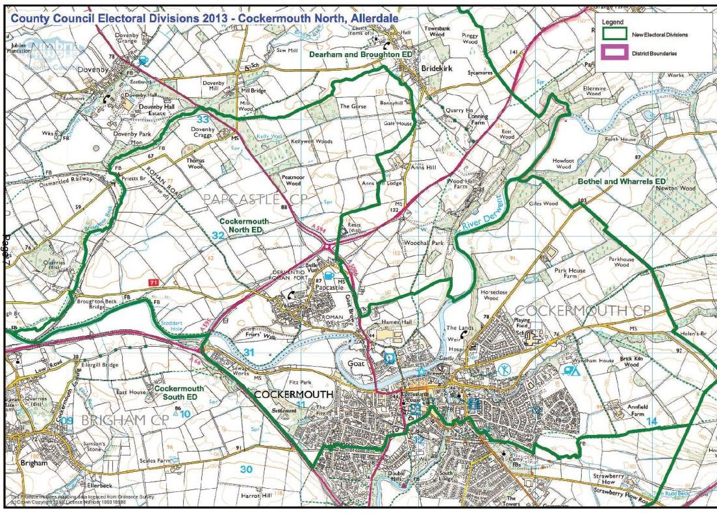
http://www.cumbria.gov.uk/Election2013/maps.asp

Communities

The electoral division of Cockermouth North covers Cockermouth Main Street, and the neighbouring areas of Gote, The Moor, Highfields, Derwent Mills, Charley Hill and Parklands. The division extends out of Cockermouth to cover the village and civil parish of Papcastle and hamlet of Belle Vue.

Statistical Profile

The 2011 Census estimated that the population of Cockermouth North Electoral Division (ED) was 6378 persons.

The table below presents estimated numbers of residents in Cockermouth North ED by age group:
 | No. Persons by Age Group (Years)
 | All Ages | 0 - 14 | 15 - 29 | 30 - 44 | 45 - 59 | 60 - 74 | 75 - 84 | 85+
Cockermouth North ED  (%) | 6378 | 975  (15%) | 960  (15%) | 1218  (19%) | 1436  (23%) | 1149  (18%) | 435  (7%) | 205  (3%)

Source: Office for National Statistics, 2011 Census
The chart below compares the proportion of Cockermouth North ED’s population within each age group with the proportion of the population within each age group across Allerdale district, Cumbria and England & Wales:

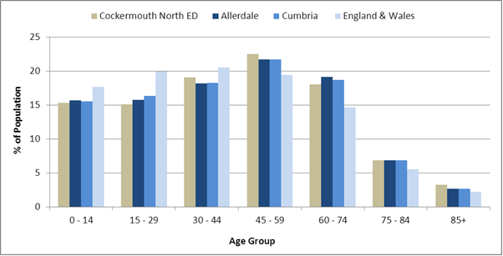

Source: Office for National Statistics, 2011 Census
County Council Electoral Divisions cover large spatial areas and so division averages can mask variation between communities within the division. Furthermore, beyond Census data, there is little statistical information available for Electoral Divisions. However, most statistical agencies produce data for Electoral Wards. Therefore, there is a very wide range of statistical information available for Electoral Wards. Furthermore, as Electoral Wards are generally smaller than Electoral Divisions, statistics at this level provide more insight into variations between communities.
The table below identifies which Electoral Wards are fully or partially within the boundaries of Cockermouth North ED, and what proportion of Cockermouth North ED’s population live within each ward:
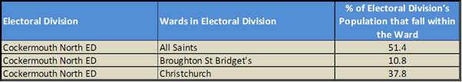
Source: Cumbria Intelligence Observatory, 2013

The map below overlays Electoral Ward boundaries on to Cockermouth North ED’s boundary: 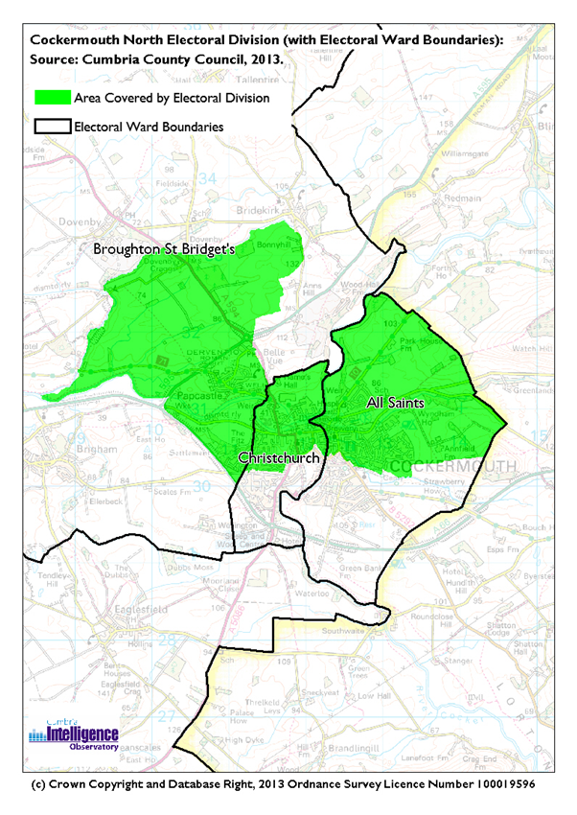

The Cumbria Intelligence Observatory presents many Electoral Ward level statistics via the interactive ‘Cumbria Atlas’ tool. The Statistics provided within the Cumbria Atlas cover topics such as, but not limited to, population, housing, health, economy, poverty, ethnicity, language, and transport. The datasets within the Cumbria Atlas are regularly updated and expanded.
For simple step by step instructions to use the Cumbria Atlas to explore statistics for the wards within your Electoral Division, please visit the following web page:
http://www.cumbria.gov.uk/eLibrary/view.asp?ID=56017
The Information and Intelligence Team within Cumbria County Council are happy to talk you through using the Cumbria Atlas over the phone, or face to face. Training sessions can also be arranged for small groups.
To contact the team please call 01228 226309, or email info@cumbriaobservatory.org.uk

Parks, Open Spaces and Leisure Facilities

Cockermouth provides an array of parks, open spaces and leisure facilities; with miles of grassy footpaths along riverbanks, through woods and agricultural land. The national cycle way, part of the Reivers Way passes through Cockermouth also.

Parks and Open areas include:
- Cockermouth Memorial Gardens and Play Area are well maintained grounds with riverside walks along the banks of the River Cocker. They stretch from Gote Bridge and up past Cockermouth Castle.

- Fitz Park and Fitz Wood is historic estate parkland surrounding The Fitz, a Grade II Listed building. The parkland is increasingly used and visited by the public as a location for public events such as fairs and shows.

- Horseclose Wood sits behind the ancient ruins of Cockermouth castle.

- Kelly Well, Peat Moor, Brick Kiln, Giles, Parkhouse are all woodlands within the Cockermouth North division.

Leisure facilities include:
- Cockermouth Leisure Centre & Pool are run by Carlisle Leisure a not for profit enterprise providing leisure services across North & West Cumbria.
- Highfield Sports Ground
- Tarn Close Sports Ground
- Cockermouth Cricket Ground
- Cockermouth School Facilities (inc. Astro turf)
- The Kirkgate Centre - a thriving cinema and live events venue.

In addition to the above, Cockermouth has allotments at Goat & Highfield, and a number of community gardens including a community orchard managed by the community interest company Riversmeet.

Active Community Organisations

There are many clubs and societies in Cockermouth and surrounding areas, which can be segmented into the following areas of interest; this is not an exhaustive list:
Community Organisations  - Highfield Residents Association  - Papcastle Village Hall - Council of Management (Trustees).  - Cockermouth and Papcastle Recreational Charity  - Riversmeet Community Network  - The Cockermouth and District Civic Society  - Cockermouth Rotary Club  - Cockermouth Round Table  - Cockermouth Lions  - Soroptomists  Health / Social Care/ self-help:  - Cockermouth Cottage Hospital League of Friends  - Cockermouth First Responders  - Cockermouth Mountain Rescue  - Branthwaite First Responders  - West Cumbria Dyslexia Association  - Cockermouth University of the Third Age (U3A)  - Cockermouth Life Saving Club  - Lamplugh Trust  Other  - West Cumbria Friends of the Earth  - Cockermouth Beekeepers Association  - The Derwent Railway Society  - Chamber of Trade Cockermouth  - Allotment and Garden Association | Sports Clubs  - Harris Park Bowling Club  - Croftside Bowling Club  - Cockermouth Lawn Tennis Club  - Cockermouth Rugby Football Club  - Cockermouth Titans Rugby League  - Cockermouth Tennis Club  - Cockermouth Football Club  - Cockermouth junior Football Club  - Cockermouth Company of Archers  - Cockermouth Golf Club (located in Bothel and Wharrels division)  - Cockermouth Ski Club.  - Cockermouth Cricket Club  - Cockermouth Squash Club  - Derwent Athletics Association  Arts/Culture Clubs/Societies  - Kirkgate Centre  - Cockermouth Amateur Dramatic Society  - Cockermouth Harmonic Society  - Cockermouth Music Society  - Cockermouth Festivals Group  - Dean Festivals Group  - Belfagan Womens Morris Dancers  - Cockermouth Mechanics' Band  - Castlegate Singers

Key Communication Networks

News & Star
A daily newspaper, produced by CN group; they produce different editions for North and West Cumbria.

Times and Star
Weekly newspaper produced by CN group for the Allerdale district of Cumbria they produce different editions for Maryport, Cockermouth and Workington

Cumberland News
The most widely read newspaper in Cumbria. This bridges the north and west communities.

BBC Radio Cumbria
Local radio station produced by the BBC for Cumbria

CFM Radio
Local radio station produced by the Bauer Media Group, covering Cumbria and Southwest Scotland

ITV News, Border region
Programme news, weather and information provided by ITV Broadcasting Limited for the England/Scotland border region, covering the majority of Cumbria, Dumfries and Galloway, the Scottish Borders and parts of Northumberland.
http://www.itv.com/news/border/story/2013-10-11/get-in-touch/

BBC News – Look North (North East & Cumbria)
BBC's nightly regional news programme for the North East of England and Cumbria

http://www.bbc.co.uk/programmes/b0070g1d/faq

Cockermouth Post
Bi-monthly, free, independent publication based in Cockermouth
http://www.thecockermouthpost.co.uk/

Town Council & Parish Newsletters, notice boards & websites
(see Key Community Contacts)

Parochial Parish newsletters

Community Assets

- Cockermouth School & Adult Education Centre
- Cockermouth Library
- Cockermouth Community Hospital
- Cockermouth Town Hall
- Kirkgate centre
- Wordsworth House
- Papcastle & Belle Vue Village Hall
- Doctors Surgeries (based at the Cockermouth C.ommunity Hospital)
  - Castlegate
  - Derwent House
- Primary Schools:
  - Fairfield
  - All Saints
  - St. Josephs
- Churches:
  - United Reformed
  - All Saints
  - Christchurch
  - St. Josephs

Local Cumbria County Council Service Hubs

Service Type | Service Point
Adult Education Centres | Cockermouth & Keswick Adult Education, Co
Doctors Surgeries | Castlegate Surgery
Doctors Surgeries | Derwent House Surgery
Hospitals | Cockermouth Community Hospital
Libraries | Cockermouth Library
Ceremonies room Coroner | Fairfield Building  Fairfield building
Primary Schools | Fairfield Primary School
Primary Schools | All Saints CE School
Primary Schools | St. Joseph's Catholic Primary School
Secondary Schools | Cockermouth School

Community Engagement

Cockermouth area has Neighbourhood Forums twice yearly and includes the local electoral divisions of Cockermouth North, Bothel & Wharrels and Dearham & Broughton. For further information, please contact the Allerdale Area Support Team (see key community contacts).

Key Community Contacts
Cumbria County Councillor, Eric Nicholson, Cockermouth South
- Address: Hilltop, Victoria Road, Cockermouth, CA13 9PA
- Phone: 01900 827944
- Email: Eric.Nicholson@cumbria.gov.uk
Allerdale Area Support Team
- Address: Workington Library, Vulcans Lane, Workington, CA14 2ND
- Phone: 01900 706010
- Email: allerdaleteam@cumbria.go.uk
- Web: www.cumbria.gov.uk
Allerdale Borough Council
- Address: Allerdale House, Workington, Cumbria, CA14 3YJ
- Phone: 01900 702702
- Email: enquiries@allerdale.gov.uk
- Web: http://www.allerdale.gov.uk/
Cockermouth Town Council
- Clerk: Mrs S Brown
- Address: Town Hall, Market Street, Cockermouth, CA13 9NL
- Phone: 01900 821869
- Email: cockermouthtowncouncil@btconnect.com
Papcastle Parish Council
- Clerk: Mrs BA Lamb
- Address: Sunningdale, Distington, Workington, CA14 5XP
- Phone: 01946 832843
- Email: lamb13@hotmail.co.uk
- Web: http://www.papcastle.org.uk/

