Cockermouth
South
Electoral Division Profile
2014

Overview of Electoral Division

Cockermouth South Electoral Division is within the District of Allerdale and lies on the edge of the western boundaries of the Lake District National Park.
The division covers the far southern proximity of Cockermouth Town, incorporating the Fire Station, Mitchell Auction Mart and the sports facility at Strawberry How. Cockermouth is an attractive market town with a unique character and full of vibrant small businesses. Cockermouth is popular with the tourists as a peaceful getaway, although it does host some of Cumbria's festivals including Taste Cumbria and The Georgian Fair
The division is largely rural incorporating a number of small villages and hamlets to the southwest of Cockermouth. These villages are surrounded by farming land; the local economy is still reliant today on farming and tourism, with light industrial facilities servicing local needs. The largest employment in the area comes from the nuclear facilities at Sellafield, followed by Education and Health.
Within the division there are two primary schools, St Bridget's in Brigham and Dean School. The village of Eaglesfield lies within the electoral division, although the school there lands within the border of the neighbouring division - Bothel & the Wharrels. Secondary education is provided at Cockermouth School.
The division is relatively small in comparison with some of the other rural electoral divisions, but it does cover a population of 5862 persons.

Map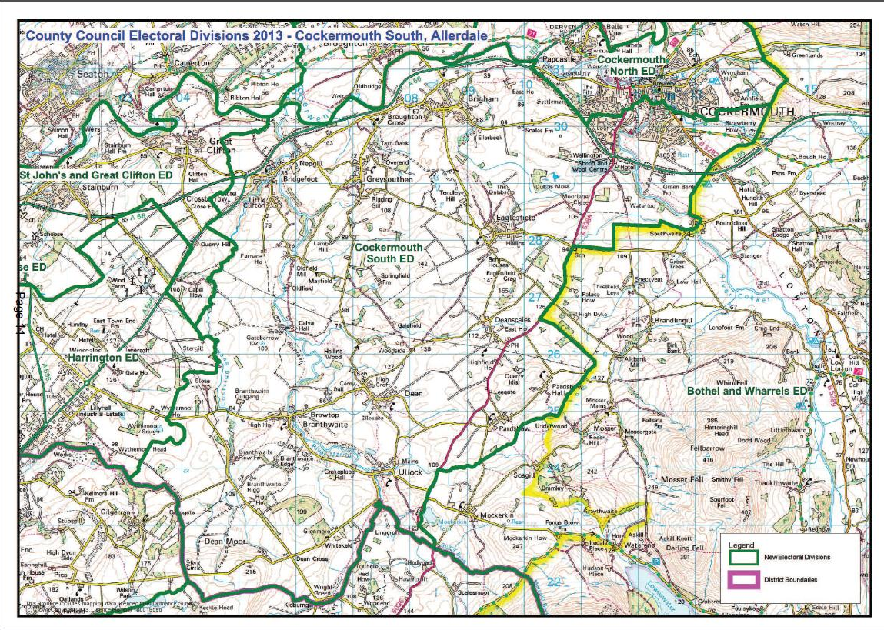
PDF Copy of Map: http://www.cumbria.gov.uk/Election2013/maps.asp

Communities

The electoral division of Cockermouth South incorporates the villages and hamlets southwest of Cockermouth, which include:

- Brigham
- Broughton Cross
- GreySouthen
- Nepgill
- Bridgefoot
- Little Clifton
- Branthwaite
- Browtop
- Ullock
- Dean
- Deanscales
- Pardshaw
- Eaglesfield

It also incorporates the southern edge of Cockermouth town including Oakhurst, Lakeland Business Park, Strawberry How and Harris Park.

The division is separated by four parish councils and Cockermouth Town Council (part of); the parish councils are Dean, Greysouthern, Little Clifton and Brigham.

Statistical Profile

The 2011 Census estimated that the population of Cockermouth South Electoral Division (ED) was 5862 persons.
The table below presents estimated numbers of residents in Cockermouth South ED by age group:

 | No. Persons by Age Group (Years)
 | All Ages | 0 - 14 | 15 - 29 | 30 - 44 | 45 - 59 | 60 - 74 | 75 - 84 | 85+
Cockermouth South ED  (%) | 5862 | 972  (17%) | 712  (12%) | 997  (17%) | 1419  (24%) | 1155  (20%) | 429  (7%) | 178  (3%)

Source: Office for National Statistics, 2011 Census

The chart below compares the proportion of Cockermouth South ED’s population within each age group with the proportion of the population within each age group across Allerdale district, Cumbria and England & Wales:
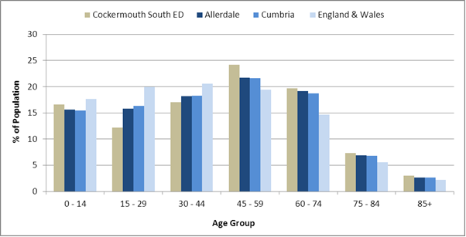
Source: Office for National Statistics, 2011 Census
County Council Electoral Divisions cover large spatial areas and so division averages can mask variation between communities within the division. Furthermore, beyond Census data, there is little statistical information available for Electoral Divisions. However, most statistical agencies produce data for Electoral Wards. Therefore, there is a very wide range of statistical information available for Electoral Wards. Furthermore, as Electoral Wards are generally smaller than Electoral Divisions, statistics at this level provide more insight into variations between communities.
The table below identifies which Electoral Wards are fully or partially within the boundaries of Cockermouth South ED, and what proportion of Cockermouth South ED’s population live within each ward:
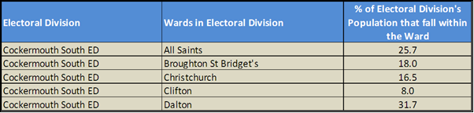
Source: Cumbria Intelligence Observatory, 2013
The map below overlays Electoral Ward boundaries on to Cockermouth South ED’s boundary: 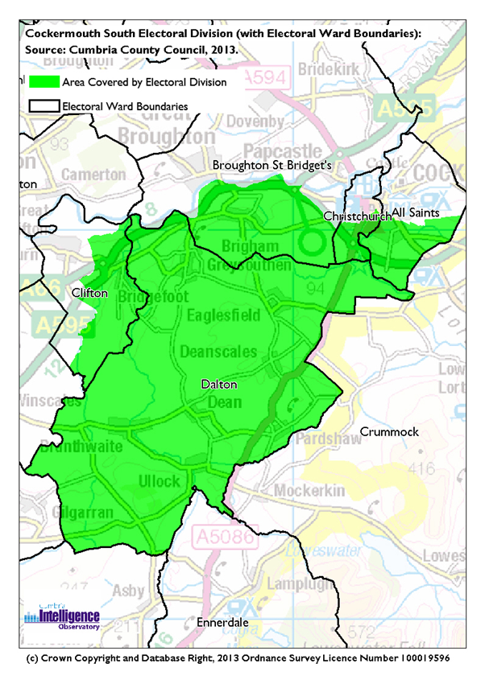
The Cumbria Intelligence Observatory presents many Electoral Ward level statistics via the interactive ‘Cumbria Atlas’ tool. The Statistics provided within the Cumbria Atlas cover topics such as, but not limited to, population, housing, health, economy, poverty, ethnicity, language, and transport. The datasets within the Cumbria Atlas are regularly updated and expanded.
For simple step by step instructions to use the Cumbria Atlas to explore statistics for the wards within your Electoral Division, please visit the following web page:
http://www.cumbria.gov.uk/eLibrary/view.asp?ID=56017
The Information and Intelligence Team within Cumbria County Council are happy to talk you through using the Cumbria Atlas over the phone, or face to face. Training sessions can also be arranged for small groups.
To contact the team please call 01228 226309, or email info@cumbriaobservatory.org.uk

Parks, Open Spaces and Leisure Facilities

Harris Park is a large green space off Fern Bank, on the edge of the town centre. The park has a play area and playing fields including tennis courts and a bowling green. The park also offers riverside walks along the River Cocker and a cycle path which runs along what used to be part of the Cockermouth, Keswick and Penrith Railway. The route goes through Harris Park to Strawberry How Rd (opposite the Strawberry How site).
The electoral division houses Grasmoor Sports Centre (behind Strawberry Howe, Lorton road) the home of the Rugby Club also with tennis courts, home of Cockermouth Tennis Club. Cockermouth School has an Astro Turf pitch which is available to hire by community groups and there is also Cockermouth golf club which just falls into the neighbouring division Bothel & The Wharrels
There are a few wooded areas open to the general public these include Oakhurst and Simonscales Wood and a number of open spaces registered these include Eaglesfield Village Green, The Bank at Eaglesfield, Deanscales Green, Beck Bottom at Deanscale, Ullock Green, Black Beck Bridge and Ellebeck Green.
A few of the villages have playgrounds, and there are also playgrounds at:
- Harris Park
- Green Bank Lane, Cockermouth
- Cockermouth Caravan Park

Active Community Organisations

There are many clubs and societies in Cockermouth and surrounding areas, which can be segmented into the following areas of interest; this is not an exhaustive list:
Community Organisations  - Highfield Residents Association  - Riversmeet Community Network  - The Cockermouth and District Civic Society  - Cockermouth Rotary Club  - CockermouthRound table  - Lions  - Soroptomists  - Cockermouth After School Scheme (CASS)  - Friends of Dean School  Health / Social Care/ self help  - Cockermouth Cottage Hospital League of Friends  - Cockermouth First Responders  - Cockermouth Mountain Rescue  - Branthwaite First Responders  - West Cumbria Dyslexia Association  - Cockermouth University of the Third Age (U3A)  - Cockermouth Life Saving Club  Other  - Greysouthern Young Farmers Club  - West Cumbria Friends of the Earth  - Cockermouth Beekeepers Association  - The Derwent Railway Society  - Chamber of Trade | Sports Clubs  - Harris Park Bowling Club  - Cockermouth Lawn Tennis Club  - Cockermouth Rugby Football Club  - Cockermouth Tennis Club  - Cockermouth Football Club  - Cockermouth Company of Archers  - Cockermouth Golf Club  - Cockermouth Ski Club.  - Cockermouth Cricket Club  Arts/Culture Clubs/Societies  - Cockermouth Amateur Dramatic Society  - Cockermouth Harmonic Society  - Cockermouth Music Society  - Cockermouth Festivals Group  - Dean Festivals Group  - Belfagan Womens Morris Dancers  - Cockermouth Mechanics' Band  - Castlegate Singers

Key Communication Networks

News & Star
A daily newspaper, produced by CN group; they produce different editions for North and West Cumbria.

Times and Star
Weekly newspaper produced by CN group for the Allerdale district of Cumbria they produce different editions for Maryport, Cockermouth and Workington

Cumberland News
The most widely read newspaper in Cumbria. This bridges the north and west communities.

BBC Radio Cumbria
Local radio station produced by the BBC for Cumbria

CFM Radio
Local radio station produced by the Bauer Media Group, covering Cumbria and Southwest Scotland

ITV News, Border region
Programme news, weather and information provided by ITV Broadcasting Limited for the England/Scotland border region, covering the majority of Cumbria, Dumfries and Galloway, the Scottish Borders and parts of Northumberland.
http://www.itv.com/news/border/story/2013-10-11/get-in-touch/

BBC News – Look North (North East & Cumbria)
BBC's nightly regional news programme for the North East of England and Cumbria
http://www.bbc.co.uk/programmes/b0070g1d/faq

Cockermouth Post
Bi-monthly, free, independent publication based in Cockermouth
http://www.thecockermouthpost.co.uk/

Parish Newsletters, notice boards & websites
(see Key Community Contacts)

Parochial Parish newsletters

Community Assets

Schools:
- St Bridget’s School
- Dean CE School
Churches:
- Brigham - Methodist Church
- Brigham - St Bridget
- Cockermouth - Methodist Church
- Dean - St Oswald
- Little Clifton - St Luke’s Church
- Pardshaw - Quakers Meeting House

Other:
- Cockermouth Fire Station
- Grassmoor Sports Centre
- Mountain Rescue Centre
- Double Mills Youth Hostel
- Greysouthern village hall
- Kirkstile Community Centre - Dean
- Dean Sports & Art Facility
- Little Clifton Parish Hall
- Little Clifton Parish Allotments
- Eaglesfiels Village Hall

Local Cumbria County Council Service Hubs

Service Type | Service Point
- Fire Stations | - Cockermouth
- Primary Schools | - St. Bridget's School
- Primary Schools | - Dean CE School

Community Engagement

Neighbourhood Forums are held twice annually for the Cockermouth locality which incorporates the neighbouring electoral divisions of Broughton, Cockermouth South and part of Bothel & the Wharrels. For further information, please contact Allerdale Area Support Team (see key contacts).

Key Community Contacts
Cumbria County Councillor, Alan Kennon, Cockermouth South
- Address: High Sand, Waterloo Street, Cockermouth, CA13 9NB
- Phone: 01900 826368
- Email: Alan.Kennon@cumbria.gov.uk

Allerdale Area Support Team
- Address: Workington Library, Vulcans Lane, Workington, CA14 2ND
- Phone: 01900 706010
- Email: allerdaleteam@cumbria.gov.uk
- Web: www.cumbria.gov.uk
Allerdale Borough Council
- Address: Allerdale House, Workington, Cumbria, CA14 3YJ
- Phone: 01900 702702
- Email: enquiries@allerdale.gov.uk
- Web: http://www.allerdale.gov.uk/
Cockermouth Town Council
- Clerk: Mrs S Brown
- Address: Town Hall, Market Street, Cockermouth, CA13 9NL
- Phone: 01900 821869
- Email: cockermouthtowncouncil@btconnect.com
- Web: www.cockermouth.org
Brigham Parish Council
- Clerk: Mrs Holliday
- Address: 10 High Brigham, Brigham, Cockermouth, CA13 0TE
- Web: www.brighamparishcouncil.org.uk
- Email: brighamparishcouncil@gmail.com
Dean Parish Council
- Clerk: Mrs B Lamb
- Address: Sunningdale, Distington, Workington, CA14 5XP
- Phone: 01946 832843
- Email: lamb13@hotmail.co.uk
Greysouthern Parish Council
- Clerk: Mrs B Lamb
- Address: Sunningdale, Distington, Workington, CA14 5XP
- Phone: 07906360728
- Email: lamb13@hotmail.co.uk
Little Clifton Parish Council
- Clerk: Rev'd Judith Morgan
- Address: 30 Queens Avenue, Seaton, Workington, CA14 1DL
- Phone: 01900 61494
- Email: LittleCliftonPC@outlook.com

