

**Dearham & Broughton**

**Electoral Division Profile**

**2014**

# Overview of Electoral Division

The Electoral Division of Dearham & Broughton is a rural area expanding from the coast above Maryport to the outskirts of Cockermouth in West Cumbria within the Allerdale District.

The division incorporates the larger villages of Dearham and Broughton and includes other small settlements such as Gilcrux, Bullgill, Tallentire, Dovenby, Oughterside, Allerby and Bridekirk.

Dovenby Hall provides the headquarters for M.Sport, a flourishing motorsport company.

Housing in the area has expanded over past years, especially in Dearham where extensive building works have been required to the local school to accommodate additional pupils.

# Map

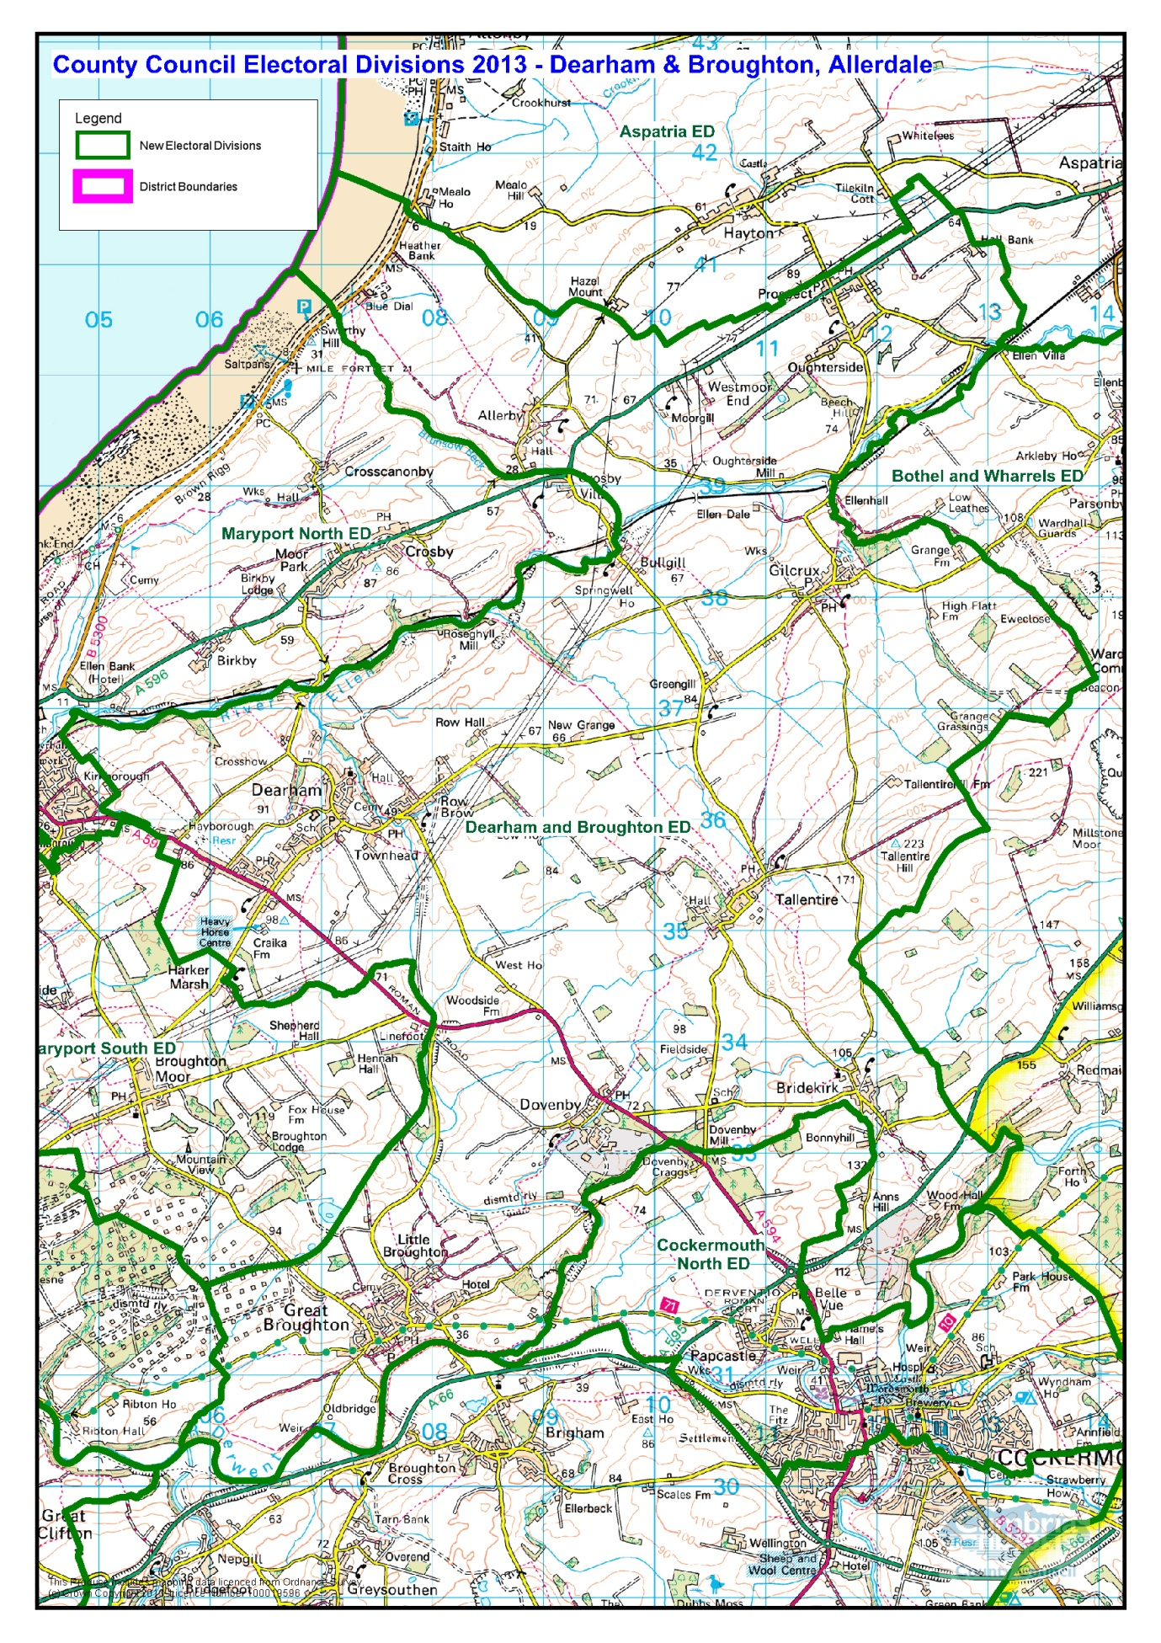

PDF copy of map: [http://www.cumbria.gov.uk/Election2013/maps.asp](http://www.cumbria.gov.uk/Election2013/maps.asp%20)

# Communities

The electoral division covers the electoral wards of:

|  |  |
| --- | --- |
| * Dearham | * Tallentire |
| * Little Broughton | * Dovenby |
| * Great Broughton | * Oughterside & Allerby |
| * Gilcrux * Bullgill | * Bridekirk |

Or the civil parishes of:

|  |  |
| --- | --- |
| * Oughterside & Allerby | * Dearham |
| * Gilcrux | * Broughton |
| * Bridekirk |  |

# Statistical Profile

The 2011 Census estimated that the population of Dearham and Broughton Electoral Division (ED) was 5508 persons.

The table below presents estimated numbers of residents in Dearham and Broughton ED by age group:

|  |  |  |  |  |  |  |  |  |
| --- | --- | --- | --- | --- | --- | --- | --- | --- |
|  | **No. Persons by Age Group (Years)** | | | | | | | |
| **All Ages** | **0 - 14** | **15 - 29** | **30 - 44** | **45 - 59** | **60 - 74** | **75 - 84** | **85+** |
| *Dearham and Broughton ED* | *5508* | *895* | *805* | *1084* | *1276* | *1060* | *288* | *100* |

*Source: Office for National Statistics, 2011 Census*

The chart below compares the proportion of Dearham and Broughton ED’s population within each age group with the proportion of the population within each age group across Allerdale district, Cumbria and England & Wales:

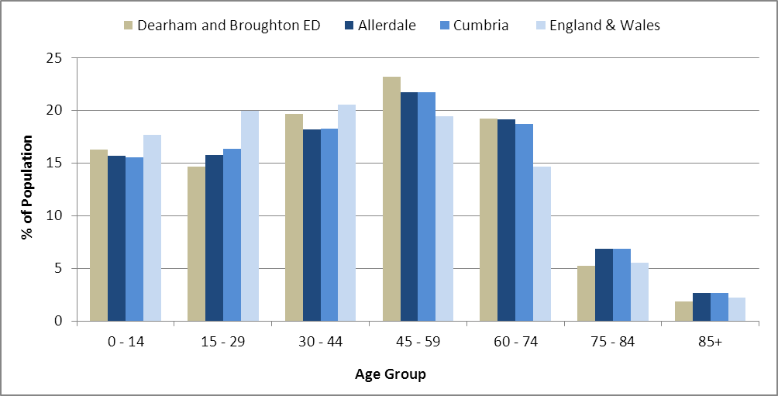

*Source: Office for National Statistics, 2011 Census*

County Council Electoral Divisions cover large spatial areas and so division averages can mask variation between communities within the division. Furthermore, beyond Census data, there is little statistical information available for Electoral Divisions. However, most statistical agencies produce data for Electoral Wards. Therefore, there is a very wide range of statistical information available for Electoral Wards. Furthermore, as Electoral Wards are generally smaller than Electoral Divisions, statistics at this level provide more insight into variations between communities.

The table below identifies which Electoral Wards are fully or partially within the boundaries of Dearham and Broughton ED, and what proportion of Dearham and Broughton ED’s population live within each ward:

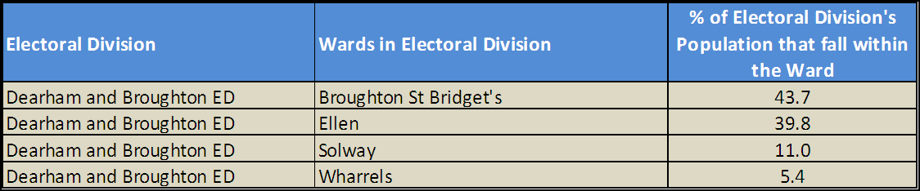*Source: Cumbria Intelligence Observatory, 2013*

The map below overlays Electoral Ward boundaries on to Dearham and Broughton ED’s boundary:

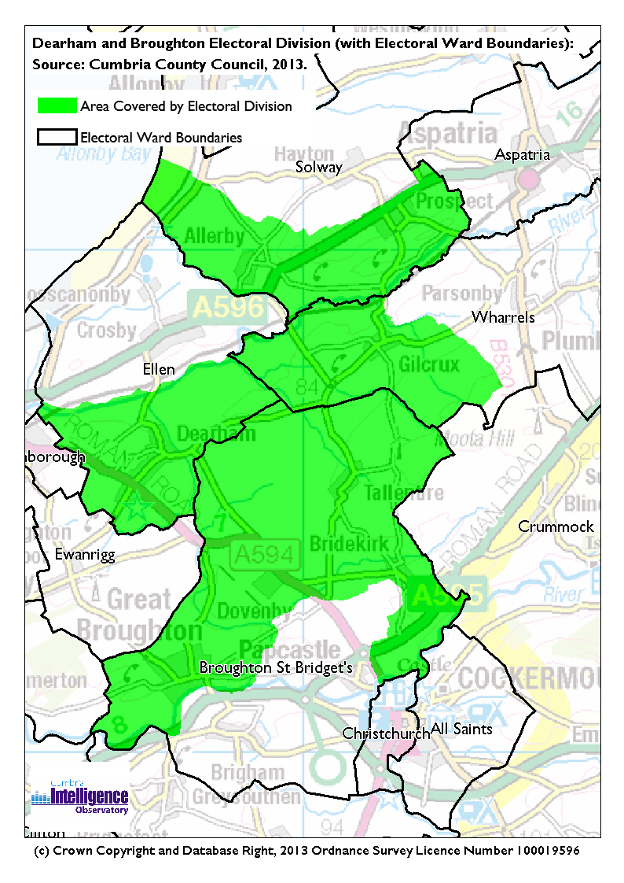

The Cumbria Intelligence Observatory presents many Electoral Ward level statistics via the interactive ‘Cumbria Atlas’ tool. The Statistics provided within the Cumbria Atlas cover topics such as, but not limited to, population, housing, health, economy, poverty, ethnicity, language, and transport. The datasets within the Cumbria Atlas are regularly updated and expanded.

For simple step by step instructions to use the Cumbria Atlas to explore statistics for the wards within your Electoral Division, please visit the following web page:

<http://www.cumbria.gov.uk/eLibrary/view.asp?ID=56017>

The Information and Intelligence Team within Cumbria County Council are happy to talk you through using the Cumbria Atlas over the phone, or face to face. Training sessions can also be arranged for small groups.

To contact the team please call 01228 226309, or email [info@cumbriaobservatory.org.uk](mailto:info@cumbriaobservatory.org.uk)

# Parks, Open Spaces and Leisure Facilities

* Ghyll Bank - Children’s play area Little Broughton
* Dovenby Hall Estate - Wood lands
* Moota Hill
* River Ellen
* Allerby Green
* Nook Allotments
* Coldgill Allotments
* Fishing

# Active Community Organisations

* Dearham Angling Society
* Broughton Red Roses Amateur RFLC
* Dearham Youth Project (Young Cumbria)
* Allerby Play Park Committee
* Dearham First Responders
* Dearham Homing Society
* 1st Dearham Boys Brigade
* Dearham & Broughton Allotment Committee
* The Dearham Environmental Task Force

# Key Communication Networks

News & Star

A daily newspaper, produced by CN group; they produce different editions for North and West Cumbria.

Times and Star

Weekly newspaper produced by CN group for the Allerdale district of Cumbria they produce different editions for Maryport, Cockermouth and Workington

Cumberland News

The most widely read newspaper in Cumbria. This bridges the north and west communities.

BBC Radio Cumbria

Local radio station produced by the BBC for Cumbria

CFM Radio

Local radio station produced by the Bauer Media Group, covering Cumbria and Southwest Scotland

Parish Newsletters, notice boards & websites

(See Key Community Contacts)

Parochial Parish newsletters:

# Community Assets

**Schools:**

* Dearham Primary School. Dearham, Maryport, CA15 7HR
* **B**roughton Moor School. Broughton Moor, Maryport, CA15 7RZ
* Oughterside Foundation School. Oughterside, Wigton, Cumbria, CA7 2PY
* Bridekirk Dovenby C of E Primary School. Dovenby, Cumbria. CA13 0PG
* St Bridgets C of E Primary School. Brigham, Cumbria. CA13 0TU
* Broughton Primary School. Moor Road, Great Broughton, Cumbria. CA13

**Village Halls:**

* Tallentire Village Hall
* Broughton Village Hall
* Prospect and Oughterside Village Hall
* Dearham Village Hall
* Gilcrux Village Hall

**Churches**

* St Mungo’s Church, Dearham
* St Bridgets Church

# Local Cumbria County Council Service Hubs

Local services hubs are within the main towns of Maryport & Cockermouth.

# Community Engagement

The electoral division falls within the North East Allerdale Neighbourhood Forum which meets twice yearly.

The Councillor for the division is Alan Clark.

For further information please contact the Allerdale Area Support Team on 01900 706015

|  |
| --- |
| Key Community Contacts |
| Councillor Alan Clark, Cumbria County Council   * Address: Everleigh, 3 Moor Road, Great Clifton, Workington. CA14 1TS * Phone: 01900 601642 * Email: [Alan.Clark@cumbria.gov.uk](mailto:Alan.Clark@cumbria.gov.uk) |
| Allerdale Area Support Team   * Address: Workington Library, Vulcans Lane, Workington, CA14 2ND * Phone: 01900 706010 * Email: allerdaleteam@cumbria.gov.uk * Web: [www.cumbria.gov.uk](http://www.cumbria.gov.uk) |
| Allerdale Borough Council   * Address: Allerdale House, Workington, Cumbria, CA14 3YJ * Phone: 01900 702702 * Email: [enquiries@allerdale.gov.uk](mailto:enquiries@allerdale.gov.uk) * Web: <http://www.allerdale.gov.uk/> |
| Broughton Parish Council   * Clerk: Becx Carter * Address: 40 Windebrowe Avenue, Keswick, CA12 4JA * **Phone:** 077866 78283 * **Email:** [broughtonparishclerk@hotmail.com](mailto:broughtonparishclerk@hotmail.com) |

|  |
| --- |
| Dearham Parish Council   * Clerk :Mr K Rogers * Address: Green Pastures, Row Brow, Maryport CA15 7JY * **Phone:** 01900 812444 * **Email:** [kratgp@btinternet.com](mailto:kratgp@btinternet.com) |
| Oughterside & Allonby Parish Council   * Clerk: Ms Debbie Cosgrove * Address: Appletree House, Allerby, Wigton, CA7 2NL * **Phone:** 07540274737 * **Email:** [outersideandallerby@hotmail.co.uk](mailto:outersideandallerby@hotmail.co.uk) |
| Gilcrux Parish Council   * Clerk: Mr T Gear * Address: Brandraw Mount, West Street, Aspatria, CA7 3HG * **Phone:** 016973 21935 * **Email:** [gilcruxparish@hotmail.com](mailto:gilcruxparish@hotmail.com) |
| Bridekirk Parish Council   * Clerk: Mrs Deborah Cosgrove * Address: Appletree House, Allerby, Wigton CA7 2NL * **Phone:** 07540275737 * **Email:** [clerk@bridekirkparish.org.uk](mailto:clerk@bridekirkparish.org.uk) |