

**Maryport South**

**Electoral Division Profile**

**2014**

# Overview of Electoral Division

**Maryport** is an attractive coastal town and civil parish within the borough of Allerdale. It is located on the A596 Road north of Workington and is the southernmost town on the Solway Firth. Maryport railway station is on the Cumbrian coast line. Maryport, located on the beautiful Solway Firth is one of the few places that can offer stunning views to the Scottish mountains and back to the Lake District Fells. Glorious sunsets, sweeping views, shoreline walks, sea and beach angling, golf links, coastal sailing, lively pubs, and memorable summer festivals make Maryport, although so near so very different to the Lakes.

# Map

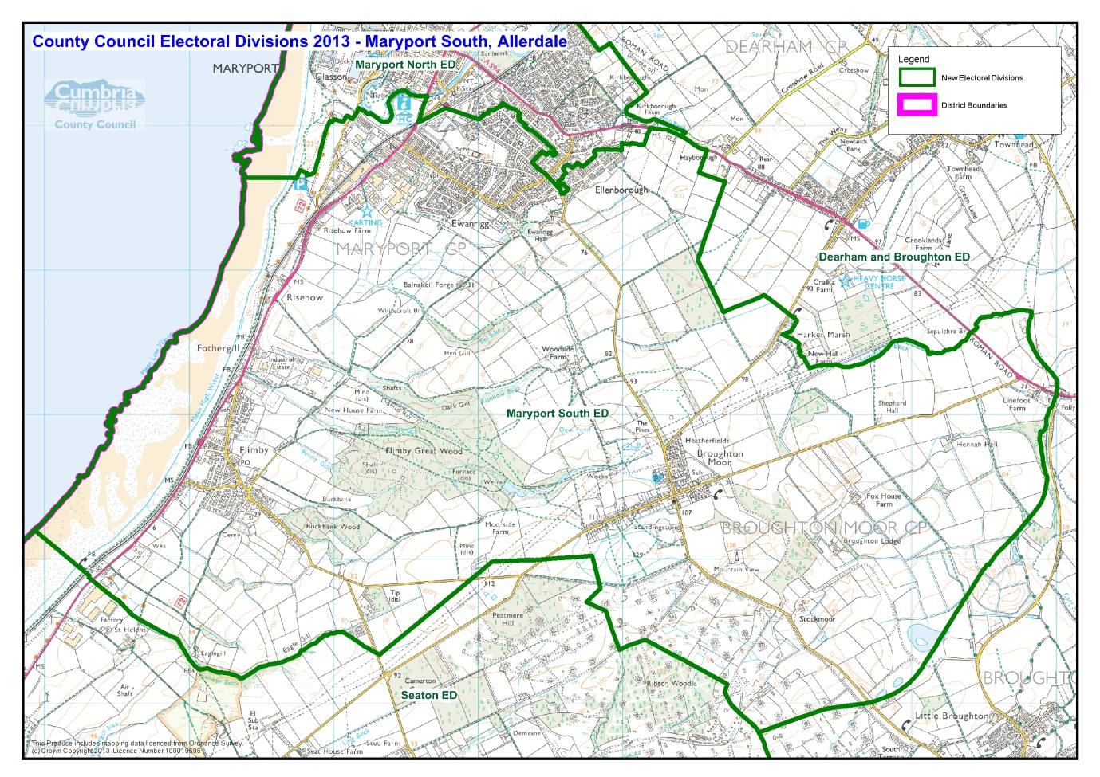

# Communities

Maryport is split into two Electoral Divisions; Maryport North and Maryport South. The South Electoral Division includes the communities of:

|  |  |
| --- | --- |
| * Maryport South * Ewanrigg * Broughton Moor | * Flimby * Part of Ellenborough * A small part of Netherhall |

# Statistical Profile

The 2011 Census estimated that the population of Maryport South Electoral Division (ED) was 6404 persons.

The table below presents estimated numbers of residents in Maryport South ED by age group:

|  |  |  |  |  |  |  |  |  |
| --- | --- | --- | --- | --- | --- | --- | --- | --- |
|  | **No. Persons by Age Group (Years)** | | | | | | | |
| **All Ages** | **0 - 14** | **15 - 29** | **30 - 44** | **45 - 59** | **60 - 74** | **75 - 84** | **85+** |
| *Maryport South ED* | *6404* | *1218* | *1213* | *1189* | *1239* | *1078* | *363* | *104* |

*Source: Office for National Statistics, 2011 Census*

The chart below compares the proportion of Maryport South ED’s population within each age group with the proportion of the population within each age group across Allerdale district, Cumbria and England & Wales:

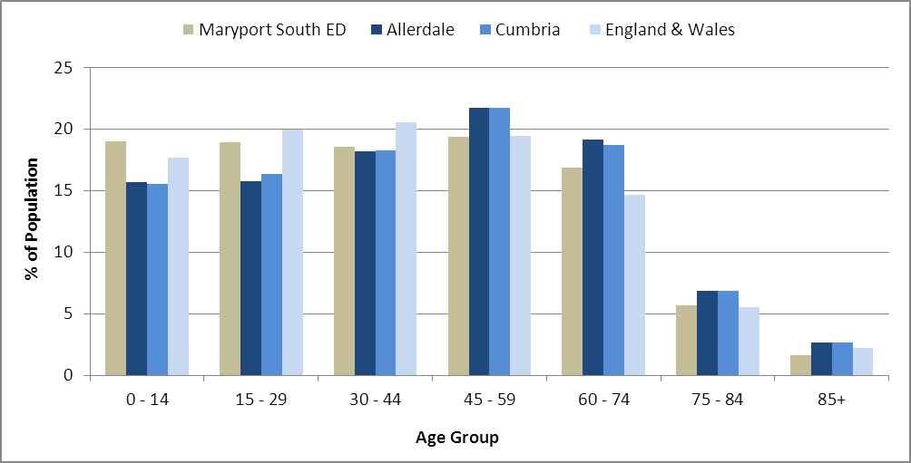

*Source: Office for National Statistics, 2011 Census*

County Council Electoral Divisions cover large spatial areas and so division averages can mask variation between communities within the division. Furthermore, beyond Census data,there is little statistical information available for Electoral Divisions. However, most statistical agencies produce data for Electoral Wards. Therefore, there is a very wide range of statistical information available for Electoral Wards. Furthermore, as Electoral Wards are generally smaller than Electoral Divisions, statistics at this level provide more insight into variations between communities.

The table below identifies which Electoral Wards are fully or partially within the boundaries of Maryport South ED, and what proportion of Maryport South ED’s population live within each ward:

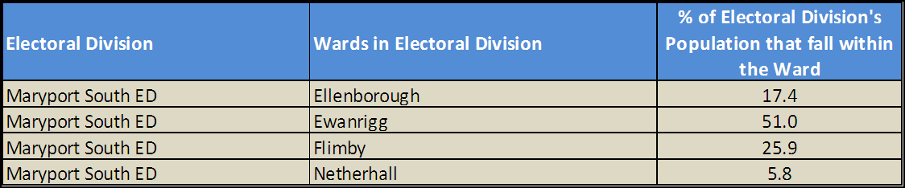*Source: Cumbria Intelligence Observatory, 2013*

The map below overlays Electoral Ward boundaries on to Maryport South ED’s boundary: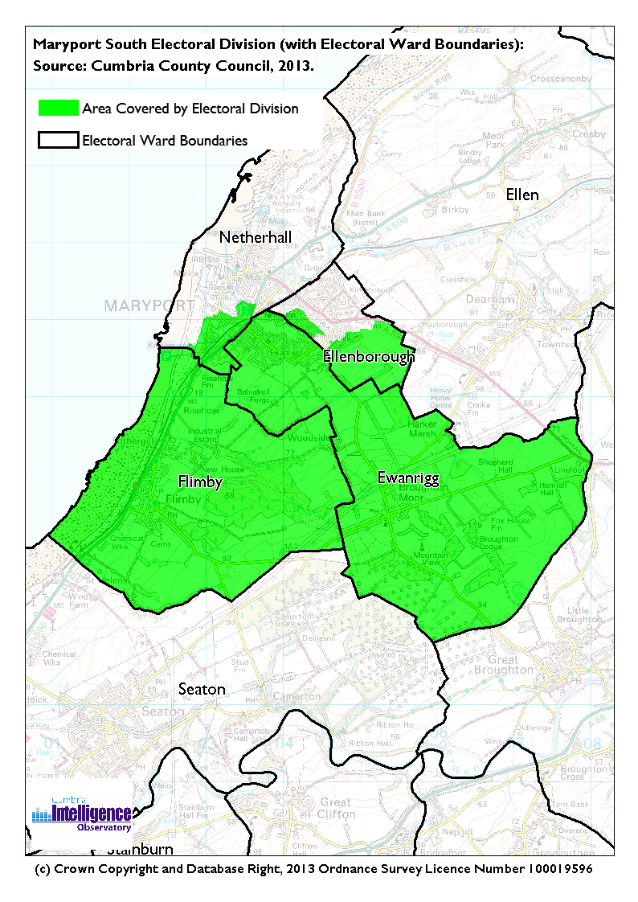The Cumbria Intelligence Observatory presents many Electoral Ward level statistics via the interactive ‘Cumbria Atlas’ tool. The Statistics provided within the Cumbria Atlas cover topics such as, but not limited to, population, housing, health, economy, poverty, ethnicity, language, and transport. The datasets within the Cumbria Atlas are regularly updated and expanded.

For simple step by step instructions to use the Cumbria Atlas to explore statistics for the wards within your Electoral Division, please visit the following web page:

<http://www.cumbria.gov.uk/eLibrary/view.asp?ID=56017>

The Information and Intelligence Team within Cumbria County Council are happy to talk you through using the Cumbria Atlas over the phone, or face to face. Training sessions can also be arranged for small groups.

To contact the team please call 01228 226309, or email [info@cumbriaobservatory.org.uk](mailto:info@cumbriaobservatory.org.uk)

# Parks, Open Spaces and Leisure Facilities

* West Coast karting
* Youth Clubs
* Tennis clubs
* Rugby clubs
* Football clubs
* Numerous uniformed groups:
  + Scouts
  + Army Cadets
  + Sea Cadets
  + Brownies
  + Girls Brigade
  + Cubs
* Play areas including;
  + Flimby
  + Broughton Moor

There is also very easy access to The Wave Centre with its activities and the West Coast Aquarium with the play area and crazy golf, plus the Netherhall Community Sports Centre which are all based in Maryport.

# Active Community Organisations

Ewanrigg Local Trust

Ewanrigg and Netherton Community Centre

ENTRA Ewanrigg and Netherton Tenants & Residents Association

Boys and Girls Club (Youth Club)

Maryport Gym (Fit4Life)

Glasson Rangers ARLFC

Flimby Community Hall Committee

# Key Communication Networks

News & Star

A daily newspaper, produced by CN group; they produce different editions for North and West Cumbria.

Times and Star

Weekly newspaper produced by CN group for the Allerdale district of Cumbria they produce different editions for Maryport, Cockermouth and Workington

Cumberland News

The most widely read newspaper in Cumbria. This bridges the north and west communities.

BBC Radio Cumbria

Local radio station produced by the BBC for Cumbria

CFM Radio

Local radio station produced by the Bauer Media Group, covering Cumbria and Southwest Scotland

ITV News, Border region

Programme news, weather and information provided by ITV Broadcasting Limited for the England/Scotland border region, covering the majority of Cumbria, Dumfries and Galloway, the Scottish Borders and parts of Northumberland.

http://www.itv.com/news/border/story/2013-10-11/get-in-touch/

BBC News – Look North (North East & Cumbria)

Look North is the BBC's nightly regional news programme for the North East of England and Cumbria

http://www.bbc.co.uk/programmes/b0070g1d/faq

Cumbria Crack

An online facility for News in Cumbria <http://www.cumbriacrack.com/>

# Community Assets

Schools:

* Ellenborough & Ewanrigg Infant School
* Broughton Moor Primary School
* Ewanrigg Junior School
* Our Lady & St. Patrick’s Catholic Primary School
* Grasslot Infants School
* Flimby Primary School
* Cuddly Koalas Preschool

Churches:

* Flimby Methodist Church, West Lane, Flimby, CA15 8QY
* Broughton Moor Methodist Church, Wyndham Row, CA15 7SB

# Local Cumbria County Council Service Hubs

* **Maryport Child & Family Centre,** Ennerdale Road, Maryport, CA15 8HN **Tel:** 01900 818726
* **Flimby Child & Family Centre,** Sand Lane, Flimby, Maryport CA15 8QS
* Flimby and Ewanrigg Community Development Centre, Flimby Primary School, Rye Hill Road, Flimby, Maryport, CA15 8TD

# Community Engagement

The Maryport Neighbourhood Forum meetings include both Maryport North and Maryport South. There are approximately three meetings per year in various locations across Maryport. There are three Cumbria County Councillors for the whole of the Maryport area, and these include:

* Cllr Keith Little (Maryport South)
* Cllr Carnie McCarron – Holmes (Maryport North)
* Cllr Alan Clark - (Bridekirk, Broughton, Dearham, Gilcrux, Oughterside and Allerby)

|  |  |
| --- | --- |
| Key Community Contacts | |
| Cumbria County Councillor | Mr Keith Little -01900 812981 |
| Cumbria County Council | Area Support Office  2nd Floor Workington Library  Vulcans Lane, Workington  Cumbria, CA14 2ND  Tel: 01900 706010  allerdaleteam@cumbria.gov.uk |
| Maryport Town Council | Town Hall, Senhouse Street, Maryport, Cumbria. CA15 6BH  [clerk@maryporttowncouncil.gov.uk](mailto:clerk@maryporttowncouncil.gov.uk)  Tel: 01900 813205 |
| Allerdale Borough Council | Allerdale House, Workington  Cumbria, CA14 3YJ  Tel: 01900 702702 |
| Home Group Ltd | 2 Bounty Avenue, Maryport, Cumbria.  CA15 8HY  Tel: 08456063033 |
| Anchor Trust | Solway Court, Crosby Street, Maryport,  Cumbria. CA15 6LF  Tel: 01900 815418 |