

**Seaton**

**Electoral Division Profile**

**2014**

# Overview of Electoral Division

**Seaton** is a civil parish and one of the largest villages in England. Historically a part of Cumberland it is situated next to the town of Workington and the village of Camerton along the River Derwent and dates back at least to medieval times. It forms part of the Borough of Allerdale.

In 1762 Seaton Iron Works was established on the north bank of the River Derwent below the village at Barepot. It was a major concern at one time, employing hundreds of people, before its blast furnace ceased operation in 1857. The structures were demolished and there is very little trace remaining of the iron works today.

Seaton has a long history of mining and farming, and had a large population increase during the 1800s caused by the boom of nearby Workington's steel industry. Although the steel industry is now subsided somewhat, it remains a dormitory settlement for other West Coast industries such as B.N.F.L.

On 7 April 1964 Seaton was the site of the murder of John Alan West which led to the two final executions in the United Kingdom.

The village is traditionally split into 'High' and 'Low' Seaton. Generally speaking, Low Seaton is the oldest part of the village and runs South West from Causeway Road towards Camerton. High Seaton makes up the remainder. Many housing estates have been built since 1950, including Ling Beck Park, Hunter's Drive Estate, Whitestiles, Meadow Vale and house the vast majority of the current population. As these developments are in the North and East of the village, they are considered a part of High Seaton.

Barepot has about 70 houses and is situated on the River Derwent. There are no transport links (e.g. Workington Circulars), but Barepot is only a 5- to 10-minute walk into the centre of Workington. Camerton is a small village and civil parish dating back at least to Medieval timessituated about 1 mile (1.6 km) north-east of Seaton. The village is linked by road to Seaton, Great Broughton and Flimby.

# Map

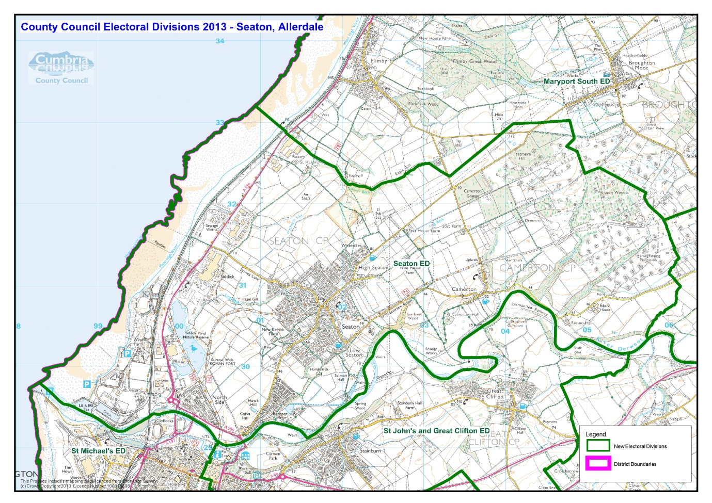

# Communities

The Electoral Division covers the Electoral Wards of Seaton includes the following:

* Seaton
* Camerton
* Barepot
* Siddick
* Northside

# Statistical Profile

*The 2011 Census estimated that the population of* ***Seaton Electoral Division (ED)*** *was* ***6411*** *persons.*

*The table below presents estimated numbers of residents in* ***Seaton******ED*** *by age group:*

|  |  |  |  |  |  |  |  |  |
| --- | --- | --- | --- | --- | --- | --- | --- | --- |
|  | **No. Persons by Age Group (Years)** | | | | | | | |
| **All Ages** | **0 - 14** | **15 - 29** | **30 - 44** | **45 - 59** | **60 - 74** | **75 - 84** | **85+** |
| *Seaton ED* | *6411* | *1109* | *1000* | *1254* | *1381* | *1183* | *350* | *134* |

*Source: Office for National Statistics, 2011 Census*

*The chart below compares the proportion of* ***Seaton ED’s*** *population within each age group with the proportion of the population within each age group across Allerdale district, Cumbria and England & Wales:*

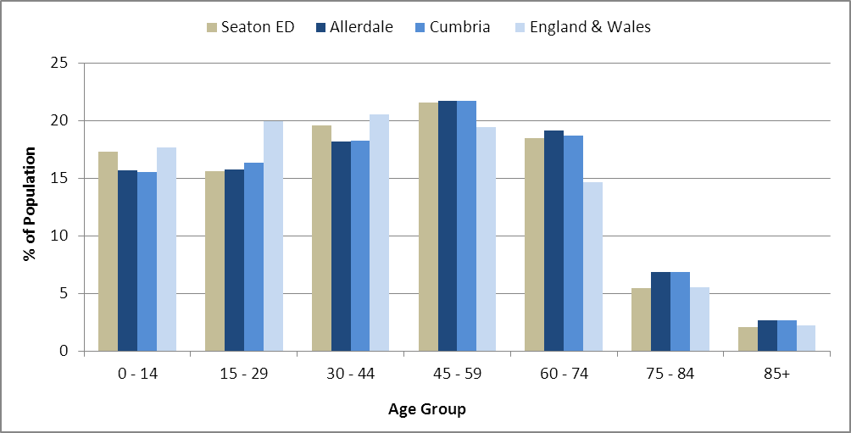

*Source: Office for National Statistics, 2011 Census*

*County Council Electoral Divisions cover large spatial areas and so division averages can mask variation between communities within the division. Furthermore, beyond Census data, there is little statistical information available for Electoral Divisions. However, most statistical agencies produce data for Electoral Wards. Therefore, there is a very wide range of statistical information available for Electoral Wards. Furthermore, as Electoral Wards are generally smaller than Electoral Divisions, statistics at this level provide more insight into variations between communities.*

*The table below identifies which Electoral Wards are fully or partially within the boundaries of* ***Seaton******ED****, and what proportion of* ***Seaton******ED****’s population live within each ward:*

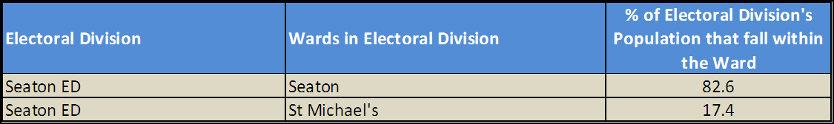

*Source: Cumbria Intelligence Observatory, 2013*

*The map below overlays Electoral Ward boundaries on to* ***Seaton******ED’s*** *boundary: 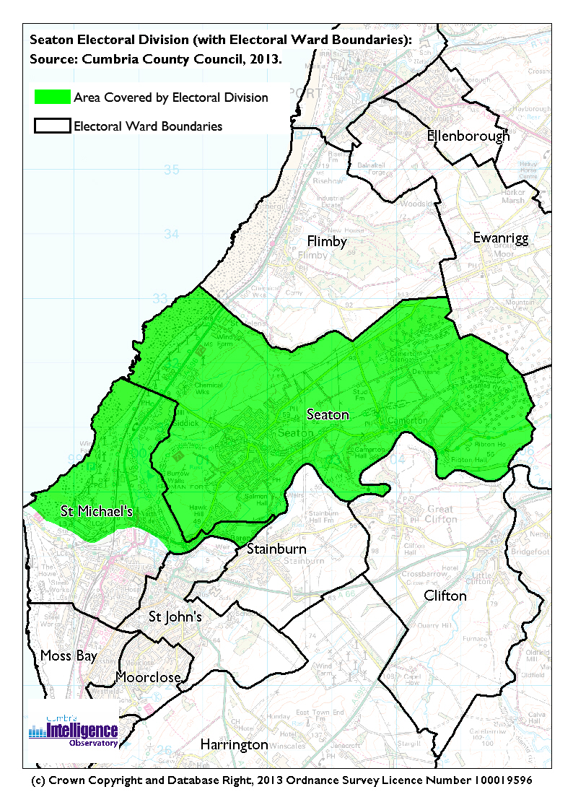The Cumbria Intelligence Observatory presents many Electoral Ward level statistics via the interactive ‘****Cumbria Atlas****’ tool. The Statistics provided within the* ***Cumbria Atlas*** *cover topics such as, but not limited to, population, housing, health, economy, poverty, ethnicity, language, and transport. The datasets within the* ***Cumbria Atlas*** *are regularly updated and expanded.*

*For simple step by step instructions to use the* ***Cumbria Atlas*** *to explore statistics for the wards within your Electoral Division, please visit the following web page:*

[*http://www.cumbria.gov.uk/eLibrary/view.asp?ID=56017*](http://www.cumbria.gov.uk/eLibrary/view.asp?ID=56017)

*The Information and Intelligence Team within Cumbria County Council are happy to talk you through using the Cumbria Atlas over the phone, or face to face. Training sessions can also be arranged for small groups.*

*To contact the team please call* ***01228 226309****, or email* [***info@cumbriaobservatory.org.uk***](mailto:info@cumbriaobservatory.org.uk)

# Parks, Open Spaces and Leisure Facilities

* Play areas in Northside, Siddick and Seaton
* Community centres in Siddick and Northside
* Village Halls in Seaton and Camerton
* Rugby pitch
* Football Pitch
* Cycle path
* Nature Reserve – Siddick
* River Derwent
* Bowling green

# Active Community Organisations

* Northside Community Centre
* Seaton Village Hall
* Seaton Parish Council - Parish Rooms
* Camerton Parish Council
* Seaton Village Pack Horse FC
* Seaton Athletics club
* Seaton Wives and Mothers
* Seaton Toddlers group
* Seaton Club for Young People
* 1st Seaton Scout Group
* Seaton Carnival Committee

# Key Communication Networks

The Villager

A monthly newsletter, delivered to all Seaton residents, produced by St Paul’s Church but covers a lot of community activity in the local area.

News & Star

A daily newspaper, produced by CN group; they produce different editions for North and West Cumbria.

Times and Star

Weekly newspaper produced by CN group for the Allerdale district of Cumbria they produce different editions for Maryport, Cockermouth and Workington

Cumberland News

The most widely read newspaper in Cumbria. This bridges the north and west communities.

BBC Radio Cumbria

Local radio station produced by the BBC for Cumbria

CFM Radio

Local radio station produced by the Bauer Media Group, covering Cumbria and Southwest Scotland

ITV News, Border region

Programme news, weather and information provided by ITV Broadcasting Limited for the England/Scotland border region, covering the majority of Cumbria, Dumfries and Galloway, the Scottish Borders and parts of Northumberland.

<http://www.itv.com/news/border/story/2013-10-11/get-in-touch/>

BBC News – Look North (North East & Cumbria)

Look North is the BBC's nightly regional news programme for the North East of England and Cumbria

<http://www.bbc.co.uk/programmes/b0070g1d/faq>

Cumbria Crack

An online facility for News in Cumbria <http://www.cumbriacrack.com/>

# Community Assets

Schools:

* Seaton C of E Junior School. Seaton Park, Workington. CA14 1HA. 01900 325232
* Seaton Academy. High Seaton, Workington. CA14 1NP. 01900 66982
* Northside Primary School. Northside, Workington. CA14 1BD. 01900 62255

Other:

* Village Halls
* Community centres
* Rugby Union building
* Royal British Legion
* Parish Rooms
* St Pauls Church
* Happy Hours Private Day Nursery

# Local Cumbria County Council Service Hubs

Seaton Library, Main Street, Seaton. CA14 1JD. 01900 32519

# Community Engagement

The area forms part of the Workington Wide. The other Councillors covering the Workington Area include:

Alan Barry – St Michael’s – 01900 604289

Joe Holliday – St Johns and Great Clifton – 01900 66319

Gerald Humes – Moss Bay & Moorclose – 01900 63976

Marjorie Rae – Harrington & Salterbeck 01946 831004

|  |  |
| --- | --- |
| Key Community Contacts | |
| Cumbria County Council | Area Support Team,  Cumbria County Council,  2nd Floor Workington Library,  Vulcan’s Lane, Workington  Cumbria, CA14 2ND  01900 706010  [allerdaleteam@cumbria.gov.uk](mailto:allerdaleteam@cumbria.gov.uk) |
| Cumbria County Councillor | Mrs Celia Tibble  10 Greengate, Seaton, Workington, Cumbria, CA14 1PH  01900 601302 |
| Allerdale Borough Council | Allerdale House, Workington, Cumbria, CA14 3YJ.  01900 702702 |
| Workington Town Council | Old Town Hall, Oxford Street, Workington, Cumbria. CA14 2RS  01900 702986 |
| Northside Community Centre | Trinity Drive, Northside  CA14 1AX.  01900 68739 |
| Seaton Village Hall | Well fare Lane  Causeway Road, CA14 1PN  07513167955. |
| Seaton Parish Council | Parish Rooms,  Causeway Road, Seaton.  01900 603194 |
| Camerton Parish Council | Clerk; Mr J Stephens  127 The Parklands  Cockermouth  CA13 0XJ  01900 822837 |