

**Maryport North**

**Electoral Division Profile**

**2014**

# Overview of Electoral Division

Maryport North electoral division covers the Town Centre of Maryport, the residential areas of Glasson and Netherhall, the harbour and the northern villages of Crosscanonby, Crosby and Crosby Villa.

Maryport is an attractive coastal town and civil parish within the borough of Allerdale. It is located on the A596 road north of Workington and is the southernmost town on the Solway Firth. The town has a rich Roman heritage and the harbour has seen recent investment to become a tourist destination.

There are sweeping views, shoreline walks, golf links, coastal sailings and summer festivals.

# Map

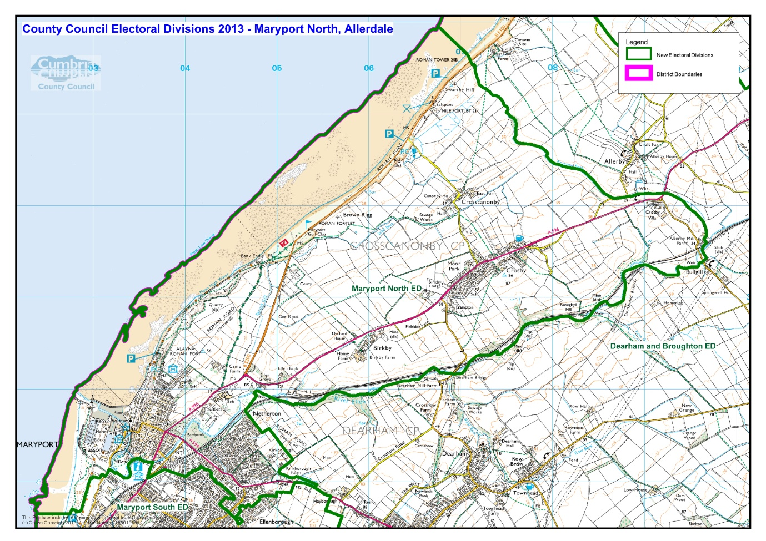

# Communities

Maryport town is split into two Electoral Divisions; Maryport North and Maryport South. The North Electoral Division includes the communities of;

|  |  |  |
| --- | --- | --- |
| * Glasson * Crosby * Ellenborough (Part of) | * Netherall * Crosby Villa | * Netherton * Crosscannonby |

# Statistical Profile

# 

The 2011 Census estimated that the population of Maryport North Electoral Division (ED) was 6754 persons.

The table below presents estimated numbers of residents in Maryport North ED by age group:

|  |  |  |  |  |  |  |  |  |
| --- | --- | --- | --- | --- | --- | --- | --- | --- |
|  | **No. Persons by Age Group (Years)** | | | | | | | |
| **All Ages** | **0 - 14** | **15 - 29** | **30 - 44** | **45 - 59** | **60 - 74** | **75 - 84** | **85+** |
| *Maryport North ED* | *6754* | *946* | *1084* | *1301* | *1336* | *1423* | *457* | *207* |

*Source: Office for National Statistics, 2011 Census*

The chart below compares the proportion of Maryport North ED’s population within each age group with the proportion of the population within each age group across Allerdale district, Cumbria and England & Wales:

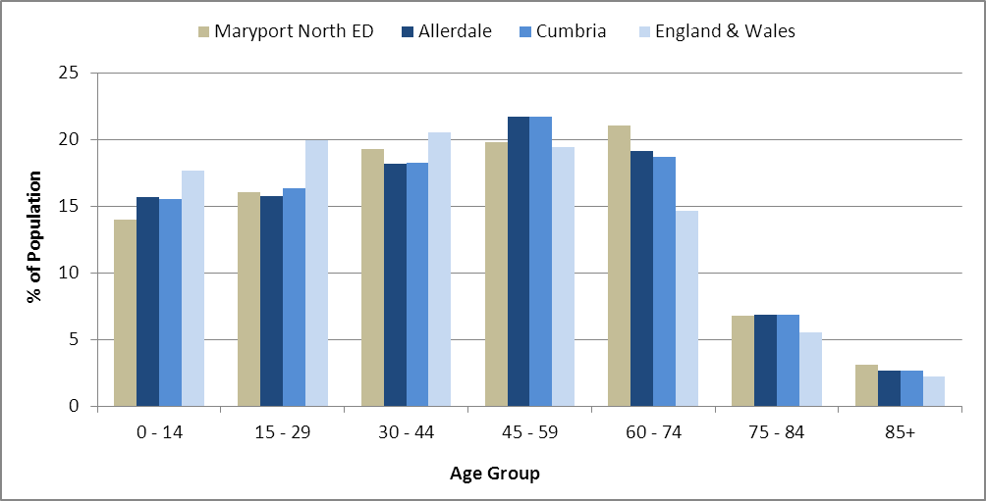*Source: Office for National Statistics, 2011 Census*

County Council Electoral Divisions cover large spatial areas and so division averages can mask variation between communities within the division. Furthermore, beyond Census data, there is little statistical information available for Electoral Divisions. However, most statistical agencies produce data for Electoral Wards. Therefore, there is a very wide range of statistical information available for Electoral Wards. Furthermore, as Electoral Wards are generally smaller than Electoral Divisions, statistics at this level provide more insight into variations between communities.

The table below identifies which Electoral Wards are fully or partially within the boundaries of Maryport North ED, and what proportion of Maryport North ED’s population live within each ward:

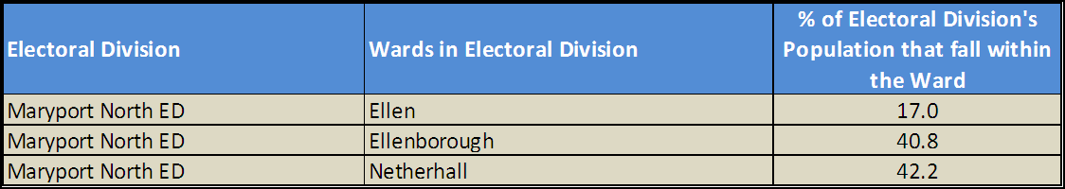*Source: Cumbria Intelligence Observatory, 2013*

The map below overlays Electoral Ward boundaries on to Maryport North ED’s boundary: 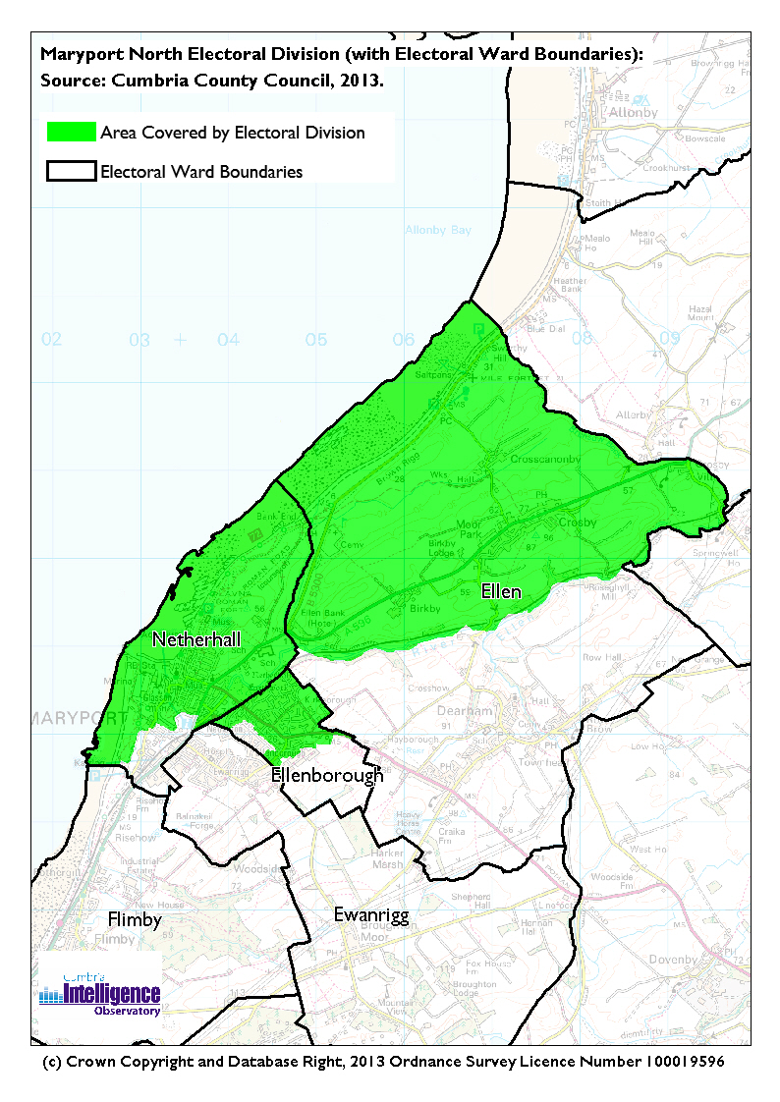

The Cumbria Intelligence Observatory presents many Electoral Ward level statistics via the interactive ‘Cumbria Atlas’ tool. The Statistics provided within the Cumbria Atlas cover topics such as, but not limited to, population, housing, health, economy, poverty, ethnicity, language, and transport. The datasets within the Cumbria Atlas are regularly updated and expanded.

For simple step by step instructions to use the Cumbria Atlas to explore statistics for the wards within your Electoral Division, please visit the following web page:

<http://www.cumbria.gov.uk/eLibrary/view.asp?ID=56017>

The Information and Intelligence Team within Cumbria County Council are happy to talk you through using the Cumbria Atlas over the phone, or face to face. Training sessions can also be arranged for small groups.

To contact the team please call 01228 226309, or email [info@cumbriaobservatory.org.uk](mailto:info@cumbriaobservatory.org.uk)

# Parks, Open Spaces and Leisure Facilities

* Community allotments
* Hallclose Wood
* Mote Hill
* Cumbrian coastline
* Play areas including;
  + Crosby
  + Ellenborough Moor
* Netherhall Swimming Pool
* Netherhall Community Sports Centre
* West Coast Karting
* Lake District Coastal Aquarium
* Maryport Golf Club
* Rugby clubs
* Football clubs
* Numerous uniformed groups:
  + Scouts
  + Sea Cadets
  + Brownies
  + Girls Brigade
  + Cubs
* Clip and Climb (indoor climbing wall)
* Crazy Golf

# Active Community Organisations

* Ewanrigg & Netherton Community Centre
* Ewanrigg & Netherton Tenants and Residents Association
* Boys and Girls Club (Youth Club)
* Maryport Gym (Fit4Life Gym)
* Crosscanonby Community Centre

# Key Communication Networks

News & Star

A daily newspaper, produced by CN group; they produce different editions for North and West Cumbria.

Times and Star

Weekly newspaper produced by CN group for the Allerdale district of Cumbria they produce different editions for Maryport, Cockermouth and Workington

Cumberland News

The most widely read newspaper in Cumbria. This bridges the north and west communities.

BBC Radio Cumbria

Local radio station produced by the BBC for Cumbria

CFM Radio

Local radio station produced by the Bauer Media Group, covering Cumbria and Southwest Scotland

ITV News, Border region

Programme news, weather and information provided by ITV Broadcasting Limited for the England/Scotland border region, covering the majority of Cumbria, Dumfries and Galloway, the Scottish Borders and parts of Northumberland.

<http://www.itv.com/news/border/story/2013-10-11/get-in-touch/>

BBC News – Look North (North East & Cumbria)

Look North is the BBC's nightly regional news programme for the North East of England and Cumbria

<http://www.bbc.co.uk/programmes/b0070g1d/faq>

Cumbria Crack

An online facility for News in Cumbria <http://www.cumbriacrack.com/>

# Community Assets

Schools:

* Maryport C of E Junior School
* Crosscannonby St. Johns C of E School
* Netherton Infant School
* Netherhall School
* Maryport Infant School
* Netherhall Adult Education Centre

Churches:

* Harbour Light Church, The Wave Centre, Irish St, Maryport
* Trinity Baptist Church , Maryport
* St Mary’s Church , https://maps.gstatic.com/intl/en_uk/mapfiles/transparent.pngChurch Street, Maryport
* Saint Mark's Methodist Church , Kirkby Street, Maryport
* Christ Church Maryport, Maryport
* All Souls' Church, Netherton, Maryport‎
* Ellenborough Methodist Church , Ellenborough Old Road, Maryport
* St Johns Evangelist Church, Crosscanonby

Other:

* The Wave – an entertainment, conference and heritage visitor centre
* Maryport Community Arts Organisation
* The West Coast Aquarium
* Senhouse Roman Museum
* Maritime Museum
* The Millennium Garden

# Local Cumbria County Council Service Hubs

* **Maryport Library**
* **West Allerdale SureStart Children’s Centre**

# Community Engagement

The Maryport engagement area includes Maryport North, and Maryport South and Dearham & Broughton electoral divisions.

The Councillors for the Maryport engagement area are:

* Carni McCarron –Holmes - Maryport North 01900 812834
* Keith Little – Maryport South 01900 812981
* Alan Clark – Dearham & Broughton 01900 601642

|  |  |
| --- | --- |
| Key Community Contacts |  |
| Cumbria County Councillor | Mrs Carni McCarron-Holmes  3 Criffel Avenue, Maryport, Cumbria, CA156JJ  Tel: 01900 812834 |
| Maryport Town Council | Town Hall, Senhouse Street  Maryport, Cumbria,  CA15 6BH  [clerk@maryporttowncouncil.gov.uk](mailto:clerk@maryporttowncouncil.gov.uk)  Tel: 01900 813205 |
| Cumbria County Council  Area Support Team | 2nd Floor Workington Library  Vulcans Lane, Workington,  Cumbria, CA14 2ND  Tel: 01900 706010  allerdaleteam@cumbria.gov.uk |
| Allerdale Borough Council | Allerdale House  Workington, Cumbria, CA14 3YJ  Tel: 01900 702702 |
| Home Group Ltd | 2 Bounty Avenue, Maryport,  Cumbria, CA15 8HY  Tel: 08456063033 |
| Anchor Trust | Solway Court, Crosby Street,  Maryport  Cumbria, CA15 6LF  Tel: 01900 815418 |