Guidance on Prejudicial Incidents
April 2013

1. Introduction Page 1

2. Tips for managing Prejudicial Incidents Page 4

3. How to use the On-Line Prejudice reporting system Page 5

1. Introduction
This document sets out council’s approach to reporting and addressing prejudicial incidents, and includes definitions and examples of prejudicial incidents, as well guidance on how to use the Council’s incident reporting system.

What is a prejudicial incident?
A prejudicial incident is a type of harassment in which the behaviour is perceived to be motivated by prejudice. In particular prejudicial incidents focus on harassment that is targeted at people who are protected under the Equality Act on the grounds of:
- Age
- Disability
- Race
- Sex
- Religion/belief
- Sexual orientation
- Marriage and Civil Partnership
- Pregnancy and maternity
- Gender reassignment

Examples where people perceive themselves to be victims of prejudice
Gender: A female member of staff is feeling stressed and a male colleague comments that it ‘must be her time of the month’. She feels hurt by the way he said this to another member of staff and that it is a slur on her gender.

Disability: A member of staff who needs to use a voice synthesiser to communicate becomes frustrated with a service user who keeps calling him Stephen Hawking and imitating his voice. At first he went along with it but now he has had enough.

Religion/Belief: A Muslim service user was waiting for an appointment and a member of the public joked with the receptionist – ‘I see you are taking in bombers’. The receptionist showed no reaction, but the Muslim service user felt more could have been done to challenge the statement.

Sexuality: A gay member of staff finds that people do not make him a cup of coffee as they do with others. One day he overheard someone saying that they hope they do not catch AIDS from him. He felt hurt and unsupported in his team.

Ethnicity: A Black member of staff is giving a report to elected Members, when one of the Members asks ‘where do you come from.’ She feels this is totally irrelevant to her report and she is only asked this because she has a black face.

Age: A young member of staff working at a public kiosk feels that customers ignore him and speak to his colleague who is 20 years older.

Prejudicial incidents can involve any of the following:
- Verbal abuse, threats and name-calling.
- Prejudicial graffiti.
- Prejudicial comments in the course of discussions.
- Physical intimidation.
- Violent attacks because of a person’s identity.
- Incitement of others to behave in a prejudicial way.
- Refusal to co-operate/work with other colleagues, Members or the public because of their identity.
- Ridicule of cultural or physical differences e.g. food, dress, language, names, appearance.
- Prejudicial jokes (including those circulated on electronically).
- Damage caused to a person’s property.
- Possession/distribution of prejudicial material.
- Wearing prejudicial badges/insignia.

What is the scope of an incident?
An incident can cover the following people:
- Between employees at the same level of the organisation
- Between employees and line managers or more senior staff.
- Between employees and members of the public (including those who use services). 3rd party harassment.
- Between members of the public where an employee intervenes, or witnesses while they are at work.

Who should report incidents?
Any elected Member or employee can report an incident directly, or their line manager can do this on their behalf, or they can report to Policy, Planning and Communities

Is it compulsory for you to record an incident?
No, it is not compulsory to report an incident, and anyone can seek advice from the Strategic Policy Advisor (Equalities), (01228) 226639, cccequality@cumbria.gov.uk

How will incidents be reported?
A member of staff who wants to report an incident has three routes available.
- Speak to line manager about the incident.
- Contact the Strategic Policy Advisor (Equalities) by telephone (01228) 226639, cccequality@cumbria.gov.uk
- Complete the on-line Prejudicial Incident report that is available on the Council’s Intranet In-Touch http://www.intouch.ccc/equalities/intranet/reportform.asp

How will incidents be monitored?
Incidents are logged on a database, which provides anonymised information.

Is there any difference between harassment and prejudicial incidents?
Harassment occurs when someone feels that another person, or group, has treated them unfairly. Often harassment involves someone abusing their power, either because of their position or because they try to use physical, intellectual or emotional means to belittle someone else. The Equality Act (2010) gives employees and service users rights against harassment, and includes the concept of Third Party Harassment. This is where an employee perceives themselves to be harassed by a member of the public who is neither their employee or a co-worker.

Harassment
At a staff meeting a line manager points at a member of staff: ‘You are letting us all down with your poor performance, I don’t know why you bother coming to work.’

Third Party Harassment
A member of staff is told by a visitor: ‘You are a waste of space, I don’t know why you bother doing your job.’

Prejudicial Incident
At a staff meeting the line manager points at a member of staff: ‘Women like you are letting us down with your poor performance. I don’t know why you bother coming to work.’

Is there a difference between the Council’s Dignity and Respect Policy and Prejudicial Incidents?
The Council’s Dignity and Respect Policy sets out the:
- Council’s stance on overall forms bullying and harassment.
- Support available to victims of bullying and harassment.
- Process for investigation and grievance procedures.

The Dignity and Respect Policy covers employees who feel they are victims of bullying and harassment. The perpetrators can be other employees, members of the public, clients and Members.

The Prejudicial Incidents apply to any of the Council’s dealings. This definition would cover a prejudicial incident between two clients of a County Council service that comes to our attention.

2. Tips for managing Prejudicial Incidents

Be aware of subtle forms of prejudice
It is important to realise that many incidents will be subtle, including behaviour that take the forms of ignoring a person, not allowing a person to join in, not sharing with a person.

Remember the victim may be more aware than other people
Prejudice can often only be obvious to the person experiencing it and while victims should certainly be encouraged to report incidents, staff should not wait for victims to take the initiative.

Remember to respond and ‘nip it in the bud’
A response is necessary to all incidents and all incidents are dealt with swiftly and effectively, no matter how small an incident seems to be.

Make reporting part of ‘normal’ business
Following up a prejudicial incident can be sensitive and difficult for everyone. It is easier when:
- The entire team is aware of the procedure and their roles and responsibilities
- Staff feel safe to report incidents, whether victims or witnesses
- There is a history of taking reports seriously and following them up
- These issues are routinely and openly discussed and such discussion is an integral part of the management of the team.

Tips for responding to an incident

Initial Response
- Treat the issue seriously
- Respond immediately
- Reinforce the Council’s position
- Support and affirm the victim
- Focus on the perpetrator’s behaviour, rather than the person, making sure he/she knows that the behaviour will be addressed.
- Explain how prejudice develops from stereotyping of an individual.
- Make sure that any witnesses know that the behaviour is being addressed.

Local resolution
  - Speak to both parties on the spot, or as soon as possible.
  - Reinforce the Council’s position.
  - Check that the victim or person reporting the incident is satisfied with the response.
  - Check that the perpetrator understands why the issue was raised.
  - Decide whether further action should take place.

Investigation
Any formal investigation must be in line with the requirements set out in the Council’s Dignity and Respect Policy. For more information log on to:
http://www.intouch.ccc/humanresources/policiesprocedures/sickabwelfare.asp

3. How to use the online Prejudice Reporting system
This section provides a step by step guide to using the Council’s on-line Prejudicial Incident form.

Enter the Intranet
Click onto the Council’s intranet In-Touch. On the home page scroll down to the bottom bar and click on Equality.

Enter the Equality and Diversity Website
The next screen says Equality for All in Cumbria. Scroll down to the link called ‘Prejudicial Incident Reporting and Hate Crime’. Click on the ‘Prejudice Incident report Form’ link.

First screen introduction
This screen explains that all reports go direct to the Strategic Policy Advisor (Equalities) who will treat the information in confidence.

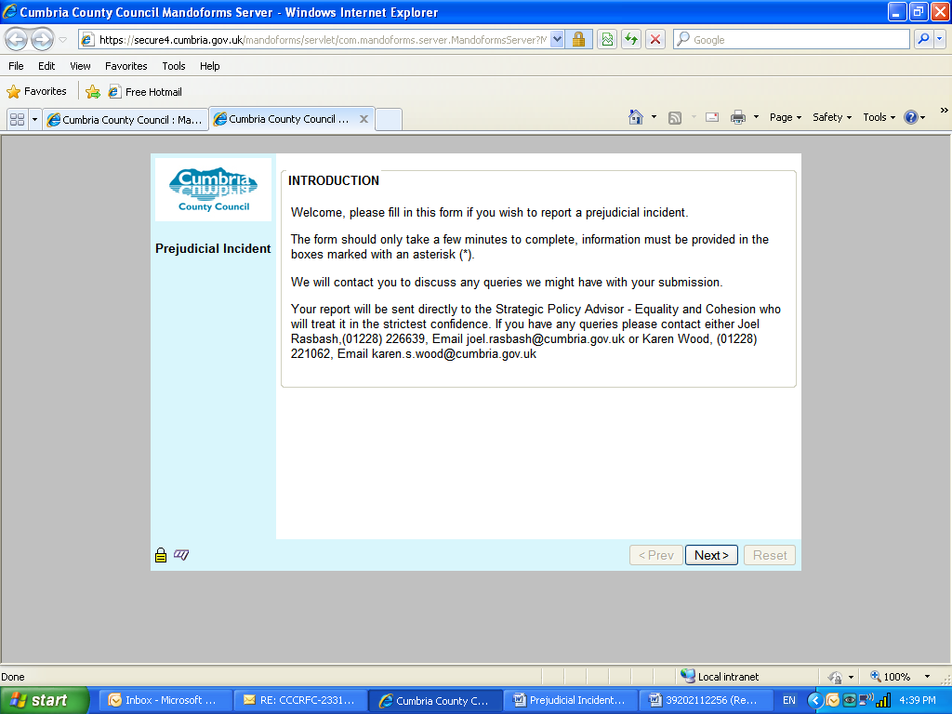
Then click next.

Second screen Data Protection
This screen explains that all information will only be processed for the purposes it was submitted. You are then asked to agree to your information being held for the reasons agreed. You click ‘I agree’ if you want to continue.

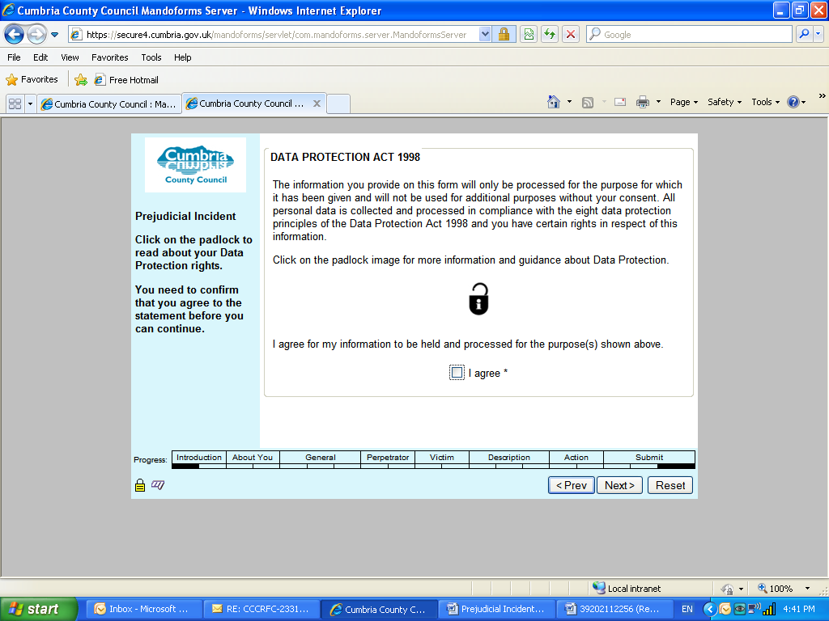
At the bottom of the screen there are two buttons: Back and Next. Click next to move to the third screen.

Third screen Your Details
This screen has fields with:
- Your name
- Telephone
- Directorate
All these fields are compulsory. If you want to be anonymous you can write Anonymous.

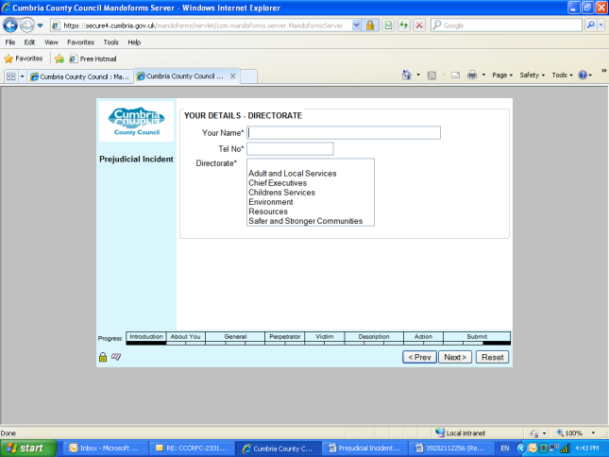
At the bottom of the screen there are two buttons: Back and Next. Click next to move to the fourth screen.

Fourth screen Your Details
This screen has a field which asks your unit. The options here are based on the Directorate you select.
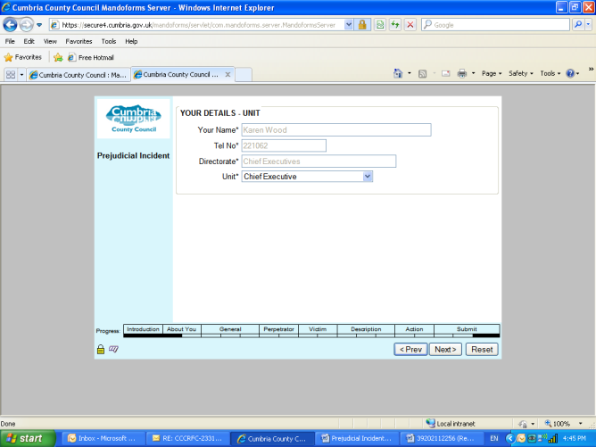
At the bottom of the screen there are two buttons: Back and Next. Click next to move to the fifth screen.

Fifth screen General details of the incident
This screen has a field asking for the Directorate where the incident took place. This screen is compulsory.
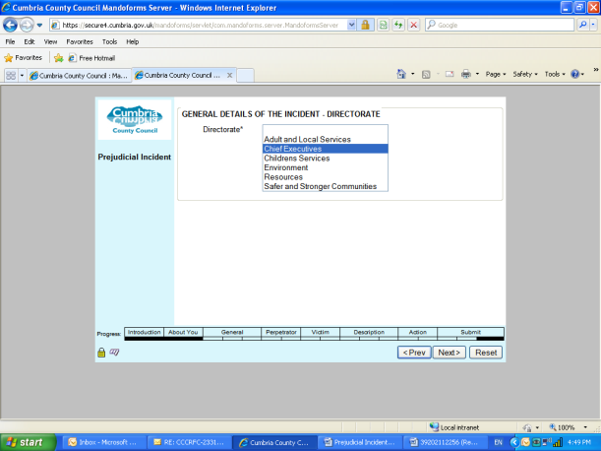
At the bottom of the screen there are two buttons: Back and Next. Click next to move to the sixth screen.

Sixth screen General details of the incident
This screen has a field asking for the Unit where the incident took place. This page is compulsory.

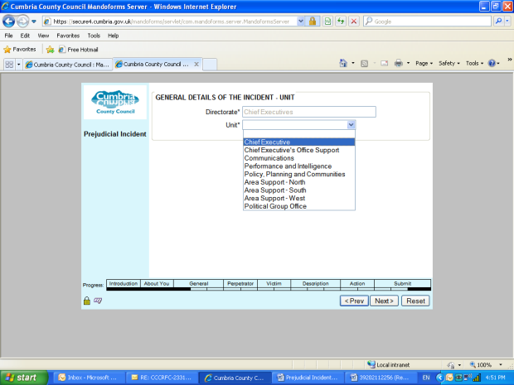
At the bottom of the screen there are two buttons: Back and Next. Click next to move to the seventh screen.

Seventh screen General details of the incident
This screen has fields with:
- Location
- Post Code
- Date
- Type of prejudice
The Location is compulsory, this may include any building such as County Hall in Kendal, or it may be off site, such as on a street, or in a vehicle such as a bus or car.
The post code field is optional.

The date is compulsory. You need to make sure you put in the full year, so if you type 13 you will be told that the date is not recognised. If you type 2013 you will be able to go to the next screen.

The type of prejudice covers the following protected characteristics:
- Race
- Gender/Gender reassignment
- Homophobia
- Age
- Disability
- Religion/belief
- Sex/Sexual orientation
- Marriage and Civil Partnership
- Pregnancy and Maternity

This field is compulsory and you need to click the type of prejudice. Where more than one type of prejudice is being recorded, tick the dominant type of prejudice.

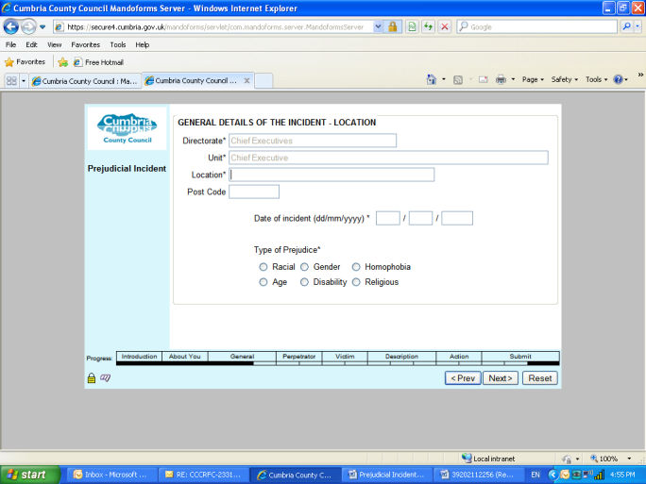
At the bottom of the screen there are two buttons: Back and Next. Click next to move to the eighth screen.

Eighth screen Perpetrator details
This screen has fields asking:
- If there is one or more than one perpetrator.
- Type of perpetrator (based on the ring leader if there is a group).

Both of these fields are compulsory.

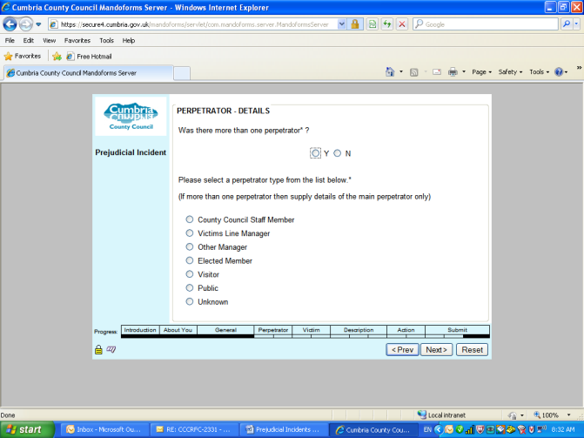
At the bottom of the screen there are two buttons: Back and Next. Click next to move to the ninth screen.

Ninth screen Perpetrator
This screen has fields asking monitoring questions about the perpetrator:
- Ethnic origin
- Sex
- Sexual orientation
- Disability
- Religion
- Age
All fields are compulsory. You can click undeclared or unknown for each field.

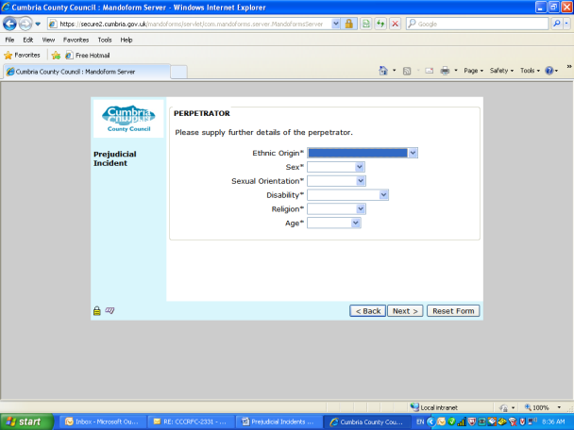
At the bottom of the screen there are two buttons: Back and Next. Click next to move to the tenth screen.

Tenth screen Victim details
This screen has fields asking:
- If there is one or more than one victim.
- Type of victim (based on the ring leader if there is a group).

Both of these fields are compulsory as we need to map whether incidents are taking place between individuals or whether groups are being victims of prejudice. An example where you may click more than one victim is where some makes a statement about all people in a group.

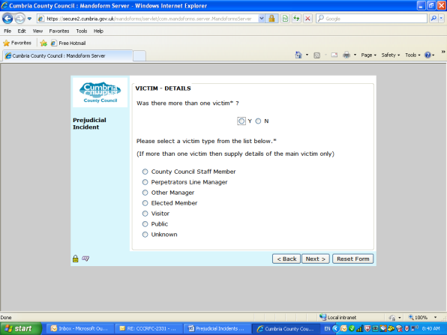
At the bottom of the screen there are two buttons: Back and Next. Click next to move to the eleventh screen.

Eleventh screen Victim
This screen has fields asking monitoring questions about the victim:
- Ethnic origin
- Sex
- Sexual orientation
- Disability
- Religion
- Age
All fields are compulsory. This is because we need to develop a picture which groups are more likely to be victim. If we notice a particular pattern we can develop training and development aimed at particular groups.

If you do not know the victim’s ethnicity, gender, sexuality, age, disability status or religion, you can click undeclared. Under religion you can click non-religious.

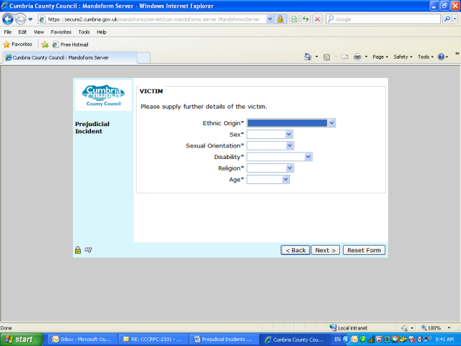
At the bottom of the screen there are two buttons: Back and Next. Click next to move to the twelfth screen.

Twelfth screen Nature of incident (screen 1 of 2)
This screen has a range of fields asking about the nature of the incident:
- Disrespect
- Non co-operation
- Verbal harassment
You can tick as many boxes as you feel describe the incident. You must tick at least one of the fields on the twelfth or thirteenth screens.

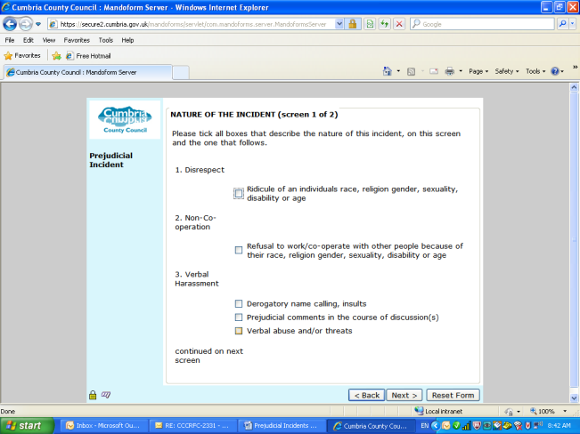
At the bottom of the screen there are two buttons: Back and Next. Click next to move to the thirteenth screen.

Thirteenth screen Nature of incident (screen 2 of 2)
This screen has a range of fields asking about the nature of the incident:
- Physical harassment
- Other
You can tick as many boxes as you feel describe the incident. You must tick at least one of the fields on the twelfth or thirteenth screens.
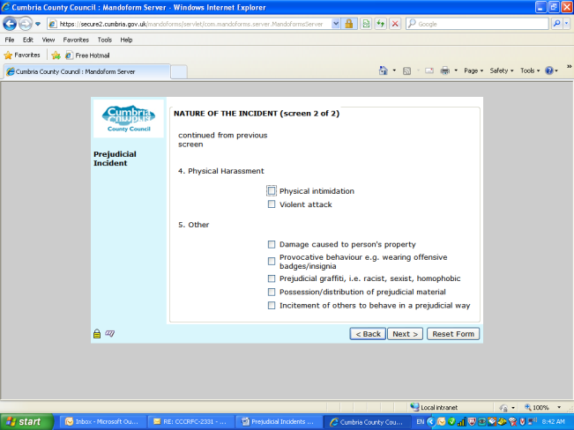
At the bottom of the screen there are two buttons: Back and Next. Click next to move to the fourteenth screen.

Fourteenth screen Brief description of the incident
This screen asks for a summary of the incident. This is open text field to capture the qualitative information about the incident. The field is compulsory as we need to know what took place.

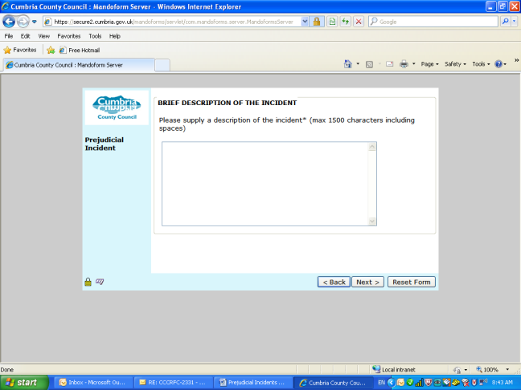
At the bottom of the screen there are two buttons: Back and Next. Click next to move to the fifteenth screen.

Fifteenth screen Action taken
This screen has a field asking about further action taken. This includes:
- Spoke to parties
- Put the issue in writing to parties
- Contacted police hate crimes officer
- Recorded incident on the perpetrators personnel file
- Initiated grievance procedure
- Initiated disciplinary procedure
- Sent Memo to staff
- Other

This screen is compulsory as we need to ensure that all incidents are being dealt with and how they are being dealt with.

