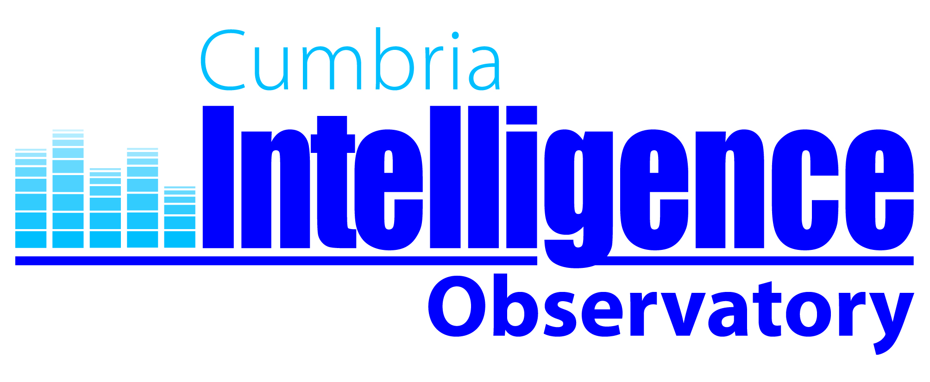

How Cumbria Intelligence Observatory Can Help You

Cumbria Intelligence Observatory is here to support anyone interested in finding out more about Cumbria. The research, information and intelligence held by the observatory has multiple uses from helping to inform strategic planning to identifying the safest area to live when moving house.

For examples of the different ways that the Observatory helps support a wide range of users please see below:

- Senior Managers: provides a broad understanding of the needs and aspirations of communities in Cumbria to help support the strategic planning of services.
- Service Manager: provides quantitative information to support the delivery of targeted, high quality, customer focused and efficient services.
- Policy Advisor: helps to quantify the impact of national policy change on local areas and services.
- Elected Member: provides quantitative information to support and evidence personal understandings of their local area. Provides comparisons about how the area and services they represent are performing against others.
- Voluntary and Community Sector: provides information to support funding bids, help target services and strengthen advocacy.
- Business: provides demographic and socio-economic information to help businesses planning to set up, expand or invest.
- Data Analyst: provides a universal and accessible hub for all of the shared data and intelligence about Cumbria.
- Academics & Students: provides a wide range of qualitative and quantitative information to support profiling, research, presentations and studies.
- Press: provides easy access to the latest social and economic statistics about Cumbria to support news stories.
- General Public: helps people find out key information about their local area from house prices, to crime levels, to educational attainment.

The data and information held by the Observatory covers a range of themes including the economy, health and wellbeing, deprivation and crime and community safety and is available down to Parish level. You can access the information by visiting the Cumbria Intelligence Observatory website at: http://www.cumbriaobservatory.org.uk/

If you can not find what you need on the website the Observatory team are always happy to help you meet your data requirements. You can contact us at: info@cumbriaobservatory.org.uk

