


Arnside National School
Church Hill, Arnside
Carnforth, Lancs
LA5 0DW
Email: admin@arnside.cumbria.sch.uk
www.arnside.cumbria.sch.uk/index.html
Tel/Fax: 01524 761159

NSS – National Support School
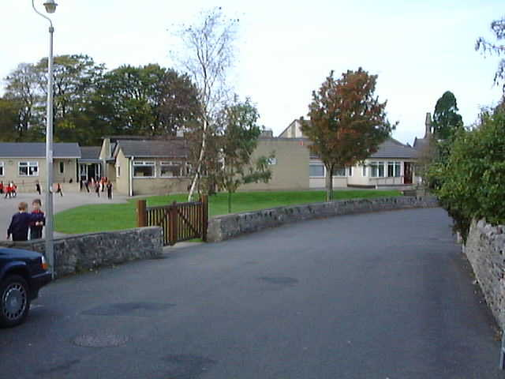





Headteacher: Mr A R Cook B.Ed(Hons) NLE National Leader of Education Telephone & Fax: (01524) 761159

APPENDIX A 1 November 2010

Dear Consultee

ARNSIDE NATIONAL CE VOLUNTARY AIDED PRIMARY SCHOOL – POSSIBLE NURSERY PROVISION

The Governing Body of Arnside Primary School would like to provide maintained nursery education at the school. The purpose of this letter is to invite comments on this possibility.

In order to establish a nursery it would be necessary for the Governors to publish a formal proposal to change the age range of children for which the school can cater. The school is currently able to provide education for children aged 4 to 11 but, if the age range is changed, it would be able in the future to cater for children aged 3 to 11.

Arnside has already fully embraced the Early Years Foundation Stage (EYFS) curriculum and all requirements have been followed for its reception pupils. In practice, the children currently attending the school will see no difference to their provision. New children entering the school will benefit from the same experience as older children who have attended the school in recent years.

Nursery children will be incorporated fully into the school. Nursery provision will be available either as a separate nursery class or as part of a mixed Early Years Foundation Class depending on numbers. The school already has suitable toilet and outdoor facilities for very young children.

Children will be allowed to attend the Nursery facility from the start of the term following their third birthday in line with Authority guidelines. Nursery education is not statutory; parents can choose whether they wish to take up their entitlement to a free place.

It is not intended, as an integral part of this proposal, to offer care other than during the standard education nursery sessions. Were the change of age range to be approved, the pupils may be taught with reception age pupils. The children would follow the foundation stage of the National Curriculum. The number of children who would be catered for during each session is likely to be 24.

Any change in the school’s age range would take effect from 1 September 2011. It is anticipated that the proposed nursery class would initially operate one session each day (Monday to Friday) and that sessions will be 3 hours duration each. It is proposed that these sessions will be from 9.00am to 1200 am, Monday to Friday, during term time. There is no other registered nursery provision within the catchment area for Arnside School. There is a local playgroup in the village. Currently children move from there to Milnthorpe Primary some 5 miles away to access nursery education.

A decision on the application for change of age range may not be made until after the usual date by which parents need to apply for a nursery place starting in September 2011. If parents would like their child to attend the proposed nursery provision at Arnside it would be helpful if they could let the school know of their wish to apply for a place in the nursery were it to be established

Admission to the nursery would be in accordance with the Governor’s ‘nursery admission policy’. Admission to the nursery would not guarantee a place in the reception group of the school that is governed by a separate policy.

If the proposal is approved transport will be provided for nursery children at the school in line with the Authority’s nursery transport policy.

The published number for admission to the reception group at the school is currently 24 (ie for entry in 2011/12) and this will not be affected by the addition of a Nursery. It is not intended that any pupils who would wish to attend the school be precluded as a result of the establishment of a nursery.

If you would like further information on the suggested nursery or its implications for the organisation of the school, this can be obtained by contacting Mr A Cook, Head Arnside National School, Church Hill, Arnside, Carnforth, Lancs LA5 0DW (Tel. 01524 761159 )

Your views on the possibility outlined in this letter would be very much welcomed. The deadline for comments is Friday 10 December 2010. These can be sent by completing the attached pro-forma or sending a letter to Arnside National School, Church Hill, Arnside, Carnforth, Lancs LA5 0DW.

I look forward to hearing from you.

Yours faithfully

Mr I Dudley
Chair of Governors

How to respond:

Complete the reply slip overleaf and return it by post to

Arnside National School,
Church Hill
Arnside
Carnforth
Lancs
LA5 0DW

Or by email to: admin@arnside.cumbria.sch.uk – the form can be accessed via our website: www.arnside.cumbria.sch.uk

The deadline for responses is Friday 10 December 2010

REPLY SLIP

Arnside National School

Proposal for change of age range to provide maintained nursery provision.

Please tick:

I support the proposal [ ].

I do not support the proposal [ ].

Additional comments

Please indicate your interest in this proposal by ticking one of the boxes below.

I am

A parent of a pupil at Arnside Primary School [ ]

A parent of a child attending the existing nursery at Arnside Primary School [ ]

A member of staff at Arnside Primary School [ ]

A Governor at Arnside Primary School [ ]

A member of the local community [ ]

Other (please indicate)……………………………………… [ ]

Signed………………………………………

Address…………………………………………………………………………

………………………………………………Postcode……………………….

Date……………………….

