



ARNSIDE

NATIONAL SCHOOL



NSS – National Support School

Business Plan for
Nursery and Change of Age Range at Arnside National School
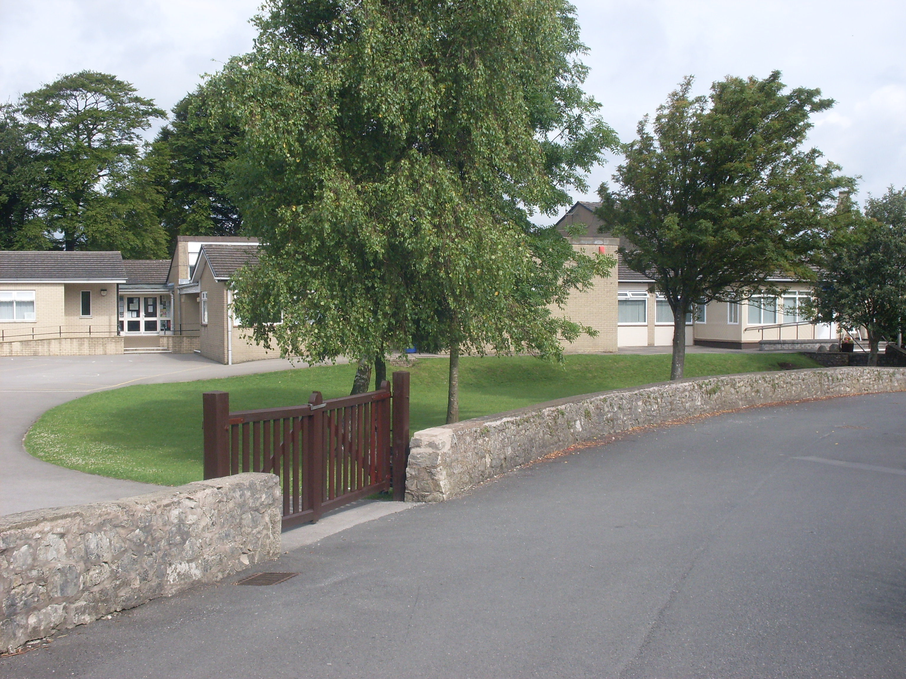
SECTION A

Context

The need for nursery provision in Arnside has been driven by parents who feel there is a definite need for provision within a community of this size. Parents have made representations to the school governors and they have genuine concerns regarding a lack of suitable provision within the area, parents currently travel five miles to Milnthorpe. It is our understanding that Milnthorpe was oversubscribed this year and that some parents were unable to secure a place. There is currently only a local ‘playgroup’ which offers any form of care and at the age of three these children move on to Milnthorpe Nursery. There has previously been a private provider in the community ‘ Greycote Nursery’ but it has not been in operation now for a number of years and consequently opportunities for parents have been reduced and demand cannot be fulfilled.

This business plan has been initiated by the school governors and was discussed, unanimously agreed and minuted at the meeting of 27th April 2010.

Description of Childcare Services

It is anticipated that provision will begin in Sept 2011 or Sept 2012 at the latest.

It is expected that provision will be from 9.00-12.00 Monday-Friday. Fifteen hours per week, term time only.

Nursery provision will be available either as single entry to a designated nursery class or as part of a mixed EYFS class depending on numbers. Arnside School is in the fortunate position that all facilities are already in place eg toilet provision, external play facilities etc. Minor building adaptations on approval will provide improved facilities for Early Years and all Key Stage 1 children.

Children will follow the EYFS curriculum with emphasis on continuous provision.

Children will be fully integrated into school and have access to extended group activities and opportunities.

Advice and Support

Advice and Support has been sought from a variety of sources:

Colin Milner. Headteacher Grange CE Primary School ) both schools have
Chris Brooksbank. Headteacher Flookburgh CE Primary School ) nursery provision.
Janice Brockbank. Haverigg Primary School currently proposing nursery provision.
Vanessa Connor.
Mary Wilkinson.
Kay Cook
Amanda McDonald) Site Visit
Daniel Taylor ) Capita Design and Business
Emma Plummer and Gary Armstrong. Asset Management and Business Dept.
Mike Tuer.

Consultation with the County Council

Most of the above are employees of Cumbria County Council.
In addition, Dale Hill SIO/SIP has been engaged in the process and has brokered support when required.
In addition, and very importantly, catchment area numbers and projected LA numbers for 2011, 2012 and 2013 are very healthy and upwards year on year. This has been a major factor in driving demand for immediate and sustained provision.

SECTION B

Market Research

There is an undoubted demand for nursery provision in Arnside and the surrounding community. The closure of private provision and the demand for suitable pre-school childcare for three year olds is a major issue within the community.

This process has been initiated by a groundswell of parental demand who feel aggrieved that they have to travel approximately five miles and in some cases more than that to access nursery education, especially when there is undoubted demand within the community.

Projected figures provided by the local authority indicate:

Catchment Area Numbers | Projected LA Numbers
2011 14 | 18
2012 15 | 19
2013 19 | 24

Market Considerations (Section A)

Local playgroup leader, Lisa Brockbank, has been consulted and confirms that playgroup will not be affected as children in their care leave to take up nursery provision immediately they are eligible.

The headteacher at Milnthorpe School is aware that Arnside School is currently considering nursery provision. I am informed that Milnthorpe Nursery was over subscribed in 2010.

The governors of Arnside School see no significant threat to other providers, more significantly, data shows that demand for places is likely to increase.

Promotion and Communication (Section B)

We are seeking to fulfil the demands from parents and local community and they are active in the promotion of this facility.
We are seeking to be registered providers for 3-5 year olds and our prospectus, website, school profile and newsletters will all promote our nursery provision.
Newsletters, EYFS profiles, parents evenings, prospectus, ‘Welcome to Arnside’ booklets etc will keep parents actively informed and involved.

Strengths, Weaknesses and Threats Analysis

Strengths:

- Ofsted 2007. ‘Outstanding School’ status.
- EYFS grade: Outstanding.
- Leading Aspect Award for Early Years Outdoor Provision.
- Current staff expertise in EarlyYears.
- Class Teacher: HLTA and TA.Ratios 1:7
- Excellent secure outdoor provision and excellent recently refurbished classroom and toilet provision.
- Excellent working relationships and communication with parents.
- After school provision child care provision ‘Arnies’
- Support of the community.

Weaknesses: Nil

Threats: Nil

SECTION C
Operational Management

Governance

The process was discussed at length by the finance/curriculum sub committee prior to presentation for discussion at the full governors meeting on 27th April 2010. It was decided to apply for a maintained nursery and change of age range for Arnside National CE School.

Day to day management has been delegated to the Headteacher, Mr Alan Cook.
Mrs Dickinson will be EYFS lead professional.

Timetable:

Representations from parents and LA projected figures indicate strong demand.
Unanimous support from Governing Body.
Staffing considerations fully costed: Viable and sustainable.
Promotion of setting: See Above.
Start date Sept 2011 or 2012 subject to LA timescales.

Staffing:

There will be no need to change current structure in school. School has considerable surplus capacity to be flexible in its organisation.
Nursery provision can be structured and reviewed annually as a EYFS class or as a stand alone nursey depending on numbers.
Staffing will be reviewed in line with numbers on roll and start date. Staffing will be increased as necessary. Current ratios are currently 1:7 this will be a minimum ratio in future with the likelihood that it will be even lower.

Premises:

Large classroom with direct secure access to outdoor play will be used as stand alone nursey or EYFS unit. Current surplus classroom to be extended/refurbished for reception class use [if/when required] with direct secure access to outdoor play.
Fixed outdoor play equipment.
Outdoor storage and play house play area for big toys.
Water access.
Garden and seating area.

Insurance:
Integrated provision. Insurance as current.
Ofsted:

Provision does not need separate Ofsted registration.
All previous Ofsted inspections have graded Arnside School as ‘Outstanding.’

Financial Summary

Arnside National School is a successful and highly regarded school both at local and National level. Numbers on roll are due to increase steadily over the next few years.
The school has a healthy and surplus school budget which has been consistent over a considerable time. School intends to provide nursery provision for eligible children to access the fifteen hours entitlement.

Building work has been costed and additional funds for start up costs allocated, all within the schools current school budget and capital expenditure grant.
All costs will be met from the general school budget.
The financial sub-committee of the governing body will retain overall financial control and will monitor and evaluate expenditure and report to the full governing body.

