Children’s Service Equality Objectives April 2012 – March 2016

The Equality Act (2010)
The Equality Act replaces existing anti-discrimination laws with a single act. The Act includes the concept of a protected ‘characteristic’. This is a characteristic of a person that protects them from discrimination, unfair treatment, harassment or victimisation. There are nine protected characteristics recognised by the Equality Act 2010:

- Gender, Maternity, Marital Status and Transgender
- Age
- Disability
- Ethnicity
- Religion and belief
- Gender
- Sexual Orientation

The Public Sector Equality Duty
Section 149 of the Equality Act places an additional set of requirements upon public bodies, known as the Public Sector Equality Duty. This is made up of a general equality duty which is supported by specific duties.

The general equality duty requires public authorities, in the exercise of their functions to have ‘due regard’ to the need to:

- Eliminate discrimination, harassment and victimisation and any other conduct that is prohibited by or under the Act;
- Advance equality of opportunity between people who share a relevant protected characteristic and people who do not share it;
- Foster good relations between people who share a relevant protected characteristic and those who do not share it.

Specific Duty

Purpose of Setting Equality Objectives
The purpose of setting objectives is to strengthen performance of the general equality duty. The process of developing and setting objectives for both internal and external functions ensuring progress is made towards them; this will enable public bodies to focus on achieving specific outcomes and demonstrate compliance with the equality duty. This is a legal requirement but it will encourage outcome-focussed measurable targets to improve service outcomes. It will also demonstrate transparency. These equality objectives are embedded into service planning and will conclude in April 2016. Additional equality objectives may be agreed annually.
NB. There is no set number of objectives that we are required to set.

Measuring Progress
Under the specific duties, public bodies are required to set out how progress against their objectives will be measured. Public bodies are required to publish information relating to their progress. This means that when setting objectives, public bodies understand what progress looks like, how it will be measured and how they will report on it.

Keeping progress under review will help public bodies identify where there is insufficient progress, and to identify where and when to revise strategy. Engaging with ‘protected groups’ and other interested stakeholders can be very useful in this process, as it will help public bodies keep in touch with the main issues and concerns on the ground.

Children’s Services Equality Objectives April 2012 to March 2016

Objective | Service Area | Year started | Target for Year 2 | Measure | Manager responsible | Action Plan developed | Annual Report for 2012/13
Narrow attainment gap between GRT and their peers at KS2 | Schools and Learning | 2012 | To be confirmed | Annual SATS results | Bev Redfern | Linked to GRT EIA | Published April 2013
Narrow gender attainment gap at KS1 | Schools and Learning | 2012 | N/A | Annual SATS results | Alan Lindsay | N/A | Published April 2013
NB. From April 2013 Children’s Services will no longer have ‘Narrow gender attainment gap at KS1’ as an equality objective and will focus on a new equality objective ‘Narrowing the gap between FSM pupils and their peers at KS2 and KS4’ for under achieving groups.

Narrowing the gender attainment gap at KS1 is in a positive position and will continue to be monitored closely with schools annually in relation to the performance of specific pupil groups, however following discussion we would be better considering an alternative measure for reporting on aspects of concern regarding underperformance of a vulnerable group.
Narrow the attainment gap between FSM pupils and their peers at KS 2 and 4. | Schools and Learning | 2013 | Not at this time | Annual SATS results | Alan Lindsay | Identified in Team Plan | April 2014
Support victims of Domestic and Sexual Abuse | Children and Families | 2012 | To be confirmed |  | To be confirmed | In development | Published April 2013
To Raise awareness in Schools and to reduce occurrence of Homophobic Bullying | Children and Families | 2012 | To be confirmed | Develop proposal consisting of support package based on Ofsted for Schools. Benchmark figures, develop traded services support package, set up monitoring process for HB  Address issues that arise | Allyson Carty | In development | Published April 2013
Increase % of staff completing their diversity details onto Midland Trent | Partnerships and Prevention | 2012 | To be confirmed | Monitoring Midland Trent and Equalities Action Plan | Gillian Martin  Allyson Carty | Children’s Services Equality Action Plan 2013 | Published April 2013
75% of all staff to have at least one method of Equality Training | Partnerships and Prevention | 2012 | To be agreed | Monitoring training and Equalities Action Plan | Beverley Morgan  Allyson Carty | Children’s Services Equality Action Plan 2013 | Published April 2013
To narrow the attainment gap between LAC and their peers as measured by the percentage gaining 5+ A*-C including English and maths at the end of Key Stage 4 | Schools and Learning | 2013 | To be confirmed | Annual SATS results | Bev Redfern | In development | Published 2014

Equality Objectives Annual Progress Report 6 April 2013

Narrow attainment gap between GRT and their peers at KS2
Key Stage 2 results

KS2 Gypsy/Roma Pupils | 2010 | 2011 | 2012
Level 4+ English | 0%  0 of 3 pupils | 12.5%  1 of 8 pupils | 57%  4 of 7 pupils
Level 4+ Maths | 0%  0 of 3 pupils | 25%  2 of 8 pupils | 57%  4 0f 7 pupils
Level 4 + English and Maths | 0%  0 of 4 pupils | 12.5%  1 of 8 pupils | 47%  3 of 7 pupils

The above table highlights the improved outcomes 2012 when compared to 2010 and 2011. As cohorts are small there can be great variation in results year on year.

In Cumbria GRT primary pupils tend to access provision in a small number of schools which they trust and have historical links with. These schools are usually small schools with a religious ethos. Children’s Services work has focussed on providing support to GRT families to enable the families. The Equality Learning Officer GRT supports the schools and GRT families with issues including: attendance; disrupted learning patterns; support with contacting and liaising with parents; SEN issues; exclusions; bullying and resources for GRT learning. The Equality Learning Officer GRT also collates and analyses data relating to attendance, exclusions and attainment. The Equality Learning Officer for English as an Additional Language has undertaken some direct teaching in an Early Years class with a high number of GRT children with weak literacy skills. Both officers have provided activities for children on one of their sites and the Equality Learning Officer worked with schools and families to produce a GRT calendar with pictures drawn by the children depicting their cultural heritage.

The improved outcomes at Key Stage 2 are an indication that the work undertaken by the Equality Learning team has impacted positively on outcomes for GRT children.

Further improving educational outcomes for GRT
The above support has continued in 2012-13 and to further improve outcomes for GRT children and young people distance learning materials are being developed to meet the needs of GRT whilst travelling. Work will also be undertaken to improve transition to secondary school.

Narrow gender attainment gap at KS1
At Key Stage 1 the national expectation and measure of attainment for pupils of this age is National Curriculum Level 2 and above in reading, writing and mathematics.

Reading
In 2012, the percentage of boys achieving Level 2 and above in reading at 83% was an increase of 2% over the previous year, whilst the same figure for girls was 90%. This means that the attainment gap between boys and girls at Level 2 and above has reduced by 2% from 9% to 7% over the last year. Nationally the gap between boys and girls was 6%, so Cumbria has reduced the gap for attainment in reading, but it remains slightly larger than the national average.

Writing
In writing, 80% of boys attained Level 2 and above in 2012, compared with 89% for girls. The girl’s level of attainment remains the same as last year, whilst the boy’s has made a good increased of 3%, meaning that the gap between the boys and the girls in writing has decreased from 12% to 9%. Cumbria now has a lower gap than the national average which is 10%.

Maths
In maths, 90% of boys attained Level 2 and above, the same as last year, whilst the average attainment of girls has reduced slightly from 93% to 92%. The gap between the attainment of boys and girls has therefore also reduced this year and stands at 2%, which is equivalent to the national gap.

From April 2013 Children’s Services will no longer have ‘Narrow gender attainment gap at KS1’ as an equality objective and will focus on a new equality objective ‘Narrowing the gap between FSM pupils and their peers at KS2 and KS4’ for under achieving groups.

Narrowing the gender attainment gap at KS1 is in a positive position and will continue to be monitored closely with schools annually in relation to the performance of specific pupil groups, however following discussion we would be better considering an alternative measure for reporting on aspects of concern regarding underperformance of a vulnerable group.

Support victims of Domestic and Sexual Abuse
Due to organisational changes at this time there is no update available.

To raise awareness in Schools and to reduce occurrence of Homophobic Bullying
Due to organisational change the proposal is only now being developed.

Narrow the attainment gap between FSM pupils and their peers at KS 2 & 4
This relates specifically to the performance of pupils in receipt of Free School Meals (FSM), where there is current underperformance in relation to their peers at both key stages (KS) 2 and 4. Currently the percentage of FSM pupils attaining both English & mathematics at Level 4 or above by the end of KS 2 is 20% below that of their peers, this is a bigger gap than both the National and North West averages. The percentage of FSM students attaining five or more GCSEs at grades A*- C including English and mathematics at the end of Key Stage 4, is 36% below that of their peers. This is a significant gap, though the criteria by which this is measured nationally have changed and there is no suitable national comparator at this time.

Increase % of staff completing their diversity details onto Midland Trent (Corporate Equality Objective)
Report to follow, corporate are compiling this information for each directorate.

Children’s Services is in the process of developing a workforce report, as part of that work their will be specific work to support and encourage staff to upload their diversity profiles onto Midland Trent.

75% of all staff to have at least one method of Equality Training (Corporate Equality Objective)
Children’s Services is in the process of completing a train the trainer programme that managers will share with their staff. This training is part of Children’s Services commitment to engage face to face with staff to ensure all equality issues are gathered that will inform future equality impact assessments. The training is the ‘Children’s Services Equality and Diversity Staff Engagement Programme’, and has an expected completion date of June 2013. This date was put back due to organisational change during 2012 and other priority work.

The corporate Equality and Diversity on-line training ‘Equality for All’ is currently being updated, once this is released Children’s Services staff will be supported to complete the training.

Statistics of Children’s Services staff completing equality and diversity training are below and were complied corporately.

Children's Services Directorate - Training Stats for 3rd Quarter as follows
 | Team | Number of staff | Training in the last 12 months | Training from 1st Jan 2009 | Training prior to 1st Jan 2009 | None logged
Children & Families | Children Looked After | 222 | 25 | 61 | 16 | 145
 | Districts | 258 | 30 | 77 | 26 | 155
 | Safeguarding & Child Protection | 5 | 1 | 2 | 1 | 2
 | Safeguarding & Quality Assurance | 29 | 2 | 4 | 6 | 19
 | Sub-total | 514 | 58 | 144 | 49 | 321
Schools & Learning | Inclusion | 182 | 22 | 69 | 25 | 88
 | Inclusive Learning | 12 | 0 | 0 | 0 | 0
 | Learning Improvement | 153 | 12 | 42 | 20 | 91
 | Learning Support Service | 825 | 38 | 64 | 25 | 736
 | Targeted Youth Support | 44 | 2 | 6 | 3 | 35
 | Sub-total | 1216 | 74 | 181 | 73 | 950
Partnerships and Preventions (previously Strategy and Commissioning) | Improvement Programme | 2 | 1 | 2 | 0 | 0
 | Information and Performance | 45 | 13 | 22 | 10 | 13
 | Planning and Commissioning | 53 | 14 | 29 | 5 | 19
 | Strategic Commissioning | 7 | 2 | 3 | 1 | 3
 | Youth Offending Service | 1 | 0 | 0 | 1 | 0
 | Sub-total | 108 | 30 | 56 | 17 | 35
Directorate |  | 1846 | 162 | 382 | 139 | 1325
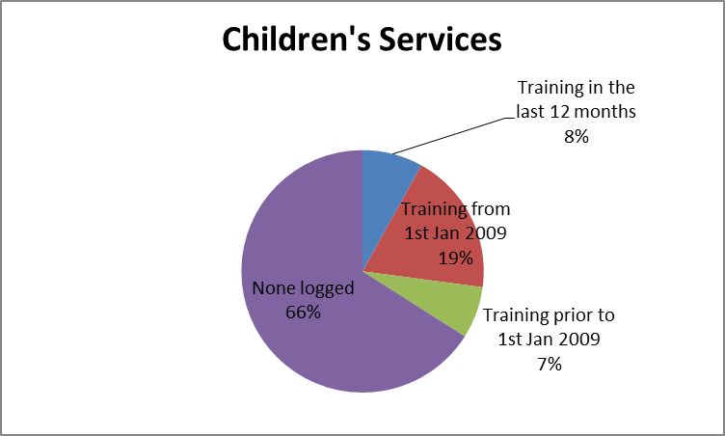 |  |  | 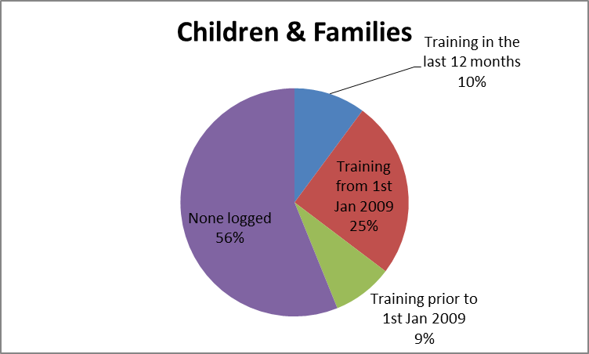
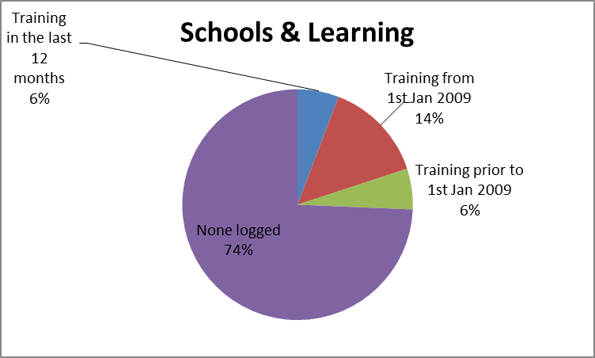 |  |  | 