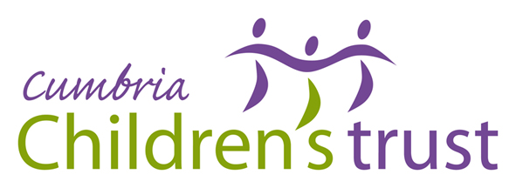
Cumbria Children and Young People’s Participation Strategy
2011-14

DRAFT

Youth Councils
UK Youth Parliament
Cumbria Youth Council
North West Regional Forums
Parent Participation
Youth Forums
Issue Forums
Children in Care Councils
Primary Participation
‘Seeking and Using the Voice of Service Users’
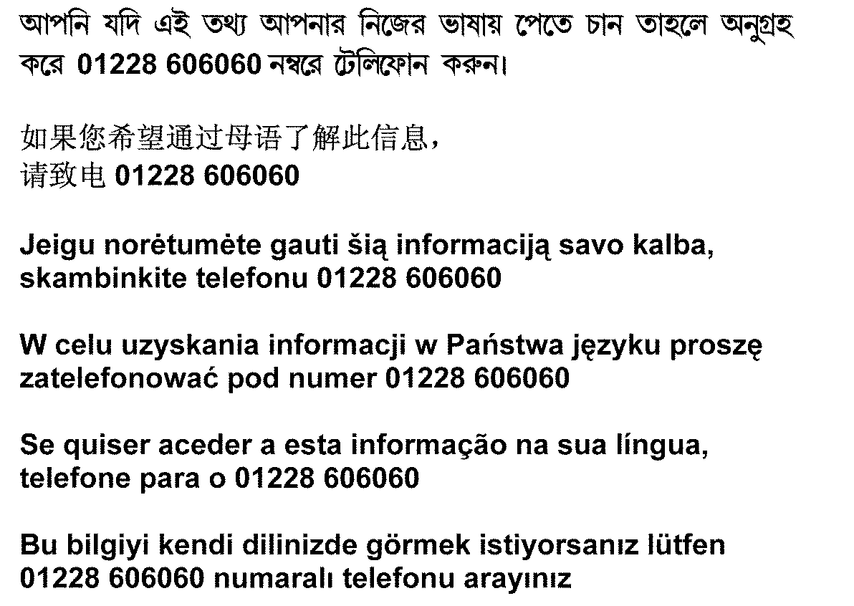

If you require this document translating into another language contact 01228 606060



2
“If the people who are supposed to be the beneficiaries of change do not know that it is happening – then it probably is not happening.”

Lord Herman Ouseley, former Chair of the Commission for Racial Equality

Introduction …………………………………………………………………………………. 4
Vision …………………………………………………………………………………………… 4
Aims …………………………………………………………………………………………….. 4
Principles …………………………………………………………………………………….. 5
Benefits ……………………………………………………………………………………….. 5
Legislation …………………………………………………………………………………… 6
Priorities and Outcomes ………………………………………………………………. 7
Logic Model …………………………………………………………………………………. 8
Common Language ………………………………………………………………………. 9
Models of Participation ………………………………………………………………… 10
Removing Barriers to Access ………………………………………………………… 11
Acknowledgements …………………………………………………………………….. 12

Appendix 1 - Implementation Plan ………………………………………………. 13
Appendix 2 - UNCRC Articles 1-42 ………………………………………………… 20
Appendix 3 – LSCB Online Communication Code of Conduct ………… 22

3
Introduction

At the heart of the Cumbria County Council Plan 2011-2014, it states that ‘Every child and young person should be able to receive the support and services they need. To do this as effectively as possible, it is important that children and young people are actively engaged in the design and development of these services. We will work with young people to explore new ways of engaging with them’.

The primary objective of the Cumbria Strategic Partnership Community Engagement Strategy is ‘To ensure communities participate to the fullest possible extent in the decisions that affect their lives and in delivering the services that make a difference to them’.

The Cumbria Children’s Trust Board partnership arrangements state that ‘The Board and District Delivery Groups will ensure effective engagement with children, young people and families to ensure that services meet their needs’.

Cumbria Children’s Services Directorate Service Plan prioritises the development of district Youth Councils and a Cumbria Youth Council; the engagement of children, young people and families in service development; and securing the endorsement of this Participation Strategy from partners and decision-makers.

The 6 County Council Local Committees have included Youth Councils and the voice of children and young people in the award criteria for their 0-19 Fund.

These strategic level commitments provide the rationale and purpose for our Participation Strategy ensuring that children and young people have a voice and are provided with opportunities to influence services.

Vision

We want Cumbria to be a great place to be a child and grow up in. This strategy will contribute to that vision by ensuring that Cumbrian children and young people know how to be involved in the decisions that affect their lives and are given the opportunity to do so.
Aims

The aims of the Strategy are:

- To promote the vision of participation for children and young people in Cumbria
- To outline the law and policy that underpins participation
- To define participation
- To support the involvement of children and young people, particularly the most vulnerable, in the decision-making processes affecting their lives
- To broaden the opportunities for influence beyond Cumbria

4
Principles

- Working together – Our priorities and outcomes can only be achieved if everyone works together.
- Inclusion – We intend to remove barriers to accessing services for those who are at risk of exclusion.
- Involvement – We are committed to ensuring that the voices of children and young people are at the centre of the decisions that we make.
Benefits

Benefits for children and young people
- Children and young people build on existing skills and develop new ones, increasing confidence and self-esteem
- Children and young people better understand particular organisations and how to influence them
- Children and young people benefit from new and better services that have changed and improved in response to their needs
- Children and young people are active participants in their own care
- The wishes and feelings of children and young people are given due consideration by decision-makers
- Children and young people are able to express their views freely

Benefits for organisations
- Information can be gained from children and young people as citizens about their changing attitudes and needs
- Children and young people can bring fresh perspectives and new ideas about services
- Services and policies can be designed, delivered and commissioned on actual rather than perceived needs.

Benefits for the wider community
- There is a more vibrant and healthy local democracy through the active involvement of children and young people
- Community cohesion is fostered through the inclusion of children and young people in local decision-making
- There is an empowering environment that raises aspirations among children and young people and the wider community
- Children and young people are pro-actively involved in shaping their communities
5
Legislation

Human Rights Act 1998 - Article 10 Freedom of Expression
- Everyone has the right to freedom of expression. This right shall include freedom to hold opinions and to receive and impart information and ideas without interference by public authority and regardless of frontiers.

United Nations Convention on the Rights of the Child (UNCRC) – Article 12
- Every child and young person has the right to express his or her views freely – about everything that affects him or her.
- The child or young person’s views must be given ‘due weight’ depending on his or her age and maturity.
- The child or young person has the right to be heard in all decision-making processes, including in court hearings. The child or young person can speak for him or herself, or someone else can speak for him or her.
Altogether there are 54 articles in the Convention. Articles 43-54 are about how adults and governments should work together to make sure all children are entitled to their rights.
Articles 1-42 set out how children should be treated.

Appendix 2 - For a full list of UNCRC Articles 1-42

Children’s Act 1989
- Requires a local authority to ascertain the ‘wishes and feelings’ of children and give due consideration (with regard to the child’s age and understanding) to these when determining what services to provide, or what action to take.

Equality Act 2010
- Covers all aspects of employment and services and identifies ‘protected characteristics’ covered by the law. These include: Gender, Maternity, Marital Status, Transgender, Age, Disability, Ethnicity, Sexual Orientation, Religion/Belief, Carers.
- To eliminate unlawful discrimination, harassment and victimisation.
- To advance equality of opportunity between different groups.
- To foster good relations between different groups.

6
Joint Strategic Priorities and Outcomes

District Delivery Outcomes

No children living
in poverty

Young people are proactive and productive citizens by age 16

All children are ready for school by the age of 5

No avoidable
child deaths

More young parents engage positively in services and programmes
More young people choose not to engage in risky activities and behaviours

More children, young people and families know how to access information and get support
Earlier intervention and support for the most vulnerable
More young people make positive life choices

More successful transitions to adulthood

Strategic Priorities
Children, young people and families are more resilient
Children and young people’s values and ethics demonstrate positive behaviours and attitudes

Children and young people respect and value themselves and each other
Families, particularly parents aged up to 20, have earlier offers of help and support

Reduction in gaps in school readiness for children aged up to 5 from different social backgrounds
Children’s life chances are improving

Children and young people believe in themselves; value and respect others

Young people have higher aspirations

Young people choose not to engage in risky activities and behaviours
Young people reach their full potential to learn and earn

Children and young people are safer from harm and have their needs met

Effective parenting enabling children to flourish

Children and young people understand consequences and the effect of their actions
Strategic Outcomes
More children and young people adopt healthy lifestyles
Increased take up of free school meals
More children and young people learn new skills, knowledge and information
Improved parenting skills and knowledge
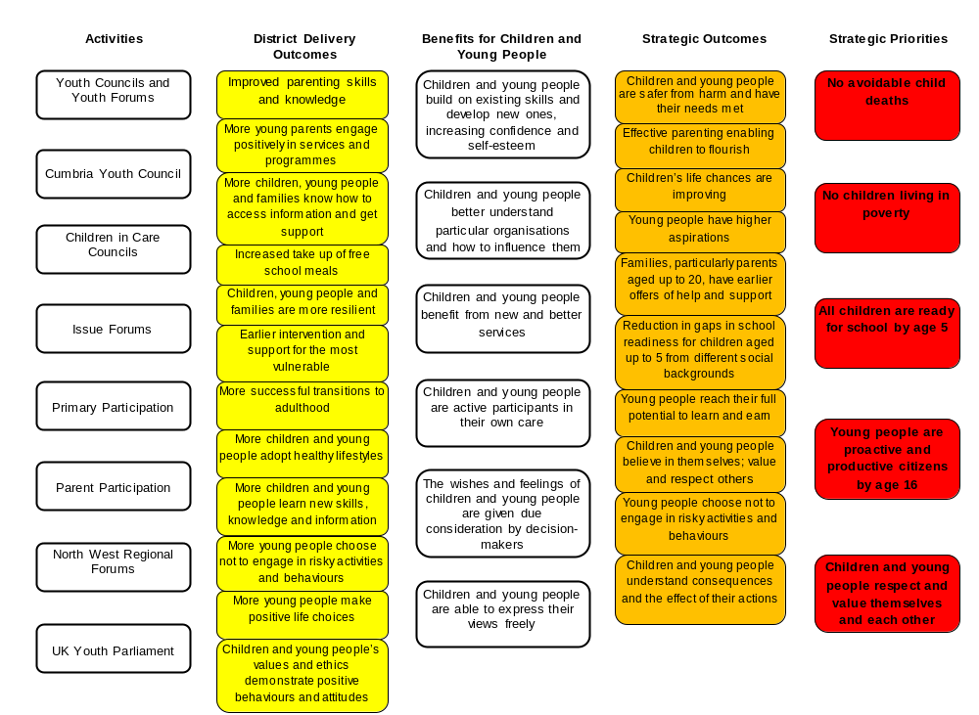
Logic
Model

Common Language

There are many different terms used to describe participation, but the main focus is that practice is underpinned by a strong commitment to a ‘right’ for children, young people and families to be heard.
- Participation - The process of involving children, young people and families in decision-making at increasing levels of control and independence.
- Engagement - The interaction of children, young people and families in the participation process.
- Empowerment - The outcome of this participation process in terms of children, young people and families increased power and influence.
- Involvement - The overall term for children, young people and their families being included in decision making processes at any level.
- Consultation - A process which requires the commitment to take on board children, young people and families views and present detailed information back to them.
- Recognition - Young people are recognised for the positive contributions they make to society, their place as citizens now and in the future.
- Equality is about everyone having the same chances in life and getting the same access to the services they need.
- Diversity is about understanding that people have different needs and aspirations. We cannot achieve equality without addressing diversity.
- Protected Characteristics – By law, those groups most likely to be affected by equality and diversity issues - Gender, Maternity, Marital Status, Transgender, Age, Disability, Ethnicity, Sexual Orientation, Religion/Belief, Carers.



9
Models of Participation

There are a number of different models of participation. Some models take a hierarchal view of an ideal level of participation whilst others see participation as a process that offers a choice from a range of involvement. All good practice models recognise the importance of reaching a constructive, safe balance between the principle of listening to a child’s wishes and feelings alongside the principle of the promoting the best interests of the child.
Roger Hart’s Ladder of Participation provides a means of evaluating the quality of engagement with children and young people. Levels show an incremental increase in active involvement with level 1 being the lowest in terms of children, young people and families having very little influence on decisions, to level 8 illustrating true involvement.

The National Youth Agency Hear By Right Standards Framework sees participation as a framework that can influence all aspects of an organisation. Hear by Right is based on the established Seven S model of organisational change.

Participation Works is a partnership of
six national children and young people's agencies that enables organisations to effectively involve children and young people in the development, delivery and
evaluation of services that affect
their lives. Models, toolkits and resources are available to download. www.participationworks.org.uk

In Cumbria these models underpin this strategy and implementation plan.
Ladder of Participation
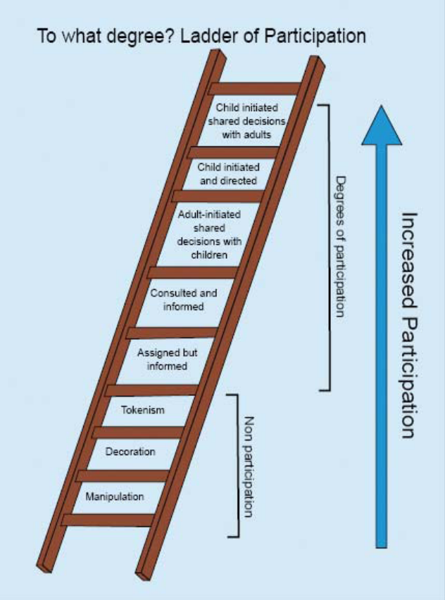

Hear By Right

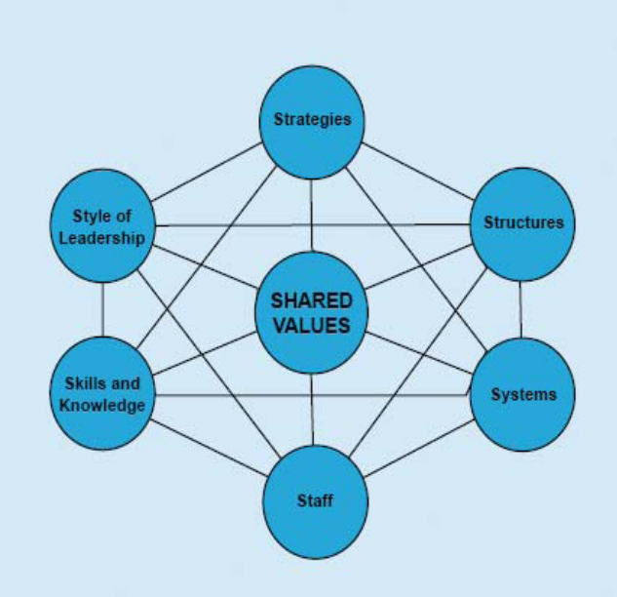

10
Removing Barriers to Access

Barriers to access can be divided into two categories:
1. Barriers that arise from problems to do with service provision
2. Barriers to do with particular characteristics of children, young people and their families

There may be many reasons why a child or young person is unable to take advantage of a participation activity. These include:

- A lack of knowledge about its existence
- An inability to make contact with activity providers
- Information about the activity being presented in an inappropriate format
- The location being difficult to reach
- Lack of transport
- The cost of transport and the activity
- The actual method of delivery being off putting in some way
- Those with disabilities finding it difficult to access activities that are designed primarily with able-bodied children and young people in mind
- Influencing factors causing vulnerability and risk e.g. those from poorer socio-economic groups; children looked after; young people with learning difficulties and disabilities; excluded from school or with poor records of school attendance; from different ethnic minority backgrounds; young offenders; young carers; those at risk from significant harm; living with vulnerable adults; not fluent in English; asylum seekers/refugees; young homeless; young victims of domestic violence; those with parents who are offenders or in prison.

Our intention is for services, providers and partners to consider and identify the actions necessary to dismantle the barriers and focus on priority areas of improvement and change.
We recommend they do this by:
- Consulting with priority groups of children, young people and their families
- Consulting with service providers
- Recommending that service providers review specific aspects of their service delivery and identify the actions needed to dismantle the barriers
- Publicising and promoting the improvements and changes

Service location and style needs should take account of the views and lifestyles of vulnerable children and young people, to ensure they feel comfortable and not labelled. Attractive activities can draw in disengaged children and young people and help build their trust, so they become willing to discuss their needs and engage in other interventions as necessary.

11
Acknowledgements

Cumbria Children’s Trust would like to thank the following organisations and partnerships whose support, advice, research, information, resources, drive and belief have helped; either directly or indirectly; with refreshing our Participation Strategy for 2011-14 and making it relevant to Cumbria.

Basingstoke and Deane Council - A Guide to Youth Councils
British Youth Council
Children’s Commissioner for England – Takeover Day
Children’s Services Partnership Development and Participation Team
Copeland Borough Council – Emma Dickinson
Cumbria Chief Executives Group
Cumbria Children’s Centre’s Providers
Cumbria Children’s Trust Board and District Delivery Groups
Cumbria County Council – Area Support
Cumbria County Council - Corporate Parenting Panel
Cumbria County Council – Local Committees
Cumbria Leaders Board
Cumbria Local Safeguarding Children’s Board
Cumbria Youth Services Providers
Derby City Council – Participation Strategy
National Parent Partnership Network
National Youth Agency
NHS Cumbria
North West Regional Youth Work Unit – Liz Harding
Participation Works Partnership
UK Youth Parliament – Dan Moxon



12
Implementation Plan

Appendix 1

Youth Councils and Youth Forums | Rationale | Implementation | Responsible Partners | Timescale
6 Youth Councils co-terminus with City and District Council areas in place, supported by youth forums | - Local youth voice  - Representative body  - Consultative body  - Influence local service delivery  - Alliance of youth forums, school councils, Children in Care Councils | Young people are supported to take part in:  - Elections  - Action and campaigns  - Research  - Consultation  - Budget management and distribution  - Needs assessment  - Assessment and evaluation of youth programmes  - Publicity and promotion  - Work alongside local decision-makers e.g. Local Committees, Councillors, MP’s, CEO’s, Directors and Managers | Partnership Development and Participation Team  Commissioned youth services providers  District Councils  Elected Members  Schools and colleges | Start April 2011  Meet monthly

13
Cumbria Youth Council | Rationale | Implementation | Responsible Partners | Timescales
Cumbria Youth Council in place with nominated young representatives from each of the 6 Youth Councils and other appropriate forums | - County youth voice  - Representative body  - Consultative body  - Influence youth policy and commissioning  - Alliance of local youth councils and forums | Young people are supported to take part in:  - Consultation  - Needs assessment  - Work alongside countywide decision-makers e.g. Leaders of the Councils, Children’s Services Portfolio Holders, Chair of the Children and Young People’s Scrutiny Panel, MP’s, CEO’s, Directors and Managers | Partnership Development and Participation Team  Commissioned youth services providers  District Councils  Elected Members | Start June 2011  Meet bi-annually

North West Regional Forums | Rationale | Implementation | Responsible Partners | Timescales
Nominated representatives from the Cumbria Youth Council and Youth Councils take part in regional events | - Wider approach to youth participation  - Stronger voice and influence around issues e.g. health, education, media, transport, policing  - Collective action  - Influence regional youth policy | Young people are supported to take part in:  - Youthforia regional youth forum for young people  - Youthforia leadership committee working on issues set by young people  - Share ideas and resources | Partnership Development and Participation Team  Commissioned youth services providers  North West Regional Youth Work Unit | Start Oct 2012  Meet bi-annually

14
UK Youth Parliament (UKYP) | Rationale | Implementation | Responsible Partners | Timescales
2 Cumbrian young people elected as Members of Youth Parliament (MYP)  UKYP is a British Youth Council programme, supported by Local Authorities across the country  Once a secure and coherent local and county Youth Council structure is in place, Cumbria can look towards sending elected representatives to UKYP. Additional resources still need to be identified for Cumbria’s participation in UKYP | - National voice  - influence the decisions of Parliament and National Government | Young people are supported to:  - Organise events and projects  - Run campaigns  - Influence decision makers on the issues which matter to young people  - Attend UKYP Annual Sitting  - Attend North West Youth Parliament bringing MYP’s together through the Youthforia project | Partnership Development and Participation Team  Commissioned youth services providers  District Councils  Elected Members  North West Regional Youth Work Unit  UKYP | Start 2013 subject to available funding  Meet bi-annually

15
Children in Care Councils | Rationale | Implementation | Responsible Partners | Timescales
3 District Children in Care Councils in place | - Additional opportunities for CLA to voice their views and opinions to Corporate Parents  - Raise awareness and profile of Children in Care Councils  - Challenge and influence CLA policy  - Service improvement  - Advocacy  - Inclusivity  - Representative body  - Consultative body | Children and young people who are looked after are supported to:  - Work with MALAP and Corporate Parents  - Work with staff and foster carers  - Work with the National Youth Advocacy Service  - Be involved in consultation and needs assessment  - Raise the profile and positive image of those in care  - Be represented on Youth Councils | Children’s Services - Partnership Development and Participation Team; CLA and Leaving Care Team; Fostering Supervision and Support Team; Safeguarding and Child Protection  MALAP  Elected Members | Start January 2012  Meet monthly

Issue Forums | Rationale | Implementation | Responsible Partners | Timescales
Specific issues and key events that are of interest to young people e.g. health, equality and diversity, environment, rurality, community, transport, safety, crime, leisure, culture, education, employment and training | - Thematic participation  - Focus on issues of interest rather than geography  - Influence policy and commissioning  - Influence service delivery  - Adults gain a fresh perspective on what they are delivering | Children and young people are supported to take part in:  - Issue based forums  - Consultation  - Debates and discussions  - Research  - Needs assessment  - Assessment and evaluation of services  - Takeover Day  - Local Democracy Week  - Youth Work Week | Children’s Services  Safer and Stronger  NHS Cumbria  Cumbria Police  Cumbria Probation  District Councils  Voluntary Sector  LSCB  Partnership Development and Participation Team  Commissioned providers | Start April 2011  As and when required
Primary Participation | Rationale | Implementation | Responsible Partners | Timescales
Engagement of primary age children in participatory activity | - Children’s views are respected and valued by adults  - Active citizenship  - Increased social interaction, new relationships and new role models  - The rights of children to be heard in services that affect them  - Feeder group for Youth Councils/Youth Participation projects | Children under 11 are supported to take part in:  - Consultation e.g. school re-organisation, home to school transport  - Primary School Councils - pupil voice  - Children’s Centre’s gather the views of children accessing services  - Young Mayors | Schools  Commissioned Children’s Centres providers  District Councils  Partnership Development and Participation Team | Start Sept 2011  Term time

Parent Participation | Rationale | Implementation | Responsible Partners | Timescales
Support for parents and carers of children with disabilities | - Views of parents of children with disabilities are heard and understood  - Influence and inform the development of services for children with disabilities  - Good information, honest consultation, effective participation | The views and needs of children with disabilities are regularly sought through appropriate groups and forums.  Parents of children with disabilities are supported through:  - Children’s Centre’s gathering the views of parents accessing services  - Parental outreach services  - Information and advice | Children’s Services  Learning to Change Group  Parent Forums  Parent Partnership Service  Short Breaks commissioned providers  Children’s Centres | Start April 2011  Ongoing
17
Online Participation | Rationale | Implementation | Responsible Partners | Timescales
Using social networking as a participation tool  Appendix 3 – LSCB Online Code of Conduct | - Social networking e.g. Facebook is rapidly becoming the communication route of choice for Cumbrian young people  - Minimise risks  - Common sense approach to online participation | - Review staff, provider and Councillor use of Facebook (or other social networking/email opportunities) against the Local Safeguarding Children's Board Online Communication Code of Conduct; cross-referencing and updating organisational online safety policies and practice should it be required  - Share Code of Conduct with young people | LSCB  Children’s Services – Safeguarding and Child Protection; Partnership Development and Participation Team  Commissioned youth services providers | Start Dec 2011  Quarterly
 |  | - SpeakUp Cumbria is a safe social networking site for Cumbrian young people aged 11-19. Young people virtually connect with decision-makers and those that can make a difference. They can write a blog, join a debate, find like-minded young people and get their voice heard. It provides the opportunity for practitioners and decision-makers to consult with young people and seek their views on the services that affect them. www.speakup.co.uk | Commissioned youth services providers | Start April 2011  Ongoing
 |  | - Wotson4u is an interactive website for Cumbrian children and young people to find out what activities are available as well as information, advice, competitions and entertainment. This site provides services with the opportunity to freely publicise and promote their opportunities to children and young people in localities and countywide. www.wotson4u.com | Children’s Services | Start April 2011  Ongoing

Participation Training | Rationale | Implementation | Responsible Partners | Timescales
Practitioners receive training on how to better engage service users | - Practitioner recognition and understanding of the benefits of participation for children and young people  - Show how participation contributes to other strategies and policies  - Better recording of participation evidence for inspections  - Better equiped staff with relevant skills  - Practitioners to see participation as essential to child centred work and not an ‘add on’ | - Multi-agency training events in districts | Children’s Services – Partnership Development and Participation Team; Children’s Workforce Development Team | Start Sept 2011  Annually

19
United Nations Convention on the Rights of the Child

Appendix 2

Article 1 - Everyone under 18 years of age has all the rights in this Convention.
Article 2 - The Convention applies to everyone whatever their race, religion, abilities, whatever they think or say and whatever type of family they come from.
Article 3 - All organisations concerned with children should work towards what is best for each child.
Article 4 - Governments should make these rights available to children.
Article 5 - Governments should respect the rights and responsibilities of families to direct and guide their children so that, as they grow, they learn to use their rights properly.
Article 6 - All children have the right of life. Governments should ensure that children survive and develop healthily.
Article 7 - All children have the right to a legally registered name, the right to a nationality and the right to know and, as far as possible, to be cared for by their parents.
Article 8 - Governments should respect children’s right to a name, a nationality and family ties.
Article 9 - Children should not be separated from their parents unless it is for their own good, for example if a parent is mistreating or neglecting a child. Children whose parents have separated have the right to stay in contact with both parents, unless this might hurt the child.
Article 10 - Families who live in different countries should be allowed to move between those countries so that parents and children can stay in contact or get back together as a family.
Article 11 - Governments should take steps to stop children being taken out of their own country illegally.
Article 12 - Children have the right to say what they think should happen, when adults are making decisions that affect them, and to have their opinions taken into account.
Article 13 - Children have the right to get and to share information as long as the information is not damaging to them or to others.
Article 14 - Children have the right to think and believe what they want and to practise their religion, as long as they are not stopping other people from enjoying their rights. Parents should guide their children on these matters.
Article 15 - Children have the right to meet together and to join groups and organisations, as long as this does not stop other people from enjoying their rights.
Article 16 - Children have a right to privacy. The law should protect them from attacks against their way of life, their good name, their families and their homes.
Article 17 - Children have the right to reliable information from the mass media. Television, radio and newspapers should provide information that children can understand, and should not promote materials that could harm children.
Article 18 - Both parents share responsibility for bringing up their children, and should always consider what is best for each child. Governments should help parents by providing services to support them, especially if both parents work.
Article 19 - Governments should ensure that children are properly cared for, and protect them from violence, abuse and neglect by their parents or anyone else who looks after them.
Article 20 - Children who cannot be looked after by their own family must be looked after properly, by people who respect their religion, culture and language.
Article 21 - When children are adopted the first concern must be what is best for them. The same rules should apply whether the children are adopted in the country where they were born or taken to live in another country.
Article 22 - Children who come into a country as refugees should have the same rights as children born in that country.
Article 23 - Children who have any kind of disability should have special care and support so that they can lead full and independent lives.
Article 24 - Children have the right to good quality health care and to clean water, nutritious food and a clean environment so that they will stay healthy. Rich countries should help poorer countries achieve this.
Article 25 - Children who are looked after by their local authority rather than their parents should have their situation reviewed regularly.
20

Article 26 - The Government should provide extra money for the children of families in need.
Article 27 - Children have a right to a standard of living that is good enough to meet their physical and mental needs. The Government should help families who cannot afford to provide this.
Article 28 - Children have a right to an education. Discipline in schools should respect children’s human dignity. Primary education should be free. Wealthy countries should help poorer countries achieve this.
Article 29 - Education should develop each child’s personality and talents to the full. It should encourage children to respect their parents, and their own and other cultures
Article 30 - Children have a right to learn and use the language and customs of their families, whether these are shared by the majority of people in the country or not.
Article 31 - All children have a right to relax and play, and to join in a wide range of activities.
Article 32 - The Government should protect children from work that is dangerous or might harm their health or their education.
Article 33 - The Government should provide ways of protecting children from dangerous drugs.
Article 34 - The Government should protect children from sexual abuse.
Article 35 - The Government should make sure that children are not abducted or sold.
Article 36 - Children should be protected from any activities that could harm their development.
Article 37 - Children who break the law should not be treated cruelly. They should not be put in prison with adults and should be able to keep in contact with their families.
Article 38 - Governments should not allow children under 15 to join the army. Children in war zones should receive special protection.
Article 39 - Children who have been neglected or abused should receive special help to restore their self respect.
Article 40 - Children who are accused of breaking the law should receive legal help. Prison sentences for children should only be used for the most serious offences.
Article 41 - If the laws of a particular country protect children better than the articles of the Convention, then those laws should stay.
Article 42 - The Government should make the Convention known to all parents and children.



21
Cumbria Local Safeguarding Children’s Board

Appendix 3

Online Communication Code of Conduct for Staff Working with Children

Rationale and context:
Over the past years the use of blogs, chat rooms and social networking sites such as Twitter, Facebook, Bebo and Myspace has become increasingly popular. Such sites are used to chat with and share information, photographs and news with friends across the world. Whilst the use of such sites has very many benefits there are potential problems concerning privacy and inappropriate usage. These may include breaches of confidentiality, unsuitable language or images, and in some cases breaches of the law. Examples of such problematic usage of publicly accessible social networking could be:

- Staff referring to parents or children and young people by name
- Staff referring to forthcoming trips/visits
- Staff using derogatory or offensive language about parents, colleagues, managers, or the organisation for which they work.
- Staff posting images of themselves in inappropriate dress or situations
- Staff participating in illegal activities such as the sharing of indecent images of children
- Partners or friends posting inappropriate comments concerning staff
- Partners and friends posting images that show staff members in situations which may not be in keeping with their professional status

This code of conduct is designed to protect staff that may use such sites in their private lives. It must be recognised that those who work with children have a duty to demonstrate the highest standards of conduct or integrity and make sure that their actions in their private lives do not put themselves in a situation when their conduct or integrity might be called into question or potentially bring their employer into disrepute. This could result in disciplinary action by your employer or even criminal prosecution. This code of conduct sets out expectations around online behaviour that could affect professional standing, integrity and dignity.

What this code does not cover:
- Social contact between adult colleagues. However, staffs needs to be mindful of what they are posting and who can see it. This is important in respect of confidentiality, workplace relationships, and the fact that their online contacts may not appreciate the difference between private and professional comments.
- Membership of professional networks or forums is not covered by this code as these are usually covered by a professional body’s own code of conduct.
- Membership of forums is not covered, although in extreme cases legal restrictions may apply. Staff should however remember that what they say may reflect upon their professional lives and moderate their comments accordingly.

Code of Conduct
- Staff should not allow themselves to enter into online contact with children they work with, parents or their families. Friend requests from parents or children and young people under the age of 18 (past or present) in this context should be politely declined by explaining that it is against agency policy, which is designed to protect staff from abuse and misunderstandings.
- Staff should not create web pages, groups or contact lists concerning professional activities carried out on behalf of their agency unless they have express written permission from a senior manager to do so.
- There must be absolutely no private online contact between staff and any children and young people with whom they have a work-related relationship. This includes the storing of images of children under the age of 18.
22
- Any contact with children and young people after they have left the organisation (e.g. moved to a secondary school) should be sanctioned by a senior manager within the organisation and the parent and not occur through social networking sites or other online communication technologies
- Online contact made as part of professional duties should always be carried out using technologies provided by the agency or local authority. These technologies should have the capability of logging and storing records securely.
- Staff are strongly advised to be careful about what they say online in contact with other young people such as relatives or family friends. This caution should apply to images or video material.

Staff Privacy and Dignity
Staff are strongly recommended to check that their online privacy settings only allow “friends” to see their profiles. It is also advised that staff do not accept friend requests from people who are not personally known to them. Staff may wish to ask friends to check before photographs are posted which may cause them embarrassment. Staff posting their own images should bear in mind the fact that any image can easily be downloaded and manipulated and they should choose which images they share accordingly. It is recommended that staff do not post images that could be used to identify their homes or families.

All staff are advised to make themselves familiar with the parent/carer pages on the CEOP “Think You Know” site at www.thinkyouknow.co.uk and keep themselves up to date with the risks of emerging technologies.

The Link with the ‘Guidance for Safer Working Practice for adults who work with children and young people’
This document is endorsed by the Cumbria Local Safeguarding Children’s Board (LSCB) and is being adopted by organisations that employ staff to work with children throughout Cumbria. Section 12 of the guidance covers communication with children and young people using (including the use of technology). This states that:
‘Communication between children and adults by whatever method should take place within clear and explicit professional boundaries.’ Specifically the guidance recommends that adults should;
- Not give their personal contact details to children and young people including their mobile telephone number and details of any blogs or personal websites.
- Only use equipment e.g. mobile phones, provided by the organisation to communicate with children and young people, making sure their parents have given permission for this form of communication to be used.
- Only make contact with children for professional reasons and in accordance with any organisational policy.
- Recognise that text messaging is rarely an appropriate response to a child in crisis or at risk of harm. It should only be used as a last resort where other forms of communication are not possible.
- Not use internet or web-based communication channels to send personal messages to a child/young person.
- Ensure that if a social networking site is used, details are not shared with children and young people and privacy settings are set at maximum.

23

Cumbria County Council Children’s Services – Strategy, Planning and Commissioning – Partnership Development and Participation
Contact: Beverly Morgan, Partnership Development and Participation Manager beverly.morgan@cumbria.org.uk

