How to make contact:

Janet Edgar (Allerdale & Copeland)
Tel. 07901 514 561
janet.edgar@cumbria.gov.uk
1st Floor, Blencathra House,
Tangier Street, Whitehaven
Cumbria, CA28 7UW

Lyz Duclos (Barrow & South Lakes)
Tel. 07774 857 509
elizabeth.duclos@cumbria.gov.uk
Top Floor, Craven House, Michaelson
Road, Barrow-in-Furness, Cumbria
LA14 1FD

Luke Jourdain (Carlisle & Eden)
Tel. 07919397543
luke.jourdain@cumbria.gov.uk
Cumbria House, 117 Botchergate,
Carlisle, Cumbria, CA11RN
Please note that this is my postal address only –
my base is Parkhouse Building, Kingmoor Park

N.B. for involvement with individual pupils, you will need to obtain parental permission and complete an Early Help form requesting our input.

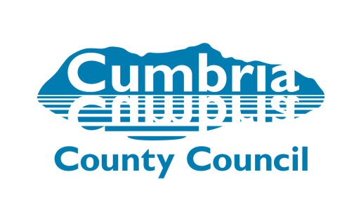

People:

Education & Skills: County Psychological Service

Behaviour & Emotional Wellbeing Officers

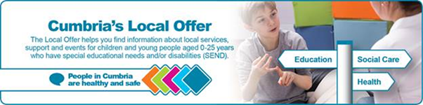

What is the BEWO role and what can the BEWO do for you?

The BEWO role covers all primary schools across Cumbria and focuses on statutory and non-statutory work, through the Early Help and EHCP process

Working closely with the Educational Psychologists, BEWOs can offer help, advice and support in building and maintaining sustainable provision for pupils with SEBMH (social, emotional, behavioural and mental health issues)

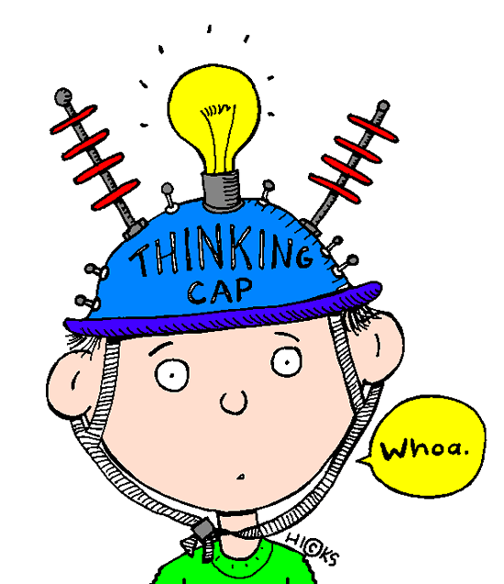

How can we do this?

- Consultation and advice by visit or telephone, with follow up contact as appropriate

- Pre and post-statutory work; assessment, advice, reports, review, etc.

- Pupil & classroom observations with feedback

- Training and resources

- Direct work with individual pupils, small groups, parents & families

Ideas!

Some of the areas we may be able to support
you with include:

- General and specific behaviour management & resources
- Behaviour management staff training
- Lunchtime supervisor training in managing challenging behaviour
- Pupil friendly IEPs/behaviour plans
- ADD/ADHD awareness raising
- Attachment difficulties
- SEAL (Social & Emotional Aspects of Learning)
- SEAL small group work
- SEAL family group work
- De-escalation techniques & training
- Relax Kids
- Brain Gym
- Circle time
- Nurture Groups
- TaMHS (Targeted Mental Health in Schools) toolkit
- Bereavement & Loss staff training (primary or teenage) with B&L toolkit for schools
- Teaching Assistant/Learning Mentor support & training
- Bullying workshops & resources
- Friendship groups
……and more on request

