
Virtual School/Equalities Learning
English as an Additional Language
in partnership with Cumbria Library Service.

Dual language rhymes in English and Polish

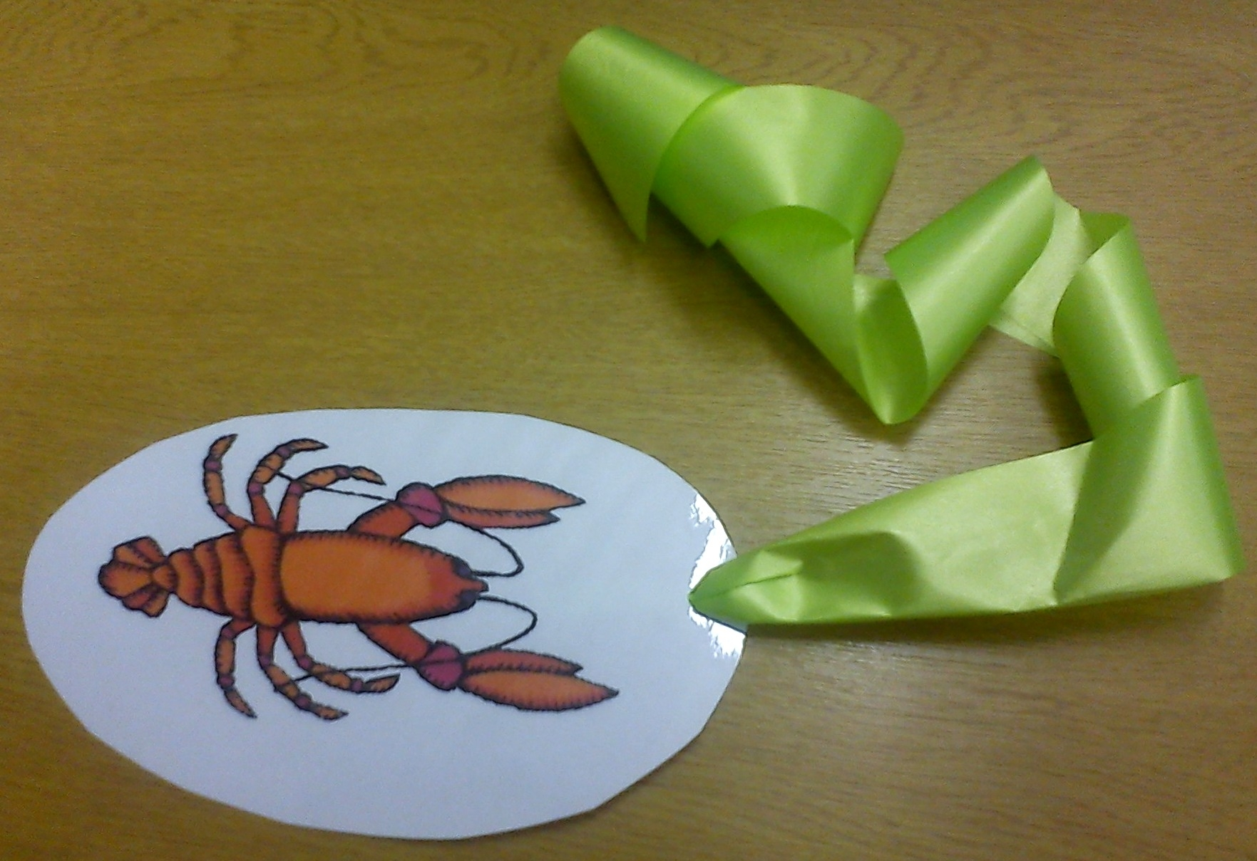

Introduction

These rhymes were used as part of the Bookstart dual language project in the autumn term 2012 run by Rachel Lee the Equalities Learning Officer for English as an additional language and Cumbria Library Service.
Frances Taylor Young Peoples Librarian and Kinga Cichowska , Community Development Worker from Kendal library hosted a dual language rhyme time at Windermere library for the children from the Early Years Foundation Stage at St Cuthbert’s School Windermere.

The materials include two well known Polish rhymes Old Brown Bear and A Crayfish is Coming.
The rhymes are translated by Kinga Cichowska and in the supporting sound files, recorded by Michal Rogala, the rhymes are performed by Frances Taylor, Kinga Cichowska and Marieca Wegener, Young People’s Librarian from Kendal

Contents

1. A Crayfish is Coming English/Polish 
Example picture of a crayfish attached to a piece of ribbon which children can use to act out the rhyme. Rather like Round and round the garden, you can pull the crayfish towards you, build up the suspense and then pretend that it gives you a nip with its claws

2. Wind Your Bobbin Up English/Polish 
Example picture of a bobbin with string attached so children can see what a bobbin is and use wind and unwind the string.

3. Head, Shoulders, Knees and Toes English/Polish 

4. Mister John (Frère Jacques) English/Polish 

5. Twinkle Twinkle Little Star English/Polish 

6. Old Brown Bear English/Polish 
Use a teddy bear for old brown bear who snores loudly then wakes up and chases the children as in what time is it Mister Wolf.
Picture of a teddy bear

Idzie rak
Nursery Rhyme
(Polish)
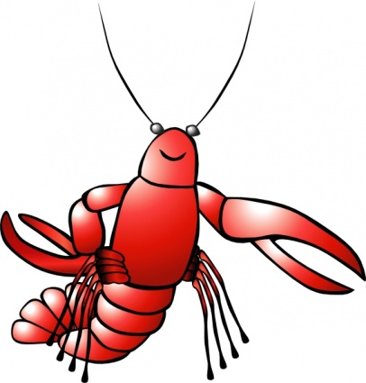
Idzie rak,
Nieborak.
Jak ugryzie,
Będzie znak.

A Crayfish Comes
Nursery Rhyme
(English)
A crayfish comes
Poor fellow
When it stings you
There will be a mark!

Nawijaj szpulkę

Nawijaj szpulkę tak
Nawijaj szpulkę tak
Ciągnij, ciągnij, klaszcz, klaszcz, klaszcz

Nawijaj jeszcze raz
Nawijaj jeszcze raz
Ciągnij, ciągnij, klaszcz, klaszcz, klaszcz

Pokaż na sufit
I na dywan
Pokaż na okno
Pokaż na drzwi
Klaszczmy teraz razem raz, dwa, trzy
Rękami dotknij kolan swych

Wind the bobbin up

Wind the bobbin up
Wind the bobbin up
Pull, pull, clap, clap, clap

Wind it back again
Wind it back again
Pull, pull, clap, clap, clap

Point to the ceiling
Point to the floor
Point to the window
Point to the door
Clap your hands together one two three
Put your hands upon your knee

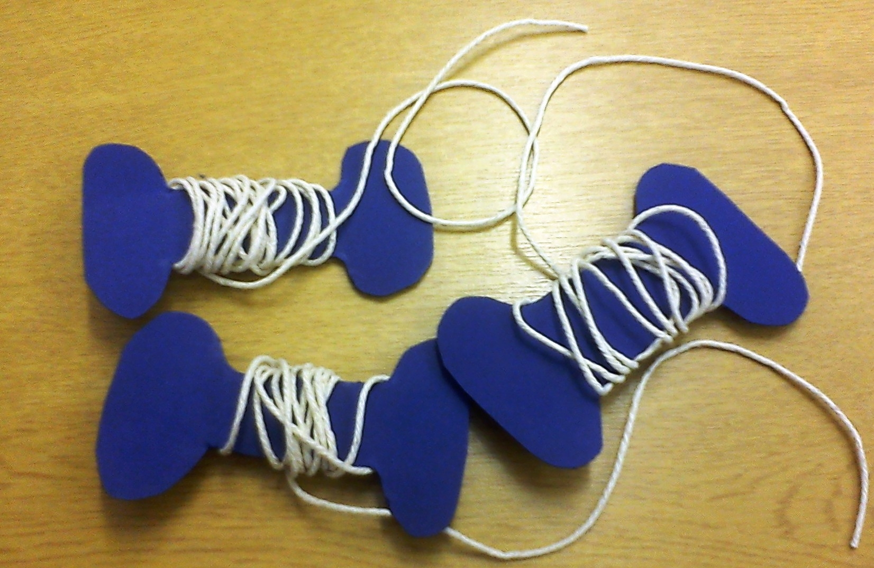

Głowa ramiona
(Polish)
Głowa, ramiona, kolana, kostki
Kolana, kostki,
Kolana, kostki.
Głowa, ramiona, kolana, kostki,
Uszy, oczy, usta, nos.
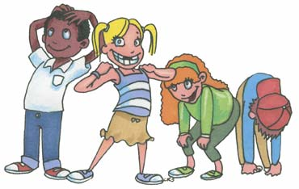

Head and Shoulders
(English)
Head, shoulders, knees and toes, knees and toes
Head, shoulders, knees and toes, knees and toes
and eyes and ears and mouth and nose,
Head, shoulders, knees and toes, knees and toes

Panie Janie
Children's Song
(Polish)
(English)
Panie Janie! Panie Janie!
Rano wstań! Rano wstań!
Wszystkie dźwony biją
Wszystkie dźwony biją
Bim, bam, bum,
Bim, bam, bum.
Bear
Circle Game

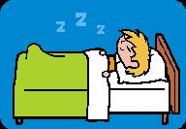
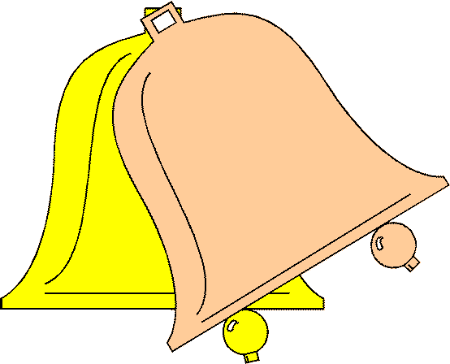

Mister John
Children's Song
(English)
Mister John! Mister John!
Get up early! Get up early!
All the bells are ringing,
All the bells are ringing,
Bim, bam, boom
Bim, bam, boom.

Migaj gwiazdeczko

Migaj, migaj gwiazdeczko
Kim ty jesteś? - chcę wiedzieć

Tak wysoko nad ziemią
Jak diamencik na niebie

Migaj, migaj gwiazdeczko
Kim ty jesteś? - chcę wiedzieć

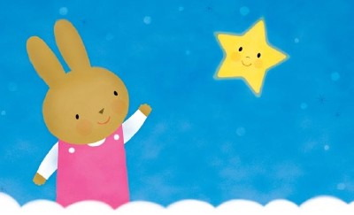

Twinkle Twinkle Little Star

Twinkle, twinkle little star
How I wonder what you are

Up above the world so high
Like a diamond in the sky

Twinkle, twinkle little star
How I wonder what you are

Stary niedźwiedź
Circle Game
(Polish)

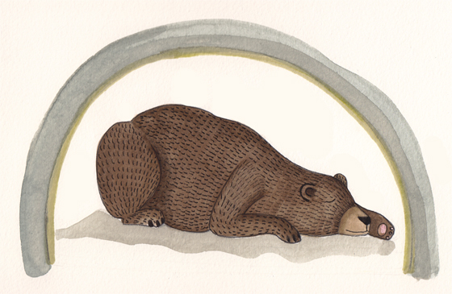
Stary niedźwiedź mocno śpi,
stary niedźwiedź mocno śpi.
My się go boimy, na palcach chodzimy,
jak się zbudzi będzie zły,
jak się zbudzi będzie zły.
Pierwsza godzina - niedźwiedź śpi,
druga godzina - niedźwiedź chrapie,
trzecia godzina – niedźwiedź... łapie!!!

Old Brown Bear
Circle Game
(English)

Old Brown Bear is sleeping soundly.
Old Brown Bear is sleeping soundly.
We walk on tiptoes,
As we’re afraid of him,
When he wakes up, he’ll be mad,
When he wakes up, he’ll be mad.
One hour passed – Bear’s Sleeping.
The second hour passed
- Bear’s snoring.
The third hour passed – Bear is… catching us!



