

Crew Manager
Fire and Rescue

Job Description

Date | February 2019
Family | Fire & Rescue Service
Purpose | Fire and Rescue – Service Delivery

Department
Service Delivery

Purpose of this post
To play a key role in making Cumbria’s communities safer through the planning, co-ordination and delivery of service activities within the station area.

Key job specific accountabilities
- To support the delivery of the Cumbria Fire & Rescue Service Integrated Risk Management Plan (IRMP).

- To provide a broad range of community services to ensure residents, businesses and visitors are supported through Prevention, Protection and Response, activities

- Plan, coordinate and deliver training to Regular and On Call employees within CFRS.

- Work in partnership with other departments and agencies ensuring good relationships are established and maintained.

- Inform and educate your community to improve awareness of safety matters.
- Contribute to fire safety solutions to minimise risks to your community.
- Line management of staff - lead the work of teams and individuals to achieve their objectives.
- Maintain activities to meet requirements.
- Take responsibility for effective performance and attend training and development courses as required.

- Support the development of teams and individuals.
- Investigate and report on events to inform future practice.
- Lead and support people to resolve operational incidents and exercises.

Key facts and figures of the post
Budget responsibilities | None
Staff management responsibilities | Manage staff and responsibilities as required
Reports to | Watch Manager - Service Delivery / Operational Command

Cumbria County Council behaviours
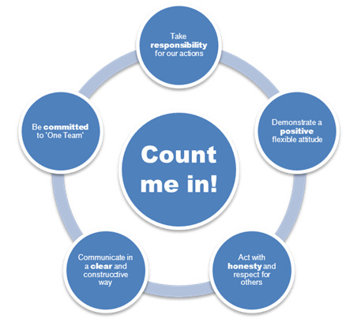
The county councils behaviours explain how we need to perform our roles, rather than what we need to deliver. They explain what behaviours are needed to move the council in the right direction for success.

For further information please see:-
www.cumbria.

Cumbria County Council competencies

The competencies shown in the role profile are for your level. They are cumulative so it is assumed that those at a higher level demonstrate the competencies from the lower levels.
For further information please see:-
www.cumbria.

Crew
Manger

Crew Manager

Person Specification

 | Essential | Desirable
Experience | Hold the post of competent operational Firefighter or above.  Experience of informing and educating the community to improve awareness of safety matters.  Experience of contributing to Fire Safety solutions to minimise risks to the Community.  Experience of working with teams and individuals to achieve their objectives.  Experience of maintaining activities to meet requirements.  Experience of taking responsibility for effective performance.  Experience of supporting individual development.  Experience of investigating and reporting on events to inform future practice.  Experience of supporting people to resolve operational incidents.
Knowledge/ Understanding | Knowledge of statutory requirements affecting role.  A knowledge of Health and Safety legislation and statutory requirements.  An understanding of the risk concept and how it can be applied within a proactive safety culture.  Understanding of equality legislation and its application in relation to the duties of a supervisory management post.  An understanding of Incident Command, and Command Support at operational incidents.  A knowledge of disciplinary, grievance and performance management procedures.  An understanding of how performance management impacts upon organisational performance.
Key Skills and Behaviours | Ability to demonstrate a comitment to CCC/CFRS behaviours  Ability to lead the work of teams and individuals to achieve their objectives.  Ability to support the iimplementation of change  Ability to maintain activities to meet requirements.  Ability to take responsibility for effective performance.  Ability to communicate effectively at all levels, with the ability to use a wide range of communication techniques.  Ability to utilise I.T systems for reports, performance management, monitoring etc.  Personal integrity with the ability to demonstrate high personal standards.  Evidence of Continual Personal Development.  Able to develop self, teams and individuals to enhance work based performance.
Other | Ability to travel throughout Cumbria and beyond, including overnight stays where necessary.

