Cumbria Libraries - Public Access PC Usage Survey 2014

Outline
The aim of the PC usage survey was to collect information on what customers use our PCs for when they go online. This information will help us to develop our service in line with customer needs and expectations, and inform decision making within CCC around future direction for the welfare reform agenda.

Timeline
The survey ran from 20th – 26th January 2014 inclusive at all libraries.

Format
Each library received an allocation of survey cards. There was also be an e-survey available via the Libraries web site.
The survey was anonymous – customers were not required to give us their name or contact details.
Distribution
The Library Support team distributed the survey cards to each Group HQ. The Group HQ staff then distributed an allocation of cards to each of its branches ahead of 20th January 2014 start date.
Filling out the survey cards
Staff made every effort to encourage customers to fill out the survey cards. Different locations and circumstances determined different or combined approaches to this. Cards were left at each PC, or on counters or tables, or handed personally to customers. Staff were given ‘crib sheets’ to enable them to answer questions from the public:
• Why are we doing this? – we want to improve the service into the future and to help us do this we need to know what the most popular uses of the PC’s are. We have made the survey as simple as possible to help people complete it quickly.
• Is the information you collect anonymous? – no personal information is being recorded
• Will the results be available to the public? – we will publish the results of the survey on our website later in the year
If a member of the public had a comment to make about the survey they were invited to complete a comment card as well. Completing a survey card was not in any way compulsory and a user was able refuse to complete one.

The results of the survey
The total usage over the survey period was:
Netloan (Public PC) Use 20 - 26th Jan 2014
User Group | Total Users | Active 20-26 Jan 14
12yrs | 521 | 51
13yrs | 368 | 29
14yrs | 283 | 18
15yrs | 285 | 15
16yrs | 2 | 0
Non Concession Adult | 19053 | 604
Concession Adult | 13567 | 1721
Baby | 144 | 12
Junior | 2236 | 152
Suspended Users | 737 | 9
Temporary | 974 | 9
Totals | 38170 | 2620

We received 1050 responses to the survey representing a return of 40%.

Question 1
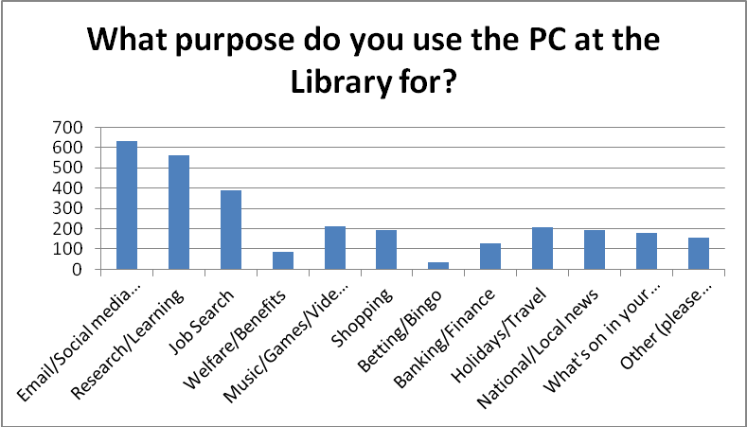

What purpose do you use the PC at the Library for? | No. responding | Percent of Sample Asked
Email/Social media (Twitter, Facebook etc) | 631 | 60.10%
Research/Learning | 563 | 53.60%
Job Search | 391 | 37.20%
Welfare/Benefits | 87 | 8.30%
Music/Games/Video/TV programmes | 211 | 20.10%
Shopping | 195 | 18.60%
Betting/Bingo | 33 | 3.10%
Banking/Finance | 128 | 12.20%
Holidays/Travel | 206 | 19.60%
National/Local news | 193 | 18.40%
What's on in your areas | 181 | 17.20%
Other (please specify) | 156 | 14.90%

Question 2
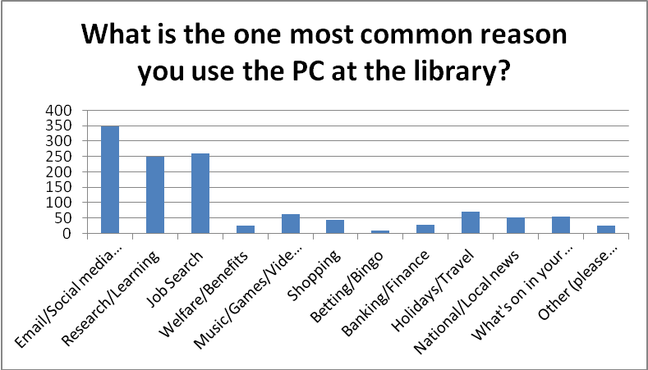

What is the one most common reason you use the PC at the library? | No. responding | Percent of Sample Asked
Email/Social media (Twitter, Facebook etc) | 349 | 33.20%
Research/Learning | 248 | 23.60%
Job Search | 259 | 24.70%
Welfare/Benefits | 25 | 2.40%
Music/Games/Video/TV programmes | 62 | 5.90%
Shopping | 43 | 4.10%
Betting/Bingo | 8 | 0.80%
Banking/Finance | 27 | 2.60%
Holidays/Travel | 71 | 6.80%
National/Local news | 51 | 4.90%
What's on in your areas | 55 | 5.20%
Other (please specify) | 26 | 2.50%

Question 3
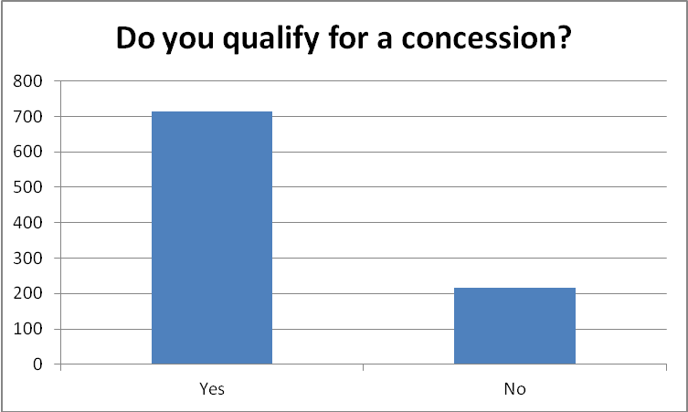

Do you qualify for a concession? | No. responding | Survey %
Yes | 715 | 76.70%
No | 217 | 23.30%

Question 4
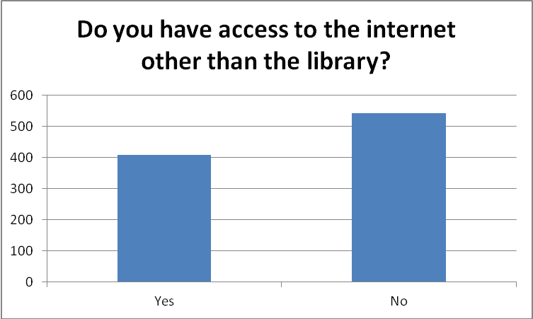
Do you have access to the internet other than the library? |  | Percentage of Total Sample
Yes | 407 | 38.80%
No | 542 | 51.60%

Question 5
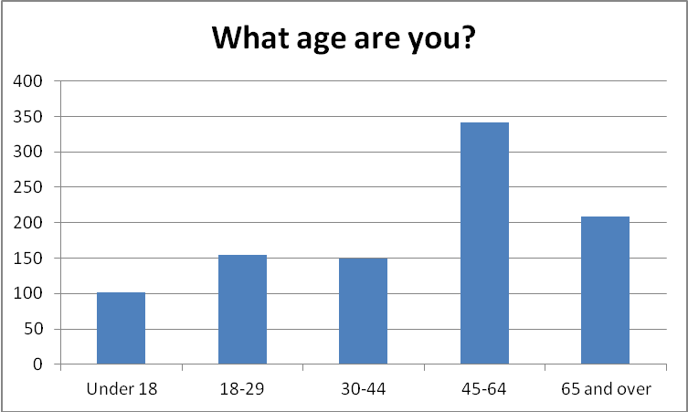
What age are you? |  | Percentage of Sample Answering | Percentage of Sample Asked | Percentage of Total Sample
Under 18 | 102 | 10.70% | 9.70% | 9.70%
18-29 | 155 | 16.20% | 14.80% | 14.80%
30-44 | 150 | 15.70% | 14.30% | 14.30%
45-64 | 341 | 35.60% | 32.50% | 32.50%
65 and over | 209 | 21.80% | 19.90% | 19.90%

Question 6
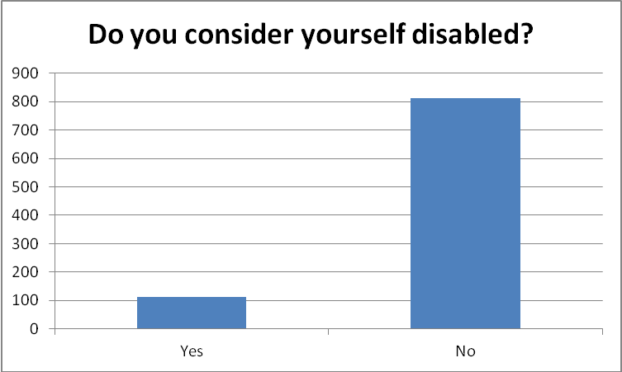

Do you consider yourself disabled? |  | Percentage of Total Sample
Yes | 113 | 10.80%
No | 813 | 77.40%

Question 7
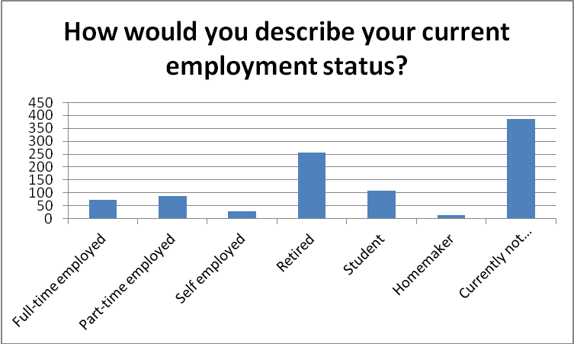
How would you describe your current employment status? |  | Percentage of Total Sample
Full-time employed | 72 | 6.90%
Part-time employed | 88 | 8.40%
Self employed | 29 | 2.80%
Retired | 256 | 24.40%
Student | 107 | 10.20%
Homemaker | 12 | 1.10%
Currently not working | 385 | 36.70%

Compiled April 2014

