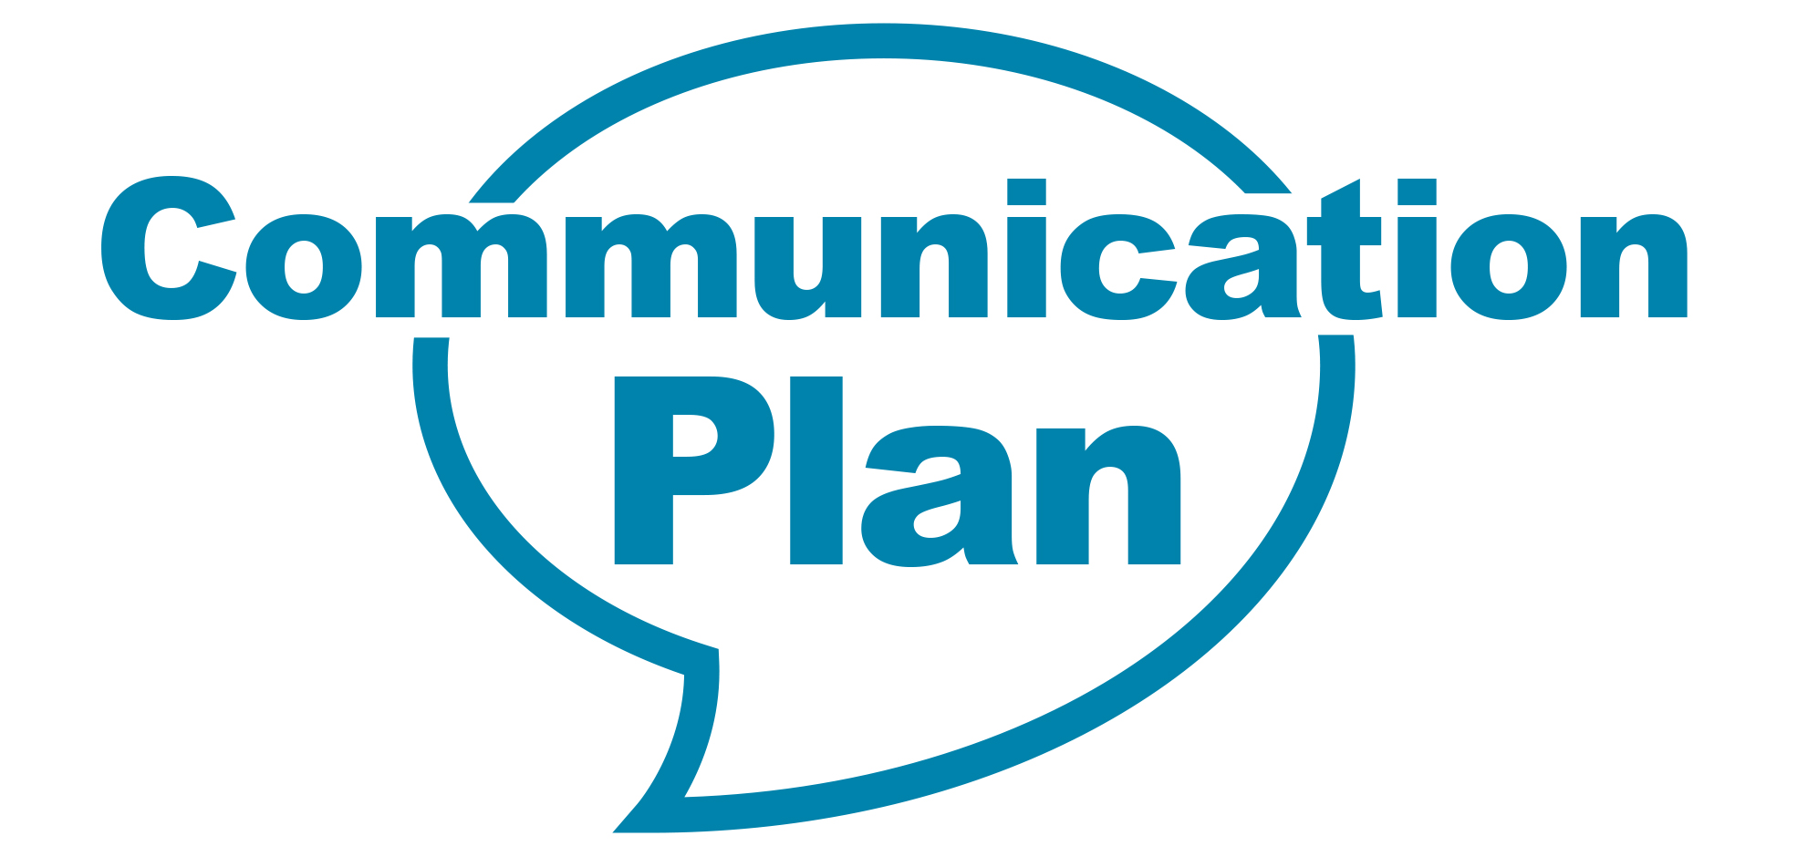
Date: Updated – October 2016
Lead communications officer: Kieran Barr, Senior Communications Manager

- Introduction/overview of issue:
Public opinion surveys routinely show roads and highways are a top priority for the Cumbrian public. This reflects the fact that, unlike many other council services, everyone is service user. Roads and highways is correspondingly a top priority for the council.
Cumbria Highways manages the council’s highways infrastructure. Service improvement is driven by the Highways Improvement Board who is responsible for the delivery of the Highways Asset Management Strategy.
The vision for Cumbria Highways is that it will be:
‘A customer focussed, resilient and cost effective service that delivers a safe and well managed highways asset’
Effective communications plays a critical role in realising that vision, alongside excellent service provision. In combination we aim to improve satisfaction with Cumbria Highways over time.
This plan sets out how we will achieve that.

- Objectives:

This plan has five key objectives:
- Develop and promote a positive narrative about Cumbria Highways with public and stakeholders - News
- Improve the quality and availability of highways related information - Information
- Improve how Cumbria Highways interacts with the public - Engagement
- Improve public awareness of Cumbria Highways and its brand – Brand
- Improve the quality of internal communications within Cumbria Highways - Internal
These objectives are expanded upon below:
News
We will keep Cumbria Highways in the news for the right reasons; working closely with highways management we will be proactive in identifying and promoting stories that demonstrate the competence, innovation and commitment of the service. We will be equally proactive in managing our communication around controversial issues.
Information
We will provide information that people want and need about highways matters in ways that are timely, relevant and accessible. Our focus will be primarily on developing digital channels which offer the greatest scope to expand and enhance the information offer to the public. This will include moving all of our Statutory Notices online.
Engagement
We will ensure that when the public interact with Cumbria Highways via consultations, Highways Hotline, compliments or complaints, surveys and other forms of customer contact that they receive an excellent quality of service that meets their expectations. Where expectations cannot be met this will communicated appropriately and professionally.
Brand
We will review and refresh the Cumbria Highways brand, ensuring it is understood across the organisation in terms of values, service standards and visual identity.
Internal
We will review and develop as necessary a comprehensive and consistent approach to internal communications with Cumbria Highways staff to ensure they are well-informed about developments within the service, understand expectations and that success is celebrated.

- Approach

To achieve the objectives described above we will take the following actions:
News
We will:
- Establish a proactive approach to managing issues through the Highways Senior Management Team. This will included regular attendance at SMT meetings by a member of the communications team.
- Develop communications horizon scanning as a routine SMT activity. This will identify in advance projects or issues of significance or which present communications/reputational risks.
- Establish standard approaches for managing communications around projects and issues of different types (will require a consistent classification system).
Information
We will:
- Review and improve the Cumbria Highways website to improve the quality of information available. This will include:
  - Comprehensive information about current and forthcoming roadworks (including work conducted by the council and by other organisations), accessible via online map and as tabular lists split by locality.
  - Details of emergency road closures and other unplanned events
  - Traffic and weather camera feeds
  - Individual pages for major projects with regularly updated information.
  - Details of current consultations, with facility to respond online
  - Statutory Notices
- Review and improve the Cumbria Highways presence on social media, this will include:
  - Rebrand of the Cumbria Gritters Twitter account to be for Cumbria Highways generally
  - Create Cumbria Highways Facebook page.
  - Training highways staff to update social media accounts for routine or emergency updates.
  - Promotional campaign to increase user numbers for these channels.
- Develop Cumbria Highways email bulletins within GovDelivery, this will include:
  - Generic highways bulletin to provide weekly/monthly round up of activity.
  - Specific email bulletins for major projects.
  - Locality specific bulletins to provide monthly update on on-going and planned road works.
- Review the provision of offline information, for example letters/leaflets to local residents, to ensure a consistent and appropriate approach.
Engagement
We will:
- Review the approach to consultations and other forms of opinion research to ensure quality and consistency across the county.
- Establish a consistent approach to engagement with Members, and other district and parish councils.
- Review the operation of the Highways Hotline from a customer service perspective and develop improvements as required, including gathering customer feedback.
- Review the service’s handling of compliments, comments and complaints through the council’s formal process and make improvements as required to ensure consistent and high quality approach.
- Develop consistent approach to managing and responding to customer feedback received via any channel.
Brand
We will:
- Review the Cumbria Highways visual brand to ensure it is fit for purpose and consistently and appropriately applied across staff, vehicles, signage and other points of public visibility.
- Establish a set of clear brand values for Cumbria Highways (complimentary to the council’s corporate behaviours) which can used as basis for discussion around performance and quality.
Internal
We will:
- Review the approach to internal communications within Cumbria Highways and develop a consistent approach across the service.
- Run an internal communications campaign with Cumbria Highways staff to promote the agreed brand values.

- Key Messages:
- Cumbria Highway’s top priority is a safe and sustainable network - safety
- Cumbria Highways delivers a cost effective and quality service – quality & value
- Cumbria Highways works with communities to improve the economic, social and environmental well-being of the area - community

- Key stakeholders:

The following list outlines the range of key stakeholders covered by our county-wide communications. This is not exhaustive and local projects requiring specific work will have unique stakeholder mapping carried out.

- Leader & Lead Cabinet Member
- Other Cabinet members
- Other CCC members
- CCC staff specifically affected (highways)
- General CCC staff
- MPs
- District Councils
- Town and Parish Councils
- Trade Unions
- Partner organisations
- Voluntary/ Third sector
- Media (local/national/trade)
- Customers
- DfT
- Local communities
- Local businesses
- Emergency services (Police, Fire, Ambulance and Health service)
- People travelling through the county eg Visitors
- Utilities
- Interest groups such as cycling and motoring groups, disability and mobility groups and motoring groups
- Neighbouring highway authorities

- Evaluation

Through this communications work - we aim to demonstrate the excellent work being carried out to maintain and improve the county’s network. Evaluation of this work would be carried out on an ongoing basis to ensure that communications are delivering the aims and objectives in this strategy. This will include the regular monitoring of media coverage and direct feedback from residents and partners.

Success of this communications plan will be measured by:

General
- Public satisfaction with highways maintenance and condition as measured by the National Highways and Transport Public Opinion Survey.
News
- Volume and tone of media coverage (generally and for specific projects)
Information
- Number of web visitors monthly
- Number of Twitter followers
- Monthly Twitter impressions (total)
- Number of Facebook likes
- Monthly Facebook reach (total)
- Number of GovDelivery sign ups
- GovMetric website feedback
Engagement
- Customer satisfaction surveys (for Highways Hotline)
- Number of complaints/compliments
- Number of complaints which progress past Stage 1
- Responsiveness to online engagement via social channels (how consistently and quickly do we respond)
Brand
- Annual brand audit to monitor compliance
Internal
- Annual staff communications survey

- Identified spokespeople for this plan:

Keith Little, Cabinet Member for Highways
Stephen Hall, Corporate Director for Environment & Community Services
Nick Raymond
Karl Melville
Other relevant officers as appropriate for particular projects.

