PRINCIPLE 1

In any circumstances, all children and young people have a core set of needs.
Maslow described these as:
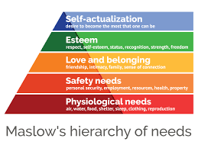

Some and maybe all of these will have been impacted for a number of children during the COVID-19 pandemic. Some families have experienced, and will continue to experience, financial difficulties which may have led to anxieties about housing, food and other essentials. Some children may, therefore, return to school not having eaten healthily and worrying about their family circumstances. Some may be feeling unsafe due to the virus itself causing sickness and so many deaths (physiological and safety needs). Despite many having access to social media, some young people may not. Relationships at home may be strained because of the lockdown and friendships affected because children are not meeting face to face. Although schools have been working hard to support pupils, it is possible that some will lose some sense of belonging – some literally if they have not had chance to say goodbye to the school community before moving to a new school. Carpenter (2020) advises that self-image, self-esteem and self-concept are grounded in peer relationships so these may have been damaged. Positively, many children with have discovered a sense of self-actualisation through their efforts to make others smile and raise money or learn a new skill, for example. It will be important for school staff and parents/carers to consider this framework when welcoming children back into school and reflecting on their needs.

References

Carpenter, B. & Carpenter, M. (2020) Evidence for Learning: Recovery Curriculum https://www.evidenceforlearning.net/recoverycurriculum/
Maslow, A. H. (1971). The farther reaches of human nature. New York: The Viking Press.

