Written by
Janet Edgar
Behaviour & Emotional Wellbeing Officer
County Psychological Service

Transition Workbook
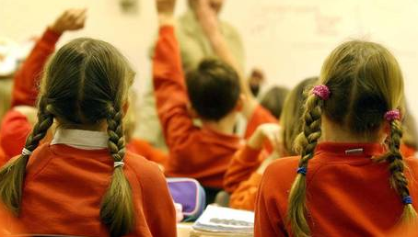

A guide to moving from primary school to secondary school

You have been given this workbook because you were part of a special transition group in Year 6. Your group had six lessons all designed to help you learn skills which will help you get on well when you start in Year 7.

This workbook is to help remind you of all the skills you learned, and make sure you fully understand them.

You can work through the book in your own time, on your own, or with your family or friends.

Each section will have some questions for you to answer using the skills you learned in the sessions (the answers are at the back but try not to peek!)

Possible answers to Session 3 questions:
1. Making a list of all the skills you already have can be a brilliant way of making yourself feel good! Confidence can be built from our strengths and knowing where we will be successful. Did your list have more than three? Great!
2. These will almost certainly be the things which will be new to you – remember practice makes perfect!
3. Step 1 – make sure you know what the problem is, Step 2 – write down your solutions, Step 3 – decide which ones are possible, Step 4 – choose the best, Step 5 – do it!
4. Well done if you thought of a problem to solve!

Possible answers to Session 4 questions:
1. The three main learning styles we looked at are Visual (learning with your eyes), Auditory (learning with your ears) and Kinaesthetic (learning with your hands)
2. If you get stuck learning, you can use your strongest learning style to look at the subject in a new way
3. Some of the coping strategies we learned are:
*ask for help *use your timetable/planner *ask a Yr8 *go to the learning support room *ask a teacher *retrace your steps *look at what others are doing *look for a prefect or mentor *write it down *follow someone in your group *be brave *stay with kind people *hang round with kind people *keep calm *take deep breaths *remind yourself you can do it *smile

Session 1: Feelings
When you make any transition (or change), big or small, you will have lots of different feelings or emotions about it. Not everyone will have the same feelings, and your friends may feel differently to you. Some of the feelings you have will make you feel good, such as *happiness *excitement *anticipation
*readiness *confidence *acceptance *optimism *joy *pleasure *hope *enthusiasm *inspiration *love *cheerfulness *courageousness *delight *determination *powerfulness *interest *wonder *stimulation *readiness *resilience *positivity *inspiration *bravery *fearlessness *eagerness *encouragement *delight.

Others may be less welcome, such as *worry *anxiety *concern *fear *nervousness *guilt *doubt *sadness *apprehension *dislike *annoyance *fearfulness *confusion *resentfulness *stress *overwhelmed *moodiness *jealousy *insecurity *bad-temper *helplessness *disbelief *despair *conflicted
Many of these emotions were on your group feelings wall
All of these are normal emotions
Questions
1. What are you looking forward to in the future? Can you name three events here?
*
*
*
2. Remember the famous or notable person you chose in the session – name two qualities you admired here
a. b.
3. List three obstacles which could have made their success hard to achieve
*
*
*
4. Which of these goals would you like to achieve? Circle them
get rich? grow old? work in show business? be an actor? live where you want? work with your hands? be a hero?
have a family? travel the world? matter to someone?
be a teacher? work in IT? be famous? be a YouTuber?
take life as it comes? buy a house? get good exam results?

Questions
- Will your feelings stay the same all the time? Yes/No – explain why here
…………………………………………………………………..
- Why did the feelings move up and down the feelings wall?
…………………………………………………………………..
- Will you have to deal with negative feelings myself? Yes/No – explain why here
…………………………………………………………………..
- Who will help if you feel upset at the new school?
…………………………………………………………………..
- Does it help to tell someone if you feel upset, scared or worried? Yes/No – explain why here
…………………………………………………………………..

Session 6: Goals and Moving On
In primary school you will have set goals in reading, writing and maths; maybe even in other subjects like PE. Goals help us to try harder to achieve more. Another word which means almost the same is ‘aspirations’.

If we know what our goals and aspirations are we are more able to work out how to reach them and how to overcome obstacles in our way.

Most people who have become famous or notable for being successful have worked hard to get where they are and have learned how to overcome difficulties along the way.

In secondary school goals and targets will be set for you to work on.
In Session 2 we worked on:
- The differences between primary school and secondary school
- Which differences we would be confident to manage independently and which we might need help with
- Ways in which we will become more independent at secondary school
- How we will organise ourselves, our routine and our equipment
- Understanding timetables and how to find the right room and teacher for each subject
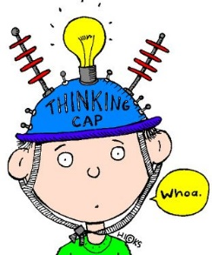

In Session 5 we worked on:
- Exploring what we think makes a good friend
- Why friends are important and why it’s good to have them
- Which friendship qualities we think are good in a friend and what we will look for when making new friends
- What to avoid when making new friends
- How to approach Year 7’s we don’t know who have come from another primary school
- How we can make and keep new friends
- How friends can help each other settle in to secondary school

Session 3: Problem Solving
Having one or more of the negative feelings from Session 1 may indicate there is a problem. Having a tried and tested problem-solving method can be useful so that you are able to solve some problems yourself.
Problems are often related to self-confidence and arise when we don’t know what to do. If people are good at certain things they usually don’t have problems managing those things. We are all different!
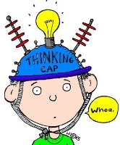

Questions
1. Can you name the three main learning styles? Have a go here
*
*
*
2. How can knowing your best learning style help you learn better?
…………………………………………………………………………………………………………………………………………………………
3. Can you remember some of the coping strategies we wrote in our pocket prompt books? List as many as you can think of here
* *
* *
* *
* *
* *

Questions
- What are you good at? Make a list here
………………………………………………………………………………………………………………………………………………
- What things do you think you might have problems with? Explain here
………………………………………………………………………………………………………………………………………………
- Do you have a tried and tested problem-solving model? Yes/No – explain it here
………………………………………………………………………………………………………………………………………………………………………………………………………………………………………………………………………………………………
- Name a problem you think you could solve using the model above
………………………………………………………………………………………………………………………………………………………………………………………………………………………

