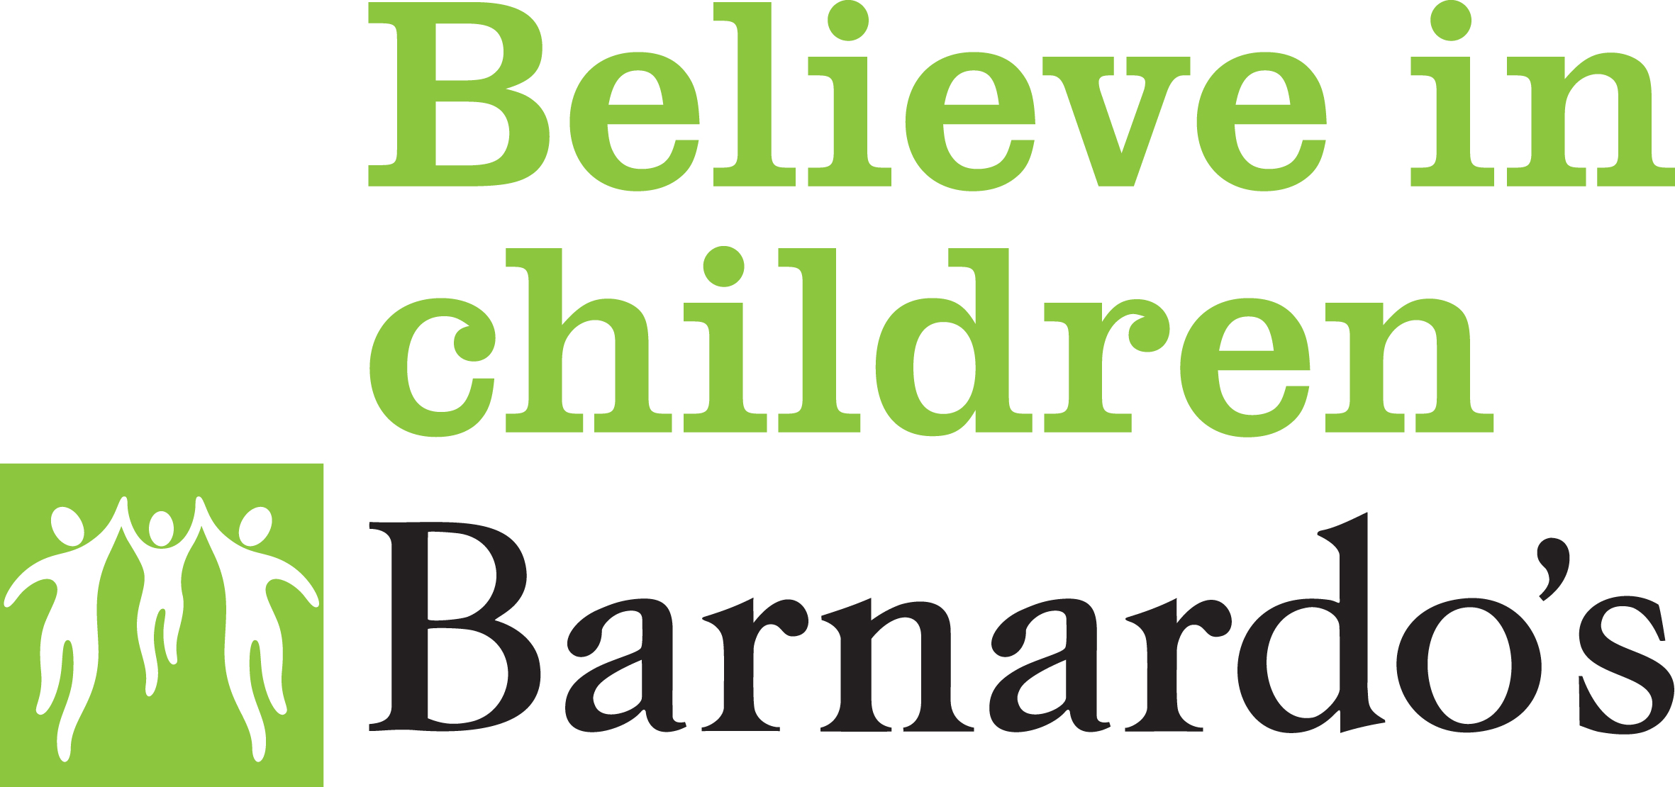

Cumbria Child and Adolescent Mental Health Service (CAMHS)
Referral Form (NCCCG)
INADEQUATELY COMPLETED FORMS AND UNJUSTIFIABLE REQUESTS WILL BE RETURNED TO THE REFERRER

PLEASE NOTE IF THE CHILD/YOUNG PERSON IS NOT SEEN AS PART OF THE REFERRAL, IT WILL NOT BE ACCPETED

IF THERE ARE IMMEDIATE SAFEGUARDING CONCERNS THEN IT IS THE RESPONSIBILITY OF THE REFERRER TO CONTACT THE SAFEGUARDING HUB.

This referral form is for access to services incorporating Primary Mental Health Early Intervention and CAMH Services which are jointly delivered by Cumbria Partnership NHS Foundation Trust and Barnardo’s across Cumbria. Your referral will be reviewed by representatives from both organisations. Onward referral to other agencies will be completed on your behalf where clear consent is included on this form.

PATIENT DETAILS: |  | Referral Date:
SURNAME: | DOB: | PRACTICE:  Tel:  Fax:  Practice code:  Registered GP:
FIRST NAME: | AGE:
NHS NUMBER: | GENDER:
ETHNICITY:
RELIGION:
ADDRESS:

PHONE:  Home:  Mobile:  Work: |  | INTERPRETER REQUIRED?  (if yes, state language including signing)  YES NO
SCHOOL (if known): |  | Is attendance an issue?  DON’T KNOW YES NO
DISABILITY (if yes, provide details): YES NO

Is the child/young person “looked after” as defined in the Children’s Act 1989? YES NO
Is the child/young person adopted? YES NO
Are there safeguarding concerns about the child/young person or family? (if yes, provide details) YES NO

Is the child/young person subject to a Child Protection Plan? DON’T KNOW YES NO

OTHER SERVICES / PROFESSIONALS INVOLVED (if known):
Name | Agency | Contact Tel No
Has an Early Help Assessment been completed? DON’T KNOW YES NO

FURTHER HELPFUL INFORMATION:
Does the parent or carer have any known literacy problems? (if yes, provide details) YES NO

Do the parents/guardians have parental responsibility? YES NO
Are the parents/guardians agreeable to the referral? YES NO
Is the child/young person aware of the referral? YES NO

REFERRAL DETAILS:
Reason for the referral:

When did the problems start?

Problems
Medication
Allergies

RISK ASSESSMENT:
Are there any issues that place this young person or others at risk? (if yes, provide details) YES NO

AGREEMENT TO REFERRAL:
The information on this form will be used to assess the emotional and mental health needs of the referred child/young person. Sometimes we may be able to re-direct the referral to a more appropriate service if consent is obtained to share the information with other agencies.
Have the parents/guardians given consent to allow CAMHS to share information as specified above? YES NO

REFERRER DETAILS:
REFERRER’S NAME:

REFERRER’S DESIGNATION:

REFERRER’S ORGANISATION:

TEL:
SIGNATURE: | DATE:

Note to provider: this referral form has been standardised locally in line with the required NHS minimum requirements and guidance from Information Governance. Please email primis@ncic.nhs.uk with any proposed amendments to the form.

CEDS Referral Form Triage Prompt Questions

Does the young person present with a suspected eating disorder?
Do they appear to have body image distortion? Are they deliberately attempting to lose weight in an unhelpful way, particularly if weight loss is not clinically indicated? Include an eating disorder diagnosis if this has been given.
What is the young person’s current weight and height? And do they have a history of weight loss? If so, please give details including the current rate of weight loss.
Single Code Entry: O/E - height
Single Code Entry: O/E - weight

Is the young person currently restricting their food or fluid intake? If yes, please give details. If malnutrition or dehydration is suspected, please include details of any physical health symptoms
Does the young person report binging (eating large volumes of food in a short space of time) episodes? If yes, please give details.
Does the young person report any compensatory behaviours to control or reduce their weight – these include vomiting, laxatives, excessive exercise, diet pills? If yes, please give details.
For any suspected eating disorder, an assessment of physical health risk is essential. Please consider when the young person last saw their GP and consider requesting an urgent appointment to check the following according to Junior MARSIPAN Guidelines: blood biochemistry (full FBC’s, U’s and E’s, Potassium, Magnesium, Phosphate, LFT’s), blood pressure standing and sitting, temperature, pulse rate, weight and height and attaching these results to the referral. Seeks guidance from CEDS clinicians if you are unsure.

SEND REQUEST TO: |  | Tel Number | Email
West Cumbria: | Ann Burrow Thomas Health Centre, South William Street,Workington, Cumbria CA14 2EW | 01900 705800 | camhs.west1@nhs.net
East Cumbria | Fairfield Centre, Carleton Clinic, Cumwhinton Drive, Carlisle, Cumbria CA1 3SX | 01228 603017 | camhs.east1@nhs.net

