They Matter – An Intervention Service for high risk/high harm perpetrators of domestic abuse – Pilot Project

As part of our offer to families experiencing conflict, violence and abuse within intimate and close relationships across Cumbria, Victim Support’s Turning the Spotlight project have developed a service for those who have been identified as high-risk/high harm perpetrators of domestic abuse.

We will be delivering a 27 week programme in the South and West of Cumbria with the potential to extend our service to deliver in the North later in October.
The programmes will start in the West of the county at the beginning of August and the end of August in the South. Evening sessions will be an option. We are now accepting referrals for assessments to be completed in July.

Programme Design
They Matter is predominantly a group work programme for a maximum of 12 participants.
The programme comprises of 3 modules with 7 sessions in each module. The modules are as follows,
• Relationships – General Awareness
• Relationships – Self-Awareness
• Relationships – Skills for Positive Change

1:1 Sessions
Each module (beginning with module 1) is preceded by a 1:1 session to prepare individuals for the subjects and tools explored in each module. 1:1 sessions provide an important opportunity to consolidate learning, discuss any issues that the participant does not wish to share in front of other group members and provide opportunities to monitor and manage risk.

Programme Style
Group work sessions are highly participatory. Sessions, tools and activities in this programme have been designed to incorporate key aspects of supportive challenge through using a psychologically informed approach. This is done by using tools that link with education, self-awareness and motivation e.g. ‘Cognitive Behavioural Coaching’ (CBC), Appreciative Inquiry (AI) and promoting critical dialogue.

A victim focused service
TTS, like many services working with high risk/high harm perpetrators, ally firmly with victims of domestic abuse. The primary task of the service is to maximise the safety, of both adults and children experiencing harm caused by high risk/high harm perpetrators of domestic abuse. Safety is the key principle upon which the service is built. In order to achieve this, TTS work transparently, and within clear boundaries outlined below.

Who is the programme suitable for?
They Matter is designed for heterosexual male perpetrators of domestic abuse, identified as causing or likely to be causing high risk/high harm within their families/relationships. The programme is suitable where the following criteria have been met:
• The individual is aged 18 or over
• The individual accepts that they have responsibility (at least some) for abusive actions and has a willingness to explore their behaviour in relationships (this may be partial)
• The individual acknowledges that their behaviour is causing/has caused harm to those closest to them
• The individual accepts that TTS operate within the context of partnership working and has read, accepted and signed the partnership agreement and information sharing protocol

Who is the programme not suitable for?
They Matter will not be suitable for everyone and when making decisions, consideration will always be given to the safety of the victim(s) and the other participants enrolled in They Matter. They Matter is a group work programme and therefore all actions have impacts or consequences on others. The following criteria outline who the programme is not suitable for.
• Individuals who are in complete denial regarding their abusive behaviour and accept no responsibility for their actions despite strengths based/motivational interventions
• Individuals who are unwilling to sign the information sharing agreement and do not agree to the release of information as a condition for participation in the programme.
• Individuals with severe learning/literacy difficulties that would impact their ability to participate.
Whilst a range of learning materials are supplied, including visual and audio formats, materials are currently not available in all learning mediums, (e.g. braille). TTS endeavour to provide learning support where possible, and particularly where the issue may be one of confidence in ability.
• Individuals whose first language is not English and where their command of English is not sufficient enough to enable them to fully participate.
Whilst TTS would strive to use interpretation services when working with individuals, They Matter is a group work programme unsuitable for the presence of interpreters. Interpretation services would lengthen the process unacceptably for other members of the group, as well as breach their confidentiality.
• Individuals who are currently using substances, without addiction support and intervention.

Whilst substance abuse does not automatically preclude someone, if it is likely that it will affect their attendance and participation in the programme, it must be addressed before They Matter can be offered as an intervention. Where drug and alcohol services are currently involved with an individual, TTS will seek to work in partnership with them to ensure interventions are co-ordinated and information exchanged to ensure robust service delivery around the relationship between substance misuse and violent/abusive behaviour within intimate relationships
• Individuals who, following assessment by TTS, are deemed not to meet the threshold for High Risk in relation to DASH/SARA (confirmed by victim assessment/information), and who are willing to engage with the healthy relationship programme

For further information or to discuss potential referrals please contact:
Jo Nelson on 07936364165 or Laraine Carr on 07919393311.

Turning the Spotlight referral form

Please complete and return this form to turningthespotlight@victimsupport.org.uk password protected. If you have access to CJSM, please send your completed form to: dvpp.referrals@victimsupport.cjsm.net For further information contact: 07919 393311
Those making referrals and clients themselves, should be aware that entry to the programme is via a needs and risk assessment. The initial assessment typically takes place over two face to face sessions and also involves the process of gathering relevant information from partner agencies, partner, ex-partner etc.

We work as part of a multi-agency approach to supporting families experiencing domestic abuse. As a referrer into our programme we would ask that you:

- Share information regarding the case and advise us if there is any change to the level of risk throughout our engagement with the client whether this be an increase or decrease in level of risk. We also ask that you share partners/ex-partners details if known. The safety, well-being and voice of Partners/ex partners of those attending the They Matter programme is of upmost importance to the high-risk perpetrator intervention service offered by TTS. When individuals are referred to They Matter, partners/ex partners will be contacted and also offered a risk and needs assessment. This is to inform the risk assessment and management plan and offer information and support as required. Partners/ex partners are under no obligation to accept ongoing support but will be asked if they would be willing to supply ‘update’ information regarding the risks/harm they are experiencing following an individuals' attendance on each module of the programme, or at 3 points following initial assessment
- Keep us informed of any meetings you would like us to attend and provide feedback within.
- If necessary, attend face to face meetings with the client to encourage engagement with our service.
- Assist with any other relevant pathways such as drug and alcohol services to ensure a holistic approach to supporting clients.

Name of referring organisation: | Name of referring practitioner:
Contact telephone number for referrer: | Email address for referrer:
Date of referral:
Please confirm consent has been given for this referral  Yes/No | Is there evidence of any escalation of violence or aggression in the home? Yes/No
Has a risk assessment been completed? Yes/No  What type? Eg DASH/OASys/SARA/  Initial assessment/Parenting assessment  Other professional involvement:  Has the client accessed any other services in the last two years? Yes/No  If yes give details below (if more than one service please use an extra sheet of paper)  Name of organisation:  Name of worker:  Date of involvement:  Contact number: | Level of risk identified and summary of key risks, please identify whether the risk is high/medium or standard risk:
Client consent
I/We give permission for details to be passed on to Turning the Spotlight (TTS). I understand that I will be contacted by a TTS member of staff to discuss what they can offer.

Signed: Date:

Client one details
Name
Gender: Male/Female
Date of birth
Address
Postcode
Preferred telephone number for contact |  | Preferred contact time(s)
Email
Employment status
Client two details | PARTNER/EX-PARTNER DETAILS
Name
Gender: Male/Female
Date of birth
Address
Postcode
Preferred telephone number  for contact |  | Preferred contact time(s)
Email
Employment status

Relationship status
Status of partner relationship: Please tick the current status of the relationship.
Married ……............ Cohabiting ……............ Divorced ……............ Separated ……............ Other
……............

Children
Name | Date of birth | Client one’s relationship to child. e.g. father, mother, step-parent | Is child subject to CP? | Client two’s relationship to child. e.g. father, mother, step-parent | Parental responsibility? Yes/No
Reason for referral
Please give full details and nature of any reported incidence of domestic abuse (including known police call outs), offences or findings of fact involving children, domestic abuse, sexual offences, drugs, arson and firearms, current legal proceedings, relevant convictions.

Participation
Are there any known issues that may affect the client’s ability to participate in TTS programmes of support? E.g. disability, mental health, substance misuse, literacy issues, denial of behaviour?
Yes/No
If yes, please provide details below.
This does not necessarily preclude any client from TTS, but is important information in terms of determining suitability and support required.

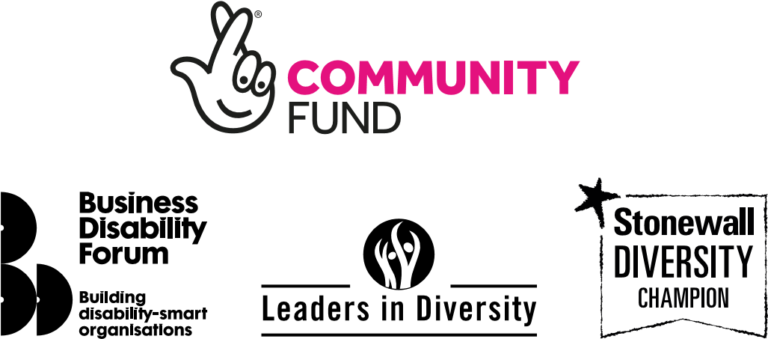

A service by:
victimsupport.org.uk
VictimSupport @VictimSupport
Registered office: Victim Support, 1 Bridge Street, Derby DE1 3HZ
T: 020 7268 0200 Next Generation Text: 18001 020 7268 0200 Registered charity no. 298028
November 2020 | P2349 © Victim Support 2020

